**MINISTRY OF EDUCATION**

**AND TRAINING**

**FPT UNIVERSITY**

Capstone Project Document

Website of Law Firm Management System

Final Report

|  |  |
| --- | --- |
| Website of Law Firm Management System | |
| Group Members | Lê Duy Hoàng – Team Leader – SE60744  Đặng Nguyễn Khiêm – Team Member – SE60595  Trần Anh Tuấn – Team Member – SE60631  Phạm Văn Duy – Team Member – SE60634 |
| Supervisor | Nguyễn Văn Sang |
| Capstone Project code | LFMS |

- Ha Noi, 09/2014 –

**LỜI CẢM ƠN,**

Chúng em xin phép được viết lời cảm ơn bằng Tiếng Việt để có thể truyền tải được trọn vẹn lời tri ân với quý Thầy Cô.

Không có thành quả nào mà không gắn liền với sợ hỗ trợ, sự giúp đỡ dù ít hay nhiều, dù trực tiếp hay gián tiếp của mọi người xung quanh. Trong suốt quá trình học tập tại FU, chúng em đã nhận được rất nhiều sự quan tâm, giúp đỡ của quý Thầy Cô và bạn bè.

Với lòng biết ơn sâu sắc nhất, chúng em xin gửi đến quý Thầy Cô đã cùng với tri thức và tâm huyết của mình để truyền đạt vốn kiến thức quý báu cho chúng em trong suốt thời gian học tập tại trường.

Chúng em xin chân thành cảm ơn Thầy Nguyễn Văn Sang đã tận tình hướng dẫn chúng em qua từng buổi gặp mặt nhóm, từng buổi chia sẻ và thảo luận. Khóa luận tốt nghiệp của chúng em có thể hoàn thiện được, góp phần lớn là nhờ công sức dạy bảo của Thầy. Một lần nữa, chúng em xin chân thành cảm ơn Thầy.

Khóa luận tốt nghiệp được thực hiện trên cơ sở dự án thực tế, cần phát triển thêm nhiều kỹ năng ngoài những bài học tại trường, cộng thêm kiến thức và kinh nghiệm thực tiễn của chúng em còn hạn chế, do vậy quá trình làm dự án không tránh khỏi những thiếu xót, rất vui khi nhận được những ý kiến đóng góp quý báu từ quý Thầy Cô để chúng em được hoàn thiện kiến thức hơn.

Sau cùng, chúng em kính chúc quý Hội Đồng dồi dào sức khỏe, chúc cho một kỳ bảo vệ đồ án tốt nghiệp thành công rực rỡ.

**Nhóm Website of Law Firm Management System**

Contents

Report No.1: Introduction 7

1.1. Introduction 7

1.1.1. Purpose 7

1.1.2. Acronyms and definitions 7

1.2. Abstract 7

1.3. Literature review 8

1.4. Proposal 8

1.4.1. Initial idea of the LFMS 8

1.4.2. Objectives 8

1.4.3. System features 9

1.5. Benefit from project 9

1.5.1. For our group 9

1.5.2. For Law firm 10

1.6. Critical assumption and constraints 10

1.7. Potential risks 10

Report No.2: Software Management Plan 12

2.1. Problem Definition 12

2.1.1 Name of this Capstone Project 12

2.1.2 Problem Abstract 12

2.1.3 Project Overview 12

2.2 Project organization 14

2.2.1 System Process Model 14

2.2.2 Roles and Responsibilities 16

2.2.3 Tools and Techniques 18

2.3 Schedule 19

2.4 Convention Rules 21

Report No.3: Software Requirement Specification 22

3.1. User Requirement Specification 22

3.1.1. Functional Requirements 22

3.1.2. Non-Functional Requirements 23

3.2. System Requirement Specification (Specific Requirements) 23

3.2.1. External Interface Requirements 23

3.2.2. Functional Requirements 24

3.2.3. Non-Functional Requirements 197

3.3. Entity Relationship Diagram 198

Report No.4: Software Design Specification 199

4.1. Design Overview 199

4.2. System Architectural Design 200

4.2.1. Choice of System Architecture 200

4.2.2. Discussion of Alternative Designs 201

4.2.3. Description of System Interface 201

4.2.4. Architectural Presentation 202

4.2.5. Package Diagram 203

4.3. Detailed Design 204

4.3.1. Data Model 204

4.3.2. Controller 205

4.3.3. Business 206

4.3.4. Data Access 207

4.3.5. Login 207

4.3.6. Change password 210

4.3.7. View Home 212

4.3.8. Notify 214

4.3.9. Manage Calendar Event 216

4.3.10. Manage Case 223

4.3.11. Manage Customer Group 274

4.3.12. Manage Customer 282

4.3.13. Manage Staff Group 292

4.3.14. Manage Staff 301

4.3.15. Manage Service Type 314

4.3.16. Manage Service 322

4.3.17. Manage Office 329

4.3.18. Statistic 340

4.4. Database Design 363

4.4.1. Relational Database Diagram 363

4.4.2. Table Dictionary 363

Report No.5: Software Testing 372

5.1. Introduction 372

5.1.1. System Overview 372

5.1.2. Test Approach 372

5.2. Test plan 372

5.2.1. Scope of testing 372

5.2.2. Requirement for testing 373

5.2.3. Test strategy 376

5.3. Test Case 381

5.4. Checklists **Error! Bookmark not defined.**

5.4.1. Checklist of Validation **Error! Bookmark not defined.**

5.4.2. Submission Checklist **Error! Bookmark not defined.**

5.5. Test Logs 385

5.5.1. Defect Logs 386

5.5.2. Test Report 386

Report No.6: Software User’s Manuals 393

6.1. Installation Guide 393

6.1.1. Introduction 393

6.1.2. Environment 393

6.1.3. Application Installation 393

6.2. User’s Guide 402

6.2.1. How to create a Calendar Event 402

6.2.2. How to view calendar event of other lawyer 403

6.2.3. How to create an Operation Event 404

6.2.4. How to upload photos to Documents Related 405

6.2.5. How to create a case 406

6.2.6. How to create a customer 407

6.2.7. How to create a Staff 408

6.2.8. How to create a service 409

6.2.9. How to create an office 410

6.2.10. How to view statistic 412

6.3. Project Result Report 413

6.3.1. Project judging 413

6.3.2. Project summary 414

6.3.3. Lesson learned 415

# Introduction

## Introduction

### Purpose

This part is the introduction for Website of Law Firm Management System (LFMS) Project – our Capstone Project in FPT University. It is included the overview of existing system, the initial idea of this project, a brief description about our expected system and some potential risks, critical assumptions, constraints, also some benefits for our group and lawyer office.

### Acronyms and definitions

|  |  |  |
| --- | --- | --- |
| **Acronym & Abbreviation** | **Definition** | **Note** |
| LFMS | Law Firm Management System |  |
| SQL | Structured Query Language |  |

**Table 1-1 :Acronyms and definitions**

## Abstract

A law firm system is website designed to manage a law firm’s case client records, billing and bookeeping, schedules and appointments, deadlines, computer files and to facilitate any [compliance](http://en.wikipedia.org/wiki/Compliance_%28regulation%29) requirements such as with document retention policies.

The benefits of law firm system is remind lawyer every day by notify in every day. Now we no need to store document in cabinet, lawyer can easily find it by storage systems.

It might be hard for accounting in law firm. System will provide some way for do this like statistical in every year.

As all of benefits of law firm system, we think this system will be great. We want to develop a website where lawyer can easily use it.

## Literature review

Thuan Nguyen Lawyer Office currently has a management software that runs on Windows, but it’s not good enough.

* + - **Advantages:**
      * User interface is very nice and easy to use
      * Quick response for user’s action
      * Can store the related document
      * Can add billing for each case.
* **Disadvantages:**
  + - * Many errors occur during the use.
      * Difficult to maintain.
      * Limit the number of computer can use
      * Lack of some function like statistical and shedules.
      * Manage with only text information.

## Proposal

### Initial idea of the LFMS

This project get requirements from "Thuan Nguyen Lawyer Office" in Vinh Long City. The majority of this project is to use internal systems used to manage Office, Service, Staff, Customer, Case Management, Consulting, Contract and Reports…

Existing solution is to go for the actual project, met the manager of law office, Mr. Thuan. And then get actual requirements for project.

### Objectives

This project is the Capstone Project for all team members. Firstly, we do this project to fulfill the requirements from FPT University studying program. During the time do this, we can learn how to develop a project, how to communicate with other team members, how to control time, how to do teamwork effectively. Therefore, after finishing this project, we can practice what we have learnt in university and learn so many new things. It is very necessary for our future work after graduating from FPT University.

Secondly, we want to create a website for law firm that help lawyers can work more effective, easier and simpler way without remember schedule and operation event.

### System features

About the feature of LFMS website, it has main features of existing website such as easy to manage than traditional methods, online data storage and centralized etc… Besisdes, it has some extra functions: schedule notify each time event occur and statistic in every year. There are the detailed functions of this application:

* **Manage seven components below:**
* Case Management: Manage all information of Case by customers, general information, operation event, lawyer viewpoint, people related, document related and Used Service. Assign one or many lawyer into Case.
* Customer Management: Add new, edit customer information and delete customer. Stored for use in later Cases.
* Staff Management: Add new, edit staff information and deactivate staff. Division of roles in the system used.
* Service Management: Add new, edit service information and delete service. Use for Used Service.
* Office Management: Add new, edit office information and deactivate office.
  + Statistical**:** Statistic revenue each office in every year.
  + Schedule**:** Notify to lawyer when had an event occurred.

## Benefit from project

If this application will be developed and implemented successfully, our group and lawyers will get some benefits from it.

### For our group

After developing and implementing this project, our group will get some benefits:

* We have more experiences of managing a software project: how to manage plan, time, and risk. These experiences help us a lot in our future work.
* Know how to communicate with other team members and how to do teamwork efficiently
* If this application is developed, we will get a good mark in Capstone Project. It makes our grade better.

### For Law firm

After developing and sending to law firm, lawyer can use it from local host in personal computer.

* Lawyers can work more effective, easier and simpler way without remember schedule and operation event.
* Law firm can manage all information like case, customer, staff service and office easier.
* Accounting easier with auto statistical in every year.

## Critical assumption and constraints

There are some critical assumptions that we realize after analyzing this project. The first assumption is about team members. We assume that all the team members can work with MVC and C#. We do not know anything about it before this project, but we have to study hard for not missing any deadline of project plan. Besides, we also assume all our members do not have any health problems, so they are not absent and can do their works.

There are also some constraints of our project. Firstly, about the time and deadline, we have to finish project on time. It has no extra time for us to complete developing and deliver application to teachers. Besides, the reports need to be submitted before the deadline. Secondly, about the quality, the application must be well enough for users to do main function. Finally, about the technique, our knowledge in C# and MVC is not in the high level. Therefore, with all the expected features that we gave before, we do not know if we can solve all of those or not. However, we will try our best to make our project successfully.

## Potential risks

After analyzing this project, we may be facing some risks:

* + - With the short duration - about 3 months – we will not have enough time to do all things and miss the delivery deadline.
    - We do not have any experiences in software project management such as time management, risk management etc. So maybe we will miss the deadline or have some unknown risks.
    - It is the first time we manage big project like this, we do not have much experiences in communicating between the team. So maybe in the future, we will have conflict and argument and we will not finish all the works in time.
    - Maybe we will lose source code or device during the developed time.

# Software Management Plan

## Problem Definition

### Name of this Capstone Project

English: Website of Law Firm Management System

Vietnamese: Trang web hệ thống quản lý hồ sơ án tại văn phòng luật sư

Abbreviation: LFMS

### Problem Abstract

Today, the emergence of the law office is very popular. Every industry, every job when disputes occur are needed to the law office to advice and resolve. However, current law office management system, mostly using traditional methods. No digitization and no online. Cause difficulties and time-consuming to manage. So, to help law offices can easily manage and store Cases, LFMS born.

### Project Overview

#### The Current System

Below are current system of Thuan Nguyen Law Office:

* Advantages:
  + Online data storage and centralized
  + Easy to manage than traditional methods
* Disadvantages:
  + Many errors occur during the use
  + Difficult to maintain
  + Limit the number of computers can use
  + Manage only 1 office.
  + Manage with only text information.

#### The Proposed System

The new system will have seven components:

* Case Management: Manage all information of Case by customers, general information, operation event, lawyer viewpoint, people related, document related and Used Service. Assign one or many lawyer into Case, payments of each case.
* Manage Calendar: Manage all calendar work of staff.
* Customer Management: Add new, edit customer information and delete customer. Stored for use in later Cases.
* Staff Management: Add new, edit staff information and deactivate staff. Division of roles in the system used.
* Service Management: Add new, edit service information and delete service. Use for Used Service.
* Office Management: Add new, edit office information and deactivate office. Can only be used by “super admin” – the admin user role have StaffId is 1.
* Statistics Management: View all Statistics of system about revenue, number of case received and compare revenue, number of case between offices, staffs.

Advantages over the old system:

* More stable
* Easy upgrade and maintenance
* Multiple computers can use at the same time by web platform
* Many other customer support function
* Manage multiple data.
* Can be used for many types of office.

#### Boundaries of the System

* The system is designed for Thuan Nguyen law offices and the same law office.
* System used internally.
* The language of the system is Vietnamese.
* The system does not include human resource management, budget and attendance.

#### Development Environment

N/A

## Project organization

### System Process Model

With the schedule of weekly reports and a huge of information every week, the software will be developed by using Rational Unified Process model which is very simple and easy for a new group want to make a big project. With RUP model, developing process will include four main phases:

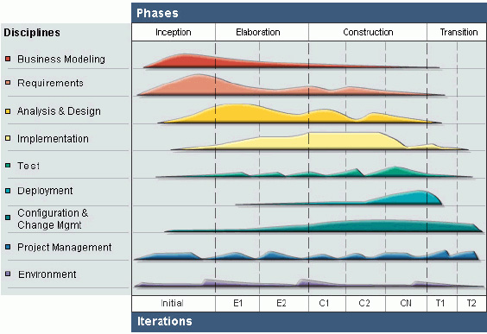

**Figure 2-1: Rational Unified Process Process Model**

* **Inception Phase**: This is the first phase of process. In this startup phase, we should provide business case of the system and determine the scope of project. Besides, we have to create the project management plan that has project schedule, effort estimation and risk management etc. At the end of this phase, we should check the objectives of project and decide whether to continue development or not. Hence, Inception phase must be properly planned and done. Based activities of this phase:
  + Study business case and feasibility study of project.
  + Complete draft ERD of system.
  + Complete draft screen prototypes.
  + Complete draft requirements.
  + Determine project scopes.
  + Complete project management plan.
* **Elaboration Phase**: The objectives of this phase are to determine appropriate architectural and construction plan for the project. The architectural decision needs to be made for the entire system, and to describe most of the requirements of system. At the end of this phase, we must examine the objectives and scopes, the choice of architecture and decide whether to proceed to the next phase. Based activities of this phases:
* Complete user requirement specification.
* Complete ERD, final prototypes.
* Complete Software Requirement Specification.
* Complete database model.
* Complete System Architecture Design.
* **Construction Phase**: Construction is the third phase of RUP lifecycle. In this phase, we must have done all the coding and testing work. After coding, developers will do unit test themselves, then test team will do functional test and regression test when finishing all. Based activities of this phase:

- Complete coding and unit test.

- Complete functional and regression test.

- Complete user manual.

* **Transition Phase**: Transition is the final phase of the RUP lifecycle. In this phase, project team has to deploy the application and give it to users. The next step is receiving feedback from users to identify the problems and then complete the system. Based activities of this phase:

- Deploy the system.

- Deliver source code.

- Complete all reports and documents.

### Roles and Responsibilities

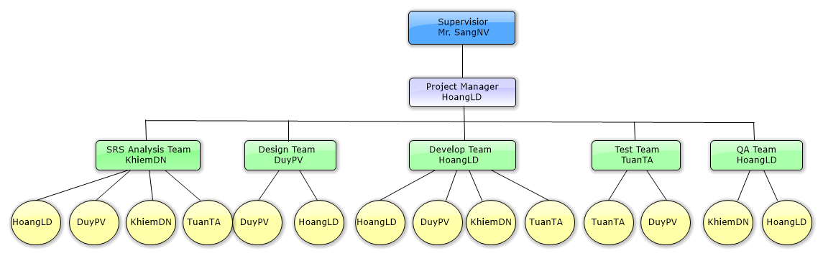

**Figure 2-2: Roles and Responsibilities**

|  |  |  |  |
| --- | --- | --- | --- |
| # | Name | Role | Responsibilities |
| 1 | Nguyễn Văn Sang | Supervisor | Support business and solution  Tracking and review project |
| 2 | Lê Duy Hoàng | Project Manager  SRS Analysis  Designer  Developer Leader  QA Leader | - PM has responsibilities to develop the project plan and manage project stakeholders, project team, project risk, project schedule, project budget, project conflicts.  - Analyze business.  - Ensure that the Project Team completes the project.  - Provide suitable technology solutions, tools for project development process.  - Design and develop interfce.  - Create coding guidelines, coding convention and standards.  - Cooperate with Developer to create software specification requirement (SRS), architectural design (SAD) and software detailed design (SDD).  - Review document, product, and reports.  - Support other team members. |
| 3 | Đặng Nguyễn Khiêm | Member  SRS Analysis Leader  Developer  QA | - Analyze business. Understand business related to project topic.  - Present and explain business information to other members.  -Create and review SRS, SAD and SDD documents.  - Coding function.  - Writing report. |
| 4 | Trần Anh Tuấn | Member  SRS Analysis  Developer  Tester Leader | - Create software specification requirement (SRS).  - Coding function.  - Develop the test plan based on project plan and SRS, SDD documents.  - Create test data for all functions.  - Create test cases for the system, both in document and script.  - Execute test to ensure all functions fulfill requirements and make test report. |
| 5 | Phạm Văn Duy | Member  Designer Leader  Developer  SRS Analysis  Tester | - Analyze business, create software specification requirement (SRS).  - Develop a plan to draw and control architectural design.  - Create and review SRS, SAD and SDD documents.  - Design and create database.  - Coding function  - Execute test to ensure all functions fulfill requirements and make test report.  - Support other team members. |

**Table 2-1: Roles and Responsibilities**

### Tools and Techniques

#### Tools

* Microsoft Visual Studio 2012: Integrated Development Environment (IDE)
* Microsoft SQL Server 2008: Database Management System (DBMS)
* Microsoft Office: Create documents and reports
* Software Ideas Modeler: Draw diagrams
* TortoiseSVN: Subversion repository for controlling source code
* Firefox: Environment to use and testing project

#### Techniques

* ASP .NET MVC4
* Entity Framework (EF) 5
* Ajax, Jquery

## Schedule

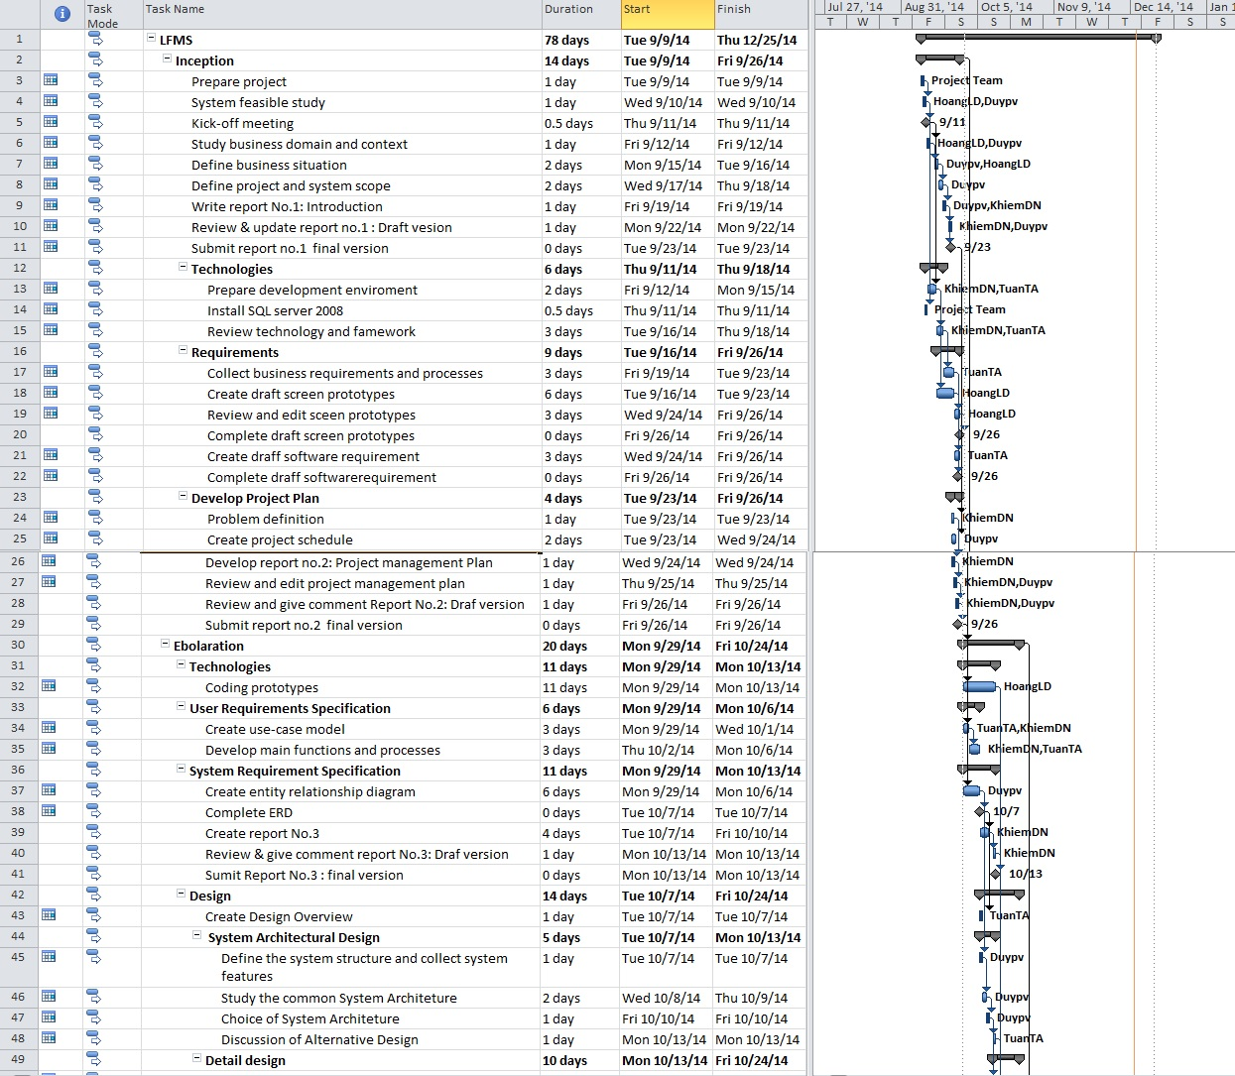

**Figure 2-3:** **Project plan - 1**

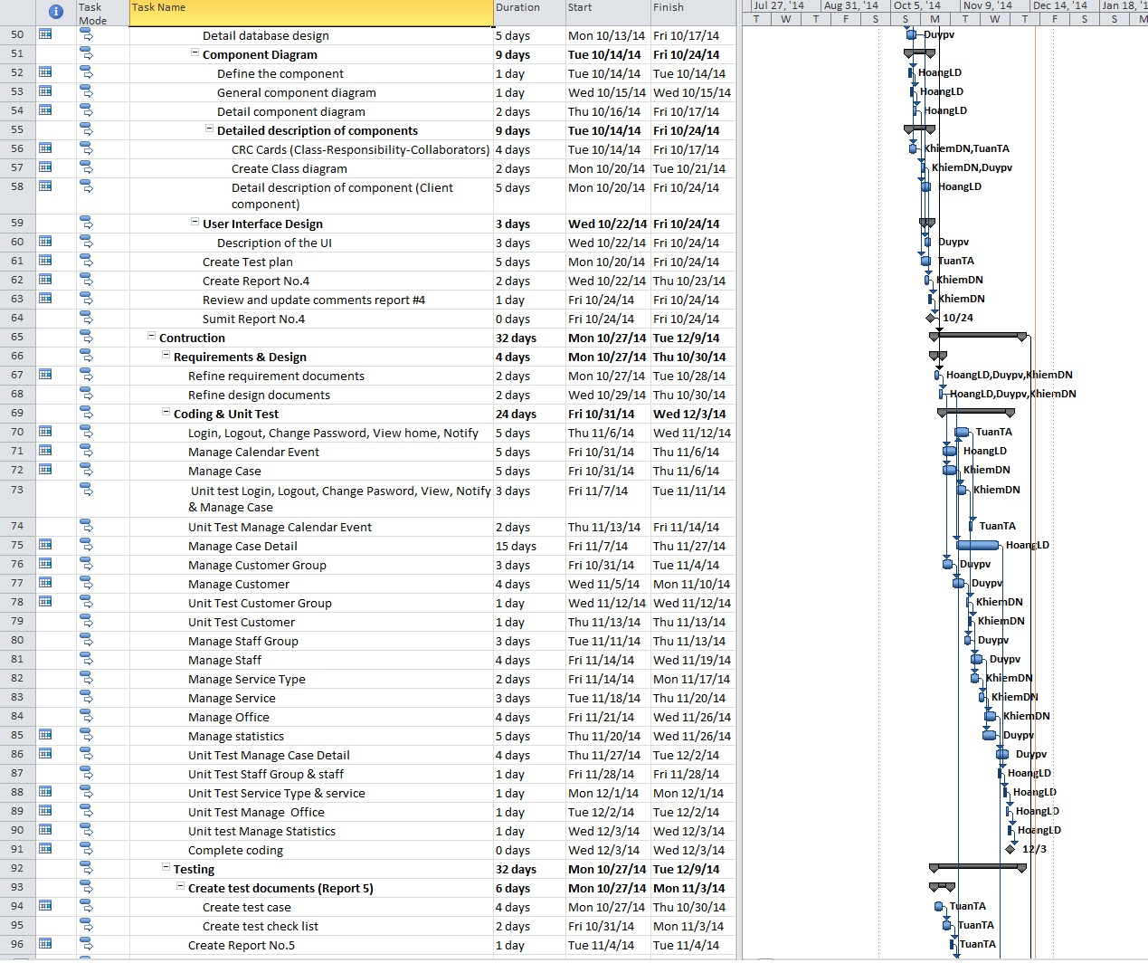

**Figure 2-4: Project plan - 2**

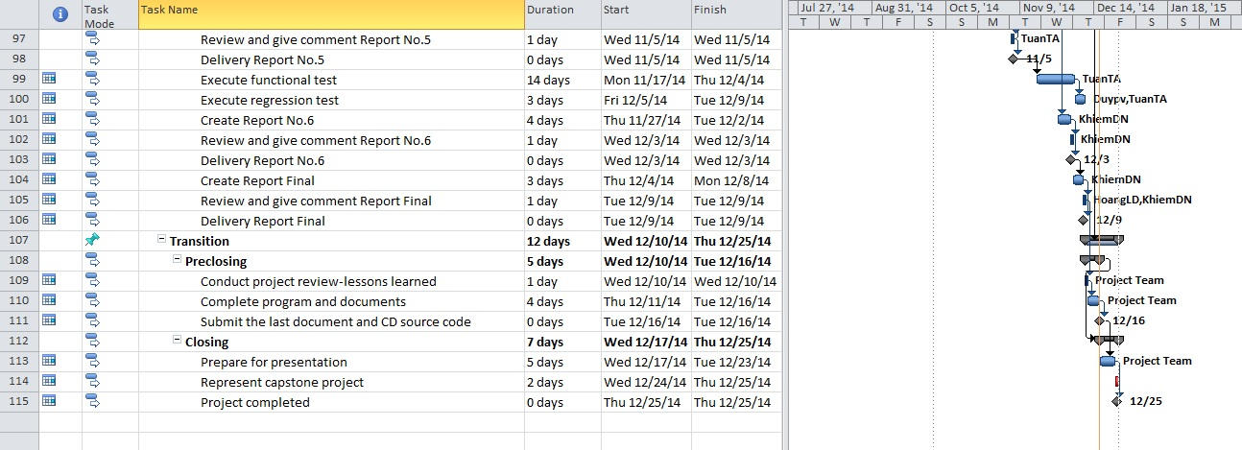

**Figure 2-5: Project plan - 3**

## Convention Rules

Summary:

* Naming Convention.
* Indentation.
* Declaration.
* Code Examples.

Follow “Code Conventions for the C# Programming Language, by Microsoft:

<http://msdn.microsoft.com/en-us/library/ff926074.aspx>

# Software Requirement Specification

## User Requirement Specification

### Functional Requirements

#### Case Management:

**Access right: All users**

* Manage all information of Case by customers, general information, operation event, lawyer viewpoint, people related, document related and Used Service. Assign one or many lawyer into Case, payments of each case.

#### Manage Calendar:

**Access right: All users**

* Manage all calendar work of staff.

#### Customer Management:

**Access right: Administrator**

* Add new, edit customer information and delete customer. Stored for use in later Cases.

#### Staff Management:

**Access right: Aministrator**

* Add new, edit staff information and deactivate staff. Division of roles in the system used.

#### Service Management:

**Access right: Administrator**

* Add new, edit service information and delete service. Use for Used Service.

#### Office Management:

**Access right: Administrator**

* Add new, edit office information and deactivate office. Can only be used by “super admin” – the admin user role have StaffId is 1.

#### Statistics Management:

**Access right: Administrator**

* View all Statistics of system about revenue, number of case received and compare revenue, number of case between offices, staffs.

### Non-Functional Requirements

The Law Firm Management System (LFMS) is an internal website, which allows management law office system.

* + - **Learnable**: The user interface must be easy to learn, even at the first time looking at the screen, user may immediately understand the function of each button or icon.
    - **Efficiency**: The user interface must minimize the number of steps that the system takes to complete its task.
    - **Memorable**: System contains some complex screens. Therefore, interface should be easier to use each time the user interacts with it.
    - **Visibility**: Important information (example: text in nodes) should be clearly visible.
    - **Consistency**: Like-items should always be displayed and act the same way through the entire application.

## System Requirement Specification (Specific Requirements)

### External Interface Requirements

#### User Interfaces

System is designed so friendly and easy to use with users. Home page list all the records of reception Cases. Besides have the calendar, prompted by notification bar at the top.

All functions in menu must be grouped in a meaningful way to make it easy for users to locate and access the features.

#### Communications Protocol

The system is web base so it’s should be applied Hypertext Transfer Protocol (HTTP) is main communication protocol.

### Functional Requirements

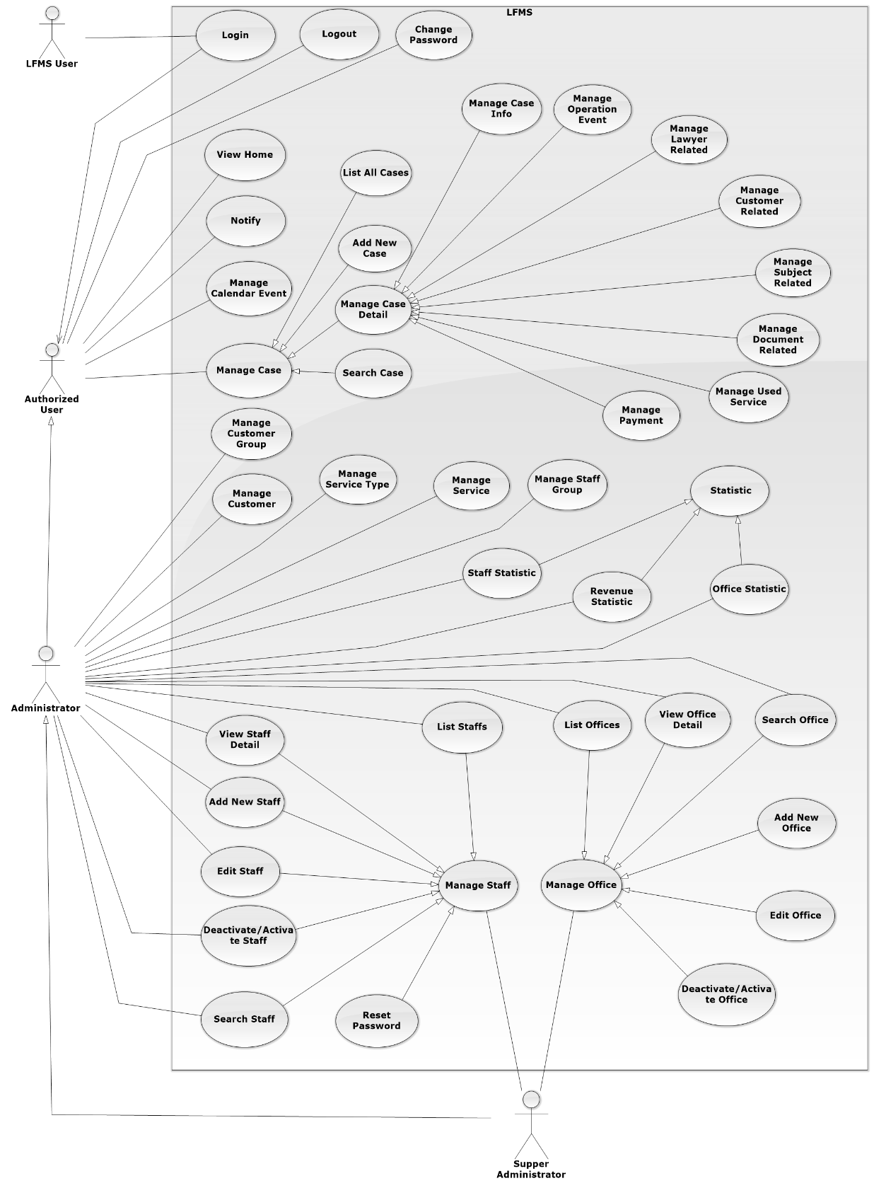

**Figure 3-1: Overview Use-Case Diagram**

#### UC0001 - Login

##### Use-Case Diagram

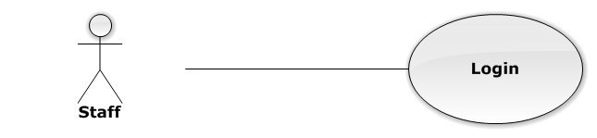

**Figure 3-2: Login Use-Case Diagram**

##### Use-Case Specification

|  |  |  |  |
| --- | --- | --- | --- |
| USE CASE SPECIFICATION | | | |
| Use-case No. | UC0001 | Use-case Version | 1.0 |
| Use-case Name | Login | | |
| Author | Trần Anh Tuấn | | |
| Date | 09/10/2014 | Priority | Normal |
| Actor:  Staff.  Summary:  This use case allows staff to log on into the system.  **Goal:**  Authenticate user.  Triggers:  User access website area that is intended staff.  Preconditions:  User has an account and has not logged in yet.  Post Conditions:  **Success**: User logged in. System redirects user to “Home” page.  **Failure**: System redirects to “Login” page.  Main Success Scenario:   |  |  |  | | --- | --- | --- | | Step | User | System | | 1 | User go to website page | Website will show [Login] page | | 2 | User input information into username field and password field |  | | 3 | Presses “Đăng nhập” button or click “Enter” key | Checks username and password.  Redirect to “Home” page.  [Exception 1]  [Exception 2] |   Alternative Scenario:  N/A  Exceptions:   |  |  |  | | --- | --- | --- | | # | User | System | | 1 | Presses “Login” button. If invalid username or password. | System redirect to “Login” page and display error message “Tên đăng nhập hoặc mật khẩu không đúng!” | | 2 | Presses “Login” button. If have error when connect database | System redirect to “Login” page and display error message “Lỗi kết nối đến máy chủ!” |     Business Rules:   * Password must be longer than 6 characters | | | |

#### UC0002 - Logout

##### Use-Case Diagram

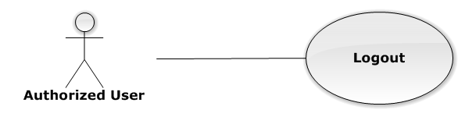

**Figure 3-3: Logout Use-Case Diagram**

##### Use-Case Specification

|  |  |  |  |
| --- | --- | --- | --- |
| USE CASE SPECIFICATION | | | |
| Use-case No. | UC0003 | Use-case Version | 1.0 |
| Use-case Name | Logout | | |
| Author | Trần Anh Tuấn | | |
| Date | 09/10/2014 | Priority | Normal |
| Actor:  Authorized User.  Summary:  This use case allows staff to logout the system.  **Goal:**  The users can log out successful from their roles.  Triggers:  Staff click on “Đăng xuất” on User Control Panel.  Preconditions:  Staff has logged in to the website.  Post Conditions:  Success: Back to login screen  Failure: An error message is displayed.  Main Success Scenario:   |  |  |  | | --- | --- | --- | | Step | User | System | | 1 | Staff click “Đăng xuất” button on User Control Panel | The user name of user will be disappeared on webstie, Redirect to “Login” page. | | | | |

#### UC0004 - Change Password

##### Use-Case Diagram

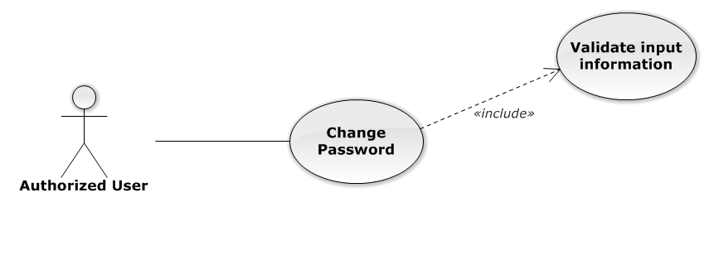

**Figure 3-4: Change Password Use-Case Diagram**

##### Use-Case Specification

|  |  |  |  |
| --- | --- | --- | --- |
| USE CASE SPECIFICATION | | | |
| Use-case No. | UC0005 | Use-case Version | 1.0 |
| Use-case Name | Change Password | | |
| Author | Trần Anh Tuấn | | |
| Date | 09/10/2014 | Priority | Normal |
| Actor:  Authorized User.  Summary:  This use case allows staff can change password of them.  **Goal:**  Change password.  Triggers:  User access website area and click on “Đổi mật khẩu”.  Preconditions:  User has logged in.  Post Conditions:  **Success**: The password is changed and display message “Cập nhật mật khẩu nhân viên thành công!”  **Failure**: Password is not changed. Display error message.  Main Success Scenario:   |  |  |  | | --- | --- | --- | | Step | User | System | | 1 | Staff has logged in, click on “Đổi mật khẩu” on User Control Panel. | Modal Popup “Thay đổi mật khẩu”is display with three fields:“Mật khẩu cũ, “Mật khẩu mới and “Lặp lại mật khẩu mới  Two button “Đóng” , “Đổi mật khẩu” | | 2 | User input information, Click “Đổi mật khẩu” button  [Alternative 1]  [Exception 1] | Check information validity and change password |   Alternative Scenario:   |  |  |  | | --- | --- | --- | | *#* | *User* | *System* | | 1 | Click on [X] button, “Đóng” button, or click out of modal | Modal popup is close |   Exceptions:   |  |  |  | | --- | --- | --- | | *#* | *User* | *System* | | 1 | Field “Mật khẩu cũ” are blank | Shows error message “Hãy nhập lại mật khẩu cũ” | | Field “Mật khẩu mới”, are blank | Shows error message “Hãy nhập mật khẩu mới” | | Field “Lặp lại mật khẩu mới ” are blank | Shows error message “Hãy nhập lại mật khẩu mới” | | Input to field “Mật khẩu cũ”, “Mật khẩu mới” and field “Lặp lại mật khẩu mới” regular expression. | Shows error message “Mật khẩu không được có kí tự đặc biệt” | | Input to field “Mật khẩu mới ” and field “Lặp lại mật khẩu mới ” not enough 6 character | Shows error message “Mật khẩu mới phải có ít nhất 6 kí tự” | | Input to field “Mật khẩu mới ” and field “Lặp lại mật khẩu mới ” are diffirent | Shows error message “Mật khẩu 2 không trùng khớp” | | Input to field “Mật khẩu cũ” not the same with database | Shows error message “Mật khẩu cũ không đúng!”. |     Business Rules:   * Password must be longer than 6 characters | | | |

#### UC0006 - View Home

##### Use-Case Diagram

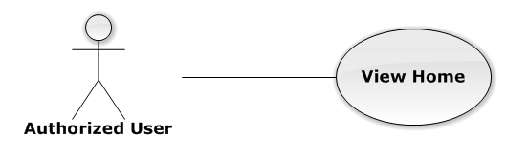

**Figure 3-5: View Home Use-Case Diagram**

##### Use-Case Specification

|  |  |  |  |
| --- | --- | --- | --- |
| USE-CASE SPECIFICATION | | | |
| Use-case No. | UC0007 | Use-case Version | 1.0 |
| Use-case Name | View Home | | |
| Author | Trần Anh Tuấn | | |
| Date | 09/10/2014 | Priority | Normal |
| Actor:  Authorized User  Summary:  User must be Login before and then redirect them to “Trang Chủ” page.  Goal:  To allowing user to view some information of all Cases, which is operating and assigned by Staff related.  Triggers:   * User click on logo LFMS * Click on “Trang Chủ” link.   Preconditions:   * Must be logged-in * The page is fully loaded   Post Conditions:  Success: System redirect user to “Trang Chủ” page and list cases  Failure: Do nothing.  Main Success Scenario:   |  |  |  | | --- | --- | --- | | Step | User | System | | 1 | Click on logo LFMS or “Trang Chủ” link | * Redirect to “Trang Chủ” page * List Cases by Office filter | | | | |

#### UC0008 - Notify

##### Use-Case Diagram

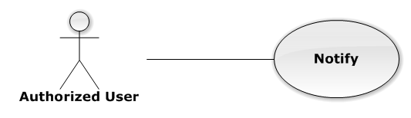

**Figure 3-6: Notify Use-Case Diagram**

##### Use-Case Specification

|  |  |  |  |
| --- | --- | --- | --- |
| USE-CASE SPECIFICATION | | | |
| Use-case No. | UC0009 | Use-case Version | 1.0 |
| Use-case Name | Notify | | |
| Author | Trần Anh Tuấn | | |
| Date | 09/10/2014 | Priority | Normal |
| Actor:  Authorized User  Summary:  User must be login before and then the system will be show notification in navigation bar.  Goal:  User can see all Today's events.  Triggers:  The notification is always to show.  Preconditions:   * Must be logged-in * The page is fully loaded   Post Conditions:  Success: Show to user  Failure: Do nothing.  Main Success Scenario:   |  |  |  | | --- | --- | --- | | Step | User | System | | 1 | Login into the system | User can see notification about all Today's events | | | | |

#### Manage Calendar Event

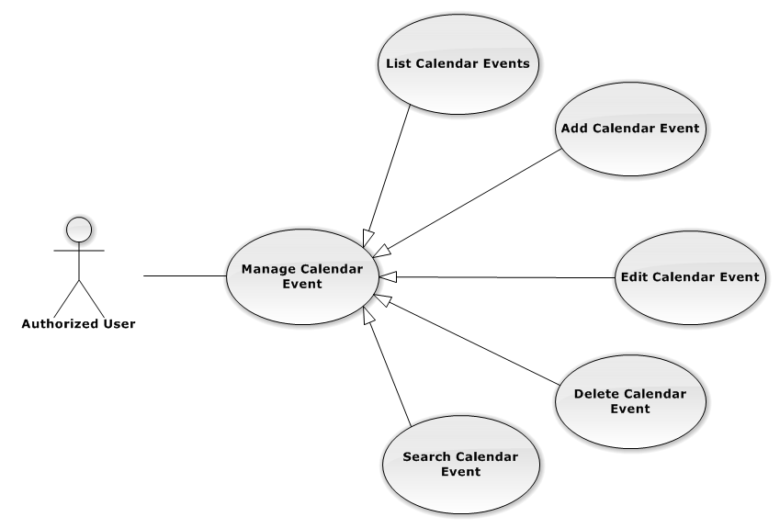

**Figure 3-7: Manage Calendar Event Use-Case Diagram**

##### UC0010 - List Calendar Events

###### Events Use-Case Diagram

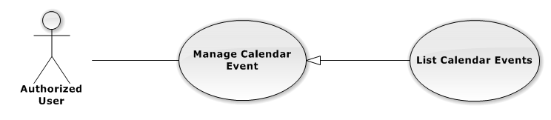

**Figure 3-8: List Calendar Event Use-Case Diagram**

###### Events Use-Case Specification

|  |  |  |  |
| --- | --- | --- | --- |
| USE CASE SPECIFICATION | | | |
| Use-case No. | UC0011 | Use-case Version | 1.0 |
| Use-case Name | List Calendar Events | | |
| Author | Trần Anh Tuấn | | |
| Date | 09/10/2014 | Priority | Normal |
| Actor:  Authorized User.  Summary:  List All Calendar Event.  Goal:  The purpose of List Calendar Event use case is allowing User to view all Events in full-calendar.  Triggers:  User choose “Lịch làm việc” tab in Homepage.  Preconditions:  User is authenticated.  Post Conditions:  Success: All Calendar Events are listed.  Failure: N/A  Main Success Scenario:   |  |  |  | | --- | --- | --- | | Step | User | System | | 1 | Click “Lịch làm việc” tab in home page. | All Calendar Events are loaded. |   Relationships:  Manage Calendar Event | | | |

##### UC0012 - Add New Calendar Event

###### Use-Case Diagram

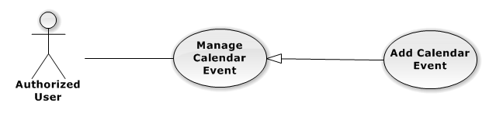

**Figure 3-9: Add New Calendar Event**

###### Use-Case Specification

|  |  |  |  |
| --- | --- | --- | --- |
| USE CASE SPECIFICATION | | | |
| Use-case No. | UC0013 | Use-case Version | 1.0 |
| Use-case Name | Add New Calendar Event | | |
| Author | Trần Anh Tuấn | | |
| Date | 09/10/2014 | Priority | Normal |
| Actor:  Authorized User.  Summary:  Add new Calendar Event.  Goal:  The purpose of Add Calendar Event use case is allowing User to add new Calendar Event.  Triggers:  User choose “Lịch làm việc” tab in home page.  Preconditions:  User is authenticated.  Post Conditions:  Success: New Calendar Event is created.  Failure: N/A  Main Success Scenario:   |  |  |  | | --- | --- | --- | | Step | User | System | | 1 | Click anywhere in calendar. | Show Add new calendar event pop-up. | | 2 | Enters the Calendar Event Name |  | | 3 | Presses “Thêm Sự kiện” button.  [Alternative: 1] | Add new Calendar Event to database. |   Alternative Scenario:   |  |  |  | | --- | --- | --- | | # | User | System | | 1 | Presses “Đóng”, “X” button or click outside pop-up. | The Add New Calendar event pop-up is close. |   Relationships:  Manage Calendar Event | | | |

##### UC0014 - Edit Calendar Event

###### Use-Case Diagram

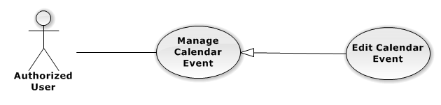

**Figure 3-10: Edit Calendar Event Use-Case Diagram**

###### Use-Case Specification

|  |  |  |  |
| --- | --- | --- | --- |
| USE CASE SPECIFICATION | | | |
| Use-case No. | UC0015 | Use-case Version | 1.0 |
| Use-case Name | Edit Calendar Event | | |
| Author | Trần Anh Tuấn | | |
| Date | 09/10/2014 | Priority | Normal |
| Actor:  Authorized User.  Summary:  Update Calendar Event.  Goal:  The purpose of Update Calendar Event use case is allowing User to edit Calendar Event.  Triggers:  User choose “Lịch làm việc” tab in Homepage.  Preconditions:  User is authenticated.  Post Conditions:  Success: The Calendar Event is Updated.  Failure: N/A  Main Success Scenario:   |  |  |  | | --- | --- | --- | | Step | User | System | | 1 | Click at an exist event. | Show edit calendar event pop-up. | | 2 | Enters the new Calendar Event Name |  | | 3 | Presses “Lưu chỉnh sửa” button.  [Alternative: 1] | Update Calendar event to database. | | 1 | Drag and drop an exist event. | Update Calendar event to database. | | 1 | Reside an exist event. | Update Calendar event to database. |   Alternative Scenario:   |  |  |  | | --- | --- | --- | | # | User | System | | 1 | Presses “Đóng”, “X” button or click outside pop-up. | The Update Clendar event pop-up is close. |   Relationships:  Manage Calendar Event | | | |

##### UC0009 - Delete Calendar Event

###### Use-Case Diagram

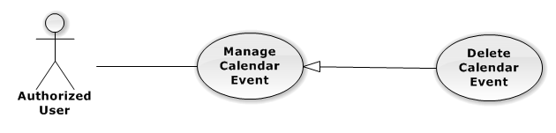

**Figure 3-11: Delete Calendar Event Use-Case Diagram**

###### Use-Case Specification

|  |  |  |  |
| --- | --- | --- | --- |
| USE CASE SPECIFICATION | | | |
| Use-case No. | UC0016 | Use-case Version | 1.0 |
| Use-case Name | Delete Calendar Event | | |
| Author | Trần Anh Tuấn | | |
| Date | 09/10/2014 | Priority | Normal |
| Actor:  Authorized User.  Summary:  Delete Calendar Event.  Goal:  The purpose of Delete Calendar Event use case is allowing User to delete Calendar Event.  Triggers:  User choose “Lịch làm việc” tab in Homepage.  Preconditions:  User is authenticated.  Post Conditions:  Success: The Calendar Event is deleted.  Failure: N/A  Main Success Scenario:   |  |  |  | | --- | --- | --- | | Step | User | System | | 1 | Click at an exist event. | Show confirm pop-up | | 2 | Presses “Xóa sự kiện” button.  [Alternative: 1] | Delete Calendar Event from database. |   Alternative Scenario:   |  |  |  | | --- | --- | --- | | # | User | System | | 1 | Presses “Đóng”, “X” button or click outside pop-up. | The confirm pop-up is close. |   Relationships:  Manage Calendar Event | | | |

##### UC0017 - Search Calendar Event

###### Use-Case Diagram

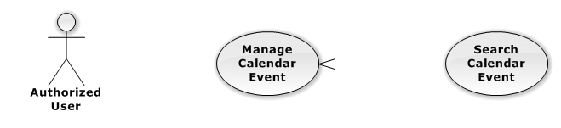

**Figure 3-12: Search Calendar Event Use-Case Diagram**

###### Use-Case Specification

|  |  |  |  |
| --- | --- | --- | --- |
| USE CASE SPECIFICATION | | | |
| Use-case No. | UC0018 | Use-case Version | 1.0 |
| Use-case Name | Search Calendar Event | | |
| Author | Trần Anh Tuấn | | |
| Date | 09/10/2014 | Priority | Normal |
| Actor:  Authorized User.  Summary:  Show all Calendar Event of a Staff.  Goal:  The purpose of Search Calendar Event use case is allowing User to view Calendar event of other staff.  Triggers:  Click at “Lịch làm việc luật sư khác” button.  Preconditions:  User is authenticated.  Post Conditions:  Success: The Calendar Event is showed.  Failure: Do nothing.  Main Success Scenario:   |  |  |  | | --- | --- | --- | | Step | User | System | | 1 | Click at “Lịch làm việc luật sư khác” button. | Show helper frame. | | 2 | Choose a staff in combo-box | Show al Calendar Event of these Staff. |   Relationships:  Manage calendar event | | | |

#### Manage Case

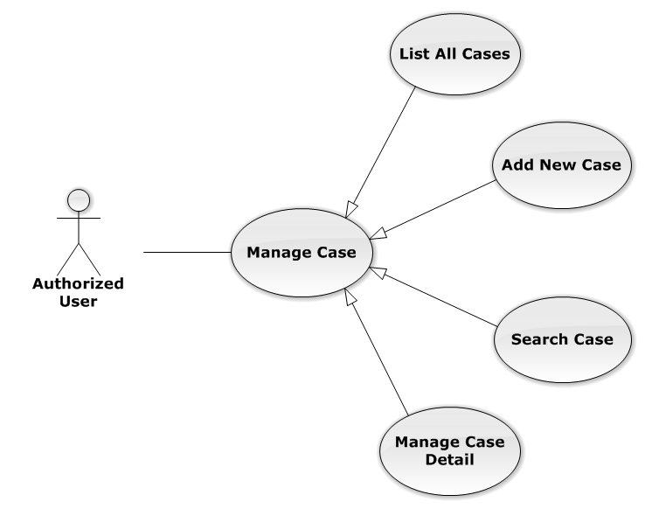

**Figure 3-13: Manage Case Use-Case Diagram**

##### UC0019 - List All Cases

###### Use-Case Diagram

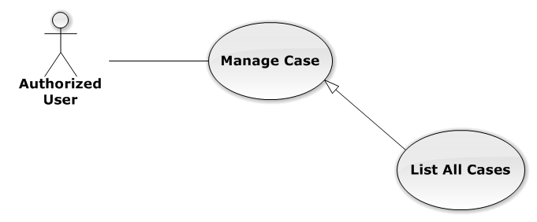

**Figure 3-14: List All Cases Use-Case Diagram**

###### Use-Case Specification

|  |  |  |  |
| --- | --- | --- | --- |
| USE-CASE SPECIFICATION | | | |
| Use-case No. | UC0020 | Use-case Version | 1.0 |
| Use-case Name | List All Cases | | |
| Author | Trần Anh Tuấn | | |
| Date | 09/10/2014 | Priority | Normal |
| Actor:  Authorized User  Summary:  Redirect to “Danh sách hồ sơ” page and list all cases.  Goal:  To allowing customer to view any detail information of all Cases  Triggers:   * User click on User Control Panel and then click on “Danh sách hồ sơ” link * Click on “Danh sách hồ sơ” link in Case Detail of each Case   Preconditions:   * Must be logged-in * The page is fully loaded   Post Conditions:  Success: System redirects user to “Danh sách hồ sơ” page.  Failure: Do nothing.  Main Success Scenario:   |  |  |  | | --- | --- | --- | | Step | User | System | | 1 | Click on “Danh sách hồ sơ” link | * Redirect to “Danh sách hồ sơ” page * Show all Cases by searching condition |   Relationships:  Manage Case | | | |

##### UC0021 - Add New Case

###### Use-Case Diagram

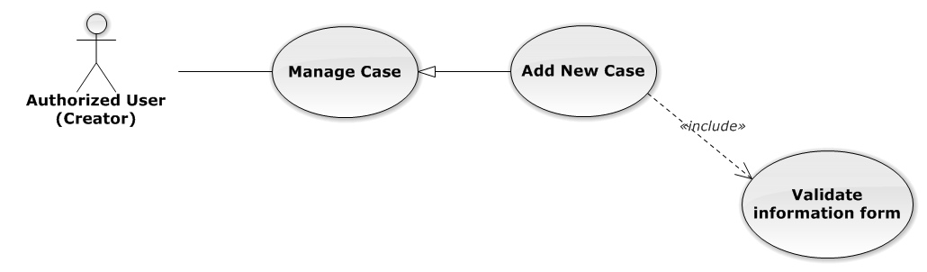

**Figure 3-15: Add New Case Use-Case Diagram**

###### Use-Case Specification

|  |  |  |  |
| --- | --- | --- | --- |
| USE-CASE SPECIFICATION | | | |
| Use-case No. | UC0022 | Use-case Version | 1.0 |
| Use-case Name | Add New Case | | |
| Author | Trần Anh Tuấn | | |
| Date | 09/10/2014 | Priority | High |
| Actor:  Authorized User have “Creator” role  Summary:  Staff can add new case by input data on form modal  Goal:  Helps Staff input information of a case when they add new one  Triggers:  Staff click on “Thêm mới” button in modal  Preconditions:   * Must be logged-in with “Creator” role * The page is fully loaded   Post Conditions:  Success:   * Add new case successful * Add current Staff to Lawyer Related of the new Case * Redirect to view detail page of new case   Failure: System display error message “Thêm hồ sơ thất bại!”  Main Success Scenario:   |  |  |  | | --- | --- | --- | | Step | User | System | | 1 | * Staff click on icon-plus button in “Trang chủ” page * Click on “Thêm hồ sơ tác nghiệp” button in “Danh sách hồ sơ” page | Modal popup is displayed with fields for input information of new case | | 2 | Input corresponding information in form then click “Thêm mới” button  [Alternative 1]  [Exception 1] | * Modal popup is close * System display successful message “Thêm hồ sơ thành công!” * Update list case on page |   Alternative Scenario:   |  |  |  | | --- | --- | --- | | # | User | System | | 1 | Click on [X] button, “Đóng” button, or click out of modal | Modal popup is close |   Exceptions:   |  |  |  | | --- | --- | --- | | # | User | System | | 1 | Leave empty require fields then click on “Thêm mới” button | Modal popup display validation for needed to input field |   Relationships:  Manage Case  Business Rules:   * Authorized User must have “Creator” role to use this function * After create case successfully, system will be automatically assign Creator into that new case | | | |

##### UC0023 - Search Case

###### Use-Case Diagram

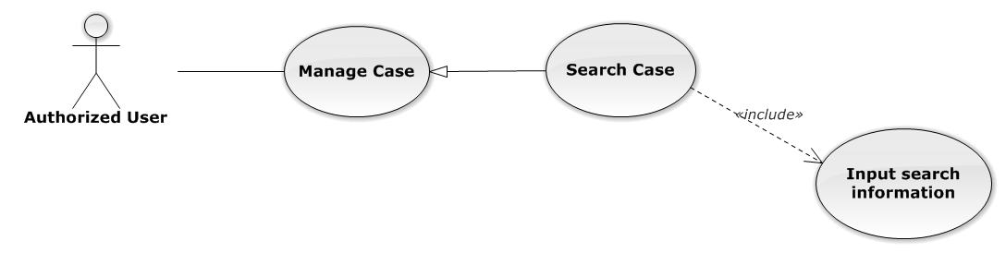

**Figure 3-16: Search Case Use-Case Diagram**

###### Use-Case Specification

|  |  |  |  |
| --- | --- | --- | --- |
| USE-CASE SPECIFICATION | | | |
| Use-case No. | UC0024 | Use-case Version | 1.0 |
| Use-case Name | Search Case | | |
| Author | Trần Anh Tuấn | | |
| Date | 09/10/2014 | Priority | Normal |
| Actor:  Authorized User  Summary:  Staff can search Cases by multi condition  Goal:  Helps Staff to search Cases of system more easy  Triggers:  Staff inputs key words on “Tìm kiếm” textbox at the top right of case list table to search follow key words inputted. When the key up, system will be automatic search.  Preconditions:   * Must be logged-in * The page is fully loaded * Inputs key words on “Tìm kiếm” textbox   Post Conditions:  Success: Cases of the system are displayed page by page  Failure: Do nothing  Main Success Scenario:   |  |  |  | | --- | --- | --- | | Step | User | System | | 1 | Input key words into textbox and then key up  [Alternative 1]  [Alternative 2]  [Alternative 3] | Display cases matches key words and multi condition |   Alternative Scenario:   |  |  |  | | --- | --- | --- | | # | User | System | | 1 | Select number result in page | Display many cases follow number result in page | | 2 | Click on another page number | Display many cases result in another page | | 3 | Click on “Mã hồ sơ” link | Redirect to view Case detail |   Relationships:  Manage Case | | | |

##### Manage Case Detail

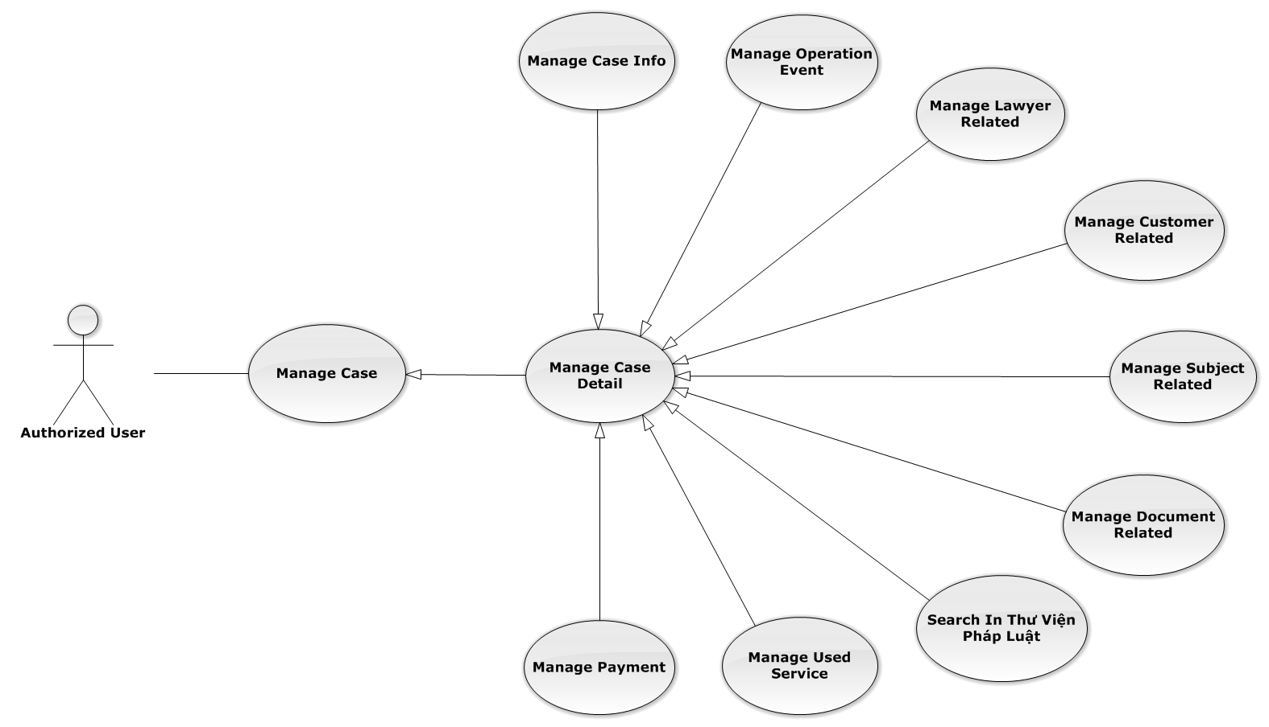

**Figure 3-17: Manage Case Detail Use-Case Diagram**

###### Manage Case Info

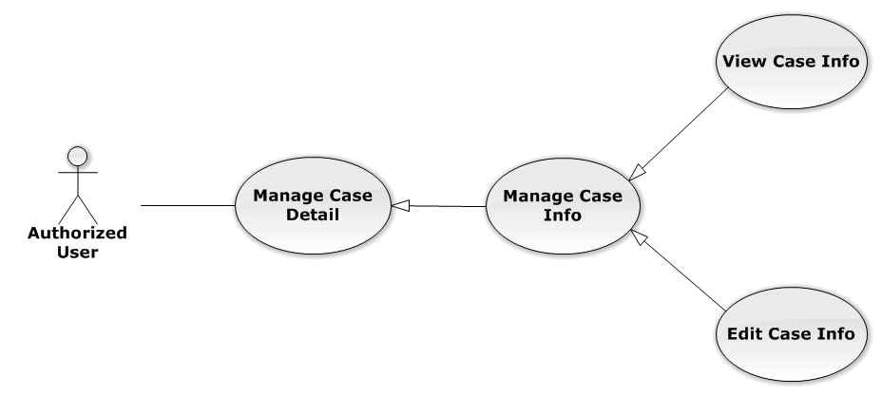

**Figure 3-18: Manage Case Info Use-Case Diagram**

UC0025 - View Case Info

Use-Case Diagram

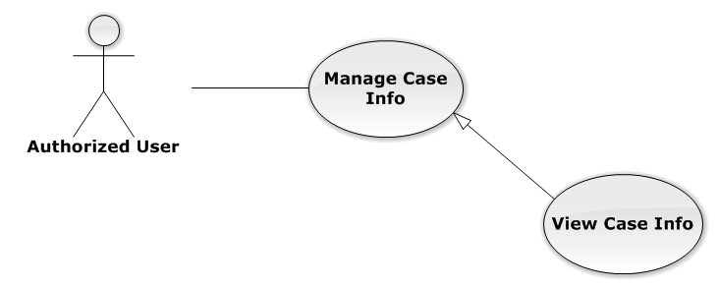

**Figure 3-19: View Case Info Use-Case Diagram**

Use-Case Specification

|  |  |  |  |
| --- | --- | --- | --- |
| USE-CASE SPECIFICATION | | | |
| Use-case No. | UC0026 | Use-case Version | 1.0 |
| Use-case Name | View Case Info | | |
| Author | Trần Anh Tuấn | | |
| Date | 09/10/2014 | Priority | Normal |
| Actor:  Authorized User  Summary:  Staff can view current case’s information  Goal:  Helps staff to get detail and main content of the case quickly  Triggers:   * Staff click on “Mã hồ sơ” link in “Danh sách hồ sơ” * Staff click on big button corresponding with each case on “Trang chủ”   Preconditions:   * Must be logged-in * The page is fully loaded * Must be in Case Detail page   Post Conditions:  Success: The case’s detail is displayed correctly and successfully  Failure: Do nothing  Main Success Scenario:   |  |  |  | | --- | --- | --- | | Step | User | System | | 1 | * Staff click on “Mã hồ sơ” link in “Danh sách hồ sơ” * Staff click on big button on “Trang chủ” | * System redirect to Case Detail page * Show detail of main case content |   Relationships:  Manage Case Info | | | |

UC0027 - Edit Case Info

Use-Case Diagram

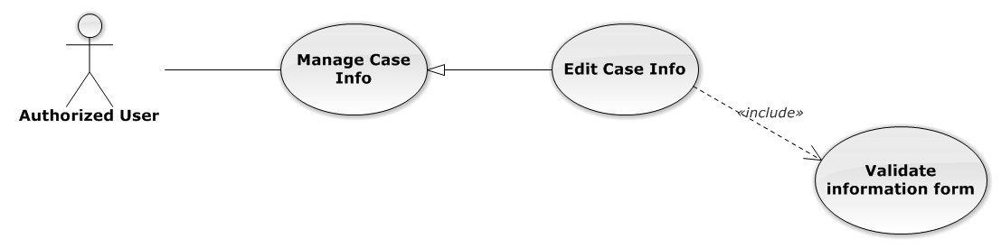

**Figure 3-20: Edit Case Info Use-Case Diagram**

Use-Case Specification

|  |  |  |  |
| --- | --- | --- | --- |
| USE-CASE SPECIFICATION | | | |
| Use-case No. | UC0028 | Use-case Version | 1.0 |
| Use-case Name | Edit Case Info | | |
| Author | Trần Anh Tuấn | | |
| Date | 09/10/2014 | Priority | Normal |
| Actor:  Authorized User who is assigned in current case  Summary:  Staff can edit and update case detail  Goal:  Helps Staff easy to update case information  Triggers:  Staff click on “Lưu chỉnh sửa” button  Preconditions:   * Must be logged-in * The page is fully loaded * Must be in Case Detail page * Click on edit icon beside “Thông tin chung” label before and the case have “Đang thụ lý” status   Post Conditions:  Success: The case detail will be updated and system display message “Cập nhật chi tiết hồ sơ thành công!”  Failure: System display message “Cập nhật chi tiết hồ sơ thất bại!”  Main Success Scenario:   |  |  |  | | --- | --- | --- | | Step | User | System | | 1 | Click on edit icon beside “Thông tin chung” label  [Exception 1] | * All off fields will enable to input * “Hủy chỉnh sửa” and “Lưu chỉnh sửa” button is display | | 2 | Input information and then click “Lưu chỉnh sửa” button  [Alternative 1]  [Exception 2] | * The case detail will be updated * System display message “Cập nhật chi tiết hồ sơ thành công!” * All off fields will disable * “Hủy chỉnh sửa” and “Lưu chỉnh sửa” button is hidden |   Alternative Scenario:   |  |  |  | | --- | --- | --- | | # | User | System | | 1 | Click on “Hủy chỉnh sửa” button | * The case detail will be reloaded * All off fields will disable * “Hủy chỉnh sửa” and “Lưu chỉnh sửa” button is hidden |   Exceptions:   |  |  |  | | --- | --- | --- | | # | User | System | | 1 | Click on edit icon when the case have “Đã thụ lý” status | System display message “Hồ sơ đã thụ lý!” | | 2 | Leave empty require fields then click on “Lưu chỉnh sửa” button | Display validation message for needed to input field |   Relationships:  Manage Case Info  Business Rules:  Only Administrator or Authorized User is assigned in current case can be use this function when status of case is “Đang thụ lý” and Office that have current case must is active. | | | |

###### Manage Operation Event

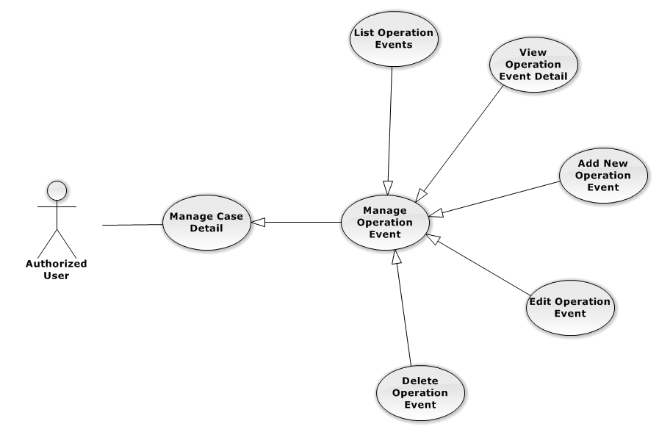

**Figure 3-21: Manage Operation Event Use-Case Diagram**

UC0029 - List Operation Events

Use-Case Diagram

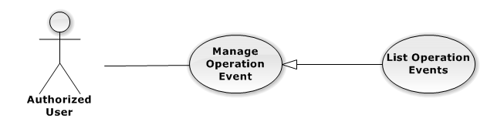

**Figure 3-22: List Operation Events Use-Case Diagram**

Use-Case Specification

|  |  |  |  |
| --- | --- | --- | --- |
| USE-CASE SPECIFICATION | | | |
| Use-case No. | UC0030 | Use-case Version | 1.0 |
| Use-case Name | List Operation Events | | |
| Author | Trần Anh Tuấn | | |
| Date | 09/10/2014 | Priority | Normal |
| Actor:  Authorized User  Summary:  Show all event of case.  Goal:  Help staff to view all event of case.  Triggers:  User click on “Sự kiện” link in Case Detail page  Preconditions:   * Must be logged-in * The page is fully loaded * Must be in Case Detail page   Post Conditions:  Success: List all event in current case  Failure: Do nothing  Main Success Scenario:   |  |  |  | | --- | --- | --- | | Step | User | System | | 1 | Click on “Sự kiện” link | Show all event in current case |   Relationships:  Manage Operation Event | | | |

UC0031 - View Operation Event Detail

Use-Case Diagram

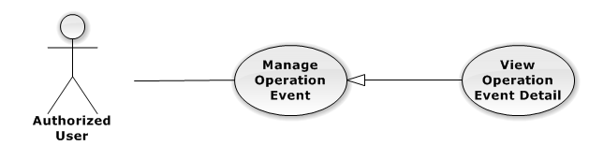

**Figure 3-23: View Operation Event Detail Use-Case Diagram**

Use-Case Specification

|  |  |  |  |
| --- | --- | --- | --- |
| USE-CASE SPECIFICATION | | | |
| Use-case No. | UC0032 | Use-case Version | 1.0 |
| Use-case Name | View operation event detail | | |
| Author | Trần Anh Tuấn | | |
| Date | 09/10/2014 | Priority | Normal |
| Actor:  Authorized User  Summary:  Staff can view detail of event information  Goal:  Helps staff to view event information  Triggers:   * Staff click on “Sự kiện” link * Click on one event * Click on “Mở rộng” button   Preconditions:   * Must be logged-in * The page is fully loaded * Must be in Lawyer related page   Post Conditions:  Success: The detail event information is displayed  Failure: Do nothing  Main Success Scenario:   |  |  |  | | --- | --- | --- | | Step | User | System | | 1 | Staff click on event day’s link  [Alternative 1], [Alternative 2] | The detail event information is displayed |   Alternative Scenario:   |  |  |  | | --- | --- | --- | | # | User | System | | 1 | Click on “Mở rộng” button | Display detail of all event of current case | | 2 | Click on “Thu nhỏ” button | Close all detail event of current case, back to list event screen. |   Relationships:  Manage Operation Event | | | |

UC0033 - Add New Operation Event

Use-Case Diagram

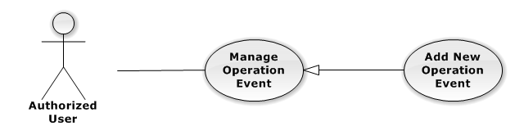

**Figure 3-24: Add New Operation Event Use-Case Diagram**

Use-Case Specification

|  |  |  |  |
| --- | --- | --- | --- |
| USE-CASE SPECIFICATION | | | |
| Use-case No. | UC0034 | Use-case Version | 1.0 |
| Use-case Name | Add New Operation Event | | |
| Author | Trần Anh Tuấn | | |
| Date | 09/10/2014 | Priority | High |
| Actor:  Authorized User, who is assigned in current case  Summary:  Staff can add new event into Case  Goal:  Helps Staff create event into Case  Triggers:   * Staff click on “Sự kiện” link in Case Detail page * Click on edit icon beside “Sư kiện tác nghiệp” button * Click on “Thêm mới” button to add new event to current case.   Preconditions:   * Must be logged-in * The page is fully loaded * Must be in event page * Click on edit icon beside “Sự kiện tác nghiệp” label before   Post Conditions:  Success:   * At new event into current Case * Show message successfully: “Thêm sự kiện thành công!”   Failure: System display error message “Thêm sự kiện thất bại!", "hãy kiểm tra lại kết nối database!”  Main Success Scenario:   |  |  |  | | --- | --- | --- | | Step | User | System | | 1 | Click on edit icon beside “Sự kiện tác nghiệp” label | Form, “Thêm sự kiện” and “Hoàn thành” button is display | | 2 | Click on the “Thêm sự kiện” button | Input form display , “Đóng” and “Tạo sự kiện” button is display | | 3 | Input information into fields and click button “Hoàn thành” button  [Alternative 1], [Exception 1] | System display message “Thêm sự kiện thành công!” |   Alternative Scenario:   |  |  |  | | --- | --- | --- | | # | User | System | | 1 | Click on “Đóng” button | Input form close back to list all event screen. |   Exceptions:   |  |  |  | | --- | --- | --- | | # | User | System | | 1 | System cannot insert event to data base. | Shows error message “Tạo sự kiện thất bại, hãy kiểm tra lại kết nối database”. |   Relationships:  Manage Operation Event  Business Rules:  Only Administrator or Authorized User is assigned in current case can be use this function when status of case is “Đang thụ lý” and Office that have current case must is active. | | | |

UC0035 - Edit Operation Event

Use-Case Diagram

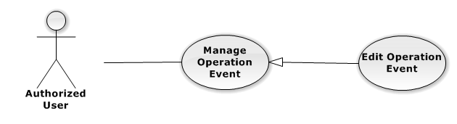

**Figure 3-25: Edit Operation Event Use-Case Diagram**

Use-Case Specification

|  |  |  |  |
| --- | --- | --- | --- |
| USE-CASE SPECIFICATION | | | |
| Use-case No. | UC0036 | Use-case Version | 1.0 |
| Use-case Name | Edit Operation Event | | |
| Author | Trần Anh Tuấn | | |
| Date | 09/10/2014 | Priority | Normal |
| Actor:  Authorized User, who is assigned in current case  Summary:  Staff can update event into Case  Goal:  Helps Staff update event into Case  Triggers:   * Staff click on “Sự kiện” link in Case Detail page * Click on edit icon beside “Sư kiện tác nghiệp” button * Click on “Edit” button to update event.   Preconditions:   * Must be logged-in * The page is fully loaded * Must be in event page * Click on edit icon beside “Sự kiện tác nghiệp” label before   Post Conditions:  Success:   * Update event into current Case * Show message successfully: “Sửa sự kiện thành công!”   Failure: System display error message “Sửa sự kiện thất bại!", "hãy kiểm tra lại kết nối database!”  Main Success Scenario:   |  |  |  | | --- | --- | --- | | Step | User | System | | 1 | Click on edit icon beside “Sự kiện tác nghiệp” label | List all event in current case, “Edit” and “Delete” icon is display, “Thêm sự kiện” and “Hoàn thành” button is display | | 2 | Click on the “Edit” button | Input form display , “Đóng” and “Lưu chỉnh sửa” button is display | | 3 | Edit information into fields and click button “Lưu chỉnh sửa” button  [Alternative 1] , [Exception 1] | System display message “Sửa sự kiện thành công!” |   Alternative Scenario:   |  |  |  | | --- | --- | --- | | # | User | System | | 1 | Click on “Đóng” button | Input form close back to list all event screen. |   Exceptions:   |  |  |  | | --- | --- | --- | | *#* | *User* | *System* | | 1 | While edit information of event click edit icon beside “Sư kiện tác nghiệp” button | Shows error message “Chỉnh sửa chưa hoàn thành! Hãy lưu hoặc đóng chỉnh sửa”. | | System cannot insert event to data base. | Shows error message “Chỉnh sửa sự kiện thất bại, hãy kiểm tra lại kết nối database”. |   Relationships:  Manage Operation Event  Business Rules:  Only Administrator or Authorized User is assigned in current case can be use this function when status of case is “Đang thụ lý” and Office that have current case must is active. | | | |

UC0037 - Delete Operation Event

Use-Case Diagram

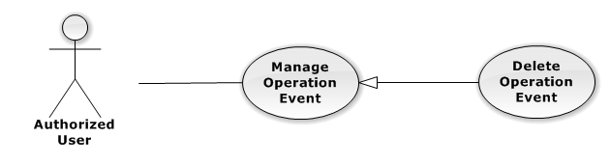

**Figure 3-26: Delete Operation Event Use-Case Diagram**

Use-Case Specification

|  |  |  |  |
| --- | --- | --- | --- |
| USE-CASE SPECIFICATION | | | |
| Use-case No. | UC0038 | Use-case Version | 1.0 |
| Use-case Name | Delete Operation Event | | |
| Author | Trần Anh Tuấn | | |
| Date | 09/10/2014 | Priority | Normal |
| Actor:  Authorized User, who is assigned in current case  Summary:  Staff can remove Event in Case  Goal:  Helps Staff remove Event in Case  Triggers:  Staff click on delete icon in the end table list  Preconditions:   * Must be logged-in * The page is fully loaded * Must be in Lawyer related page * Click on edit icon beside “Sự kiện tác nghiệp” label before   Post Conditions:  Success:   * Remove the Event out of current Case * Show message remove successfully: “Xóa sự kiện thành công!”   Failure: System display error message “Xóa sự kiện thất bại!”  Main Success Scenario:   |  |  |  | | --- | --- | --- | | Step | User | System | | 1 | Click on edit icon beside “Sự kiện tác nghiệp” label | Icon delete is display | | 2 | Click on icon delete corresponding with Event want to remove | Show a modal popup to confirm | | 3 | Click on “Xác nhận” button  [Alternative 1] | System display message “Xóa sự kiện thành công!” |   Alternative Scenario:   |  |  |  | | --- | --- | --- | | # | User | System | | 1 | Click on “Bỏ qua” button | Modal popup is close and system do not remove the Event |   Relationships:  Manage Operation Event  Business Rules:  Only Administrator or Authorized User is assigned in current case can be use this function when status of case is “Đang thụ lý” and Office that have current case must is active. | | | |

###### Manage Lawyer Related

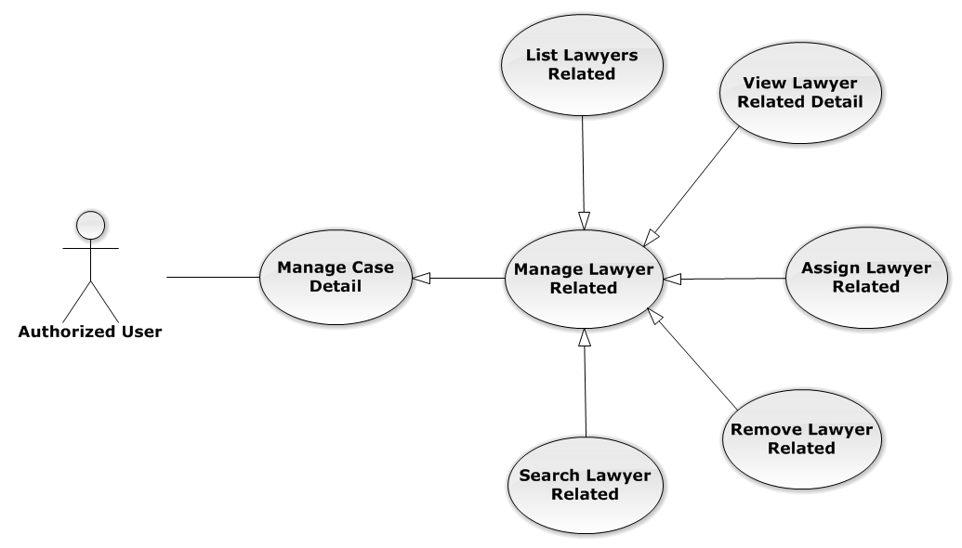

**Figure 3-27: Manage Lawyer Related Use-Case Diagram**

UC0039 - List Lawyers Related

Use-Case Diagram

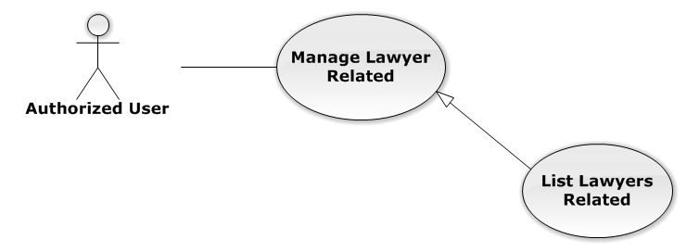

**Figure 3-28: List Lawyers Related Use-Case Diagram**

Use-Case Specification

|  |  |  |  |
| --- | --- | --- | --- |
| USE-CASE SPECIFICATION | | | |
| Use-case No. | UC0040 | Use-case Version | 1.0 |
| Use-case Name | List Lawyers Related | | |
| Author | Đặng Nguyễn Khiêm | | |
| Date | 09/10/2014 | Priority | Normal |
| Actor:  Authorized User  Summary:  Show all Lawyers, who is assigned in current case  Goal:  Help to view all Lawyers, who is assigned in current case  Triggers:   * User click on “Người liên quan” link in Case Detail page * Click on “Luật sư” link at right top page   Preconditions:   * Must be logged-in * The page is fully loaded * Must be in Case Detail page   Post Conditions:  Success: List all Staffs is assigned in current case  Failure: Do nothing  Main Success Scenario:   |  |  |  | | --- | --- | --- | | Step | User | System | | 1 | Click on “Người liên quan” link or “Luật sư” link | Show all Lawyers is assigned in current case |   Relationships:  Manage Lawyer Related | | | |

UC0041 - View Lawyer Related Detail

Use-Case Diagram

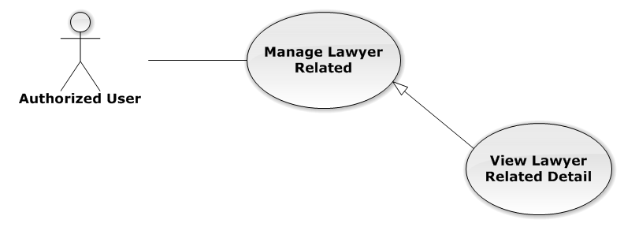

**Figure 3-29: View Lawyer Related Detail Use-Case Diagram**

Use-Case Specification

|  |  |  |  |
| --- | --- | --- | --- |
| USE-CASE SPECIFICATION | | | |
| Use-case No. | UC0042 | Use-case Version | 1.0 |
| Use-case Name | View Lawyer Related Detail | | |
| Author | Đặng Nguyễn Khiêm | | |
| Date | 09/10/2014 | Priority | Normal |
| Actor:  Authorized User  Summary:  Staff can view Lawyer related information  Goal:  Helps staff to view Lawyer related information  Triggers:   * Staff click on “Họ và tên” link * Click on avatar image   Preconditions:   * Must be logged-in * The page is fully loaded * Must be in “Người liên quan” page   Post Conditions:  Success: The popup modal have lawyer information is displayed  Failure: Do nothing  Main Success Scenario:   |  |  |  | | --- | --- | --- | | Step | User | System | | 1 | Staff click on “Họ và tên” link or avatar image | The popup modal have lawyer information is displayed  [Alternative 1] |   Alternative Scenario:   |  |  |  | | --- | --- | --- | | # | User | System | | 1 | Click on [X] button, “Đóng” button, or click out of modal | Modal popup is close |   Relationships:  Manage Lawyer Related | | | |

UC0043 - Assign Lawyer Related

Use-Case Diagram

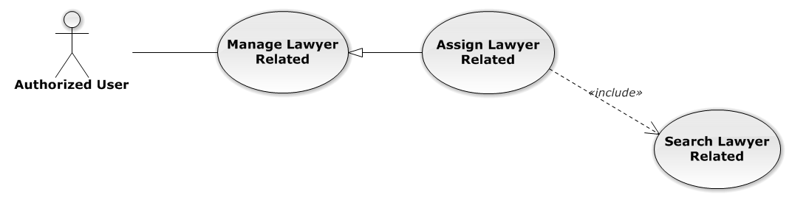

**Figure 3-30: Assign Lawyer Related Use-Case Diagram**

Use-Case Specification

|  |  |  |  |
| --- | --- | --- | --- |
| USE-CASE SPECIFICATION | | | |
| Use-case No. | UC0044 | Use-case Version | 1.0 |
| Use-case Name | Assign Lawyer Related | | |
| Author | Đặng Nguyễn Khiêm | | |
| Date | 09/10/2014 | Priority | High |
| Actor:  Authorized User, who create the current Case  Summary:  Staff can assign Lawyer into Case  Goal:  Helps Staff assign any Lawyers into Case  Triggers:  Staff click on “Thêm vào danh sách” button after choose Lawyer in search form beside  Preconditions:   * Must be logged-in * The page is fully loaded * Must be in “Người liên quan” page * Click on edit icon beside “Luật sư phụ trách” label and used Search Lawyer Related function before   Post Conditions:  Success:   * Assign the Lawyer in search form to current Case * Show message assign successfully: “Đã phân công luật sư!”   Failure: System display error message “Phân công luật sư thất bại!”  Main Success Scenario:   |  |  |  | | --- | --- | --- | | Step | User | System | | 1 | Click on edit icon beside “Luật sư phụ trách” label | Search form, “Thêm vào danh sách” and “Hoàn thành” button is display | | 2 | After search and choose a Lawyer, Staff click on “Thêm vào danh sách” button  [Alternative 1]  [Exception 1]  [Exception 2] | System display message “Đã phân công luật sư!” |   Alternative Scenario:   |  |  |  | | --- | --- | --- | | # | User | System | | 1 | Click on “Hoàn thành” button | Search form, “Thêm vào danh sách” and “Hoàn thành” button is hidden |   Exceptions:   |  |  |  | | --- | --- | --- | | # | User | System | | 1 | Not search lawyer then click on “Thêm vào danh sách” button | Display validation message for needed to search lawyer before: “Hãy chọn 1 luật sư!” | | 2 | Lawyer is exist in list lawyer related | Display message “Đã tồn tại luật sư!” |   Relationships:  Manage Lawyer Related  Business Rules:  Only Administrator or Authorized User, who create the current Case can be use this function when status of case is “Đang thụ lý” and Office that have current case must is active. | | | |

UC0045 - Remove Lawyer Related

Use-Case Diagram

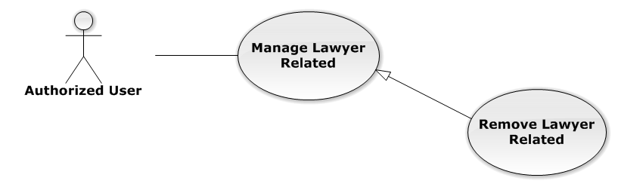

**Figure 3-31: Remove Lawyer Related Use-Case Diagram**

Use-Case Specification

|  |  |  |  |
| --- | --- | --- | --- |
| USE-CASE SPECIFICATION | | | |
| Use-case No. | UC0046 | Use-case Version | 1.0 |
| Use-case Name | Remove Lawyer Related | | |
| Author | Đặng Nguyễn Khiêm | | |
| Date | 09/10/2014 | Priority | Normal |
| Actor:  Authorized User, who create the current Case  Summary:  Staff can remove Lawyer related in Case  Goal:  Helps Staff remove Lawyer related in Case  Triggers:  Staff click on delete icon in the end table list  Preconditions:   * Must be logged-in * The page is fully loaded * Must be in “Người liên quan” page * Click on edit icon beside “Luật sư phụ trách” label before   Post Conditions:  Success:   * Remove the Lawyer out of current Case * Show message remove successfully: “Loại bỏ luật sư thành công!”   Failure: System display error message “Loại bỏ luật sư thất bại!”  Main Success Scenario:   |  |  |  | | --- | --- | --- | | Step | User | System | | 1 | Click on edit icon beside “Luật sư phụ trách” label | Icon delete is display | | 2 | Click on icon delete corresponding with Lawyer want to remove | Show a modal popup to confirm | | 3 | Click on “Xác nhận” button  [Alternative 1] | System display message “Loại bỏ luật sư thành công!” |   Alternative Scenario:   |  |  |  | | --- | --- | --- | | # | User | System | | 1 | Click on “Bỏ qua” button | Modal popup is close and system do not remove the Lawyer |   Relationships:  Manage Lawyer Related  Business Rules:  Only Administrator or Authorized User, who create the current Case can be use this function when status of case is “Đang thụ lý” and Office that have current case must is active. | | | |

UC0047 - Search Lawyer Related

Use-Case Diagram

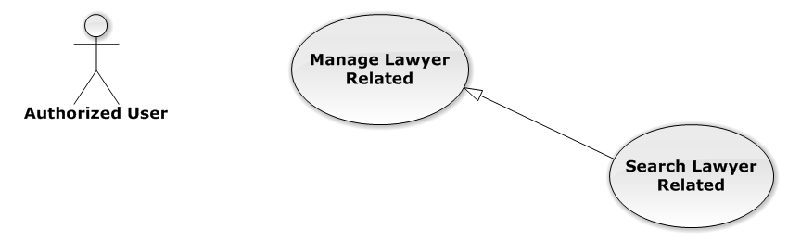

**Figure 3-32: Search Lawyer Related Use-Case Diagram**

Use-Case Specification

|  |  |  |  |
| --- | --- | --- | --- |
| USE-CASE SPECIFICATION | | | |
| Use-case No. | UC0048 | Use-case Version | 1.0 |
| Use-case Name | Search Lawyer Related | | |
| Author | Đặng Nguyễn Khiêm | | |
| Date | 09/10/2014 | Priority | Normal |
| Actor:  Authorized User, who create the current Case  Summary:  Staff can search Lawyer for assign into Case  Goal:  Helps Staff can assign Lawyer easily  Triggers:  Staff input key word is StaffName or Username of Lawyer. When the key up, system will be automatic search.  Preconditions:   * Must be logged-in * The page is fully loaded * Must be in “Người liên quan” page * Click on edit icon beside “Luật sư phụ trách” label before   Post Conditions:  Success: The lawyer has been choose in search form by StaffName or Username  Failure: Do nothing  Main Success Scenario:   |  |  |  | | --- | --- | --- | | Step | User | System | | 1 | Click on edit icon beside “Luật sư phụ trách” label | Search form is display | | 2 | Input key words into search form and then key up | Display lawyers matches key words by StaffName and Username | | 3 | Click on result have lawyer want to assign  [Alternative 1] | The lawyer has been choose, wait for assign |   Alternative Scenario:   |  |  |  | | --- | --- | --- | | # | User | System | | 1 | Click out of result list | Result list is clear |   Relationships:  Manage Lawyer Related  Business Rules:  Only Administrator or Authorized User, who create the current Case can be use this function when status of case is “Đang thụ lý” and Office that have current case must is active. | | | |

###### Manage Customer Related

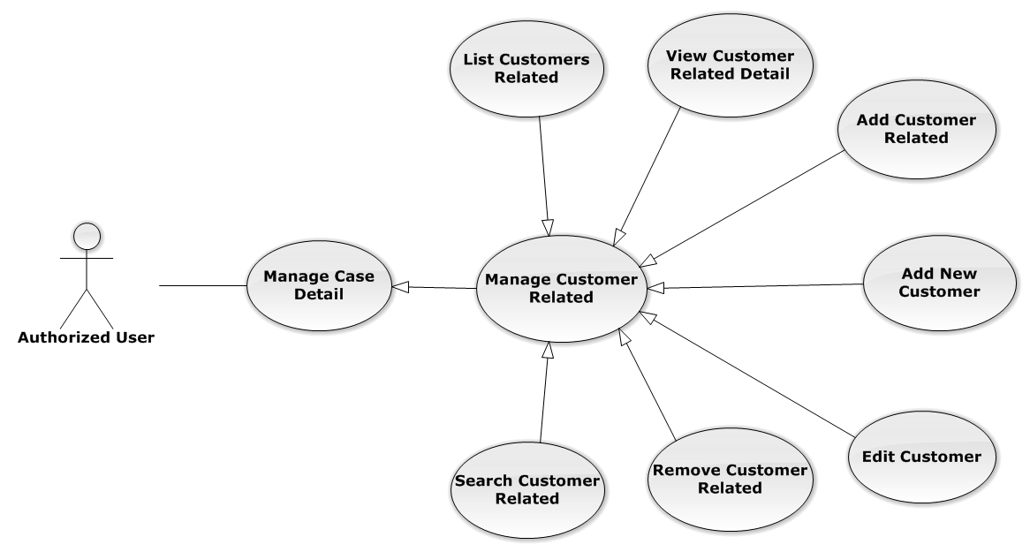

**Figure 3-33: Manage Customer Related Use-Case Diagram**

UC0049 - List Customers Related

Use-Case Diagram

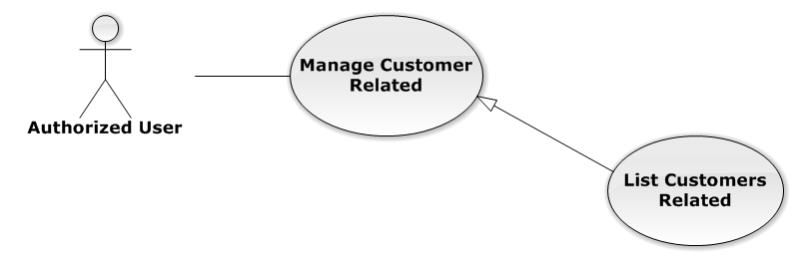

**Figure 3-34: List Customers Related Use-Case Diagram**

Use-Case Specification

|  |  |  |  |
| --- | --- | --- | --- |
| USE-CASE SPECIFICATION | | | |
| Use-case No. | UC0050 | Use-case Version | 1.0 |
| Use-case Name | List Customers Related | | |
| Author | Đặng Nguyễn Khiêm | | |
| Date | 09/10/2014 | Priority | Normal |
| Actor:  Authorized User  Summary:  List all Customers of current case, each case can have one or more customers  Goal:  Help to view all Customers related  Triggers:  User click on “Khách hàng” link at right top page  Preconditions:   * Must be logged-in * The page is fully loaded * Must be in “Người liên quan” page   Post Conditions:  Success: Show all Customers of current case in table  Failure: Do nothing  Main Success Scenario:   |  |  |  | | --- | --- | --- | | Step | User | System | | 1 | Click on “Khách hàng” link | Show all Customers of current case in table line by line |   Relationships:  Manage Customer Related | | | |

UC0051 - View Customer Related Detail

Use-Case Diagram

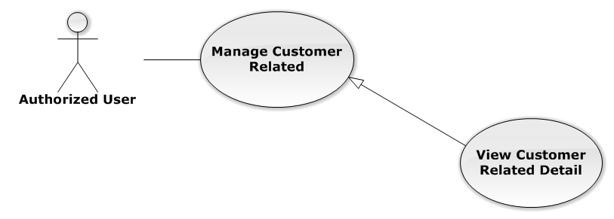

**Figure 3-35: View Customer Related Detail Use-Case Diagram**

Use-Case Specification

|  |  |  |  |
| --- | --- | --- | --- |
| USE-CASE SPECIFICATION | | | |
| Use-case No. | UC0052 | Use-case Version | 1.0 |
| Use-case Name | View Customer Related Detail | | |
| Author | Đặng Nguyễn Khiêm | | |
| Date | 09/10/2014 | Priority | Normal |
| Actor:  Authorized User  Summary:  Staff can view Customer related information  Goal:  Helps staff to view Customer related information  Triggers:  Staff click on “Họ và tên” link  Preconditions:   * Must be logged-in * The page is fully loaded * Must be in “Khách hàng” page   Post Conditions:  Success: The popup modal have customer information is displayed  Failure: Do nothing  Main Success Scenario:   |  |  |  | | --- | --- | --- | | Step | User | System | | 1 | Staff click on “Họ và tên” link | The popup modal have customer information is displayed  [Alternative 1] |   Alternative Scenario:   |  |  |  | | --- | --- | --- | | # | User | System | | 1 | Click on [X] button, “Đóng” button, or click out of modal | Modal popup is close |   Relationships:  Manage Customer Related | | | |

UC0053 - Add Customer Related

Use-Case Diagram

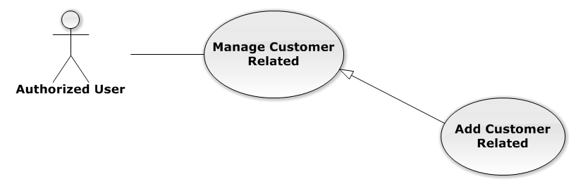

**Figure 3-36: Add Customer Related Use-Case Diagram**

Use-Case Specification

|  |  |  |  |
| --- | --- | --- | --- |
| USE-CASE SPECIFICATION | | | |
| Use-case No. | UC0054 | Use-case Version | 1.0 |
| Use-case Name | Add Customer Related | | |
| Author | Đặng Nguyễn Khiêm | | |
| Date | 09/10/2014 | Priority | Normal |
| Actor:  Authorized User, who is assigned in current case  Summary:  Staff can add a available customer on Database into Case  Goal:  Helps Staff add a available customer into Case  Triggers:  Staff click on “Thêm vào danh sách” button after choose Customer in search form beside  Preconditions:   * Must be logged-in * The page is fully loaded * Must be in “Khách hàng” page * Click on edit icon beside “Khách hàng” label and used Search Customer Related function before   Post Conditions:  Success:   * Add a customer into Case * Show message assign successfully: “Thêm khách hàng thành công!”   Failure: System display error message “Thêm khách hàng thất bại!”  Main Success Scenario:   |  |  |  | | --- | --- | --- | | Step | User | System | | 1 | Click on edit icon beside “Khách hàng” label | Search form, “Thêm vào danh sách” and “Hoàn thành” button is display | | 2 | After search and choose a Customer, Staff click on “Thêm vào danh sách” button  [Alternative 1]  [Exception 1]  [Exception 2] | System display message “Thêm khách hàng thành công!” |   Alternative Scenario:   |  |  |  | | --- | --- | --- | | # | User | System | | 1 | Click on “Hoàn thành” button | Search form, “Thêm vào danh sách” and “Hoàn thành” button is hidden |   Exceptions:   |  |  |  | | --- | --- | --- | | # | User | System | | 1 | Not search customer then click on “Thêm vào danh sách” button | Display validation message for needed to search lawyer before: “Hãy chọn 1 khách hàng!” | | 2 | Customer is exist in list customer related | Display message “Đã tồn tại khách hàng!” |   Relationships:  Manage Customer Related  Business Rules:  Only Administrator or Authorized User is assigned in current case can be use this function when status of case is “Đang thụ lý” and Office that have current case must is active. | | | |

Add New Customer

Reference to Add New Customer function in Manage Customer

Edit Customer

Reference to Edit Customer function in Manage Customer

UC0055 - Remove Customer Related

Use-Case Diagram

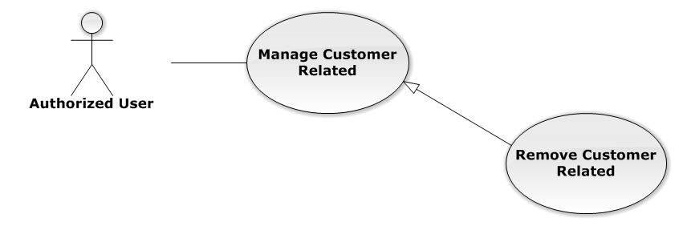

**Figure 3-37: Remove Customer Related Use-Case Diagram**

Use-Case Specification

|  |  |  |  |
| --- | --- | --- | --- |
| USE-CASE SPECIFICATION | | | |
| Use-case No. | UC0056 | Use-case Version | 1.0 |
| Use-case Name | Remove Customer Related | | |
| Author | Đặng Nguyễn Khiêm | | |
| Date | 09/10/2014 | Priority | Normal |
| Actor:  Authorized User, who is assigned in current case  Summary:  Staff can remove Customer related in Case  Goal:  Helps Staff remove Customer related in Case  Triggers:  Staff click on delete icon in the end table list  Preconditions:   * Must be logged-in * The page is fully loaded * Must be in “Khách hàng” page * Click on edit icon beside “Khách hàng” label before   Post Conditions:  Success:   * Remove the Customer out of current Case * Show message remove successfully: “Loại bỏ khách hàng thành công!”   Failure: System display error message “Loại bỏ khách hàng thất bại!”  Main Success Scenario:   |  |  |  | | --- | --- | --- | | Step | User | System | | 1 | Click on edit icon beside “Khách hàng” label | Icon delete is display | | 2 | Click on icon delete corresponding with Customer want to remove | Show a modal popup to confirm | | 3 | Click on “Xác nhận” button  [Alternative 1] | System display message “Loại bỏ khách hàng thành công!” |   Alternative Scenario:   |  |  |  | | --- | --- | --- | | # | User | System | | 1 | Click on “Bỏ qua” button | Modal popup is close and system do not remove the Customer |   Relationships:  Manage Customer Related  Business Rules:  Only Administrator or Authorized User is assigned in current case can be use this function when status of case is “Đang thụ lý” and Office that have current case must is active. | | | |

UC0057 - Search Customer Related

Use-Case Diagram

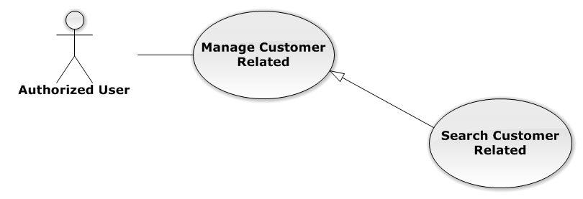

**Figure 3-38: Search Customer Related Use-Case Diagram**

Use-Case Specification

|  |  |  |  |
| --- | --- | --- | --- |
| USE-CASE SPECIFICATION | | | |
| Use-case No. | UC0058 | Use-case Version | 1.0 |
| Use-case Name | Search Customer Related | | |
| Author | Đặng Nguyễn Khiêm | | |
| Date | 09/10/2014 | Priority | Normal |
| Actor:  Authorized User, who is assigned in current case  Summary:  Staff can search Customer for add customer related  Goal:  Helps Staff can search Customer easily  Triggers:  Staff input key word is CustomerName or Address of Customer. When the key up, system will be automatic search after 500ms delay time.  Preconditions:   * Must be logged-in * The page is fully loaded * Must be in “Khách hàng” page * Click on edit icon beside “Khách hàng” label before   Post Conditions:  Success: The customer has been choose in search form by CustomerName or Address  Failure: Do nothing  Main Success Scenario:   |  |  |  | | --- | --- | --- | | Step | User | System | | 1 | Click on edit icon beside “Khách hàng” label | Search form is display | | 2 | Input key words into search form and then key up | Display customers matches key words by CustomerName or Address | | 3 | Click on result have customer want to add  [Alternative 1] | The customer has been choose, wait for add |   Alternative Scenario:   |  |  |  | | --- | --- | --- | | Step | User | System | | 1 | Click out of result list | Result list is clear |   Relationships:  Manage Customer Related  Business Rules:  Only Administrator or Authorized User is assigned in current case can be use this function when status of case is “Đang thụ lý” and Office that have current case must is active. | | | |

###### Manage Subject Related

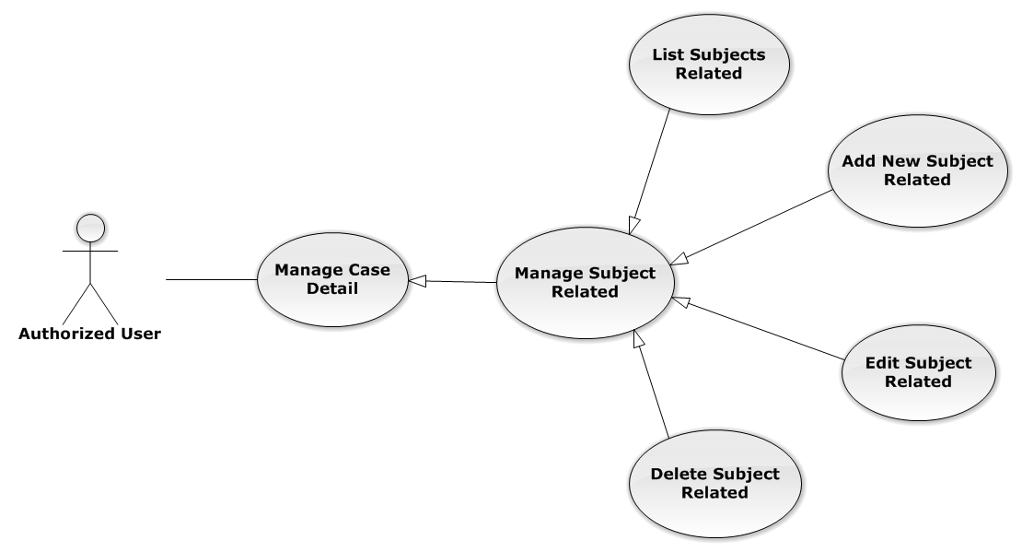

**Figure 3-39: Manage Subject Related Use-Case Diagram**

UC0059 - List Subjects Related

Use-Case Diagram

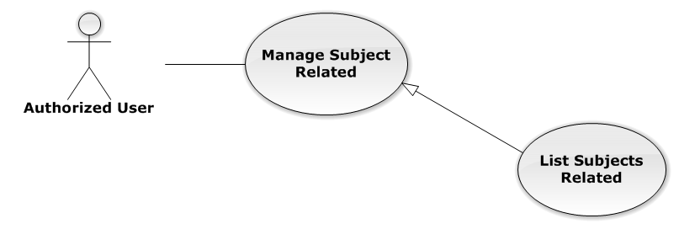

**Figure 3-40: List Subjects Related Use-Case Diagram**

Use-Case Specification

|  |  |  |  |
| --- | --- | --- | --- |
| USE-CASE SPECIFICATION | | | |
| Use-case No. | UC0060 | Use-case Version | 1.0 |
| Use-case Name | List Subjects Related | | |
| Author | Đặng Nguyễn Khiêm | | |
| Date | 09/10/2014 | Priority | Normal |
| Actor:  Authorized User  Summary:  List all Subjects of current case, each case can have one or more subjects  Goal:  Help to view all Subject related  Triggers:  User click on “Chủ thể” link at right top page  Preconditions:   * Must be logged-in * The page is fully loaded * Must be in “Người liên quan” page   Post Conditions:  Success: Show all Subjects of current case in table  Failure: Do nothing  Main Success Scenario:   |  |  |  | | --- | --- | --- | | Step | User | System | | 1 | Click on “Chủ thể” link | Show all Subjects of current case in table line by line |   Relationships:  Manage Subject Related | | | |

UC0061 - Add New Subject Related

Use-Case Diagram

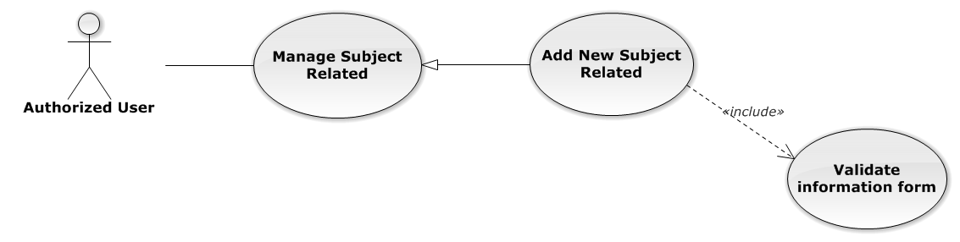

**Figure 3-41: Add New Subject Related Use-Case Diagram**

Use-Case Specification

|  |  |  |  |
| --- | --- | --- | --- |
| USE-CASE SPECIFICATION | | | |
| Use-case No. | UC0062 | Use-case Version | 1.0 |
| Use-case Name | Add New Subject Related | | |
| Author | Đặng Nguyễn Khiêm | | |
| Date | 09/10/2014 | Priority | Normal |
| Actor:  Authorized User, who is assigned in current case  Summary:  Staff can create new a subject related into case  Goal:  Helps Staff create new a subject easily  Triggers:  Staff click on “Tạo chủ thể” button at the bottom of table  Preconditions:   * Must be logged-in * The page is fully loaded * Must be in “Chủ thể” page * Click on edit icon beside “Chủ thể liên quan” label before   Post Conditions:  Success:   * Add new a subject into Case * Show message assign successfully: “Thêm chủ thể thành công!”   Failure: System display error message “Thêm chủ thể thất bại!”  Main Success Scenario:   |  |  |  | | --- | --- | --- | | Step | User | System | | 1 | Click on edit icon beside “Chủ thể liên quan” label | “Thêm chủ thể mới” button is display | | 2 | Staff click on “Tạo chủ thể” button | Modal popup is displayed with fields for input information of new subject  [Alternative 1] | | 3 | Input corresponding information in form then click “Thêm mới” button  [Exception 1] | * Modal popup is close * System display successful message “Thêm chủ thể thành công!” * Update list subject on page |   Alternative Scenario:   |  |  |  | | --- | --- | --- | | # | User | System | | 1 | Click on [X] button, “Đóng” button, or click out of modal | Modal popup is close |   Exceptions:   |  |  |  | | --- | --- | --- | | # | User | System | | 1 | Leave empty require fields then click on “Thêm mới” button | Modal popup display validation for needed to input field |   Relationships:  Manage Subject Related  Business Rules:   * Only Administrator or Authorized User is assigned in current case can be use this function when status of case is “Đang thụ lý” and Office that have current case must is active. * After create subject successfully, system will be automatically add new subject into that case | | | |

UC0063 - Edit Subject Related

Use-Case Diagram

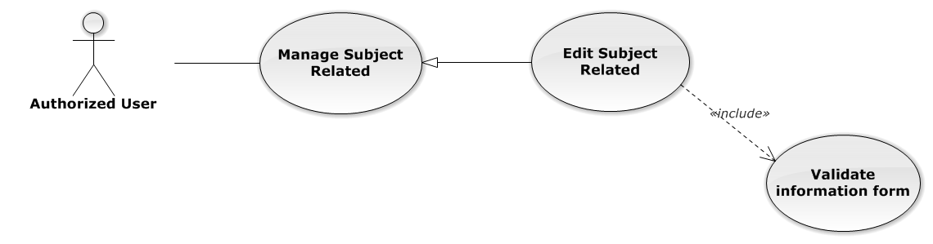

**Figure 3-42: Edit Subject Related Use-Case Diagram**

Use-Case Specification

|  |  |  |  |
| --- | --- | --- | --- |
| USE-CASE SPECIFICATION | | | |
| Use-case No. | UC0064 | Use-case Version | 1.0 |
| Use-case Name | Edit Subject Related | | |
| Author | Đặng Nguyễn Khiêm | | |
| Date | 09/10/2014 | Priority | Normal |
| Actor:  Authorized User, who is assigned in current case  Summary:  Staff can edit a available subject related  Goal:  Helps Staff edit a available subject information  Triggers:  Staff click on edit icon at the right table  Preconditions:   * Must be logged-in * The page is fully loaded * Must be in “Chủ thể” page * Click on edit icon beside “Chủ thể liên quan” label before   Post Conditions:  Success:   * Edit a subject information * Show message assign successfully: “Cập nhật chủ thể thành công!”   Failure: System display error message “Cập nhật chủ thể thất bại!”  Main Success Scenario:   |  |  |  | | --- | --- | --- | | Step | User | System | | 1 | Click on edit icon beside “Chủ thể liên quan” label | The icon to edit subject is display | | 2 | Staff click on edit icon | Modal popup is displayed with fields for input new information of subject  [Alternative 1] | | 3 | Input corresponding information in form then click “Lưu chỉnh sửa” button  [Exception 1] | * Modal popup is close * System display successful message “Cập nhật chủ thể thành công!” * Update list subject on page |   Alternative Scenario:   |  |  |  | | --- | --- | --- | | # | User | System | | 1 | Click on [X] button, “Đóng” button, or click out of modal | Modal popup is close |   Exceptions:   |  |  |  | | --- | --- | --- | | # | User | System | | 1 | Leave empty require fields then click on “Lưu chỉnh sửa” button | Modal popup display validation for needed to input field |   Relationships:  Manage Subject Related  Business Rules:  Only Administrator or Authorized User is assigned in current case can be use this function when status of case is “Đang thụ lý” and Office that have current case must is active. | | | |

UC0065 - Delete Subject Related

Use-Case Diagram

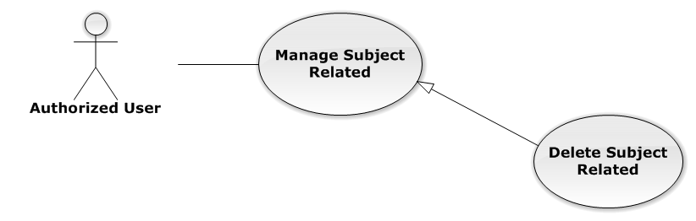

**Figure 3-43: Delete Subject Related Use-Case Diagram**

Use-Case Specification

|  |  |  |  |
| --- | --- | --- | --- |
| USE-CASE SPECIFICATION | | | |
| Use-case No. | UC0066 | Use-case Version | 1.0 |
| Use-case Name | Delete Subject Related | | |
| Author | Đặng Nguyễn Khiêm | | |
| Date | 09/10/2014 | Priority | Normal |
| Actor:  Authorized User, who is assigned in current case  Summary:  Staff can delete Subject related in Case  Goal:  Helps Staff delete Subject related  Triggers:  Staff click on delete icon in the end table list  Preconditions:   * Must be logged-in * The page is fully loaded * Must be in “Chủ thể” page * Click on edit icon beside “Chủ thể liên quan” label before   Post Conditions:  Success:   * Delete the subject out of current Case * Show message remove successfully: “Xóa chủ thể thành công!”   Failure: System display error message “Xóa chủ thể hàng thất bại!”  Main Success Scenario:   |  |  |  | | --- | --- | --- | | *Step* | *User* | *System* | | 1 | Click on edit icon beside “Chủ thể liên quan” label | Icon delete is display | | 2 | Click on icon delete corresponding with Subject want to delete | Show a modal popup to confirm | | 3 | Click on “Xác nhận” button  [Alternative 1] | System display message “Xóa chủ thể thành công!” |   Alternative Scenario:   |  |  |  | | --- | --- | --- | | *#* | *User* | *System* | | 1 | Click on “Bỏ qua” button | Modal popup is close and system do not remove the Subject |   Relationships:  Manage Subject Related  Business Rules:  Only Administrator or Authorized User is assigned in current case can be use this function when status of case is “Đang thụ lý” and Office that have current case must is active. | | | |

###### Manage Used Service

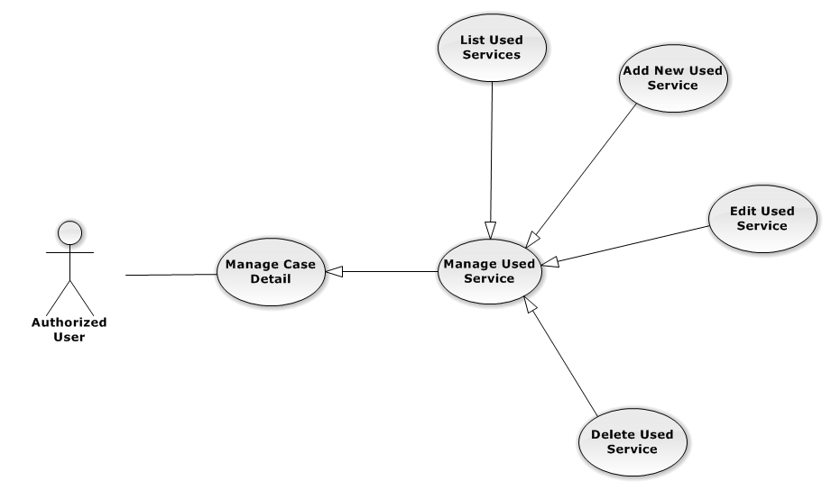

**Figure 3-44: Manage Used Service Use-Case Diagram**

UC0067 - List Used Services

Use-Case Diagram

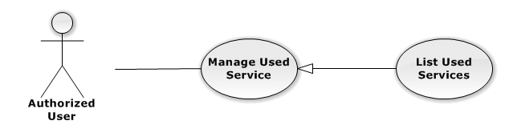

**Figure 3-45: List Used Services Use-Case Diagram**

Use-Case Specification

|  |  |  |  |
| --- | --- | --- | --- |
| USE-CASE SPECIFICATION | | | |
| Use-case No. | UC0068 | Use-case Version | 1.0 |
| Use-case Name | List Used Services | | |
| Author | Đặng Nguyễn Khiêm | | |
| Date | 09/10/2014 | Priority | Normal |
| Actor:  Authorized User  Summary:  Show all Used Service of case.  Goal:  Help staff to view all Used Service of case.  Triggers:  User click on “Hóa đơn” link in Case Detail page  Preconditions:   * Must be logged-in * The page is fully loaded * Must be in Case Detail page   Post Conditions:  Success:   * List all Used Service in current case include company name and customer name. * Display total money of list Used Service   Failure: Do nothing  Main Success Scenario:   |  |  |  | | --- | --- | --- | | *Step* | *User* | *System* | | 1 | Click on “Hóa đơn” link | Show all Used Service in current case |   Relationships:  Manage Used Service  Business Rules:  In the end of Used Service table have fill name “Tổng chi phí” display total money of all Used Service.  In the end of table have fill name “Chưa Thanh Toán” display total money of all Used Service. | | | |

UC0069 - Add New Used Service

Use-Case Diagram

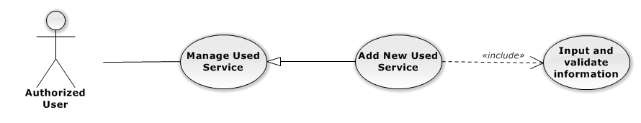

**Figure 3-46: Add New Used Service Use-Case Diagram**

Use-Case Specification

|  |  |  |  |
| --- | --- | --- | --- |
| USE-CASE SPECIFICATION | | | |
| Use-case No. | UC0070 | Use-case Version | 1.0 |
| Use-case Name | Add New Used Service | | |
| Author | Đặng Nguyễn Khiêm | | |
| Date | 09/10/2014 | Priority | Normal |
| Actor:  Authorized User, who is assigned in current case  Summary:  Staff can add new Used Service into Case  Goal:  Helps Staff create event into Case  Triggers:   * Staff click on “Hóa đơn” link in Case Detail page * Click on edit icon beside “Chi phí dịch vụ” button * Click on “Thêm dịch vụ” button to add new Used Service to current case.   Preconditions:   * Must be logged-in * The page is fully loaded * Must be in Used Service page * Click on edit icon beside “Chi phí dịch vụ” label before   Post Conditions:  Success:   * At new Used Service into current Case * Calculation and display the total money of Used Service to “Tổng Chi Phí” field and “Chưa Thanh Toán” fileld. * Show message successfully: “Thêm dịch vụ thành công!”   Failure: System display error message “Thêm dịch vụ thất bại!", "hãy kiểm tra lại kết nối database!”  Main Success Scenario:   |  |  |  | | --- | --- | --- | | *Step* | *User* | *System* | | 1 | Click on edit icon beside “Chi phí dịch vụ” label, click “Thêm dịch vụ” button | Pop-up input is display.  With two button “Đóng” and “Tạo dịch vụ” is display | | 2 | Input information into fields and click button “Tạo mới”  button  [Alternative 1], [Exception 1], [Exception 2] | System display message “Thêm dịch vụ thành công!” |   Alternative Scenario:   |  |  |  | | --- | --- | --- | | *#* | *User* | *System* | | 1 | Click on “Đóng” button | Input form close back to list all Used Service screen. |   Exceptions:   |  |  |  | | --- | --- | --- | | *#* | *User* | *System* | | 1 | Field “Loại Dịch Vụ”, are blank | Shows error message “Nhập vào tên dịch vụ!”. | | Field “Tên Dịch Vụ”, are blank | Shows error message “Chọn dịch vụ!”. | | Field “Chi Phí”, are blank | Shows error message “Nhập chi phí!”. | | Field “Nội dung”, are blank | Shows error message “Nhập nội dung!”. | | 2 | System cannot insert Used Service to data base. | Shows error message “Thêm thanh toán thất bại!", "Hãy kiểm tra lại kết nối database” |   Relationships:  Manage Used Service  Business Rules:  Only Administrator or Authorized User is assigned in current case can be use this function when status of case is “Đang thụ lý” and Office that have current case must is active. | | | |

UC0071 - Edit Used Service

Use-Case Diagram

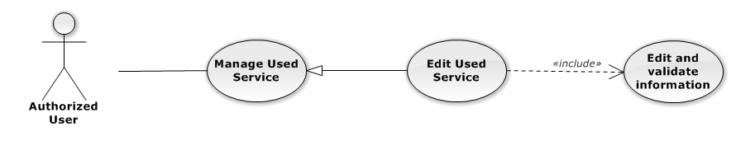

**Figure 3-47: Edit Used Service Use-Case Diagram**

Use-Case Specification

|  |  |  |  |
| --- | --- | --- | --- |
| USE-CASE SPECIFICATION | | | |
| Use-case No. | UC0072 | Use-case Version | 1.0 |
| Use-case Name | Edit Used Service | | |
| Author | Đặng Nguyễn Khiêm | | |
| Date | 09/10/2014 | Priority | Normal |
| Actor:  Authorized User, who is assigned in current case  Summary:  Staff can update Used Service into Case  Goal:  Helps Staff update Used Service into Case  Triggers:   * Staff click on “Hóa đơn” link in Case Detail page * Click on edit icon beside “Chi phí dịch vụ” button * Click on “Edit” button to update event.   Preconditions:   * Must be logged-in * The page is fully loaded * Must be in Used Service page * Click on edit icon beside “Chi phí dịch vụ” label before   Post Conditions:  Success:   * Update Used Service into current Case * Show message successfully: “Sửa dịch vụ thành công!” * Calculation and display the total money of Used Service to “Tổng Chi Phí” field and “Chưa Thanh Toán” fileld   Failure: System display error message “Sửa dịch vụ thất bại!", "hãy kiểm tra lại kết nối database!”  Main Success Scenario:   |  |  |  | | --- | --- | --- | | *Step* | *User* | *System* | | 1 | Click on edit icon beside “Chi phí dịch vụ” label | List all Used Service in current case, “Edit” and “Delete” icon is display, “Thêm dịch vụ” and “Hoàn thành” button is display | | 2 | Click on the “Edit” button | Pop-up “Sửa chi phí” is display load detail of 1 Used Service, “Đóng” and “Sửa chi phí” button is display | | 3 | Edit information into fields and click button “Sửa chi phí” button  [Alternative 1], [Exception 1], [Exception 2] | System display message “Sửa dịch vụ thành công!” |   Alternative Scenario:   |  |  |  | | --- | --- | --- | | *#* | *User* | *System* | | 1 | Click on “Đóng” button | Input form close back to list all event screen. |   Exceptions:   |  |  |  | | --- | --- | --- | | *#* | *User* | *System* | | 1 | Field “Chi Phí”, are blank | Shows error message “Nhập chi phí!”. | | Field “Nội dung”, are blank | Shows error message “Nhập nội dung!”. | | 2 | System cannot insert event to data base. | Shows error message “Sửa dịch vụ thất bại!", "Hãy kiểm tra lại kết nối database”. |   Relationships:  Manage Used Service  Business Rules:  Only Administrator or Authorized User is assigned in current case can be use this function when status of case is “Đang thụ lý” and Office that have current case must is active. | | | |

UC0073 - Delete Used Service

Use-Case Diagram

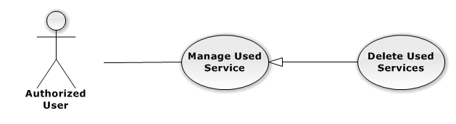

**Figure 3-48: Delete Used Service Use-Case Diagram**

Use-Case Specification

|  |  |  |  |
| --- | --- | --- | --- |
| USE-CASE SPECIFICATION | | | |
| Use-case No. | UC0074 | Use-case Version | 1.0 |
| Use-case Name | Delete Used Service | | |
| Author | Đặng Nguyễn Khiêm | | |
| Date | 09/10/2014 | Priority | Normal |
| Actor:  Authorized User, who is assigned in current case  Summary:  Staff can remove Used Service in Case  Goal:  Helps Staff remove Used Service in Case  Triggers:  Staff click on delete icon in the end table list  Preconditions:   * Must be logged-in * The page is fully loaded * Must be in Lawyer related page * Click on edit icon beside “Chi phí dịch vụ” label before   Post Conditions:  Success:   * Remove the Event out of current Case * Show message remove successfully: “Xóa dịch vụ thành công!” * Calculation and display the total money of Used Service to “Tổng Chi Phí” field and “Chưa Thanh Toán” fileld   Failure: System display error message “Xóa dịch vụ thất bại!", "Hãy kiểm tra lại kết nối database”  Main Success Scenario:   |  |  |  | | --- | --- | --- | | *Step* | *User* | *System* | | 1 | Click on edit icon beside “Chi phí dịch vụ” label | Icon delete is display | | 2 | Click on icon delete corresponding with Used Service want to remove | Show a modal popup to confirm | | 3 | Click on “Xác nhận” button  [Alternative 1] | System display message “Xóa dịch vụ thành công!” |   Alternative Scenario:   |  |  |  | | --- | --- | --- | | *#* | *User* | *System* | | 1 | Click on “Bỏ qua” button | Modal popup is close and system do not remove the Event |   Relationships:  Manage Used Service  Business Rules:  Only Administrator or Authorized User is assigned in current case can be use this function when status of case is “Đang thụ lý” and Office that have current case must is active. | | | |

###### Manage Payment

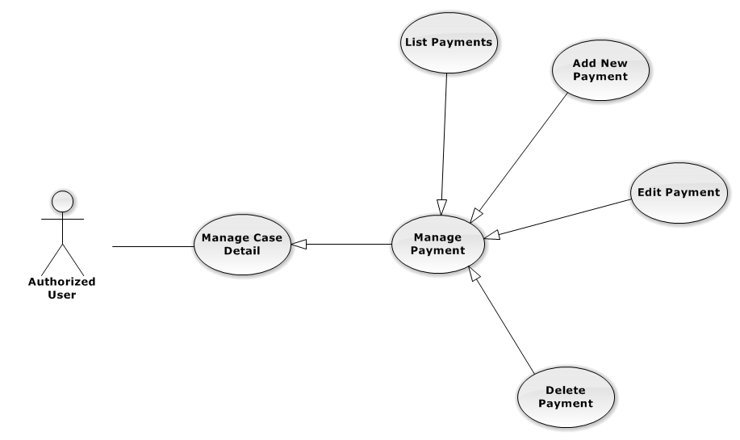

**Figure 3-49: Manage Payment Use-Case Diagram**

UC0075 - List Payments

Use-Case Diagram

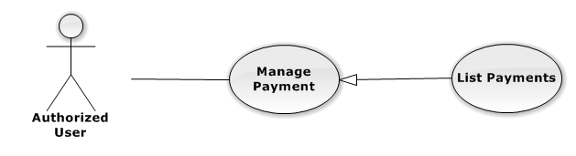

**Figure 3-50: List Payments Use-Case Diagram**

Use-Case Specification

|  |  |  |  |
| --- | --- | --- | --- |
| USE-CASE SPECIFICATION | | | |
| Use-case No. | UC0076 | Use-case Version | 1.0 |
| Use-case Name | List Payments | | |
| Author | Đặng Nguyễn Khiêm | | |
| Date | 09/10/2014 | Priority | Normal |
| Actor:  Authorized User  Summary:  Show all payment of case.  Goal:  Help staff to view all payment of case.  Triggers:  User click on “Hóa đơn” link in Case Detail page  Preconditions:   * Must be logged-in * The page is fully loaded * Must be in Case Detail page   Post Conditions:  Success:   * List all payment in current case include * Display total money of list payment.   Failure: Do nothing  Main Success Scenario:   |  |  |  | | --- | --- | --- | | *Step* | *User* | *System* | | 1 | Click on “Hóa đơn” link [Alternative 1], [Alternative 2] | Show all payment in current case |   Alternative Scenario:   |  |  |  | | --- | --- | --- | | *#* | *User* | *System* | | 1 | If total Payment > total Used Services | Display total money Unpaid in field “Số dư” | | 2 | If total Payment < total Used Services | Display total money balance in field “Chưa thanh toán” |   Relationships:  Manage Payment  Business Rules:  In the end of Used Service table have fill name “Tổng chi phí” display total money of all Used Service. | | | |

UC0077 - Add New Payment

Use-Case Diagram

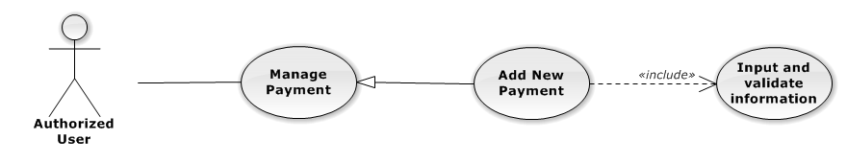

**Figure 3-51: Add New Payment Use-Case Diagram**

Use-Case Specification

|  |  |  |  |
| --- | --- | --- | --- |
| USE-CASE SPECIFICATION | | | |
| Use-case No. | UC0078 | Use-case Version | 1.0 |
| Use-case Name | Add New Payment | | |
| Author | Đặng Nguyễn Khiêm | | |
| Date | 09/10/2014 | Priority | High |
| Actor:  Authorized User, who is assigned in current case  Summary:  Staff can add new payment into Case  Goal:  Helps Staff create payment into Case  Triggers:   * Staff click on “Hóa đơn” link in Case Detail page * Click on edit icon beside “Hóa đơn thanh toán” button * Click on “Thêm thanh toán button to add new payment to current case.   Preconditions:   * Must be logged-in * The page is fully loaded * Must be in payment page * Click on edit icon beside “Hóa đơn thanh toán” label before   Post Conditions:  Success:   * At new Used Service into current Case * Calculation and display the total money of Payment and display total of money unpaid or balancein field “Chưa thanh toán” , “Số dư”. * Show message successfully: “Thêm thanh toán thành công!”   Failure: System display error message “Thêm thanh toán thất bại!", "hãy kiểm tra lại kết nối database!”  Main Success Scenario:   |  |  |  | | --- | --- | --- | | *Step* | *User* | *System* | | 1 | Click on edit icon beside “Hóa đơn thanh toán” label, click “Thêm thanh toán” button | Pop-up input is display. | | 2 | Input information into fields and click button “Tạo thanh toán” button  [Alternative 1], [Exception 1], [Exception 2] | System display message “Thêm thanh toán thành công!” |   Alternative Scenario:   |  |  |  | | --- | --- | --- | | *#* | *User* | *System* | | 1 | Click on “Đóng” button | Input form close back to list all Used Service screen. |   Exceptions:   |  |  |  | | --- | --- | --- | | *#* | *User* | *System* | | 1 | Field “Thanh Toán”, are blank | Shows error message “Nhập số tiền thanh toán!”. | | Field “Nội dung”, are blank | Shows error message “Nhập nội dung!”. | | 2 | System cannot insert payment to data base. | Shows error message “Thêm thanh toán thất bại!", "Hãy kiểm tra lại kết nối database” |   Relationships:  Manage Payment  Business Rules:  Only Administrator or Authorized User is assigned in current case can be use this function when status of case is “Đang thụ lý” and Office that have current case must is active. | | | |

UC0079 - Edit Payment

Use-Case Diagram

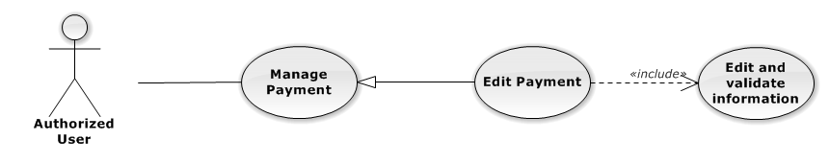

**Figure 3-52: Edit Payment Use-Case Diagram**

Use-Case Specification

|  |  |  |  |
| --- | --- | --- | --- |
| USE-CASE SPECIFICATION | | | |
| Use-case No. | UC0080 | Use-case Version | 1.0 |
| Use-case Name | Edit Payment | | |
| Author | Đặng Nguyễn Khiêm | | |
| Date | 09/10/2014 | Priority | Normal |
| Actor:  Authorized User, who is assigned in current case  Summary:  Staff can update payment service into Case  Goal:  Helps Staff update payment service into Case  Triggers:   * Staff click on “Hóa đơn” link in Case Detail page * Click on edit icon beside “Hóa đơn thanh toán” button * Click on “Edit” button to update event.   Preconditions:   * Must be logged-in * The page is fully loaded * Must be in Used Service page * Click on edit icon beside “Hóa đơn thanh toán” label before   Post Conditions:  Success:   * Update Used Service into current Case * Show message successfully: “Sửa thanh toán thành công!” * Calculation and display the total money of Payment and display total of money unpaid or balancein field “Chưa thanh toán” , “Số dư”.   Failure: System display error message “Sửa thanh toán thất bại!", "hãy kiểm tra lại kết nối database!”  Main Success Scenario:   |  |  |  | | --- | --- | --- | | *Step* | *User* | *System* | | 1 | Click on edit icon beside “Hóa đơn thanh toán” label | List all payment in current case, “Edit” and “Delete” icon is display, “Thêm dịch vụ” and “Hoàn thành” button is display | | 2 | Click on the “Edit” button | Pop-up “Sửa thanh toán” is display load detail of 1 Used Service, “Đóng” and “Sửa chi phí” button is display | | 3 | Edit information into fields and click button “Sửa thanh toán” button  [Alternative 1], [Exception 1] ,[Exception 2] | System display message “Sửa thanh toán thành công!” |   Alternative Scenario:   |  |  |  | | --- | --- | --- | | *#* | *User* | *System* | | 1 | Click on “Đóng” button | Input form close back to list all event screen. |   Exceptions:   |  |  |  | | --- | --- | --- | | *#* | *User* | *System* | | 1 | Field “Thanh Toán”, are blank | Shows error message “Nhập số tiền thanh toán!”. | | Field “Nội dung”, are blank | Shows error message “Nhập nội dung!”. | | 2 | System cannot insert event to data base. | Shows error message “Sửa thanh toán thất bại!", "Hãy kiểm tra lại kết nối database”. |   Relationships:  Manage Payment  Business Rules:  Only Administrator or Authorized User is assigned in current case can be use this function when status of case is “Đang thụ lý” and Office that have current case must is active. | | | |

UC0081 - Delete Payment

Use-Case Diagram

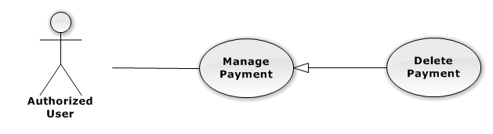

**Figure 3-53: Delete Payment Use-Case Diagram**

Use-Case Specification

|  |  |  |  |
| --- | --- | --- | --- |
| USE-CASE SPECIFICATION | | | |
| Use-case No. | UC0082 | Use-case Version | 1.0 |
| Use-case Name | Delete Payment | | |
| Author | Đặng Nguyễn Khiêm | | |
| Date | 09/10/2014 | Priority | Normal |
| Actor:  Authorized User, who is assigned in current case  Summary:  Staff can remove payment in Case  Goal:  Helps Staff remove payment in Case  Triggers:  Staff click on delete icon in the end table list  Preconditions:   * Must be logged-in * The page is fully loaded * Must be in Lawyer related page * Click on edit icon beside “Hóa đơn thanh toán” label before   Post Conditions:  Success:   * Remove the Event out of current Case * Show message remove successfully: “Xóa thanh toán thành công!” * Calculation and display the total money of payment   Failure: System display error message “Xóa thanh toán thất bại!", "Hãy kiểm tra lại kết nối database”  Main Success Scenario:   |  |  |  | | --- | --- | --- | | *Step* | *User* | *System* | | 1 | Click on edit icon beside “Chi phí dịch vụ” label | Icon delete is display | | 2 | Click on icon delete corresponding with Used Service want to remove | Show a modal popup to confirm | | 3 | Click on “Xác nhận” button  [Alternative 1] | System display message “Xóa thanh toán thành công!” |   Alternative Scenario:   |  |  |  | | --- | --- | --- | | *#* | *User* | *System* | | 1 | Click on “Bỏ qua” button | Modal popup is close and system do not remove the Event |   Relationships:  Manage Payment  Business Rules:  Only Administrator or Authorized User is assigned in current case can be use this function when status of case is “Đang thụ lý” and Office that have current case must is active. | | | |

#### Manage Customer Group

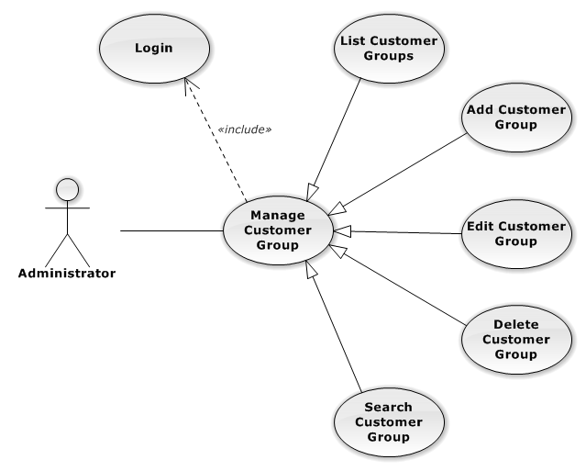

**Figure 3-54: Manage Customer Group Use-Case Diagram**

##### UC008343 - List Customer Groups

###### Use-Case Diagram

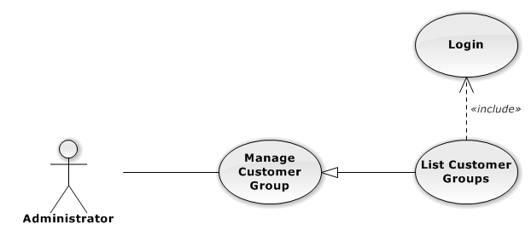

**Figure 3-55: List Customer Groups Use-Case Diagram**

###### List Customer Groups Use-Case Specification

|  |  |  |  |
| --- | --- | --- | --- |
| USE CASE SPECIFICATION | | | |
| Use-case No. | UC008443 | Use-case Version | 1.0 |
| Use-case Name | List Customer Groups | | |
| Author | Đặng Nguyễn Khiêm | | |
| Date | 09/10/2014 | Priority | Normal |
| Actor:  Administrator  Summary:  List All Customer Group.  Goal:  The purpose of List Customer Group use case is allowing Admin to view all Customer Groups.  Triggers:  User choose “Quản lý Nhóm Khách Hàng” in menu.  Preconditions:  User is authenticated and has role “admin”.  The page is fully loaded.  Post Conditions:  Success: All Customer Groups are listed.  Failure: N/A  Main Success Scenario:   |  |  |  | | --- | --- | --- | | *Step* | *User* | *System* | | 1 | Click “Quản lý Nhóm Khách Hàng” in menu. | All Customer Groups are loaded. |   Relationships:  Manage Customer Group | | | |

##### UC0044 - Add New Customer Group

###### Use-Case Diagram

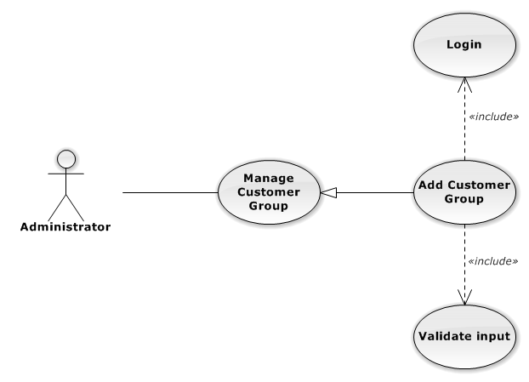

**Figure 3-56: Add New Customer Group Use-Case Diagram**

###### Use-Case Specification

|  |  |  |  |
| --- | --- | --- | --- |
| USE CASE SPECIFICATION | | | |
| Use-case No. | UC0044 | Use-case Version | 1.0 |
| Use-case Name | Add Customer Group | | |
| Author | Đặng Nguyễn Khiêm | | |
| Date | 09/10/2014 | Priority | Normal |
| Actor:  Administrator  Summary:  Add new Customer Group.  Goal:  The purpose of Add Customer Group use case is allowing Admin to add new Customer Group.  Triggers:  User choose “Quản lý Nhóm Khách Hàng” in menu.  Preconditions:  User is authenticated and has role “admin”.  Post Conditions:  Success: New Customer Group is created.  Failure: No Customer Group is created and Error message will be showed.  Main Success Scenario:   |  |  |  | | --- | --- | --- | | *Step* | *User* | *System* | | 1 | Click “Thêm Nhóm Khách Hàng” button. | Show add new customer group pop-up. | | 2 | Enters the Customer Group Name and Description |  | | 3 | Presses “Thêm Nhóm Khách Hàng” button.  [Alternative: 1] | Checks validate, add new Customer Group to database.  Show success message.  [Exception: 1]  [Exception: 2]  [Exception: 3] |   Alternative Scenario:   |  |  |  | | --- | --- | --- | | *#* | *User* | *System* | | 1 | Presses “Đóng”, “X” button or click outside pop-up. | The Add New Customer Group pop-up is close. |   Exceptions:   |  |  |  | | --- | --- | --- | | *#* | *User* | *System* | | 1 | Customer Group Name is missing. | Show error “Nhập tên nhóm khách hang” to user. | | 2 | Add Customer group fail. | The Add New Customer Group is closed and display error message “Tạo nhóm khách hàng thất bại!", "Hãy kiểm tra lại kết nối database." | | 3 | Add Customer group error. | The Add New Customer Group is closed and display error message "Tạo nhóm khách hàng thất bại!", "Có lỗi xảy ra trong quá trình tạo nhóm khách hàng." |   Relationships:  Manage Customer Group | | | |

##### UC0045 - Edit Customer Group

###### Use-Case Diagram

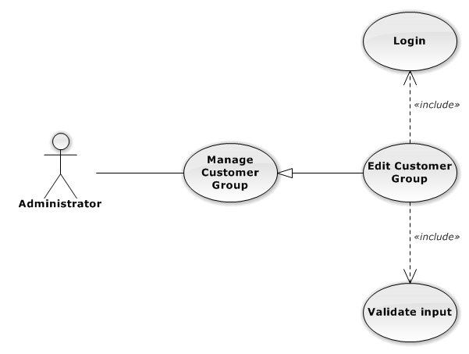

**Figure 3-57: Edit Customer Group Use-Case Diagram**

###### Use-Case Specification

|  |  |  |  |
| --- | --- | --- | --- |
| USE CASE SPECIFICATION | | | |
| Use-case No. | UC0045 | Use-case Version | 1.0 |
| Use-case Name | Delete Customer Group | | |
| Author | Đặng Nguyễn Khiêm | | |
| Date | 09/10/2014 | Priority | Normal |
| Actor:  Administrator  Summary:  Update Customer Group.  Goal:  The purpose of Update Customer Group use case is allowing Admin to update Customer Group.  Triggers:  User choose “Quản lý Nhóm Dịch Vụ” in menu.  Preconditions:  User is authenticated and has role “admin”.  Post Conditions:  Success: The Customer Group id Updated.  Failure: The Customer Group is not updated and Error message will be showed.  Main Success Scenario:   |  |  |  | | --- | --- | --- | | *Step* | *User* | *System* | | 1 | Click Update icon. |  | | 2 | Enters the new Customer Group Name and Description |  | | 3 | Presses “Lưu chỉnh sửa” button.  [Alternative: 1] | Checks validate, update Customer Group to database.  Show success message.  [Exception: 1]  [Exception: 2]  [Exception: 3] |   Alternative Scenario:   |  |  |  | | --- | --- | --- | | *#* | *User* | *System* | | 1 | Presses “Đóng”, “X” button or click outside pop-up. | The Update Customer Group pop-up is close. |   Exceptions:   |  |  |  | | --- | --- | --- | | *#* | *User* | *System* | | 1 | Customer Group Name is missing. | Show error “Nhập tên nhóm khách hàng” to user. | | 2 | Update Customer group fail. | The Update Customer Group is closed and display error message “Chỉnh sửa nhóm khách hàng thất bại!", "Hãy kiểm tra lại kết nối database." | | 3 | Update Customer group error. | The Update Customer Group is closed and display error message "Chỉnh sửa nhóm khách hàng thất bại!", "Có lỗi xảy ra trong quá trình tạo nhóm khách hàng." |   Relationships:  Manage Customer Group | | | |

##### UC0046 - Delete Customer Group

###### Use-Case Diagram

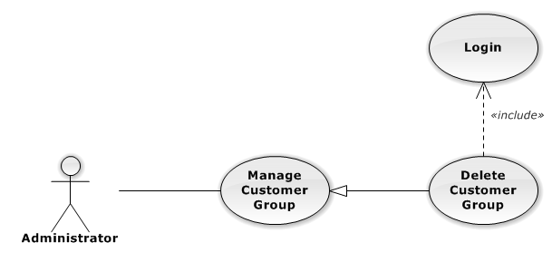

**Figure 3-58: Delete Customer Group Use-Case Diagram**

###### Use-Case Specification

|  |  |  |  |
| --- | --- | --- | --- |
| USE CASE SPECIFICATION | | | |
| Use-case No. | UC0046 | Use-case Version | 1.0 |
| Use-case Name | Delete Customer Group | | |
| Author | Đặng Nguyễn Khiêm | | |
| Date | 09/10/2014 | Priority | Normal |
| Actor:  Administrator  Summary:  Delete Customer Group.  Goal:  The purpose of Delete Customer Group use case is allowing Admin to delete Customer Group.  Triggers:  User choose “Quản lý Nhóm Khách Hàng” in menu.  Preconditions:  User is authenticated and has role “admin”.  Post Conditions:  Success: The Customer Group is deleted.  Failure: The Customer Group is not delete and Error message will be showed.  Main Success Scenario:   |  |  |  | | --- | --- | --- | | *Step* | *User* | *System* | | 1 | Click Delete icon. | Show confirm pop-up | | 2 | Presses “Đồng ý” button.  [Alternative: 1] | Delete Customer Group from database.  Show success message.  [Exception: 1]  [Exception: 2] |   Alternative Scenario:   |  |  |  | | --- | --- | --- | | *#* | *User* | *System* | | 1 | Presses “Đóng”, “X” button or click outside pop-up. | The confirm pop-up is close. |   Exceptions:   |  |  |  | | --- | --- | --- | | *#* | *User* | *System* | | 1 | Delete Customer group fail. | The Add New Customer Group is closed and display error message “Xóa nhóm khách hàng thất bại!", "Hãy kiểm tra lại kết nối database." | | 2 | Delete Customer group error. | The Add New Customer Group is closed and display error message "Xóa nhóm khách hàng thất bại!", "Có lỗi xảy ra trong quá xóa nhóm khách hàng." |   Relationships:  Manage Customer Group | | | |

##### UC0047 - Search Customer Group

###### Use-Case Diagram

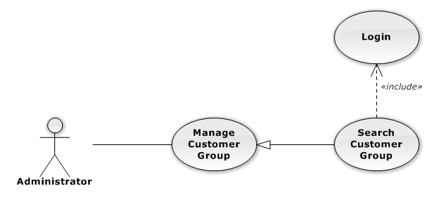

**Figure 3-59: Search Customer Group Use-Case Diagram**

###### Use-Case Specification

|  |  |  |  |
| --- | --- | --- | --- |
| USE CASE SPECIFICATION | | | |
| Use-case No. | UC0085 | Use-case Version | 1.0 |
| Use-case Name | Search Customer Group | | |
| Author | Đặng Nguyễn Khiêm | | |
| Date | 09/10/2014 | Priority | Normal |
| Actor:  Administrator  Summary:  Search Customer Group.  Goal:  The purpose of Search Customer Group use case is allowing Admin to search Customer.  Triggers:  User choose “Quản lý Nhóm khách hàng” in menu.  Preconditions:  User is authenticated and has role “admin”.  Post Conditions:  Success: List of Customer Group with search key words is displayed.  Failure: No record is displayed.  Main Success Scenario:   |  |  |  | | --- | --- | --- | | *Step* | *User* | *System* | | 1 | In “Quản lý Nhóm khách hàng” screen, input key word at “Tìm kiếm” textbox. | List of Customer Group with search key words is displayed. |   Relationships:  Manage Customer Group | | | |

#### Manage Customer

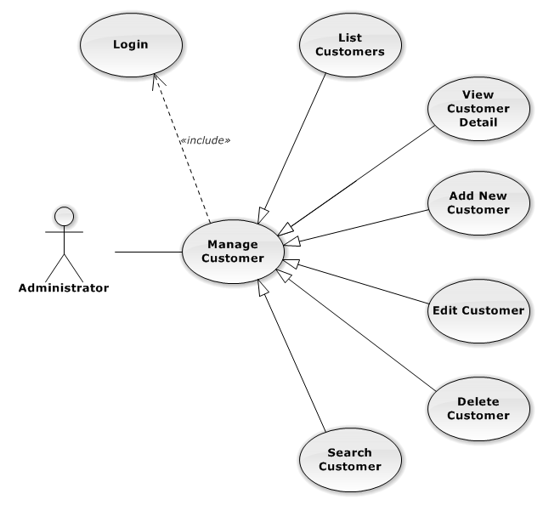

**Figure 3-60: Manage Customer Use-Case Diagram**

##### UC0048 - List Customers

###### Use-Case Diagram

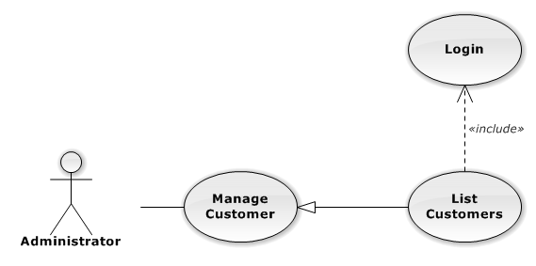

**Figure 3-61: List Customers Use-Case Diagram**

###### Use-Case Specification

|  |  |  |  |
| --- | --- | --- | --- |
| USE CASE SPECIFICATION | | | |
| Use-case No. | UC0048 | Use-case Version | 1.0 |
| Use-case Name | List Customers | | |
| Author | Đặng Nguyễn Khiêm | | |
| Date | 09/10/2014 | Priority | Normal |
| Actor:  Administrator  Summary:  List All Customer.  Goal:  The purpose of List Customers use case is allowing Admin to view all Customers.  Triggers:  User choose “Quản lý Khách Hàng” in menu.  Preconditions:  User is authenticated and has role “admin”.  The page is fully loaded.  Post Conditions:  Success: All Customer is listed.  Failure: N/A  Main Success Scenario:   |  |  |  | | --- | --- | --- | | *Step* | *User* | *System* | | 1 | Click “Quản lý Khách Hàng” in menu. | All Customers are loaded. |   Relationships:  Manage Customer | | | |

##### UC0049 - View Customer Detail

###### Use-Case Diagram

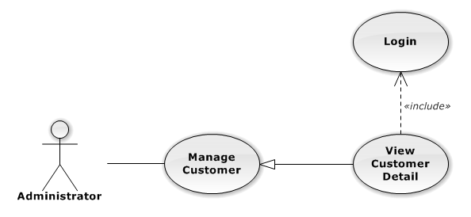

**Figure 3-62: View Customer Detail Use-Case Diagram**

###### Use-Case Specification

|  |  |  |  |
| --- | --- | --- | --- |
| USE CASE SPECIFICATION | | | |
| Use-case No. | UC0049 | Use-case Version | 1.0 |
| Use-case Name | View Customer Detail | | |
| Author | Đặng Nguyễn Khiêm | | |
| Date | 09/10/2014 | Priority | Normal |
| Actor:  Administrator  Summary:  View Customer Detail.  Goal:  The purpose of View Customer Detail use case is allowing Admin to view a Customer detail.  Triggers:  User choose “Quản lý Khách Hàng” in menu. Then click “View detail” icon.  Preconditions:  User is authenticated and has role “admin”.  Post Conditions:  Success: Customer Detail is showed.  Failure: Do nothing.  Main Success Scenario:   |  |  |  | | --- | --- | --- | | *Step* | *User* | *System* | | 1 | In Manage Customer page, click “View detail” icon | The Customer Detail is showed. |   Relationships:  Manage Customer | | | |

##### UC0050 - Add New Customer

###### Use-Case Diagram

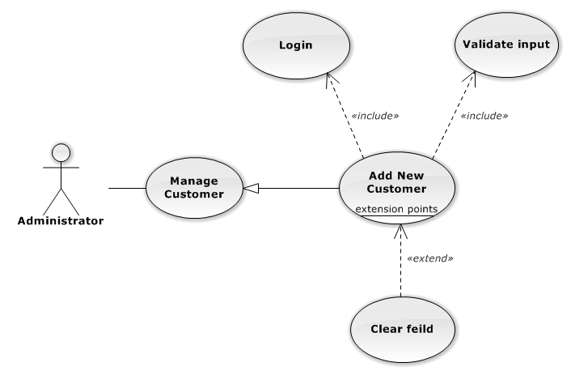

**Figure 3-63: Add New Customer Use-Case Diagram**

###### Use-Case Specification

|  |  |  |  |
| --- | --- | --- | --- |
| USE CASE SPECIFICATION | | | |
| Use-case No. | UC0050 | Use-case Version | 1.0 |
| Use-case Name | Add New Customer | | |
| Author | Đặng Nguyễn Khiêm | | |
| Date | 09/10/2014 | Priority | Normal |
| Actor:  Administrator  Summary:  Add Customer.  Goal:  The purpose of Add Customer use case is allowing Admin to add new Customer.  Triggers:  User choose “Quản lý Khách Hàng” in menu.  Preconditions:  User is authenticated and has role “admin”.  Post Conditions:  Success: New Customer is created.  Failure: No Customer is created and Error message will be showed.  Main Success Scenario:   |  |  |  | | --- | --- | --- | | *Step* | *User* | *System* | | 1 | Click “Thêm Khách Hàng” button. | Show add Customer pop-up. | | 2 | Enters the Customer detail. |  | | 3 | Presses “Thêm Khách Hàng” button.  [Alternative: 1] | Checks validate, add new Customer to database.  Show success message.  [Exception: 1]  [Exception: 2]  [Exception: 3] |   Alternative Scenario:   |  |  |  | | --- | --- | --- | | *#* | *User* | *System* | | 1 | Presses “Đóng”, “X” button or click outside pop-up. | The Add New Customer pop-up is close. |   Exceptions:   |  |  |  | | --- | --- | --- | | *#* | *User* | *System* | | 1 | Customer Name is missing. | Show error “"Nhập tên khách hàng!" to user. | | Represent-Person is missing. | Show error “"Nhập tên người đại diện!” to user. | | Customer Group is not chosen. | Show error “"Chọn nhóm khách hàng!” to user. | | Address is missing. | Show error “"Nhập địa chỉ!" to user. | | Email format is wrong. | Show error “Email chưa đúng định dạng!" to user. | | Mobile is missing. | Show error “Nhập số điện thoại di động!” to user. | | 2 | Add Customer fail. | The Add New Customer is closed and display error message “Tạo khách hàng thất bại!", "Hãy kiểm tra lại kết nối database." | | 3 | Add Customer error. | The Add New Customer is closed and display error message "Tạo khách hàng thất bại!", "Có lỗi xảy ra trong quá trình tạo khách hàng." |   Relationships:  Manage Customer | | | |

##### UC0051 - Edit Customer

###### Use-Case Diagram

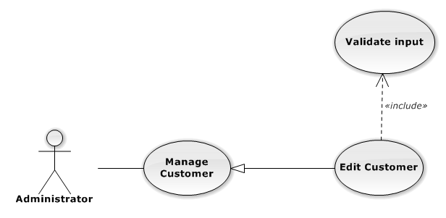

**Figure 3-64: Edit Customer Use-Case Diagram**

###### Use-Case Specification

|  |  |  |  |
| --- | --- | --- | --- |
| USE CASE SPECIFICATION | | | |
| Use-case No. | UC0051 | Use-case Version | 1.0 |
| Use-case Name | Edit Customer | | |
| Author | Đặng Nguyễn Khiêm | | |
| Date | 09/10/2014 | Priority | Normal |
| Actor:  Administrator  Summary:  Update Customer.  Goal:  The purpose of Update Customer use case is allowing Admin to update Customer.  Triggers:  User choose “Quản lý Khách Hàng” in menu.  Preconditions:  User is authenticated and has role “admin”.  Post Conditions:  Success: The Customer is Updated.  Failure: The Customer is not updated and Error message will be showed.  Main Success Scenario:   |  |  |  | | --- | --- | --- | | *Step* | *User* | *System* | | 1 | Click Update icon. | Show update Customer pop-up. | | 2 | Enters the new Customer’s detail. |  | | 3 | Presses “Lưu chỉnh sửa” button.  [Alternative: 1] | Checks validate, update Customer to database.  Show success message.  [Exception: 1]  [Exception: 2]  [Exception: 3] |   Alternative Scenario:   |  |  |  | | --- | --- | --- | | *#* | *User* | *System* | | 1 | Presses “Đóng”, “X” button or click outside pop-up. | The Update Customer pop-up is close. |   Exceptions:   |  |  |  | | --- | --- | --- | | *#* | *User* | *System* | | 1 | Customer Name is missing. | Show error “"Nhập tên khách hàng!" to user. | | Represent-Person is missing. | Show error “"Nhập tên người đại diện!” to user. | | Customer Group is not chosen. | Show error “"Chọn nhóm khách hàng!” to user. | | Address is missing. | Show error “"Nhập địa chỉ!" to user. | | Email format is wrong. | Show error “Email chưa đúng định dạng!" to user. | | Mobile is missing. | Show error “Nhập số điện thoại di động!” to user. | | 2 | Update Customer fail. | The Update Customer pop-up is closed and display error message “Chỉnh sửa khách hàng thất bại!", "Hãy kiểm tra lại kết nối database." | | 3 | Update Customer error. | The Update Customer pop-up is closed and display error message "Chỉnh sửa khách hàng thất bại!", "Có lỗi xảy ra trong quá trình chỉnh sửa khách hàng." |   Relationships:  Manage Customer | | | |

##### UC0052 - Delete Customer

###### Use-Case Diagram

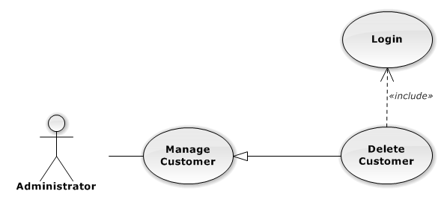

**Figure 3-65: Delete Customer Use-Case Diagram**

###### Use-Case Specification

|  |  |  |  |
| --- | --- | --- | --- |
| USE CASE SPECIFICATION | | | |
| Use-case No. | UC0052 | Use-case Version | 1.0 |
| Use-case Name | Delete Customer | | |
| Author | Đặng Nguyễn Khiêm | | |
| Date | 09/10/2014 | Priority | Normal |
| Actor:  Administrator  Summary:  Delete Customer.  Goal:  The purpose of Delete Customer use case is allowing Admin to delete Customer.  Triggers:  User choose “Quản lý Khách Hàng” in menu.  Preconditions:  User is authenticated ans has role “admin”.  Post Conditions:  Success: The Customer is deleted.  Failure: The Customer is not delete and Error message will be showed.  Main Success Scenario:   |  |  |  | | --- | --- | --- | | *Step* | *User* | *System* | | 1 | Click Delete icon. | Show confirm pop-up | | 2 | Presses “Đồng ý” button.  [Alternative: 1] | Delete Customer from database.  Show success message.  [Exception: 1]  [Exception: 2] |   Alternative Scenario:   |  |  |  | | --- | --- | --- | | *#* | *User* | *System* | | 1 | Presses “Đóng”, “X” button or click outside pop-up. | The confirm pop-up is close. |   Exceptions:   |  |  |  | | --- | --- | --- | | *#* | *User* | *System* | | 1 | Delete Customer fail. | The confirm pop-up is closed and display error message “Xóa nhóm dịch vụ thất bại!", "Hãy kiểm tra lại kết nối database." | | 2 | Delete Customer error. | The confirm pop-up is closed and display error message “Xóa nhóm dịch vụ thất bại!", "Có lỗi xảy ra trong quá trình xóa khách hàng." |   Relationships:  Manage Customer | | | |

##### UC0053 - Search Customer

###### Use-Case Diagram

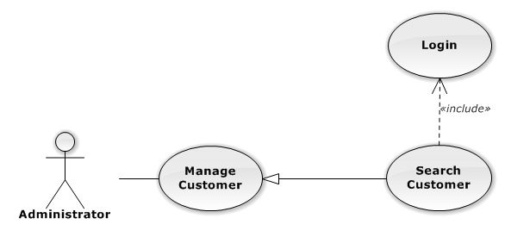

**Figure 3-66: Search Customer Use-Case Diagram**

###### Use-Case Specification

|  |  |  |  |
| --- | --- | --- | --- |
| USE CASE SPECIFICATION | | | |
| Use-case No. | UC0053 | Use-case Version | 1.0 |
| Use-case Name | Search Customer | | |
| Author | Đặng Nguyễn Khiêm | | |
| Date | 09/10/2014 | Priority | Normal |
| Actor:  Administrator  Summary:  Search Customer.  Goal:  The purpose of Search Customer use case is allowing Admin to search Customer.  Triggers:  User choose “Quản lý Khách hàng” in menu.  Preconditions:  User is authenticated and has role “admin”.  Post Conditions:  Success: List of Customer with search key words is displayed.  Failure: No record is displayed.  Main Success Scenario:   |  |  |  | | --- | --- | --- | | *Step* | *User* | *System* | | 1 | In “Quản lý Khách hàng” screen, input key word at “Tìm kiếm” textbox. | List of Customer with search key words is displayed. | | | | |

#### Manage Staff Group

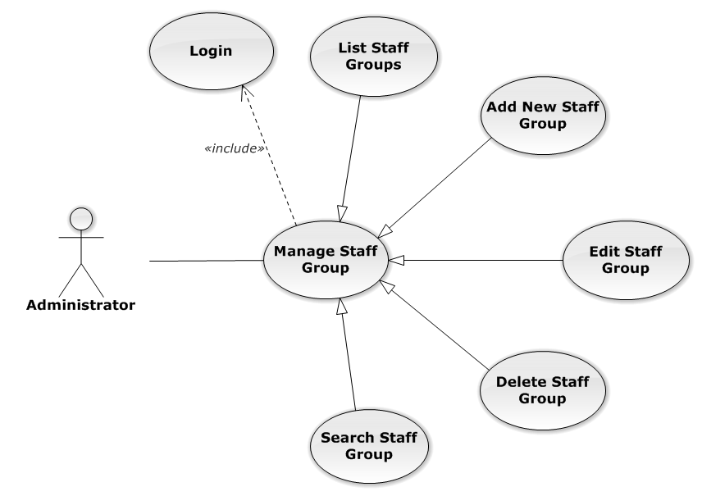

**Figure 3-67: Manage Staff Group Use-Case Diagram**

##### UC0054 - List Staff Groups

###### Use-Case Diagram

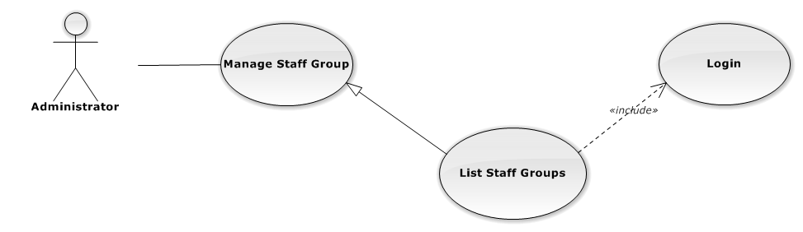

**Figure 3-68: List Staff Groups Use-Case Diagram**

###### Use-Case Specification

|  |  |  |  |
| --- | --- | --- | --- |
| USE-CASE SPECIFICATION | | | |
| Use-case No. | UC0054 | Use-case Version | 1.0 |
| Use-case Name | List Staff Groups | | |
| Author | Đặng Nguyễn Khiêm | | |
| Date | 09/10/2014 | Priority | Normal |
| Actor:  Administrator  Summary:  Redirect user to “Quản lí nhóm nhân viên” page and list all staff group.  Goal:  To allowing Administrator view any detail information of all staff group.  Triggers:   * User click on User Control Panel and then click on “Quản lí nhân viên” link * On sub menu click on “nhóm nhân viên”.   Preconditions:   * Must be logged-in with “Admin” role. * The page is fully loaded   Post Conditions:  Success: System redirects user to “Quản lí nhóm nhân viên” page.  Failure: Do nothing.  Main Success Scenario:   |  |  |  | | --- | --- | --- | | *Step* | *User* | *System* | | 1 | Click on “Quản lí nhóm nhân viên” link | Redirect to “Quản lí nhóm nhân viên” page  Show all staff group. |   Relationships:  Manage Staff Group  Business Rules:  Only Staff with role =”Admin” can be use this function. | | | |

##### UC0055 - Add New Staff Group

###### Use-Case Diagram

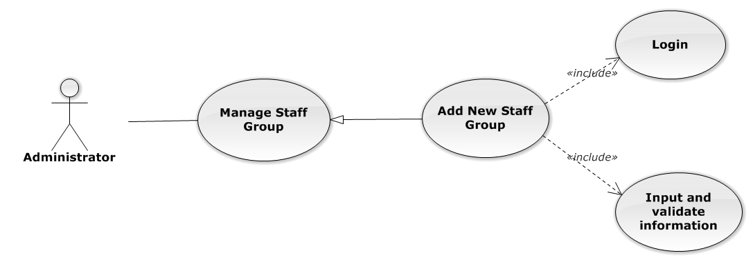

**Figure 3-69: Add New Staff Group Use-Case Diagram**

###### Use-Case Specification

|  |  |  |  |
| --- | --- | --- | --- |
| USE CASE SPECIFICATION | | | |
| Use-case No. | UC0055 | Use-case Version | 1.0 |
| Use-case Name | Add New Staff Group | | |
| Author | Đặng Nguyễn Khiêm | | |
| Date | 09/10/2014 | Priority | Normal |
| Actor:  Administrator.  Summary:  Administrator can insert new staff group in the system.  **Goal:**  Add new staff group.  Triggers:  At “Quản lí nhóm nhân viên” page click “Thêm nhóm nhân viên” button, fill information and click button “Thêm mới”.  Preconditions:   * Logged-in as “Admin” role. * The page is fully loaded   Post Conditions:  Success: New staff group is inserted into database, message show “Tạo nhóm nhân viên mới thành công!” and display on “Quản lí nhân viên” screen.  Failure: Show message “Tạo nhóm nhân viên mới thất bại!”  Main Success Scenario:   |  |  |  | | --- | --- | --- | | *Step* | *User* | *System* | | 1 | Administrator click on “Thêm nhóm nhân viên” button at “Quản lí Nhóm nhân viên” page. | Modal popup is displayed with fields for input information of new staff group. | |  | Fill information into fields and click button “Thêm mới”  [Alternative 1]  [Exception 1], [Exception 2], [Exception 3] | Modal popup is close  System display successful message “Tạo nhóm nhân viên mới thành công!”  Update list staff group on page |   Alternative Scenario:   |  |  |  | | --- | --- | --- | | *#* | *User* | *System* | | 1 | Click on [X] button, “Đóng” button, or click out of modal | Modal popup is close |   Exceptions:   |  |  |  | | --- | --- | --- | | *#* | *User* | *System* | | 1 | Field “Tên nhóm nhân viên” are blank | Shows error message “Nhập tên nhóm nhân viên!”. | | Field “Chi tiết nhóm nhân viên”, are blank | Shows error message “Nhập chi tiết chi tiết nhân viên!” | | 2 | System cannot insert staff group to data base. | Shows error message “Tạo nhóm nhân viên thất bại!” | | 3 | System fail insert staff group to data base. | Shows error message “Tạo nhóm nhân viên thất bại!", "Hãy kiểm tra lại kết nối database!”. |   Relationships:  Manage Staff Group  Business Rules:  Only Staff with role=”Admin” can be use this function. | | | |

##### UC0056 - Edit Staff Group

###### Use-Case Diagram

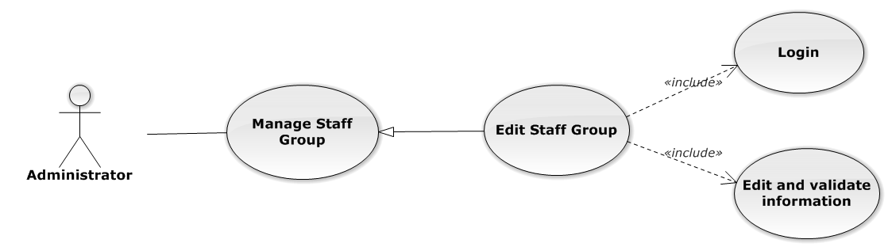

**Figure 3-70: Edit Staff Group Use-Case Diagram**

###### Use-Case Specification

|  |  |  |  |
| --- | --- | --- | --- |
| USE CASE SPECIFICATION | | | |
| Use-case No. | UC0056 | Use-case Version | 1.0 |
| Use-case Name | Edit Staff Group | | |
| Author | Đặng Nguyễn Khiêm | | |
| Date | 09/10/2014 | Priority | Normal |
| Actor:  Administrator.  Summary:  Administrator can update information of staff group.  **Goal:**  Administrator can update information of staff group and save to database system.  Triggers:   * Administrator goes to “Chi tiết nhóm nhân viên” Popup and click “Chỉnh Sửa” button and modify information, after that click button “Lưu Chỉnh Sửa”. * Administrator goes to “Nhóm nhân viên” screen, click “Chỉnh Sửa” button and modify information, after that click button “Lưu Chỉnh Sửa”.   Preconditions:   * User has logged-in as “Admin” role. * The page is fully loaded   Post Conditions:  Success:  Information of staff group is updated and saves to database, message show “Cập nhật chi tiết nhóm nhân viên thành công!” and display information after update on “Quản lý nhóm nhân viên” screen.  Failure:  Show message “Cập nhật chi tiết nhóm nhân viên thất bại!”  Main Success Scenario:   |  |  |  | | --- | --- | --- | | *Step* | *User* | *System* | | 1 | Manager click on “Chỉnh sửa” button at “Quản lí nhóm nhân viên” screen. | Modal popup is displayed with fields for detil information of staff group. | | 2 | Edit information into fields and click button “Lưu chỉnh sửa”  [Alternative 1]  [Exception 1], [Exception 1], [Exception 3] | Modal popup is close  System display successful message “Cập nhật chi tiết nhóm nhân viên thành công!”  Update list staff group on page |   Alternative Scenario:   |  |  |  | | --- | --- | --- | | *#* | *User* | *System* | | 1 | Click on [X] button, “Đóng” button, or click out of modal | Modal popup is close |   Exceptions:   |  |  |  | | --- | --- | --- | | *#* | *User* | *System* | | 1 | Field “Tên nhóm nhân viên” are blank | Shows error message “Nhập tên nhóm nhân viên!”. | | Field “Chi tiết nhóm nhân viên”, are blank | Shows error message “Nhập chi tiết chi tiết nhân viên!”. | | 2 | System cannot update staff to data base. | Shows error message “Cập nhật chi tiết nhóm nhân viên thất bại!”. | | 3 | System fail insert staff to data base. | Shows error message “Cập nhật chi tiết nhóm nhân viên thất bại!", "Hãy kiểm tra lại kết nối database!”. |   Relationships:  Manage Staff Group  Business Rules:  Only Staff with role=”Admin” can be use this function. | | | |

##### UC0057 - Delete Staff Group

###### Use-Case Diagram

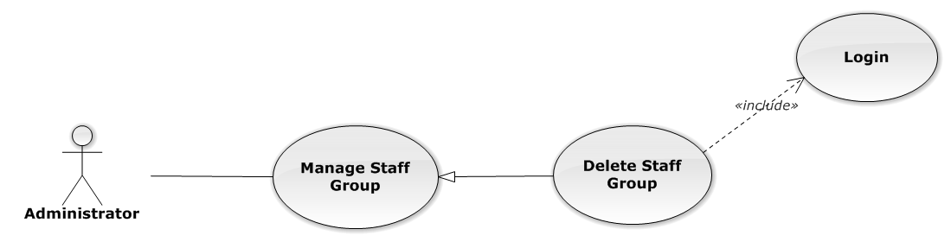

**Figure 3-71: Delete Staff Group Use-Case Diagram**

###### Use-Case Specification

|  |  |  |  |
| --- | --- | --- | --- |
| USE CASE SPECIFICATION | | | |
| Use-case No. | UC0057 | Use-case Version | 1.0 |
| Use-case Name | Delete Staff Group | | |
| Author | Đặng Nguyễn Khiêm | | |
| Date | 09/10/2014 | Priority | Normal |
| Actor:  Administrator.  Summary:  Administrator can delete staff group.  **Goal:**  Helps Administrator delete staff group if it didn’t use in Staff manager and save to database system.  Triggers:  Administrator goes to “Quản lí nhóm nhân viên ”page click button “Xóa”. After that click on “Bỏ qua” or“Xác nhận” button to confirm delete staff group.  Preconditions:   * User has logged-in as Admin role. * The page is fully loaded   Post Conditions:  Success:  Delete staff group and save to database system, display message “Xóa nhóm nhân viên thành công!”  Failure:  Show message “Xóa nhóm nhân viên thất bại!","Nhóm nhân viên này hiện đang được sử dụng!”.  Main Success Scenario:   |  |  |  | | --- | --- | --- | | *Step* | *User* | *System* | | 1 | Supper admin click on “Xóa” button at “Quản lí nhóm nhân viên” screen. | Show Pop-up confirm “Bạn có muốn thực hiện thao tác này” with two button “Xác nhận” and “Bỏ qua” | | 2 | User click “Bỏ qua” button | Staff group not delete, comeback to “Chi tiết nhóm nhân viên” screen. | | 3 | User click “ Xác nhận” button  [Exception 1], [Exception 2] | Show message “Xóa nhóm nhân viên thành công!” |   Exceptions:   |  |  |  | | --- | --- | --- | | *#* | *User* | *System* | | 1 | Delete staff group fail because staff group is use. | Shows error message “Xóa nhóm nhân viên thất bại!","Nhóm nhân viên này hiện đang được sử dụng!” | | 2 | Delete staff group error because staff group is use. | Shows error message “Xóa nhóm nhân viên thất bại!", "Có lỗi xảy ra trong quá trình xóa nhóm nhân viên”. |   Relationships:  Manage Staff Group  Business Rules:  Only Staff with role=”Admin” can be use this function. | | | |

##### UC0058 - Search Staff Group

###### Use-Case Diagram

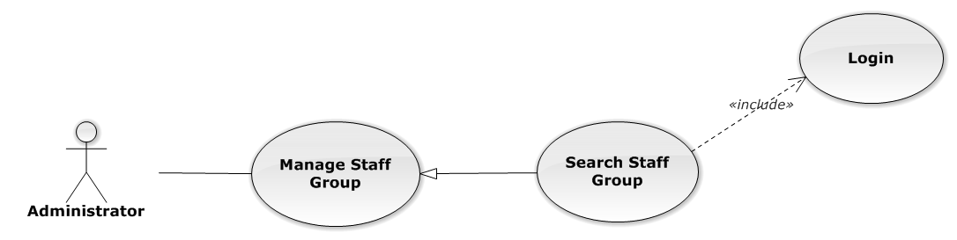

**Figure 3-72: Search Staff Group Use-Case Diagram**

###### Use-Case Specification

|  |  |  |  |
| --- | --- | --- | --- |
| USE CASE SPECIFICATION | | | |
| Use-case No. | UC0058 | Use-case Version | 1.0 |
| Use-case Name | Search Staff Group | | |
| Author | Đặng Nguyễn Khiêm | | |
| Date | 09/10/2014 | Priority | Normal |
| Actor:  Administrator.  Summary:  Administrator search staff in list of staff group.  **Goal:**  Helps Administrator search staff group.  Triggers:   * Administrator wants to search staff group. * Administrator goes to “Quản lý nhóm nhân viên” screen, input word into “Tìm Kiếm” textbox.   Preconditions:   * User has logged-in as Admin role. * The page is fully loaded   Post Conditions:  Success:  List of staff group map with word search is displayed.  Failure:  Do nothing  Main Success Scenario:   |  |  |  | | --- | --- | --- | | *Step* | *User* | *System* | | 1 | In “Quản lý nhóm nhân viên” screen, input key word at “Tìm kiếm” textbox. | List of staff group mapping with word search is display. |   Relationships:  Manage Staff Group  Business Rules:  Only Staff with role=”Admin” can be use this function. | | | |

#### Manage Staff

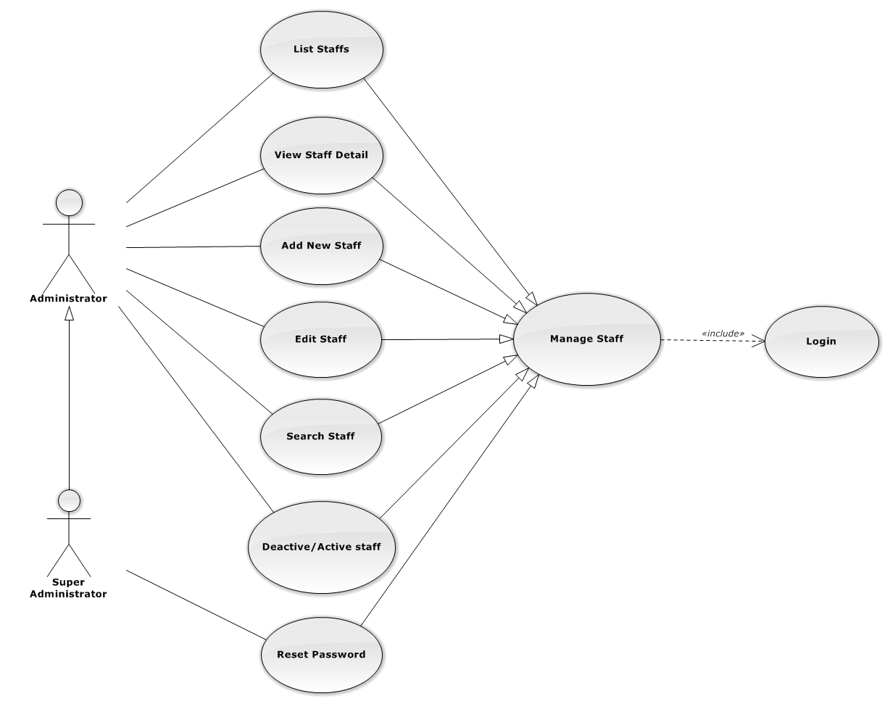

**Figure 3-73: Manage Staff Use-Case Diagram**

##### UC0059 - List Staffs

###### Use-Case Diagram

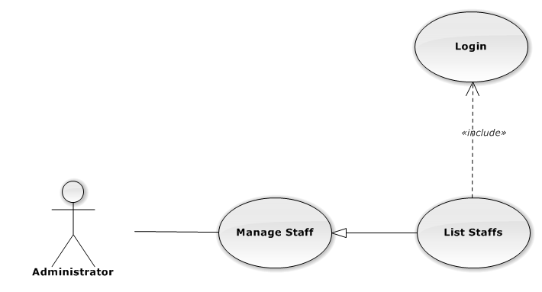

**Figure 3-74: List Staffs Use-Case Diagram**

###### Use-Case Specification

|  |  |  |  |
| --- | --- | --- | --- |
| USE-CASE SPECIFICATION | | | |
| Use-case No. | UC0059 | Use-case Version | 1.0 |
| Use-case Name | List Staffs | | |
| Author | Đặng Nguyễn Khiêm | | |
| Date | 09/10/2014 | Priority | Normal |
| Actor:  Administrator  Summary:  Redirect user to “Quản lí nhân viên” page and list all staff.  Goal:  To allowing Administrator view any detail information of all staff.  Triggers:  User click on User Control Panel and then click on “Quản lí nhân viên” link  Preconditions:   * Must be logged-in with “Admin” role. * The page is fully loaded   Post Conditions:  Success: System redirects user to “Quản lí nhân viên” page.  Failure: Do nothing.  Main Success Scenario:   |  |  |  | | --- | --- | --- | | *Step* | *User* | *System* | | 1 | Click on “Quản lí nhân viên” link | Redirect to “Quản lí nhân viên” page. Show all staff. |   Relationships:  Manage Staff  Business Rules:  Only Staff login with role “Admin” can be use this function. | | | |

##### UC0060 - View Staff Detail

###### Use-Case Diagram

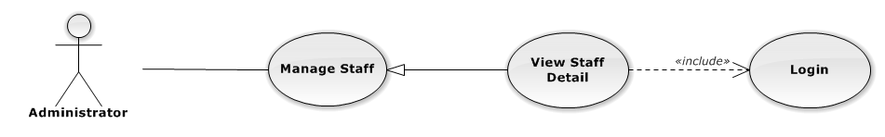

**Figure 3-75: View Staff Detail Use-Case Diagram**

###### Use-Case Specification

|  |  |  |  |
| --- | --- | --- | --- |
| USE-CASE SPECIFICATION | | | |
| Use-case No. | UC0060 | Use-case Version | 1.0 |
| Use-case Name | View Staff Detail | | |
| Author | Đặng Nguyễn Khiêm | | |
| Date | 09/10/2014 | Priority | Normal |
| Actor:  Administrator  Summary:  Administrator can view detail of staff information  Goal:  Helps Administrator view staff information  Triggers:   * On User Control Panel click on “Quản lí nhân viên**”,** * Click click on “Chi tiết” button * Click on image staff.   Preconditions:   * Must be logged-in with “Admin” role * The page is fully loaded   Post Conditions:  Success: The detail staff information is displayed  Failure: Do nothing  Main Success Scenario:   |  |  |  | | --- | --- | --- | | *Step* | *User* | *System* | | 1 | Staff click on “chi tiết” button or click on image link  [Alternative 1] ,[Alternative 2]  [Alternative 3] ,[Alternative 4] | The detail staff information is displayed. |   Alternative Scenario:   |  |  |  | | --- | --- | --- | | *#* | *User* | *System* | | 1 | Click on [X] button, “Đóng” button, or click out of modal | Modal popup is close | | 2 | If staff login with Id=”1”, Click on “Chỉnh sửa” button | Administrator can update information of office (ref 3.2.2.2.4. Update staff) | | 3 | If staff login with Id=”1”, Click on “Hoạt động lại” or “Ngừng hoạt động” link | Administrator can Deactivate/Activate staff (ref 3.2.2.2.5. Deactivate/Activate staff) | | 4 | If staff login with Id=”1”, Click on “Đặt lại mật khẩu” link | Administrator can reset password staff (ref 3.2.2.2.7. Reset Password staff) |   Relationships:  Manage Staff  Business Rules:  Only Staff login with role “Admin” can be use this function. | | | |

##### UC0061 - Add New Staff

###### Use-Case Diagram

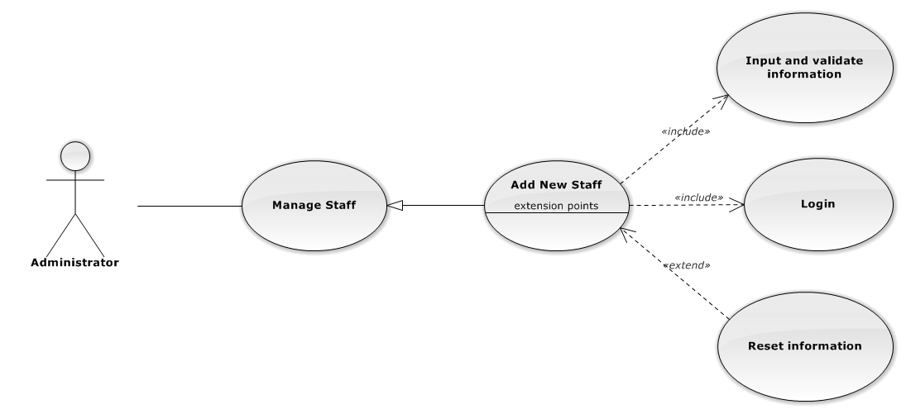

**Figure 3-76: Add New Staff Use-Case Diagram**

###### Use-Case Specification

|  |  |  |  |
| --- | --- | --- | --- |
| USE CASE SPECIFICATION | | | |
| Use-case No. | UC0061 | Use-case Version | 1.0 |
| Use-case Name | Add New Staff | | |
| Author | Đặng Nguyễn Khiêm | | |
| Date | 09/10/2014 | Priority | High |
| Actor:  Administrator.  Summary:  Administrator can insert new staff into the system.  **Goal:**  Add new staff.  Triggers:  At “Quản lí nhân viên” page, Administrator click on “Thêm nhân viên” button and fill information after that click button “Thêm mới” button.  Preconditions:   * User has logged-in as “Admin” role. * The page is fully loaded   Post Conditions:  Success:   * Add new case successful and message show “Thêm nhân viên thành công”. * Add current staff’s office to data system. * New staff’s status is “Đang hoạt động”. * Add current with username and default password is “123456” to data system.   Failure:  Show message “Thêm nhân viên thất bại, hãy kiểm tra lại kết nối database”.  Main Success Scenario:   |  |  |  | | --- | --- | --- | | *Step* | *User* | *System* | | 1 | Administrator click on “Thêm nhân viên” button at “Quản lí nhân viên” page. | Modal popup is displayed with fields for input information of new staff. | | 2 | Fill information into fields and click button “Thêm mới”  [Alternative 1]  [Exception 1], [Exception 2], [Exception 3], [Exception 4] | Modal popup is closed.  System display successful message “Thêm nhân viên thành công!”  Update list staff on page |   Alternative Scenario:   |  |  |  | | --- | --- | --- | | *#* | *User* | *System* | | 1 | Click “Làm trống” button | All input field reset to blank. |   Exceptions:   |  |  |  | | --- | --- | --- | | *#* | *User* | *System* | | 1 | Field “Tên nhân viên” are blank | Shows error message “Nhập tên nhân viên!”. | | Field “Tên đăng nhập”, are blank | Shows error message “Nhập vào tên đăng nhập!”. | | Field “Nhóm nhân viên” are blank | Shows error message “Chọn nhóm cho nhân viên!”. | | Field “Ngày sinh” are blank | Shows error message “Chọn ngày sinh của nhân viên!”. | | Field “Điện thoại di động” are blank | Shows error message “Nhập vào số điện thoại nhân viên!”. | | Field “Email” are blank | Shows error message “Hãy nhập Email của nhân viên!”. | | Input “Email” not follow the rule | Shows error message “Hãy nhập địa chỉ email đúng!”. | | Field “Địa chỉ liên hệ” are blank | Shows error message “Nhập địa chỉ của nhân viên!”. | | Field “Thuộc văn phòng ” are blank | Shows error message “Chọn một văn phòng!”. | | Field “Vai trò nhân viên” are blank | Shows error message “Chọn vai trò cho nhân viên!”. | | Field “CMND” are blank | Shows error message “Nhập vào số chứng minh nhân dân!”. | | Field “Ngày cấp CMND” are blank | Shows error message “Chọn ngày cấp chứng minh nhân dân!“. | | Field “Nơi cấp CMND” are blank | Shows error message “Nhập vào nơi cấp chứng minh nhân dân!”. | | Input “Tên đăng nhập” not follow the rule | Shows error message “Tên đăng nhập không được chứa ký tự đặc biệt!”. | | 2 | Input “Tên đăng nhập” is existed in Database | Shows error message “Tên đăng nhập nhân viên đã tồn tại!”. | | 3 | System cannot insert staff to data base. | Shows error message “Tạo nhân viên thất bại!” | | 4 | System error insert staff to data base. | Shows error message “Tạo nhân viên thất bại!", "Hãy kiểm tra lại kết nối database!”. |   Relationships:  Manage Staff.  Manage Staff Group  Business Rules:  Only Staff login with role “Admin” can be use this function. | | | |

##### UC0062 - Edit Staff

###### Use-Case Diagram

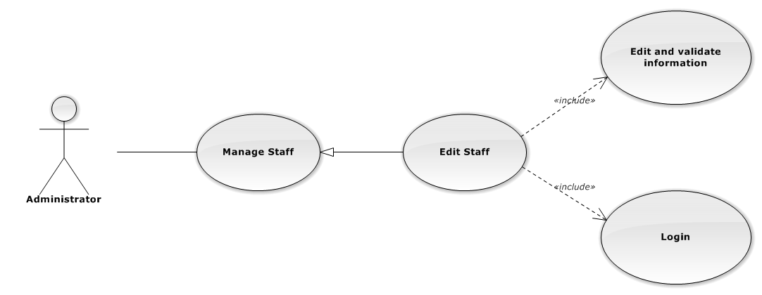

**Figure 3-77: Edit Staff Use-Case Diagram**

###### Use-Case Specification

|  |  |  |  |
| --- | --- | --- | --- |
| USE CASE SPECIFICATION | | | |
| Use-case No. | UC0062 | Use-case Version | 1.0 |
| Use-case Name | Edit Staff | | |
| Author | Đặng Nguyễn Khiêm | | |
| Date | 09/10/2014 | Priority | Normal |
| Actor:  Administrator.  Summary:  Administrator can update information of staff.  **Goal:**  Administrator can update information of staff and save to database system.  Triggers:   * Administrator goes to “Quản lý nhân viên” screen, click button “Chỉnh Sửa” button and modify information, after that click button “Lưu Chỉnh Sửa”. * Manager goes to “Chi tiết nhân viên” Popup screen, click on “Chỉnh Sửa” button and modify information, after that click button “Lưu Chỉnh Sửa”.   Preconditions:   * Logged-in as “Admin” role. * The page is fully loaded   Post Conditions:  Success:   * Information of Office is updated and saves to database * Message show “Cập nhật chi tiết nhân viên thành công” and display information after update on “Quản lý nhân viên” screen.   Failure:  Show message “Cập nhật chi tiết nhân viên thất bại!", "Hãy kiểm tra lại kết nối database.”  Main Success Scenario:   |  |  |  | | --- | --- | --- | | *Step* | *User* | *System* | | 1 | Manager click on “Chỉnh sửa” button at “Quản lí nhân viên” screen. | Modal popup is displayed with fields for detail information of new staff. | | 2 | Edit information into fields and click button “Lưu chỉnh sửa”  [Alternative 1]  [Exception 1], [Exception 2], [Exception 3] | Modal popup is close  System display successful message “Cập nhật chi tiết nhân viên thành công!”  Update list staff on page |   Alternative Scenario:   |  |  |  | | --- | --- | --- | | *#* | *User* | *System* | | 1 | Click on [X] button, “Đóng” button, or click out of modal | Modal popup is close |   Exceptions:   |  |  |  | | --- | --- | --- | | *#* | *User* | *System* | | 1 | Field “Tên nhân viên” are blank | Shows error message “Nhập tên nhân viên!”. | | Field “Tên đăng nhập”, are blank | Shows error message “Nhập vào tên đăng nhập!”. | | Field “Nhóm nhân viên” are blank | Shows error message “Chọn nhóm cho nhân viên!”. | | Field “Ngày sinh” are blank | Shows error message “Chọn ngày sinh của nhân viên!”. | | Field “Điện thoại di động” are blank | Shows error message “Nhập vào số điện thoại nhân viên!”. | | Field “Email” are blank | Shows error message “Hãy nhập Email của nhân viên!” | | Input “Email” not a regular expression | Shows error message “Hãy nhập địa chỉ email đúng!” | | Field “Địa chỉ liên hệ” are blank | Shows error message “Nhập địa chỉ của nhân viên!”. | | Field “Thuộc văn phòng ” are blank | Shows error message “Chọn một văn phòng!”. | | Field “Vai trò nhân viên” are blank | Shows error message “Chọn vai trò cho nhân viên!”. | | Field “CMND” are blank | Shows error message “Nhập vào số chứng minh nhân dân!” | | Field “Ngày cấp CMND” are blank | Shows error message “Chọn ngày cấp chứng minh nhân dân!” | | Field “Nơi cấp CMND” are blank | Shows error message “Nhập vào nơi cấp chứng minh nhân dân!” | | 2 | System cannot insert staff to data base. | Shows error message “Cập nhật chi tiết nhân viên thất bại!” | | 3 | System error insert staff to data base. | Shows error message “Cập nhật chi tiết nhân viên thất bại!", "Hãy kiểm tra lại kết nối database!” |   Relationships:  Manage Staff  Business Rules:  Only Staff login with role “Admin” can be use this function. | | | |

##### UC0063 - Deactivate/Activate staff

###### Use-CaseDiagram

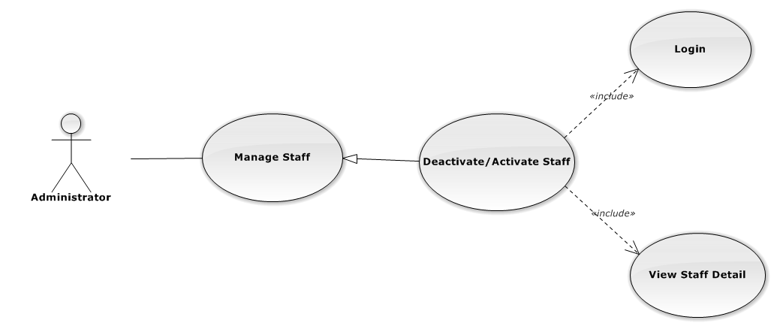

**Figure 3-78: Deactivate/Activate Staff Use-Case Diagram**

###### Use-Case Specification

|  |  |  |  |
| --- | --- | --- | --- |
| USE CASE SPECIFICATION | | | |
| Use-case No. | UC0063 | Use-case Version | 1.0 |
| Use-case Name | Deactivate/Activate staff | | |
| Author | Đặng Nguyễn Khiêm | | |
| Date | 09/10/2014 | Priority | Normal |
| Actor:  Administrator.  Summary:  Administrator can change status of Staff.  **Goal:**  Helps Administrator update Status of staff and save to database system.  Triggers:  Administrator goes “Chi tiết nhân viên” Pop-Up screen , Click button “Ngừng hoạt động” or “Hoạt động lại”. After that click on “Bỏ qua” or “Xác nhận” button to confirm change status Staff.  Preconditions:   * Logged-in as “Admin” role * The page is fully loaded   Post Conditions:  Success:  Information of Staff is updated and saves to database, message show “[…] đã hoạt động lại!” or “[…] đã ngừng hoạt động!” and display information after update on “Quản lý nhân viên” screen.  Failure:  Show message “Thay đổi hoạt động nhân viên thất bại!", "Hãy kiểm tra lại kết nối database”.  Main Success Scenario:   |  |  |  | | --- | --- | --- | | *Step* | *User* | *System* | | 1 | Supper admin click on “Chỉnh sửa” button at “Quản lí nhân viên” screen. | Show “Chi tiết nhân viên” Pop-up information. | | 2 | On “Chi tiết văn phòng” Pop-up click button “Ngừng hoạt động ” if Staff have status “Đang hoạt động” or Click button “Hoạt động lại” if staff have status "Ngừng hoạt động”.  [Alternative 1] | Display message box confirm “Bạn có muốn thực hiện thao tác này” with two button “Xác nhận” and “Bỏ qua” | | 3 | User click “Bỏ qua” button | Status of staff not change comeback to “Chi tiết nhân viên” Pop-up screen. | | 4 | User click “ Xác nhận” button  [Exception 1] ,[Exception 2] | Status of staff is change and comeback to “Quản lí nhân viên”screen |   Alternative Scenario:  Alternative:   |  |  |  | | --- | --- | --- | | *#* | *User* | *System* | | 1 | Click on [X] button, “Đóng” button, or click out of modal | Modal popup is close |   Exceptions:   |  |  |  | | --- | --- | --- | | *#* | *User* | *System* | | 1 | System fail change status of staff | Shows error message “Thay đổi hoạt động nhân viên thất bại!", "Có lỗi xảy ra trong quá trình xóa nhân viên.”. | | 2 | System error change status of staff. | Shows error message “Thay đổi hoạt động nhân viên thất bại!", "Hãy kiểm tra lại kết nối database”. |   Relationships:  Manage Staff  Business Rules:  Only Staff login with role “Admin” can be use this function. | | | |

##### UC0064 - Search Staff

###### Use-Case Diagram

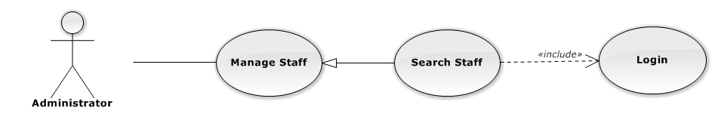

**Figure 3-79: Search Staff Use-Case Diagram**

###### Use-Case Specification

|  |  |  |  |
| --- | --- | --- | --- |
| USE CASE SPECIFICATION | | | |
| Use-case No. | UC0064 | Use-case Version | 1.0 |
| Use-case Name | Search Staff | | |
| Author | Đặng Nguyễn Khiêm | | |
| Date | 09/10/2014 | Priority | Normal |
| Actor:  Administrator.  Summary:  Administrator search staff in list of staff  **Goal:**  Helps Administrator search staff.  Triggers:   * Administrator wants to search staff. * Administrator input key word is StaffName. When the key up, system will be automatic search.   Preconditions:   * Logged-in as “Admin” role. * The page is fully loaded   Post Conditions:  Success: List of staff map with word search is displayed.  Failure: Do nothing.  Main Success Scenario:   |  |  |  | | --- | --- | --- | | *Step* | *User* | *System* | | 1 | In “Quản lý nhân viên” screen, input key word at “Tìm kiếm” textbox. | List of staff mapping with word search is display. |   Relationships:  Manage Staff  Business Rules:  Only Staff with role=”Admin” can be use this function. | | | |

##### UC0065 - Reset Password

###### Use-Case Diagram

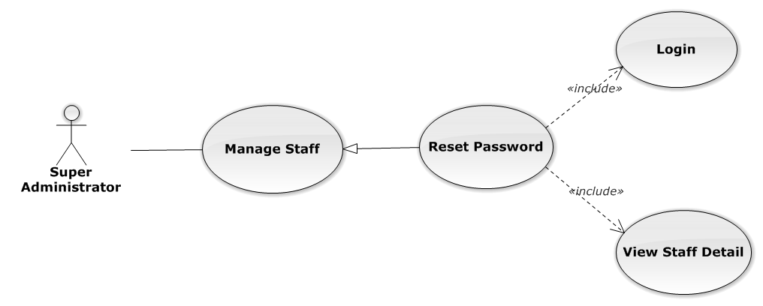

**Figure 3-80: Reset Password Use-Case Diagram**

###### Use-Case Specification

|  |  |  |  |
| --- | --- | --- | --- |
| USE CASE SPECIFICATION | | | |
| Use-case No. | UC0065 | Use-case Version | 1.0 |
| Use-case Name | Reset Password | | |
| Author | Đặng Nguyễn Khiêm | | |
| Date | 09/10/2014 | Priority | Normal |
| Actor:  Supper Administrator.  Summary:  Supper Administrator can reset password of all staff to default.  **Goal:**  Helps Supper Administrator reset password to default is “123456”.  Triggers:  Supper Supper Administrator wants to reset password staff.  Supper Administrator goes to “Staff detail” screen, and click to button “Đặt lại mật khẩu”  Preconditions:   * Logged-in to system. * The page is fully loaded   Post Conditions:  Success: Default password “123456” is save to database, message show “Khôi phục mật khẩu thành công  Failure:   * The user is presented with an error message on screen. * Show message “Khôi phục mật mật khẩu thất bại!”.   Main Success Scenario:   |  |  |  | | --- | --- | --- | | *Step* | *User* | *System* | | 1 | Supper admin click on “Chi tiết” button at “Quản lí nhân viên” screen. | Show “Chi tiết nhân viên” Pop-up information. | | 2 | On “Chi tiết văn phòng” Pop-up click button “Đặt lại mật khẩu”  [Alternative 1] | Display message box confirm “Bạn muốn khôi phục mật khẩu nhân viên này về mặc định?” with two button “Xác nhận” and “Bỏ qua” | | 3 | User click “Bỏ qua” button | Password of staff not change comeback to “Chi tiết nhân viên” Pop-up screen. | | 4 | User click “ Xác nhận” button  [Exception 1], [Exception 2] | Password of staff is reset to default “123456” and comeback to “Quản lí nhân viên” screen |   Alternative Scenario:   |  |  |  | | --- | --- | --- | | *#* | *User* | *System* | | 1 | Click on [X] button, “Đóng” button, or click out of modal | Modal popup is close |   Exceptions:   |  |  |  | | --- | --- | --- | | *#* | *User* | *System* | | 1 | System cannot reset password staff. | Shows error message “Khôi phục mật mật khẩu thất bại!” | | 2 | System fail reset password staff. | Shows error message “"Khôi phục mật khẩu thất bại", "Hãy kiểm tra lại kết nối database.”. |   Relationships:  Manage Staff  Business Rules:  Only Staff with id=”1” (Super Administrator) can be use this function. | | | |

#### Manage Service Type

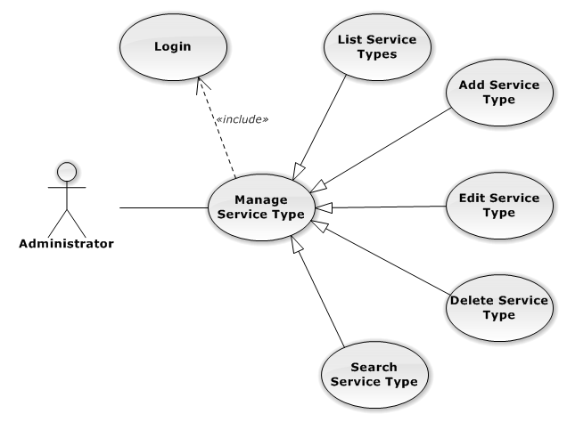

**Figure 3-81: Manage Service Type Use-Case Diagram**

##### UC0066 - List Service Types

###### Use-Case Diagram

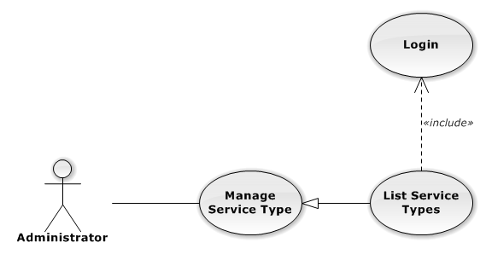

**Figure 3-82: List Service Types Use-Case Diagram**

###### Use-Case Specification

|  |  |  |  |
| --- | --- | --- | --- |
| USE CASE SPECIFICATION | | | |
| Use-case No. | UC0066 | Use-case Version | 1.0 |
| Use-case Name | List Service Types | | |
| Author | Trần Anh Tuấn | | |
| Date | 09/10/2014 | Priority | Normal |
| Actor:  Administrator  Summary:  List All Service Type.  Goal:  The purpose of List Service Type use case is allowing Admin to view all Services Type.  Triggers:  User choose “Quản lý Loại Dịch Vụ” in menu.  Preconditions:  User is authenticated and has role “admin”.  The page is fully loaded.  Post Conditions:  Success: All Services Type is listed.  Failure: Do nothing.  Main Success Scenario:   |  |  |  | | --- | --- | --- | | *Step* | *User* | *System* | | 1 | Click “Quản lý Loại Dịch Vụ” in menu. | All Service Types are loaded. |   Relationships:  Manage Service Type | | | |

##### UC0067 - Add New Service Type

###### Use-Case Diagram

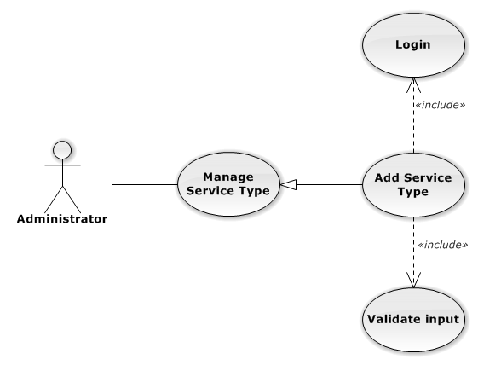

**Figure 3-83: Add New Service Type Use-Case Diagram**

###### Use-Case Specification

|  |  |  |  |
| --- | --- | --- | --- |
| USE CASE SPECIFICATION | | | |
| Use-case No. | UC0067 | Use-case Version | 1.0 |
| Use-case Name | Add New Service Type | | |
| Author | Trần Anh Tuấn | | |
| Date | 09/10/2014 | Priority | Normal |
| Actor:  Administrator  Summary:  Add Service Type.  Goal:  The purpose of Add Service Type use case is allowing Admin to add Service Type.  Triggers:  User choose “Quản lý Nhóm Dịch Vụ” in menu. Then click “Thêm loại dịch vụ” button.  Preconditions:  User is authenticated and has role “admin”.  Post Conditions:  Success: New Service Type is created.  Failure: No Service Type is created and Error message will be showed.  Main Success Scenario:   |  |  |  | | --- | --- | --- | | *Step* | *User* | *System* | | 1 | Click “Thêm loại dịch vụ” button. | Show add Service type pop-up. | | 2 | Enters the Service Type Name and Description |  | | 3 | Presses “Thêm mới” button.  [Alternative: 1] | Checks validate, add new Service Type to database.  Show success message.  [Exception: 1]  [Exception: 2]  [Exception: 3] |   Alternative Scenario:   |  |  |  | | --- | --- | --- | | *#* | *User* | *System* | | 1 | Presses “Đóng”, “X” button or click outside pop-up. | The Add New Service Type pop-up is close. |   Exceptions:   |  |  |  | | --- | --- | --- | | *#* | *User* | *System* | | 1 | Service Type Name is missing. | Show error “Nhập tên loại dịch vụ” | | 2 | Add Service type fail. | The Add New Service Type is closed and display error message “Tạo loại dịch vụ thất bại!", "Hãy kiểm tra lại kết nối database." | | 1 | Add Service type error. | The Add New Service Type is closed and display error message "Tạo loại dịch vụ thất bại!", "Có lỗi xảy ra trong quá trình tạo loại dịch vụ." |   Relationships:  Manage Service Type | | | |

##### UC0068 - Edit Service Type

###### Use-Case Diagram

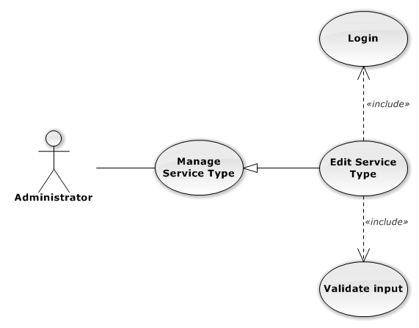

**Figure 3-84: Edit Service Type Use-Case Diagram**

###### Use-Case Specification

|  |  |  |  |
| --- | --- | --- | --- |
| USE CASE SPECIFICATION | | | |
| Use-case No. | UC0068 | Use-case Version | 1.0 |
| Use-case Name | Edit Service Type | | |
| Author | Trần Anh Tuấn | | |
| Date | 09/10/2014 | Priority | Normal |
| Actor:  Administrator  Summary:  Update Service Type.  Goal:  The purpose of Update Service Type use case is allowing Admin to update Service Type.  Triggers:  User choose “Quản lý Loại Dịch Vụ” in menu. Then click update icon.  Preconditions:  User is authenticated and has role “admin”.  Post Conditions:  Success: The Service Type is Updated.  Failure: The Service Type is not updated and Error message will be showed.  Main Success Scenario:   |  |  |  | | --- | --- | --- | | *Step* | *User* | *System* | | 1 | Click Update icon. | Show update Service type pop-up. | | 2 | Enters the new Service Type Name and Description |  | | 3 | Presses “Lưu chỉnh sửa” button.  [Alternative: 1] | Checks validate, update Service Type to database.  Show success message.  [Exception: 1]  [Exception: 2]  [Exception: 3] |   Alternative Scenario:   |  |  |  | | --- | --- | --- | | *#* | *User* | *System* | | 1 | Presses “Đóng”, “X” button or click outside pop-up. | The Update Service Type pop-up is close. |   Exceptions:   |  |  |  | | --- | --- | --- | | *#* | *User* | *System* | | 1 | Service Type Name is missing. | Show error “Nhập tên loại dịch vụ!” to user. | | 2 | Update Service type fail. | The Add New Service Type is closed and display error message “Chỉnh sửa loại dịch vụ thất bại!", "Hãy kiểm tra lại kết nối database." | | 3 | Update Service type error. | The Add New Service Type is closed and display error message "Chỉnh sửa loại dịch vụ thất bại!", "Có lỗi xảy ra trong quá trình tạo loại dịch vụ." |   Relationships:  Manage Service Type | | | |

##### UC0069 - Delete Service Type

###### Use-Case Diagram

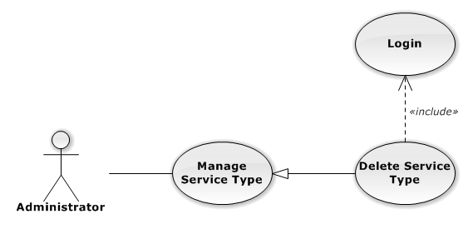

**Figure 3-85: Delete Service Type Use-Case Diagram**

###### Use-Case Specification

|  |  |  |  |
| --- | --- | --- | --- |
| USE CASE SPECIFICATION | | | |
| Use-case No. | UC0069 | Use-case Version | 1.0 |
| Use-case Name | Delete Service Type | | |
| Author | Trần Anh Tuấn | | |
| Date | 09/10/2014 | Priority | Normal |
| Actor:  Administrator  Summary:  Delete Service Type.  Goal:  The purpose of Delete Service Type use case is allowing Admin to delete Service Type.  Triggers:  User choose “Quản lý Dịch Vụ” in menu.  Preconditions:  User is authenticated and has role “admin”.  Post Conditions:  Success: The Service Type is deleted.  Failure: The Service Type is not delete and Error message will be showed.  Main Success Scenario:   |  |  |  | | --- | --- | --- | | *Step* | *User* | *System* | | 1 | Click Delete icon. | Show confirm pop-up | | 2 | Presses “Đồng ý” button.  [Alternative: 1] | Delete Service Type from database.  Show success message.  [Exception: 1]  [Exception: 2] |   Alternative Scenario:   |  |  |  | | --- | --- | --- | | *#* | *User* | *System* | | 1 | Presses “Hủy bỏ”, “X” button. | The confirm pop-up is close. |   Exceptions:   |  |  |  | | --- | --- | --- | | *#* | *User* | *System* | | 1 | Delete Service type fail. | The Add New Service Type is closed and display error message “Xóa loại dịch vụ thất bại!", "Hãy kiểm tra lại kết nối database." | | 2 | Delete Service type error. | The Add New Service is closed and display error message "Xóa loại dịch vụ thất bại!", "Có lỗi xảy ra trong quá xóa loại dịch vụ." |   Relationships:  Manage Service Type | | | |

##### UC0070 - Search Service Type

###### Use-Case Diagram

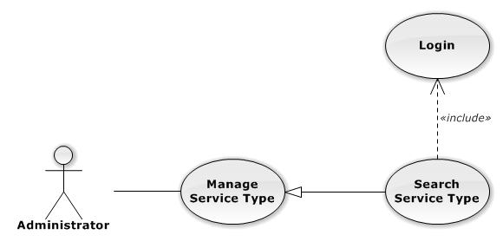

**Figure 3-86: Search Service Type Use-Case Diagram**

###### Use-Case Specification

|  |  |  |  |
| --- | --- | --- | --- |
| USE CASE SPECIFICATION | | | |
| Use-case No. | UC0070 | Use-case Version | 1.0 |
| Use-case Name | Search Service Type | | |
| Author | Trần Anh Tuấn | | |
| Date | 09/10/2014 | Priority | Normal |
| Actor:  Administrator  Summary:  Search Service Type.  Goal:  The purpose of Search Service Type use case is allowing Admin to search Service Type.  Triggers:  User choose “Quản lý Dịch Vụ” in menu.  Preconditions:  User is authenticated and has role “admin”.  Post Conditions:  Success: List of Service Type with search key words is displayed.  Failure: No record is displayed.  Main Success Scenario:   |  |  |  | | --- | --- | --- | | *Step* | *User* | *System* | | 1 | In “Quản lý loại dịch vụ” screen, input key word at “Tìm kiếm” textbox. | List of Service Type with search key words is displayed. |   Relationships:  Manage Service Type | | | |

#### Manage Service

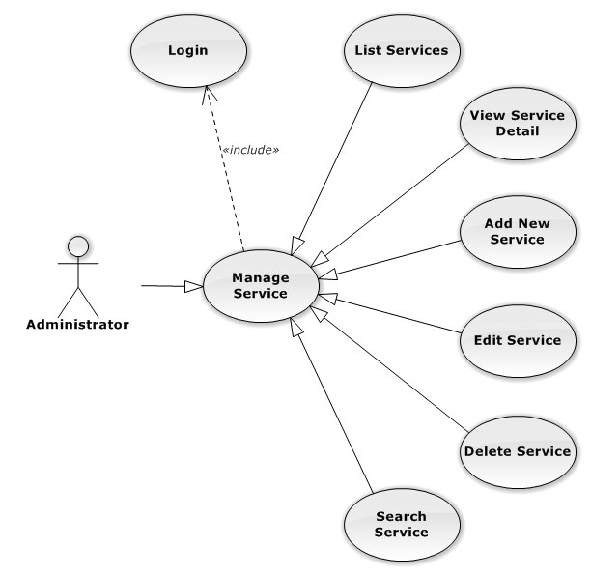

**Figure 3-87: Manage Service Use-Case Diagram**

##### UC0071 - List Services

###### Use-Case Diagram

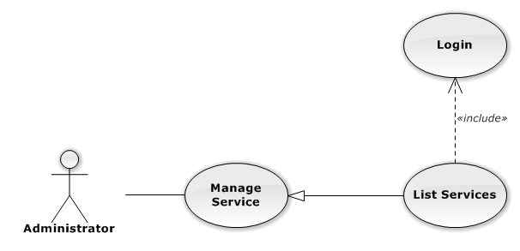

**Figure 3-88: List Services Use-Case Diagram**

###### Use-Case Specification

|  |  |  |  |
| --- | --- | --- | --- |
| USE CASE SPECIFICATION | | | |
| Use-case No. | UC0071 | Use-case Version | 1.0 |
| Use-case Name | List Services | | |
| Author | Trần Anh Tuấn | | |
| Date | 09/10/2014 | Priority | Normal |
| Actor:  Administrator  Summary:  List All Service.  Goal:  The purpose of List Service use case is allowing Admin to view all Services.  Triggers:  User choose “Quản lý Dịch Vụ” in menu.  Preconditions:  User is authenticated and has role “admin”.  The page is fully loaded.  Post Conditions:  Success: All Services is listed.  Failure: Do nothing.  Main Success Scenario:   |  |  |  | | --- | --- | --- | | *Step* | *User* | *System* | | 1 | Click “Quản lý Dịch Vụ” in menu. | All Services are loaded. |   Relationships:  Manage Service | | | |

##### UC0072 - View Service Detail

###### Use-Case Diagram

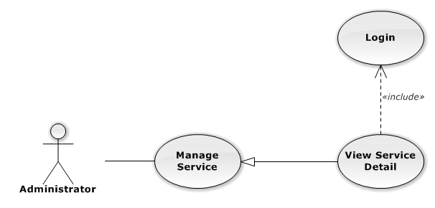

**Figure 3-89: View Service Detail Use-Case Diagram**

###### Use-Case Specification

|  |  |  |  |
| --- | --- | --- | --- |
| USE CASE SPECIFICATION | | | |
| Use-case No. | UC0072 | Use-case Version | 1.0 |
| Use-case Name | View Service Detail | | |
| Author | Trần Anh Tuấn | | |
| Date | 09/10/2014 | Priority | Normal |
| Actor:  Administrator  Summary:  View Service Detail.  Goal:  The purpose of View Service Detail use case is allowing Admin to view a Service detail.  Triggers:  User choose “Quản lý Dịch Vụ” in menu. Then click “View detail” icon.  Preconditions:  User is authenticated and has role “admin”.  Post Conditions:  Success: Service Detail is showed.  Failure: Do nothing.  Main Success Scenario:   |  |  |  | | --- | --- | --- | | *Step* | *User* | *System* | | 1 | In Manage Service page, click “View detail” icon | The Service Detail is showed. |   Relationships:  Manage Service | | | |

##### UC0073 - Add New Service

###### Use-Case Diagram

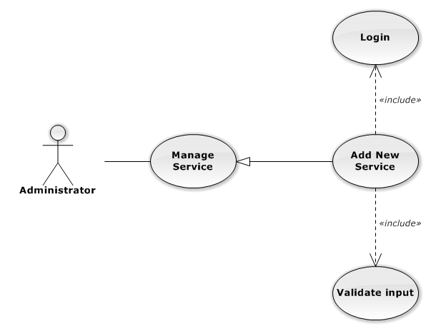

**Figure 3-90: Add New Service Use-Case Diagram**

###### Use-Case Specification

|  |  |  |  |
| --- | --- | --- | --- |
| USE CASE-n SPECIFICATION | | | |
| Use-case No. | UC0073 | Use-case Version | 1.0 |
| Use-case Name | Add New Service | | |
| Author | Trần Anh Tuấn | | |
| Date | 09/10/2014 | Priority | Normal |
| Actor:  Administrator  Summary:  Add new Service.  Goal:  The purpose of Add Service use case is allowing Admin to add new Service.  Triggers:  User choose “Quản lý Dịch Vụ” in menu. Then click “Thêm dịch vụ mới” button.  Preconditions:  User is authenticated and has role “admin”.  Post Conditions:  Success: New Service is created.  Failure: No Service is created and Error message will be showed.  Main Success Scenario:   |  |  |  | | --- | --- | --- | | *Step* | *User* | *System* | | 1 | Click “Thêm dịch vụ mới” button. | Show add Service pop-up. | | 2 | Enters the Service Name and Description |  | | 3 | Presses “Thêm mới” button.  [Alternative: 1] | Checks validate, add new Service to database.  Show success message.  [Exception: 1]  [Exception: 2]  [Exception: 3] |   Alternative Scenario:   |  |  |  | | --- | --- | --- | | *#* | *User* | *System* | | 1 | Presses “Đóng”, “X” button or click outside pop-up. | The Add New Service pop-up is close. |   Exceptions:   |  |  |  | | --- | --- | --- | | *#* | *User* | *System* | | 1 | Service Name is missing. | Show error “Nhập tên dịch vụ!” to user. | | Service Group is not chosen. | Show error “Chọn loại dịch vụ!” to user. | | 2 | Add Service fail. | The Add New Service is closed and display error message “Tạo dịch vụ thất bại!", "Hãy kiểm tra lại kết nối database." | | 3 | Add Service error. | The Add New Service is closed and display error message "Tạo dịch vụ thất bại!", "Có lỗi xảy ra trong quá trình tạo dịch vụ." |   Relationships:  Manage Service | | | |

##### UC0074 - Edit Service

###### Use-Case Diagram

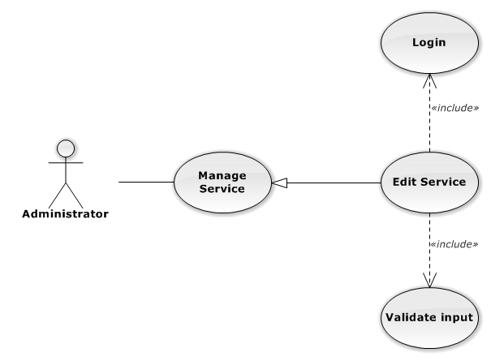

**Figure 3-91: Edit Service Use-Case Diagram**

###### Use-Case Specification

|  |  |  |  |
| --- | --- | --- | --- |
| USE CASE SPECIFICATION | | | |
| Use-case No. | UC0074 | Use-case Version | 1.0 |
| Use-case Name | Edit Service | | |
| Author | Trần Anh Tuấn | | |
| Date | 09/10/2014 | Priority | Normal |
| Actor:  Administrator  Summary:  Update Service.  Goal:  The purpose of Update Service use case is allowing Admin to update Service.  Triggers:  User choose “Quản lý Dịch Vụ” in menu. Then click update icon.  Preconditions:  User is authenticated and has role “admin”.  Post Conditions:  Success: The Service is Updated.  Failure: The Service is not updated and Error message will be showed.  Main Success Scenario:   |  |  |  | | --- | --- | --- | | *Step* | *User* | *System* | | 1 | Click Update icon. | Show update Service pop-up. | | 2 | Enters the new Service Name and Description |  | | 3 | Presses “Lưu chỉnh sửa” button.  [Alternative: 1] | Checks validate, update Service to database.  Show success message.  [Exception: 1]  [Exception: 2]  [Exception: 3] |   Alternative Scenario:   |  |  |  | | --- | --- | --- | | *#* | *User* | *System* | | 1 | Presses “Đóng”, “X” button or click outside pop-up. | The Update Service pop-up is close. |   Exceptions:   |  |  |  | | --- | --- | --- | | *#* | *User* | *System* | | 1 | Service Name is missing. | Show error “Nhập tên dịch vụ!” to user. | | 2 | Update Service fail. | The Add New Service is closed and display error message “Chỉnh sửa dịch vụ thất bại!", "Hãy kiểm tra lại kết nối database." | | 1 | Update Service error. | The Add New Service is closed and display error message "Chỉnh sửa dịch vụ thất bại!", "Có lỗi xảy ra trong quá trình chỉnh sửa dịch vụ." |   Relationships:  Manage Service | | | |

##### UC0075 - Delete Service

###### Use-Case Diagram

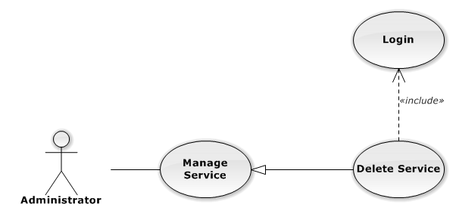

**Figure 3-92: Delete Service Use-Case Diagram**

###### Use-Case Specification

|  |  |  |  |
| --- | --- | --- | --- |
| USE CASE SPECIFICATION | | | |
| Use-case No. | UC0075 | Use-case Version | 1.0 |
| Use-case Name | Delete Service | | |
| Author | Trần Anh Tuấn | | |
| Date | 09/10/2014 | Priority | Normal |
| Actor:  Administrator  Summary:  Delete Service.  Goal:  The purpose of Delete Service use case is allowing Admin to delete Service.  Triggers:  User choose “Quản lý Dịch Vụ” in menu. Then click delete icon.  Preconditions:  User is authenticated and has role “admin”.  Post Conditions:  Success: The Service is deleted.  Failure: The Service is not delete and Error message will be showed.  Main Success Scenario:   |  |  |  | | --- | --- | --- | | *Step* | *User* | *System* | | 1 | Click Delete icon. | Show confirm pop-up | | 2 | Presses “Xác nhận” button.  [Alternative: 1] | Delete Service from database.  Show success message.  [Exception: 1]  [Exception: 2] |   Alternative Scenario:   |  |  |  | | --- | --- | --- | | *#* | *User* | *System* | | 1 | Presses “Bỏ qua” or “X” button. | The confirm pop-up is close. |   Exceptions:   |  |  |  | | --- | --- | --- | | *#* | *User* | *System* | | 1 | Delete Service fail. | The Add New Service is closed and display error message “Xóa dịch vụ thất bại!", "Hãy kiểm tra lại kết nối database." | | 2 | Delete Service error. | The Add New Service is closed and display error message "Xóa dịch vụ thất bại!", "Có lỗi xảy ra trong quá xóa dịch vụ." |   Relationships:  Manage Service | | | |

##### UC0076 - Search Service

###### Use-Case Diagram

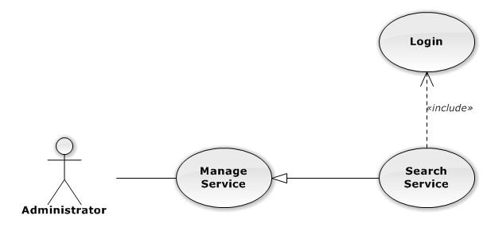

**Figure 3-93: Search Service Use-Case Diagram**

###### Use-Case Specification

|  |  |  |  |
| --- | --- | --- | --- |
| USE CASE SPECIFICATION | | | |
| Use-case No. | UC0076 | Use-case Version | 1.0 |
| Use-case Name | Search Service | | |
| Author | Trần Anh Tuấn | | |
| Date | 09/10/2014 | Priority | Normal |
| Actor:  Administrator  Summary:  Search Service.  Goal:  The purpose of Search Service use case is allowing Admin to search Service.  Triggers:  User choose “Quản lý Dịch Vụ” in menu.  Preconditions:  User is authenticated and has role “admin”.  Post Conditions:  Success: List of Service with search key words is displayed.  Failure: No record is displayed.  Main Success Scenario:   |  |  |  | | --- | --- | --- | | *Step* | *User* | *System* | | 1 | In “Quản lý dịch vụ” screen, input key word at “Tìm kiếm” textbox. | List of Service with search key words is displayed. |   Relationships:  Manage Service | | | |

#### Manage Office

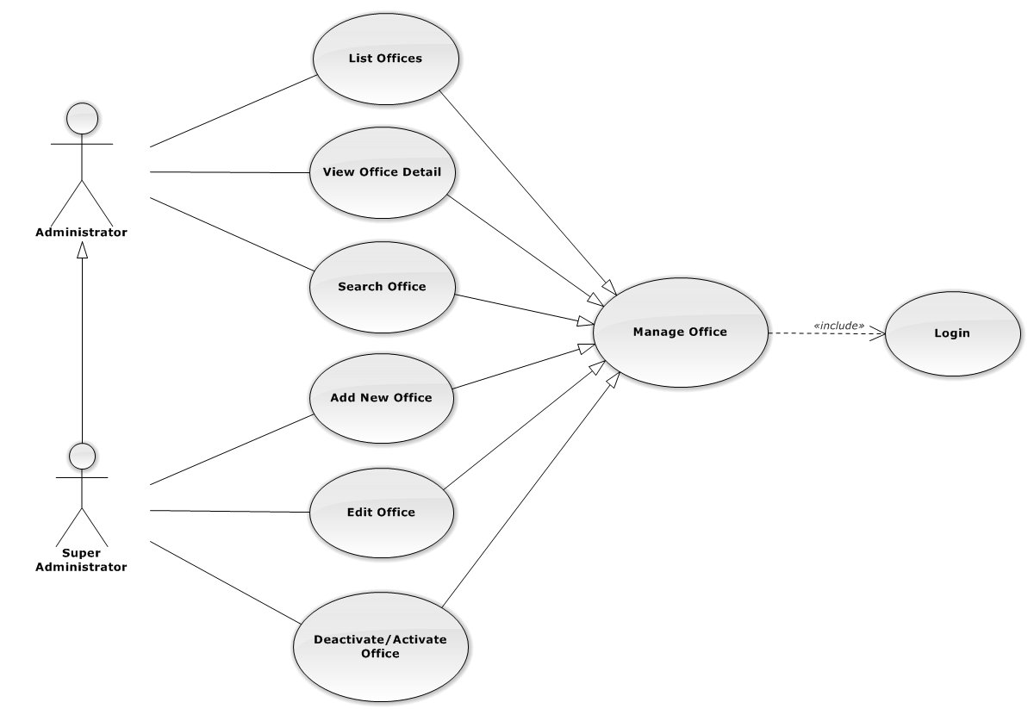

**Figure 3-94: Manage Office Use-Case Diagram**

##### UC0077 - List Offices

###### Use-Case Diagram

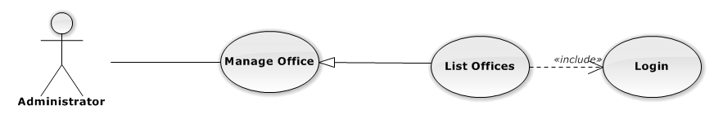

**Figure 3-95: List Offices Use-Case Diagram**

###### Use-Case Specification

|  |  |  |  |
| --- | --- | --- | --- |
| USE-CASE SPECIFICATION | | | |
| Use-case No. | UC0077 | Use-case Version | 1.0 |
| Use-case Name | List Offices | | |
| Author | Trần Anh Tuấn | | |
| Date | 09/10/2014 | Priority | Normal |
| Actor:  Administrator  Summary:  Redirect user to “Quản lí văn phòng” page and list all offfice.  Goal:  To allowing Administrator view any detail information of all Office.  Triggers:   * User click on User Control Panel and then click on “Quản lí văn phòng” link   Preconditions:   * Must be logged-in with “Admin” role. * The page is fully loaded   Post Conditions:  Success: System redirects user to “Quản lí văn phòng” page.  Failure: Do nothing.  Main Success Scenario:   |  |  |  | | --- | --- | --- | | *Step* | *User* | *System* | | 1 | Click on “Quản lí văn phòng” link | Redirect to “Quản lí văn phòng” page.Show all Office |   Relationships:  Management Office  Business Rules:  Only Staff with role =”Admin” can be use this function. | | | |

##### UC0078 - View Office Detail

###### Use-Case Diagram

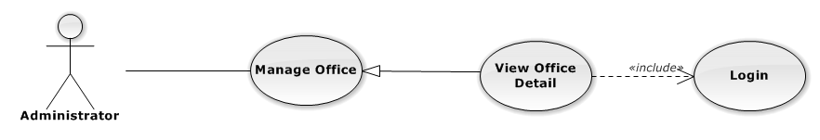

**Figure 3-96: View Office Detail Use-Case Diagram**

###### Use-Case Specification

|  |  |  |  |
| --- | --- | --- | --- |
| USE-CASE SPECIFICATION | | | |
| Use-case No. | UC0078 | Use-case Version | 1.0 |
| Use-case Name | View Office Detail | | |
| Author | Trần Anh Tuấn | | |
| Date | 09/10/2014 | Priority | Normal |
| Actor:  Administrator  Summary:  Staff can view detail of office information  Goal:  Helps staff to view offfice information  Triggers:   * On User Control Panel click on “Quản lí văn phòng**”,** * Click click on “Chi tiết” button * Click on name’s office link.   Preconditions:   * Must be logged-in * The page is fully loaded   Post Conditions:  Success: The detail offfice information is displayed  Failure: Do nothing  Main Success Scenario:   |  |  |  | | --- | --- | --- | | *Step* | *User* | *System* | | 1 | Staff click on “chi tiết” button or click on name’s offfce link  [Alternative 1], [Alternative 2], [Alternative 3] | The detail offfice information is displayed |   Alternative Scenario:   |  |  |  | | --- | --- | --- | | *#* | *User* | *System* | | 1 | Click on [X] button, “Đóng” button, or click out of modal | Modal popup is close | | 2 | If staff login with Id=”1”, Click on “Chỉnh sửa” button | Staff can update information of office (ref 3.2.2.2.4. Update office) | | 3 | If staff login with Id=”1”, Click on “Hoạt động lại” or “Ngừng hoạt động” link | Staff can Deactivate/Activate office (ref 3.2.2.2.5. Deactivate/Activate office) |   Relationships:  Management office.  Business Rules:  Only Staff login with role “Admin” can be use this function. | | | |

##### UC0079 - Add New Office

###### Use-Case Diagram

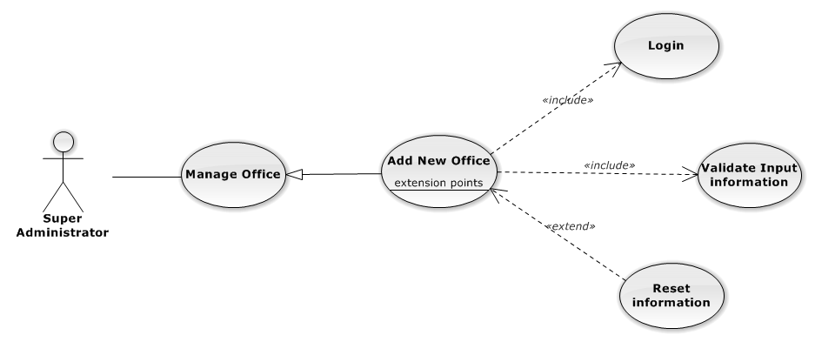

**Figure 3-97: Add New Office Use-Case Diagram**

###### Use-Case Specification

|  |  |  |  |
| --- | --- | --- | --- |
| USE CASE SPECIFICATION | | | |
| Use-case No. | UC0079 | Use-case Version | 1.0 |
| Use-case Name | Add New Office | | |
| Author | Trần Anh Tuấn | | |
| Date | 09/10/2014 | Priority | Normal |
| Actor:  Supper Administrator.  Summary:  Insert new office in the system.  **Goal:**  Add new office.  Triggers:  On User Control Panel click on “Quản lí nhân viên” link, at “Quản lí nhân viên” page click on “Thêm văn phòng” button.  Preconditions:   * Logged-in to system. * The page is fully loaded   Post Conditions:  Success:   * New office is inserted into database, message show “Thêm văn phòng thành công” and display on “Quản lí văn phòng” screen. * New office’s status is “Đang hoạt động”.   Failure:  Show error message “Thêm văn phòng thất bại, hãy kiểm tra lại kết nối database”.  Main Success Scenario:   |  |  |  | | --- | --- | --- | | *Step* | *User* | *System* | | 1 | Administrator click on “Thêm văn phòng” button at “Quản lí văn phòng”page. | Modal popup is displayed with fields for input information of new office. | | 2 | Fill information into fields and click button “Thêm mới”  [Alternative 1]  [Exception 2], [Exception 3] | Modal popup is close  System display successful message “Thêm văn phòng thành công!”  Update list office on page |   Alternative Scenario:   |  |  |  | | --- | --- | --- | | *#* | *User* | *System* | | 1 | Click “Làm trống” button | All input field reset to blank. |   Exceptions:   |  |  |  | | --- | --- | --- | | *Step* | *User* | *System* | | 1 | Field “Tên văn phòng” are blank | Shows error message “Nhập tên văn phòng!” | | Field “Địa chỉ văn phòng”, are blank | Shows error message “Nhập địa chỉ văn phòng!” | | Field “Người quản lí” are blank | Shows error message “Nhập tên người quản lí văn phòng!” | | Field “Ðiện thoại” are blank | Shows error message “Nhập số điện thoại văn phòng!” | | Field “Email” are blank | Shows error message “Hãy nhập Email của văn phòng!” | | Input “Email” not follow the rule | Shows error message “Hãy nhập địa chỉ email đúng!” | | 2 | System cannot insert office to data base. | Shows error message “Thêm văn phòng thất bại!” | | 3 | System error insert office to data base. | Shows error message “Thêm văn phòng thất bại!", "Hãy kiểm tra lại kết nối data base”. |   Relationships:  Manage Office  Business Rules:  Only Staff with id=”1” (Supper Administrator)can be use this function. | | | |

##### UC0080- Edit Office

###### Use-Case Diagram

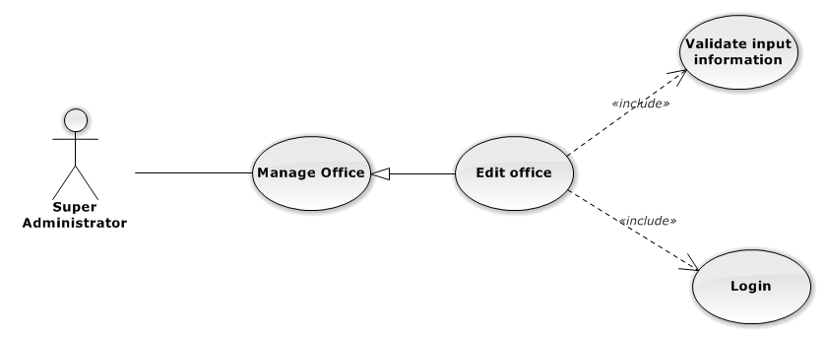

**Figure 3-98: Edit Office Use-Case Diagram**

###### Use-Case Specification

|  |  |  |  |
| --- | --- | --- | --- |
| USE CASE SPECIFICATION | | | |
| Use-case No. | UC0080 | Use-case Version | 1.0 |
| Use-case Name | Edit Office | | |
| Author | Trần Anh Tuấn | | |
| Date | 09/10/2014 | Priority | Normal |
| Actor:  Supper Administrator.  Summary:  Supper Administrator can update information of office.  **Goal:**  Helps Supper Administrator update information of office and save to database system.  Triggers:   * Supper Administrator goes to “Quản lý văn phòng” screen, click button “Chỉnh Sửa” and modify information, after that click button “Lưu Chỉnh Sửa”. * Supper Administrator goes to “Chi tiết nhân viên” Popup screen, click on “Chỉnh Sửa” button and modify information, after that click button “Lưu Chỉnh Sửa”.   Preconditions:   * Logged-in to system. * The page is fully loaded   Post Conditions:  Success:  Information of office is updated and saves to database, message show “Cập nhật chi tiết văn phòng thành công” and display information after update on “Quản lý văn phòng” screen.  Failure:  Show error message “Cập nhật chi tiết văn phòng thất bại!”  Main Success Scenario:   |  |  |  | | --- | --- | --- | | *Step* | *User* | *System* | | 1 | Administrator click on “Chỉnh sửa” button at “Quản lí văn phòng” screen. | Modal popup is displayed with fields for input information of new office. | | 2 | Edit information into fields and click button “Lưu chỉnh sửa”  [Alternative 1]  [Exception 1], [Exception 2], [Exception 3] | Modal popup is close  System display successful message “Cập nhật chi tiết văn phòng thành công!”  Update list office on page |   Alternative Scenario:   |  |  |  | | --- | --- | --- | | *#* | *User* | *System* | | 1 | Click on [X] button, “Đóng” button, or click out of modal | Modal popup is close. |   Exceptions:   |  |  |  | | --- | --- | --- | | *Step* | *User* | *System* | | 1 | Field “Tên văn phòng” are blank | Shows error message “Nhập tên văn phòng!” | | Field “Địa chỉ văn phòng”, are blank | Shows error message “Nhập địa chỉ văn phòng!” | | Field “Người quản lí” are blank | Shows error message “Nhập tên người quản lí văn phòng!” | | Field “Ðiện thoại” are blank | Shows error message “Nhập số điện thoại văn phòng!” | | Field “Email” are blank | Shows error message “Hãy nhập Email của văn phòng!” | | Input “Email” not follow the rule | Shows error message “Hãy nhập địa chỉ email đúng!” | | 2 | System cannot update office to data base. | Shows error message “Cập nhật chi tiết văn phòng thất bại!” | | 3 | System error update office to data base. | Shows error message “Cập nhật chi tiết văn phòng thất bại! ", "Hãy kiểm tra lại kết nối database”. |   Relationships:  Manage Office  Business Rules:  Only Staff with id=”1”( Supper Administrator) can be use this function. | | | |

##### UC0081 - Deactivate/Activate Office

###### Use-Case Diagram

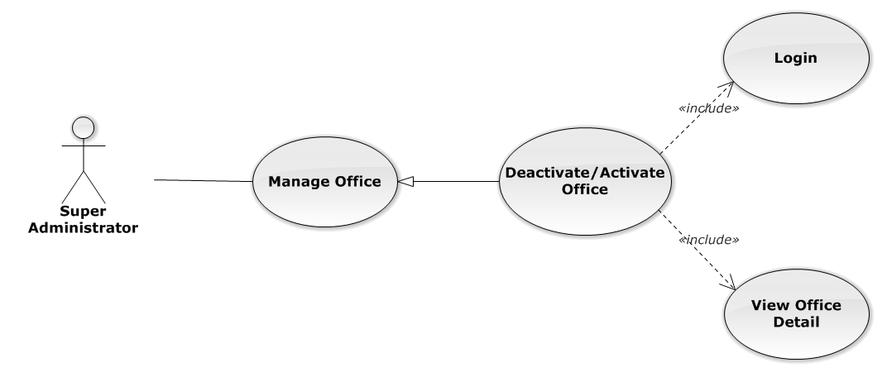

**Figure 3-99: Deactivate/Activate Office Use-Case Diagram**

###### Use-Case Specification

|  |  |  |  |
| --- | --- | --- | --- |
| USE CASE SPECIFICATION | | | |
| Use-case No. | UC0081 | Use-case Version | 1.0 |
| Use-case Name | Deactivate/Activate office | | |
| Author | Trần Anh Tuấn | | |
| Date | 09/10/2014 | Priority | Normal |
| Actor:  Supper Administrator.  Summary:  Supper Administrator can change status of Office to De active or Active.  **Goal:**  Helps Supper Administrator update Status of Office and save to database system.  Triggers:   * Supper Administrator wants to update Status of office. * Supper Administrator goes “Chi tiết văn phòng” screen Pop-Up, Click button “Ngừng hoạt động văn phòng” or “Hoạt động lại”. After that click on “Bỏ qua” or “Xác nhận” button to confirm change status Office.   Preconditions:   * Logged-in to system. * The page is fully loaded   Post Conditions:  Success:  Information of Office is updated and saves to database, message show “Văn phòng đã hoạt động lại!” or “Văn phòng đã ngừng hoạt động!” and display information after update on “Quản lý văn phòng” screen.  Failure:  Show error message “Chỉnh hoạt động văn phòng thất bại!  Main Success Scenario:   |  |  |  | | --- | --- | --- | | *Step* | *User* | *System* | | 1 | Administrator click on “Chỉnh sửa” button at “Quản lí văn phòng” screen. | Show “Chi tiết văn phòng” Pop-up information. | | 2 | On “Chi tiết văn phòng” Pop-up click button “Ngừng hoạt động văn phòng” if Office have status “Đang hoạt động” or Click button “Hoạt động lại” if Office have status "Ngừng hoạt động”.  [Alternative 1] | Display message box confirm “Bạn có muốn thực hiện thao tác này” with two button “Xác nhận” and “Bỏ qua” | | 3 | User click “Bỏ qua” button | Status of Office not change comeback to “Chi tiết văn phòng” Pop-up screen. | | 4 | User click “ Xác nhận” button  [Exception 1], [Exception 2] | Status of Office is change and comeback to “Quản lí văn phòng” screen |   Alternative Scenario:   |  |  |  | | --- | --- | --- | | *#* | *User* | *System* | | 1 | Click on [X] button, “Đóng” button, or click out of modal | Modal popup is close |   Exceptions:   |  |  |  | | --- | --- | --- | | *#* | *User* | *System* | | 1 | System error update status office to data base. | Shows error message “Chỉnh hoạt động văn phòng thất bại!", "Hãy kiểm tra lại kết nối database!”. | | 2 | System error update status office to data base. | Shows error message “Chỉnh hoạt động văn phòng thất bại!", "Có lỗi xảy ra trong quá trình xóa văn phòng!”. |   Relationships:  Manage Office  Business Rules:  Only Staff with id=”1”( Supper Administrator) can be use this function. | | | |

##### UC0082 - Search Office

###### Use-Case Diagram

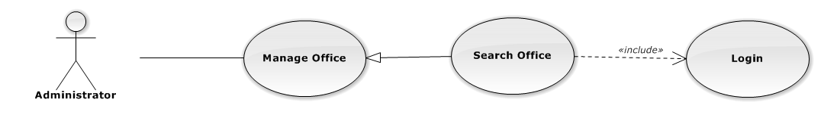

**Figure 3-100: Search Office Use-Case Diagram**

###### Use-Case Specification

|  |  |  |  |
| --- | --- | --- | --- |
| USE CASE SPECIFICATION | | | |
| Use-case No. | UC0082 | Use-case Version | 1.0 |
| Use-case Name | Search Office | | |
| Author | Trần Anh Tuấn | | |
| Date | 09/10/2014 | Priority | Normal |
| Actor:  Administrator.  Summary:  Administrator search Office in list of office  **Goal:**  Helps Administrator search Office.  Triggers:   * Manager wants to search office. * Manager goes to “Quản lý văn phòng” screen, input word into “Tìm Kiếm” textbox.   Preconditions:   * Logged-in as “Admin” role. * The page is fully loaded   Post Conditions:  Success: List of Office map with word search is displayed.  Failure: Do nothing  Main Success Scenario:   |  |  |  | | --- | --- | --- | | *Step* | *User* | *System* | | 1 | In “Quản lý văn phòng” screen, input key word at “Tìm kiếm” textbox. | List of office mapping with word search is display. |   Relationships:  Manage Office | | | |

#### Statistic

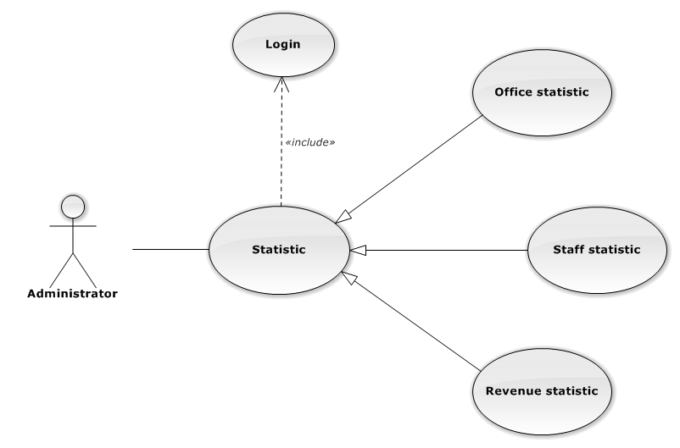

**Figure 3-101: Statistic Use-Case Diagram**

##### UC0083 - Office Statistic

###### Use-Case Diagram

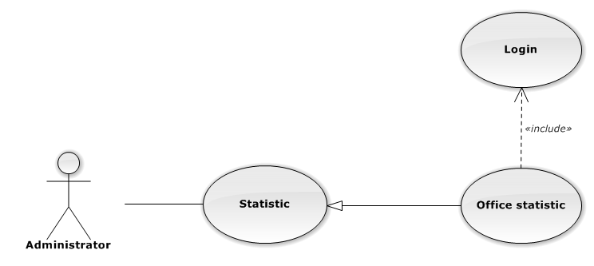

**Figure 3-102: Office Statistic Use-Case Diagram**

###### Use-Case Specification

|  |  |  |  |
| --- | --- | --- | --- |
| USE CASE SPECIFICATION | | | |
| Use-case No. | UC0083 | Use-case Version | 1.0 |
| Use-case Name | Office Statistic | | |
| Author | Đặng Nguyễn Khiêm | | |
| Date | 09/10/2014 | Priority | Normal |
| Actor:  Administrator.  Summary:  The statistic about office.  Goal:  The purpose of Office Statistic use case is allowing User to view Office index in graphs.  Triggers:  User choose “Thống kê” link in menu.  Preconditions:  User is authenticated.  Post Conditions:  Success: The graphs are showed.  Failure: N/A  Main Success Scenario:   |  |  |  | | --- | --- | --- | | *Step* | *User* | *System* | | 1 | Click “Văn phòng” tab in statistic page. | The graphs are loaded. |   Relationships:  Statistic | | | |

##### UC0084 - Staff Statistic

###### Use-Case Diagram

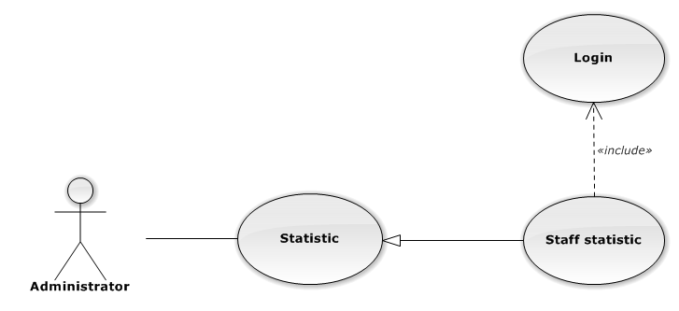

**Figure 3-103: Staff Statistic Use-Case Diagram**

###### Use-Case Specification

|  |  |  |  |
| --- | --- | --- | --- |
| USE CASE SPECIFICATION | | | |
| Use-case No. | UC0084 | Use-case Version | 1.0 |
| Use-case Name | Staff Statistic | | |
| Author | Đặng Nguyễn Khiêm | | |
| Date | 09/10/2014 | Priority | Normal |
| Actor:  Administrator.  Summary:  The statistic about staffs.  Goal:  The purpose of Staff Statistic use case is allowing User to view Staff index in graphs.  Triggers:  User choose “Thống kê” link in menu.  Preconditions:  User is authenticated.  Post Conditions:  Success: The graphs are showed.  Failure: N/A  Main Success Scenario:   |  |  |  | | --- | --- | --- | | *Step* | *User* | *System* | | 1 | Click “Nhân viên” tab in statistic page. | The graphs are loaded. |   Relationships:  Statistic | | | |

##### UC0085 - Revenue Statistic

###### Use-Case Diagram

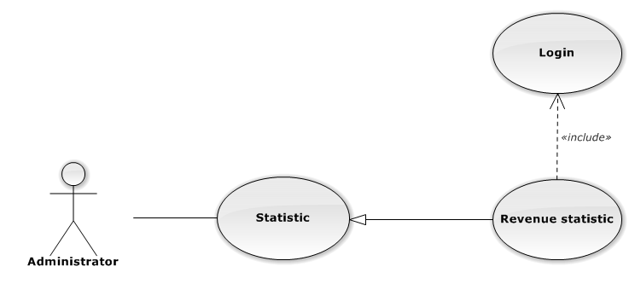

**Figure 3-104: Revenue Statistic Use-Case Diagram**

###### Use-Case Specification

|  |  |  |  |
| --- | --- | --- | --- |
| USE CASE SPECIFICATION | | | |
| Use-case No. | UC0085 | Use-case Version | 1.0 |
| Use-case Name | Revenue Statistic | | |
| Author | Đặng Nguyễn Khiêm | | |
| Date | 09/10/2014 | Priority | Normal |
| Actor:  Administrator.  Summary:  The statistic about revenue.  Goal:  The purpose of Revenue Statistic use case is allowing User to view Revenue index in graphs.  Triggers:  User choose “Thống kê” link in menu.  Preconditions:  User is authenticated.  Post Conditions:  Success: The graphs are showed.  Failure: N/A  Main Success Scenario:   |  |  |  | | --- | --- | --- | | *Step* | *User* | *System* | | 1 | Click “Doanh thu” tab in statistic page. | The graphs are loaded. |   Relationships:  Statistic | | | |

### Non-Functional Requirements

#### Reliability

The systems with high reliability, can be used like “always on” system. However, if exist accident, it's not need require immediate repair. All information and Cases can be updated later.

#### Availability

The system always responds to every user who got permission. The expected downtime for maintenance is about 5 minutes each time.

#### Security

Users must login for using the system. The user passwords are MD5 encrypted before being put into Database. Staff are restricted to view other user’s information and any function. Super Administrator has full permission to use the system.

#### Maintainability

Each component only perform specific functions so the modification of a component will not affect other components.

#### Portability

The system can be accessed anywhere with a web browser and Internet connection. It can be run on any browser, but recommend for user is Mozilla Firefox with highest version.

#### Performance

N/A

## Entity Relationship Diagram

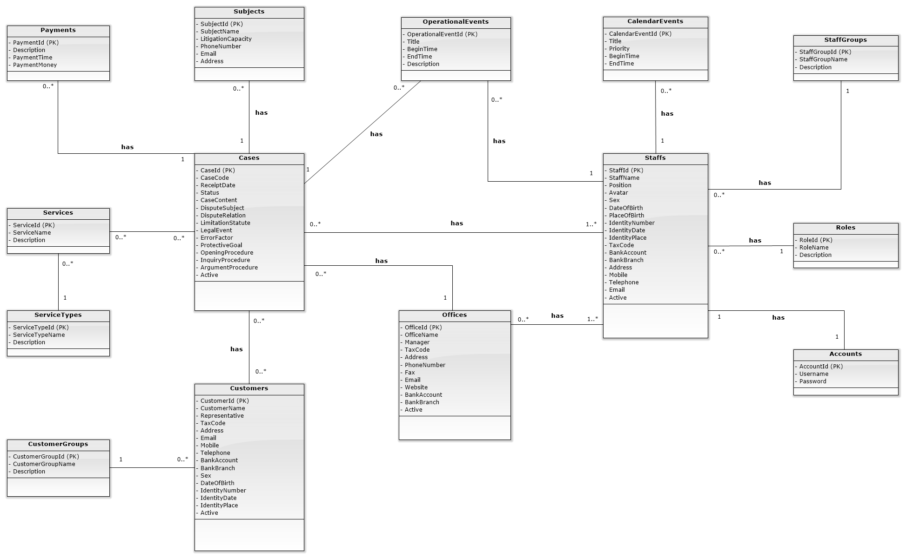

**Figure 3-105: Entity Relationship Diagram**

# Software Design Specification

## Design Overview

This document describes the detailed design for both architectural and user interface design of the Law Firm Management System. It includes the architectural design and the detailed design of common functions and business functions. It also includes the design of database model. Each section in this report will describe a perspective of the system specifically.

The architectural design describes the overall architecture of the system, and the architecture of each main component and subsystem. It will describe the patterns being used, the role of each component and the role of the system in the working environment, gives you an overview how the system is about to work.

The detailed design describes static and dynamic structure for each component and function. It includes class diagrams, class explanations, and sequence diagrams of the main use cases.

The database design describes the relationship between entities, and details of each entity.

The user interface design describes the layout of the system, and some design for the screens.

## System Architectural Design

### Choice of System Architecture

#### System Architecture



**Figure 4-1: System Architecture**

* Database: This is the central data storage for the system.
* Management site: This is the website to manage Case, Customer, Staff, Service, Office.

#### MVC Architecture

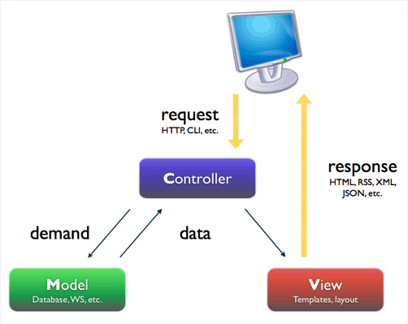

**Figure 4-2: MVC Architecture**

* Model: Functions that interact with the database or perform complex operations. In this architecture, model includes business logic and data access in one layer.
* View: The view displays the data and also takes input form user. It renders the model data into a form, such as graphics, buttons, and tables, and so on to display to the user.
* Controller: The controller handles all requests coming from the view or user interface. The data flows to whole application are controlled by controller.

### Discussion of Alternative Designs

### Description of System Interface

#### User Interfaces

* UI should be simple, model and easy to use.
* Support drag & drop easy for using Calendar Event.

#### Hardware Interfaces

The site should be deployed and available to a many devices can be use online.

* Server hardware: Support Windows hosting
* Client hardware: Can be desktop, laptop, smart phone, tablet,.. have internet connection

#### Software Interfaces

Run best on FireFox browser.

#### Communication Interfaces

The system using HTTP protocol to communicate between server and clients.

### Architectural Presentation

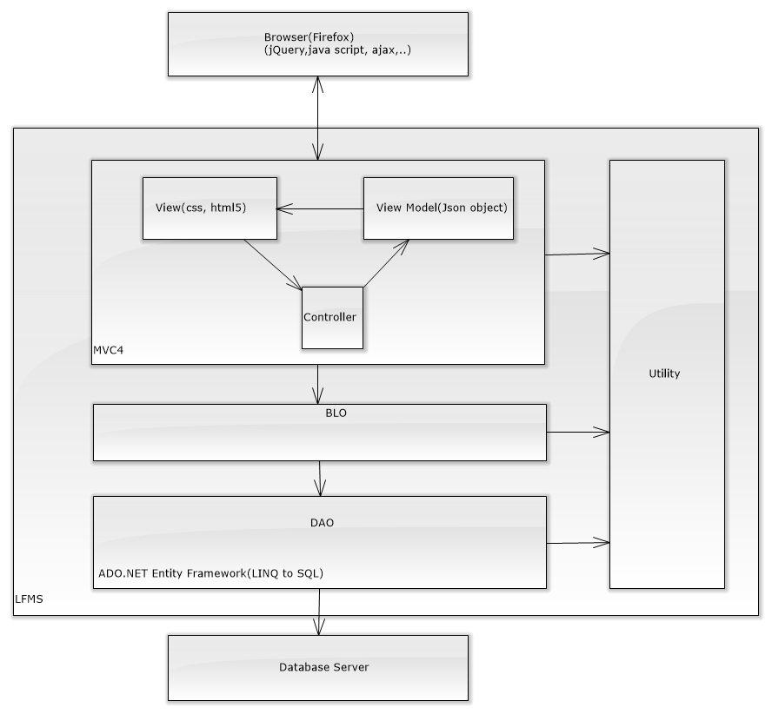

**Figure 4-3: System overview**

* The view knows how to display, and might allow users to edit the data from the Database Server
* The controller receives all the action from view or by system calling, the controller will send requet to business logic layer of system (BLO) and call to DAO from this. DAO is a layer will excute all query data to database. Finally, the controller will using Model (Json Object) and return it to view.
* Utility layer is used to parse data

### Package Diagram

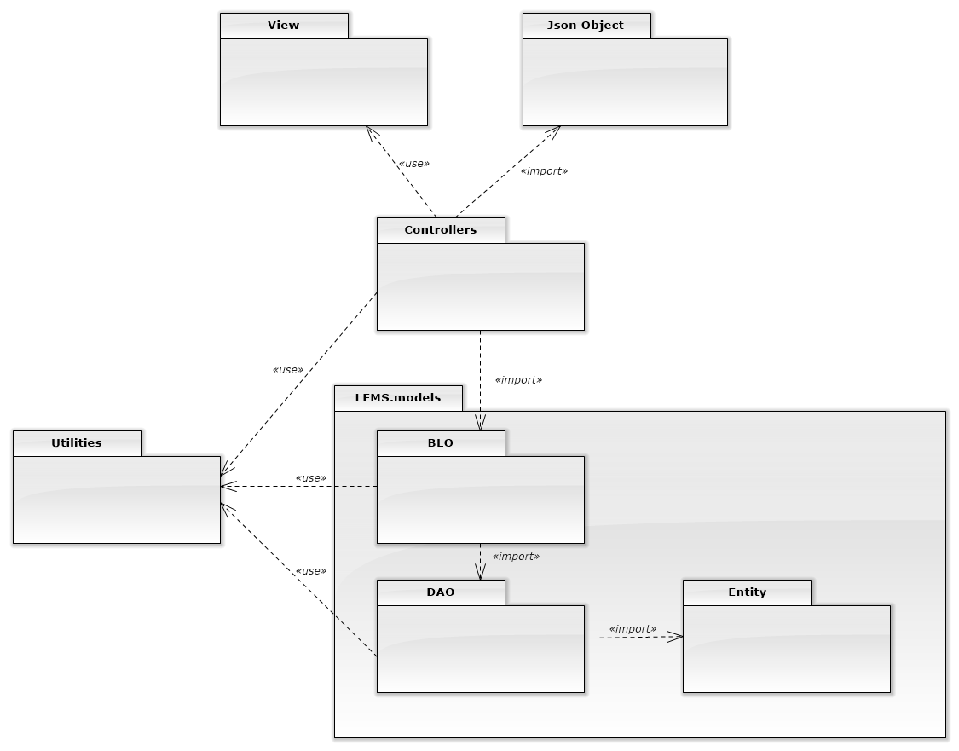

**Figure 4-4: Package Diagram**

## Detailed Design

### Data Model

#### Data Model Class Diagram

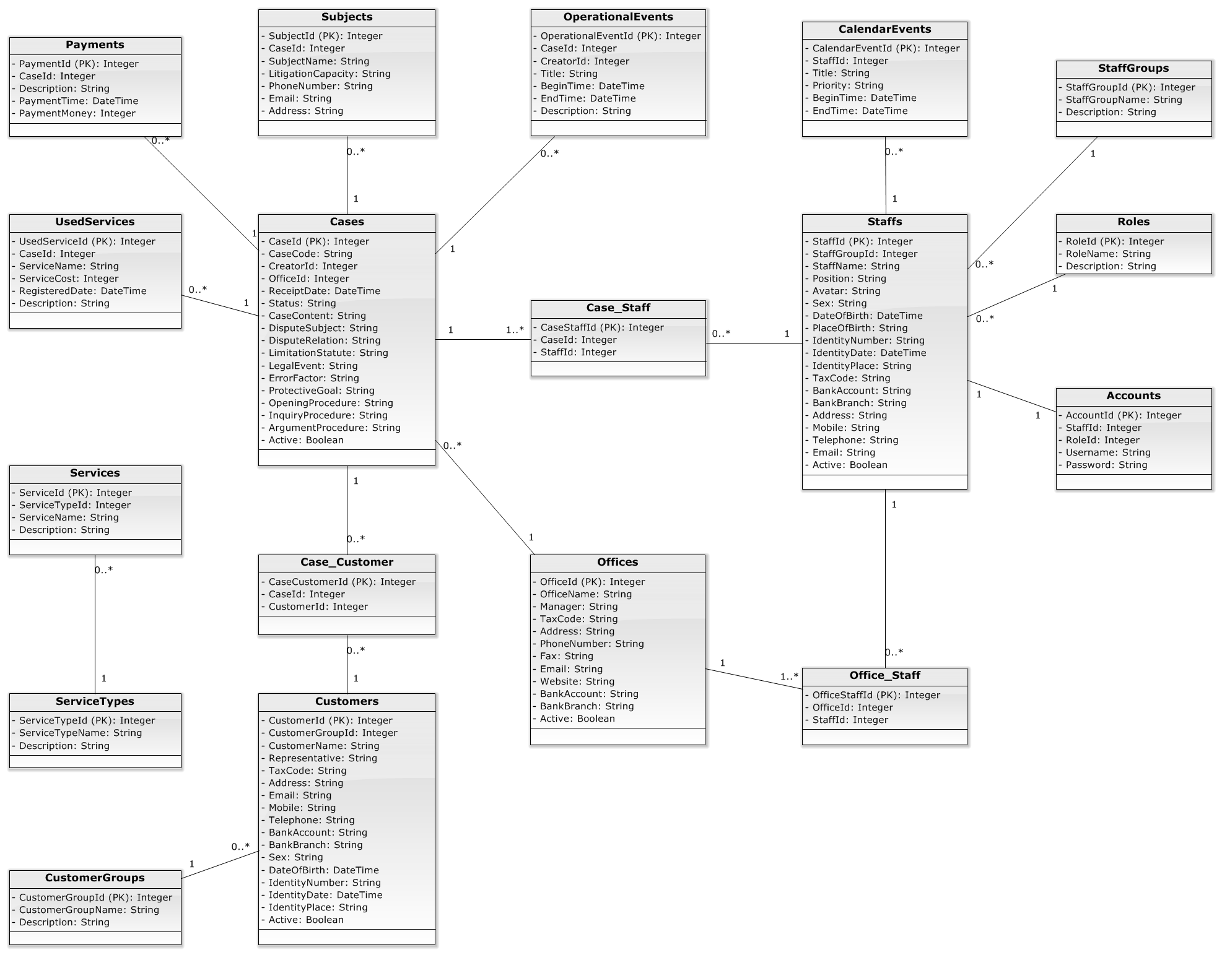

**Figure 4-5: Data Model Class Diagram**

### Controller

#### Controller Class Diagram

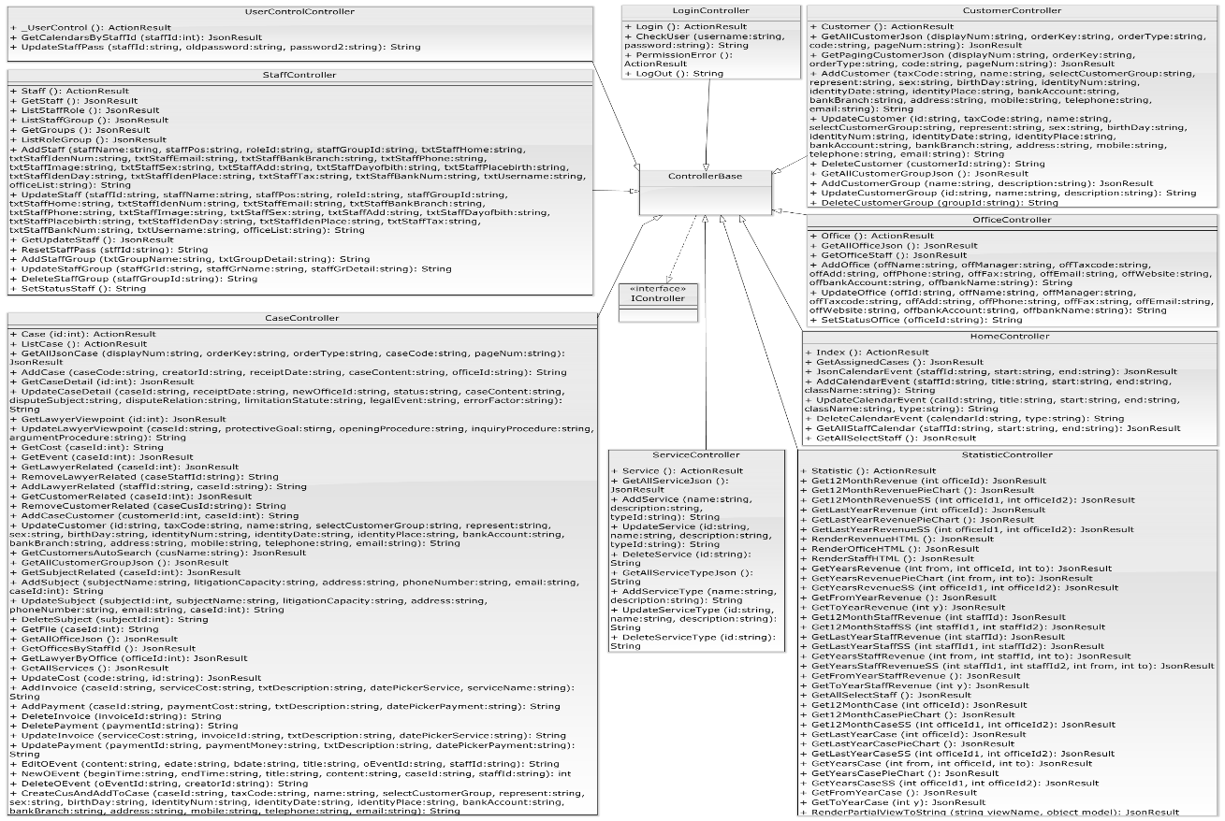

**Figure 4-6: Controller Class Diagram**

#### Controller Class Diagram Explanation

Reference to DVD: <root>/Documents/LFMS Project Document - Full Report.docx

### Business

#### Business Logic Class Diagram

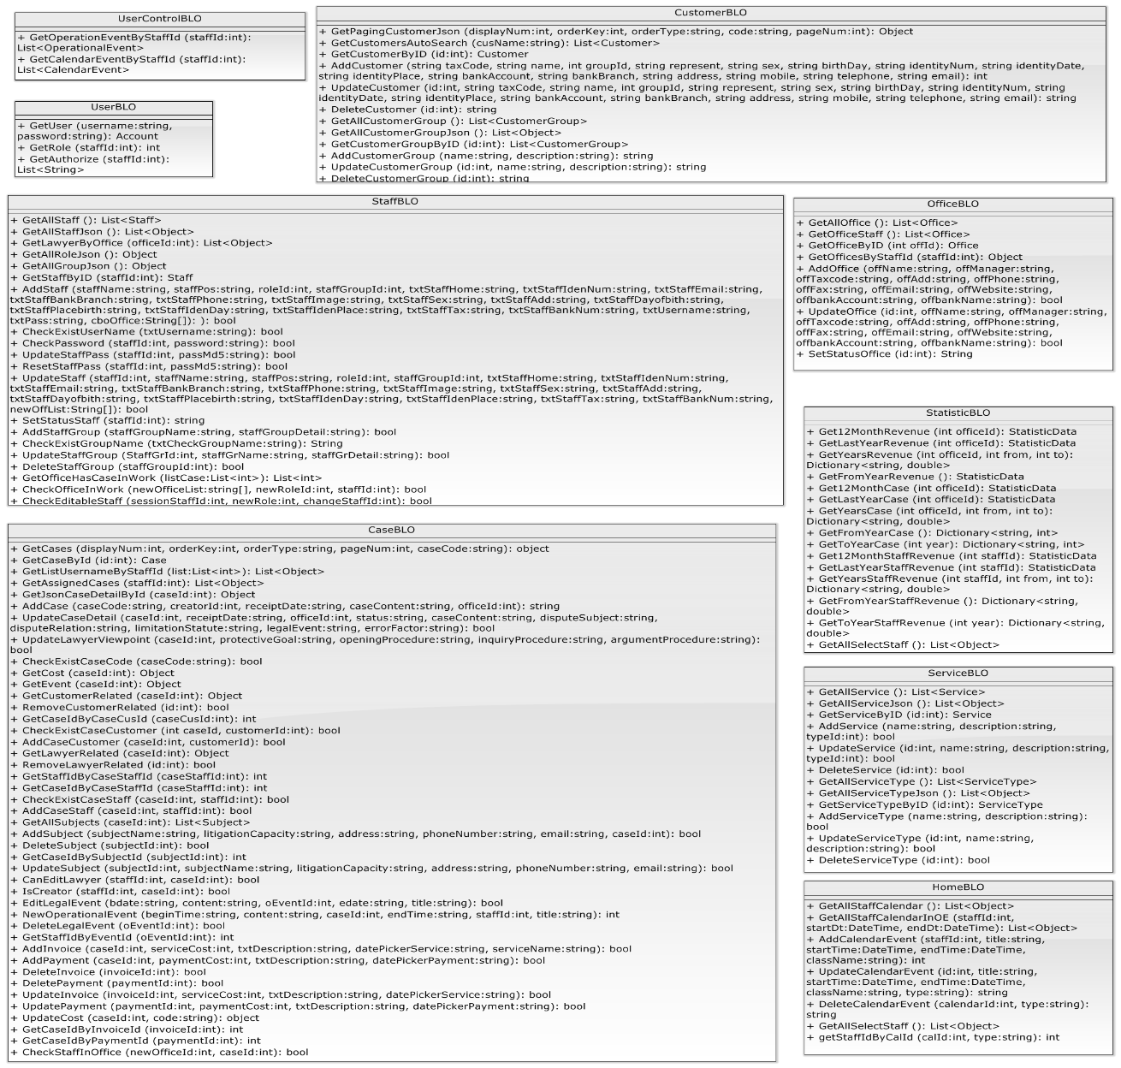

**Figure 4-7: Business Class Diagram**

#### Business Logic Class Diagram Explanation

Reference to DVD: <root>/Documents/LFMS Project Document - Full Report.docx

### Data Access

#### Data Access Class Diagram

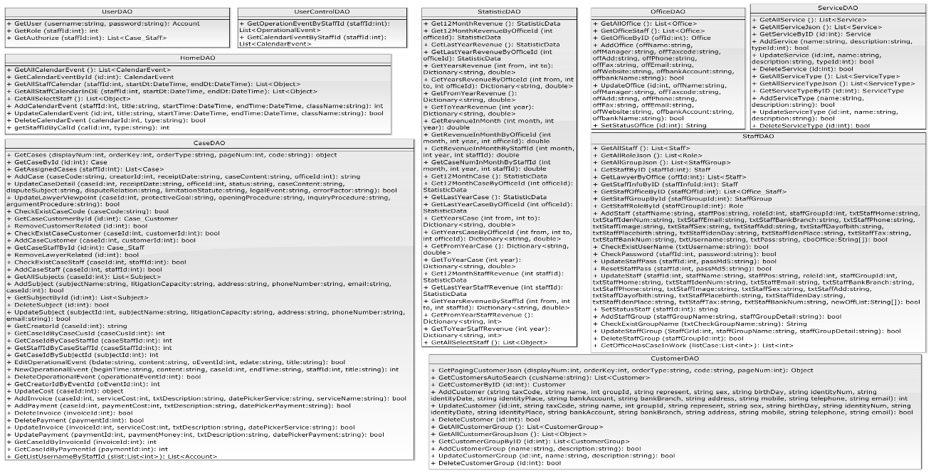

**Figure 4-8: Data Access Class Diagram**

#### Data Access Class Diagram Explanation

Reference to DVD: <root>/Documents/LFMS Project Document - Full Report.docx

### Login

#### Class diagram

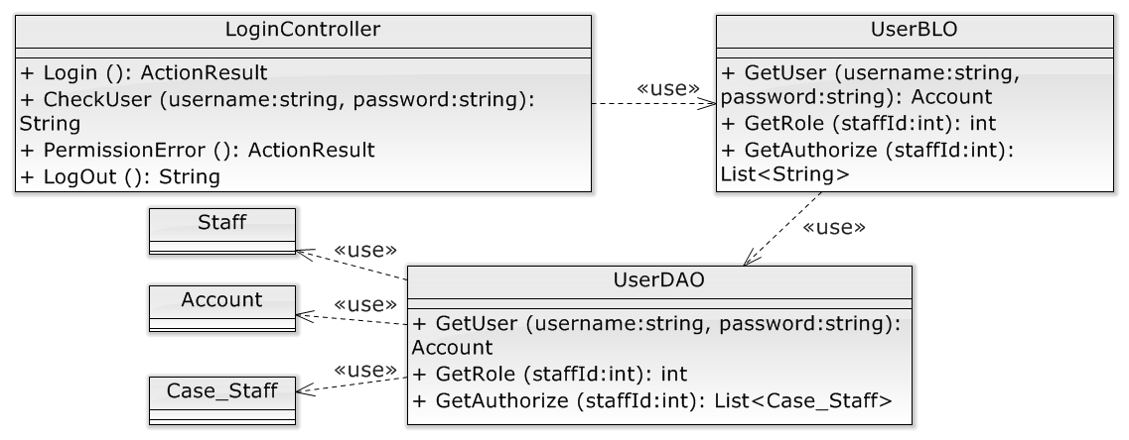

**Figure 4-9: Login Class Diagram**

#### Screen design

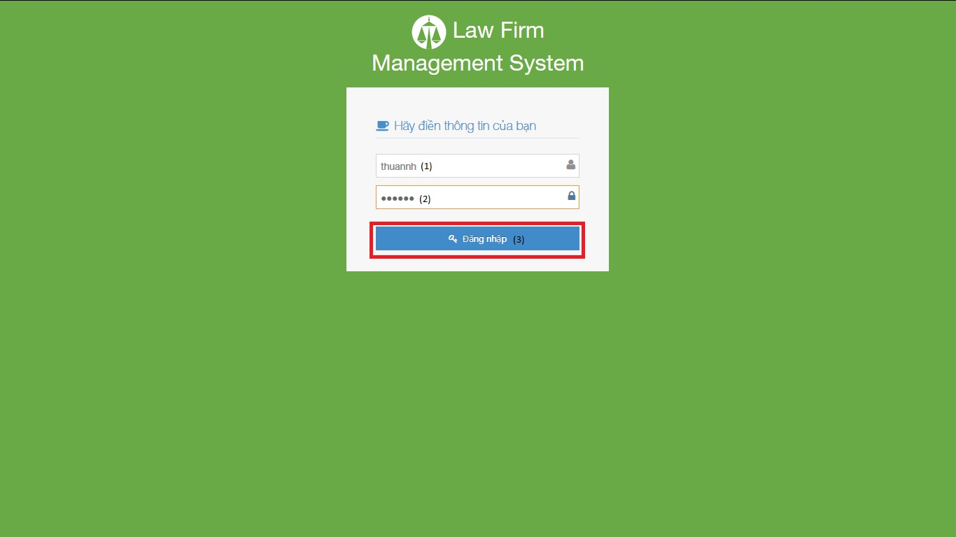

**Figure 4-10: Login Image**

|  |  |  |  |  |
| --- | --- | --- | --- | --- |
| No | Object/ControlName | Type | Required | Description |
| 1 | Tên đăng nhập | Textbox | Yes | Username for login |
| 2 | Mật khẩu | Textbox | Yes | Password for login |
| 3 | Đăng nhập | Button | Yes | Click for login to website |

#### Sequence diagram

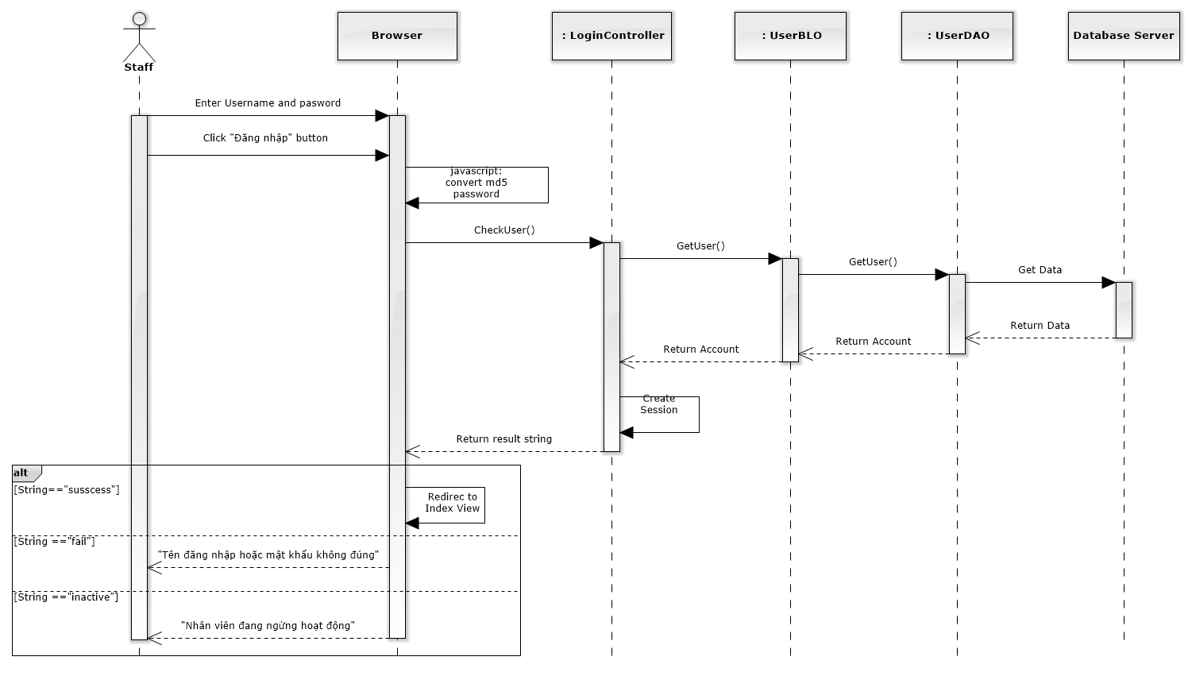

**Figure 4-11: Login Sequence Diagram**

### Change password

#### Class diagram

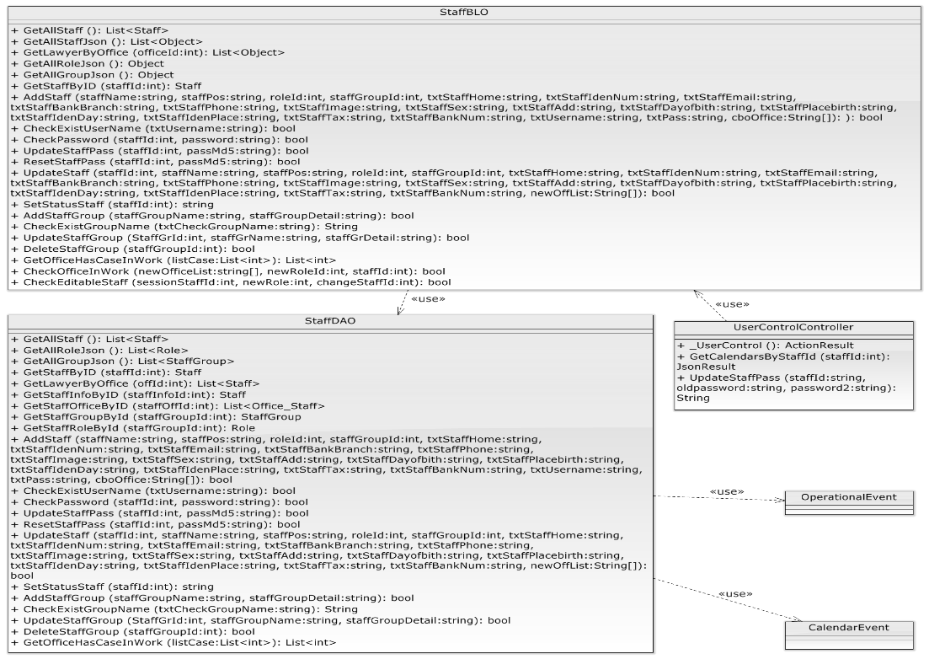

**Figure 4-12: Change password class diagram**

#### Screen design

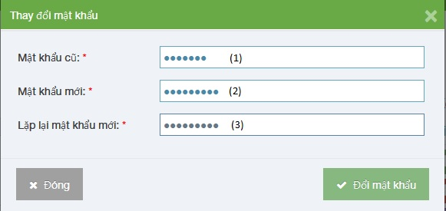

**Figure 4-13: Change password Image**

|  |  |  |  |  |
| --- | --- | --- | --- | --- |
| No | Object/ControlName | Type | Required | Description |
| 1 | Mật khẩu cũ | Textbox | Yes | Your old password |
| 2 | Mật khẩu mới | Textbox | Yes | Your new password |
| 3 | Lặp lại mật khẩu mới | Textbox | Yes | Re-input your new password |

#### Sequence diagram

**Figure 4-14: Change Password Sequence Diagram**

### View Home

#### Class diagram

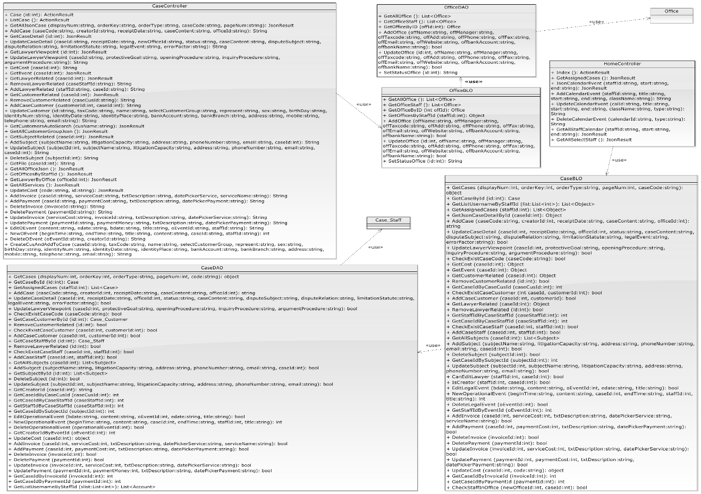

**Figure 4-15: View Home class diagram**

#### Screen design

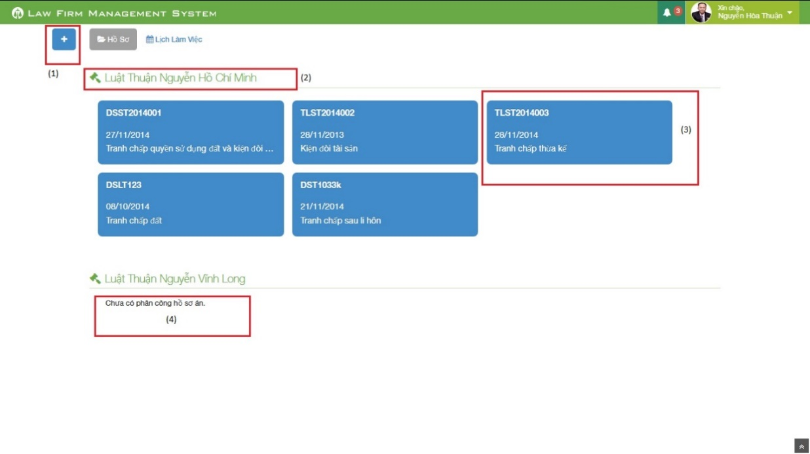

**Figure 4-16: View Home image**

|  |  |  |  |  |
| --- | --- | --- | --- | --- |
| No | Object/ControlName | Type | Required | Description |
| 1 | Plus | Button | Yes | Click to show popup for add new case |
| 2 | Office name | Label | Yes | Show name of office the staff work in |
| 3 | Case information | Button | Yes | Show important information of the case, click and redirect to view case detail page |
| 4 | “Chưa có phân công hồ sơ án” | Label | Yes | If the office have no “Đang thụ lý” case, message will be show |

#### Sequence diagram

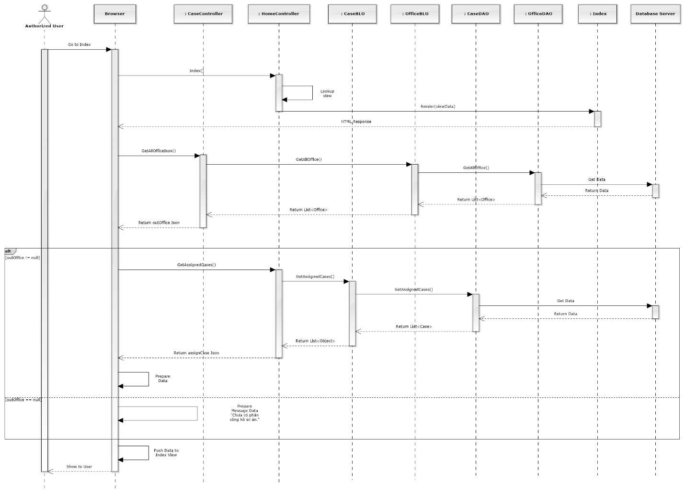

**Figure 4-17: View Home Sequence Diagram**

### Notify

#### Class diagram

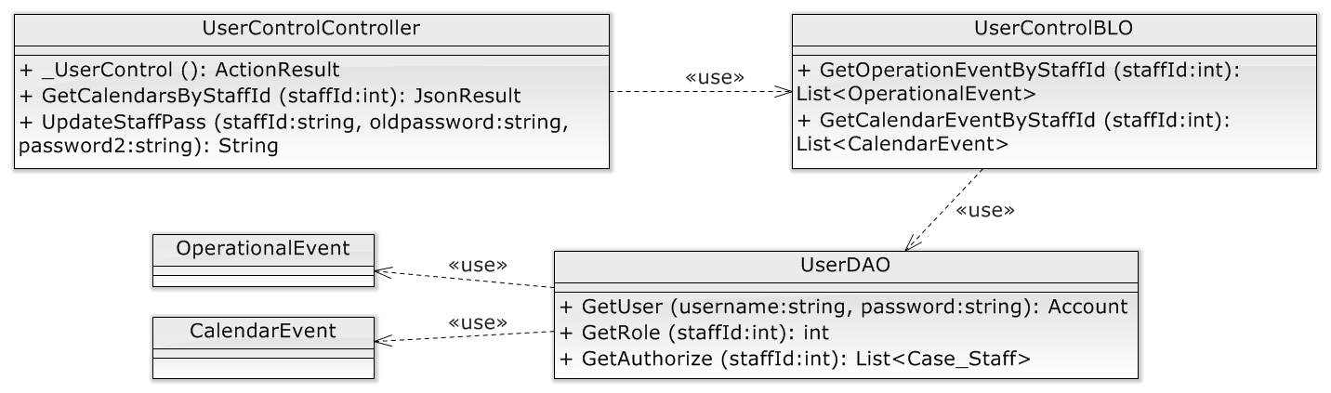

**Figure 4-18: Notify event class diagram**

#### Screen design

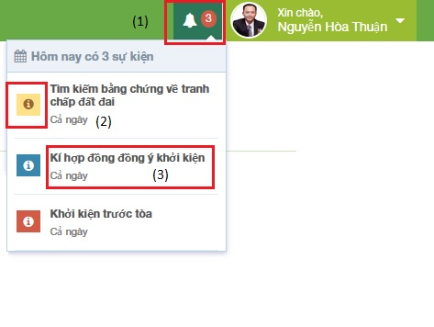

**Figure 4-19: Notify Event Screen Image**

|  |  |  |  |  |
| --- | --- | --- | --- | --- |
| No | Object/ControlName | Type | Required | Description |
| 1 | Event count | Label | Yes | Event quantity in “today” need to do. If there is at least 1 event, ring the bell |
| 2 | Priority | Icon | Yes | Show priority of event |
| 3 | Title | Label | Yes | Show title and time range of event |

#### Sequence diagram

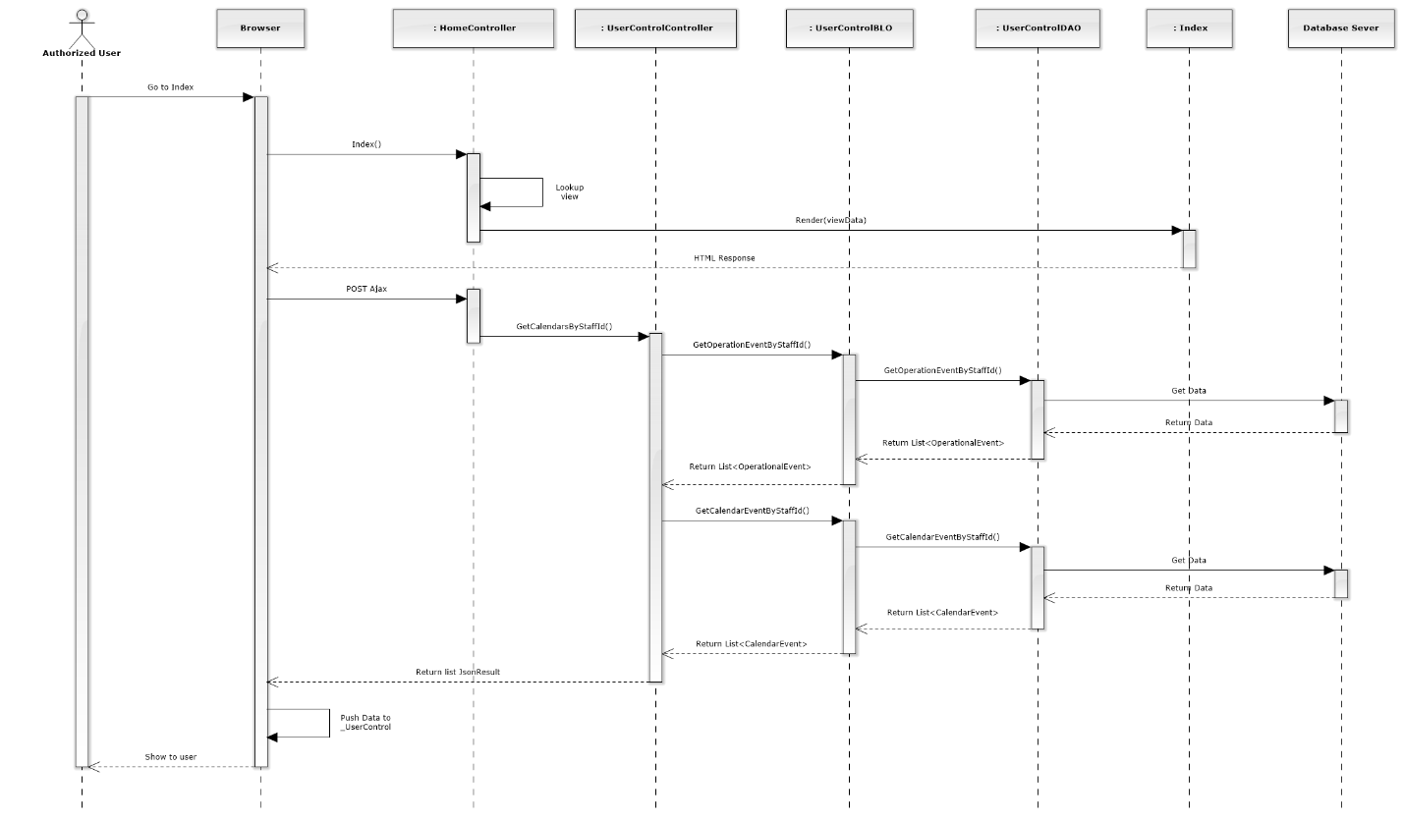

**Figure 4-20: Notify Sequence Diagram**

### Manage Calendar Event

#### List Calendar Events

##### Class diagram

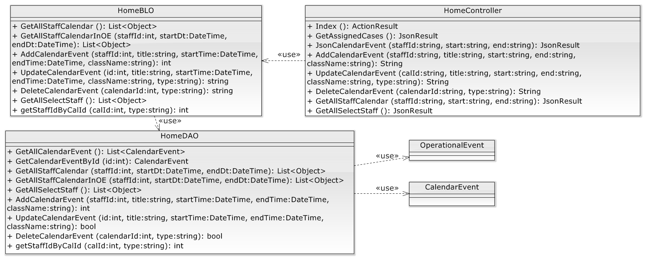

**Figure 4-21: List calendar events class diagram**

##### Screen design

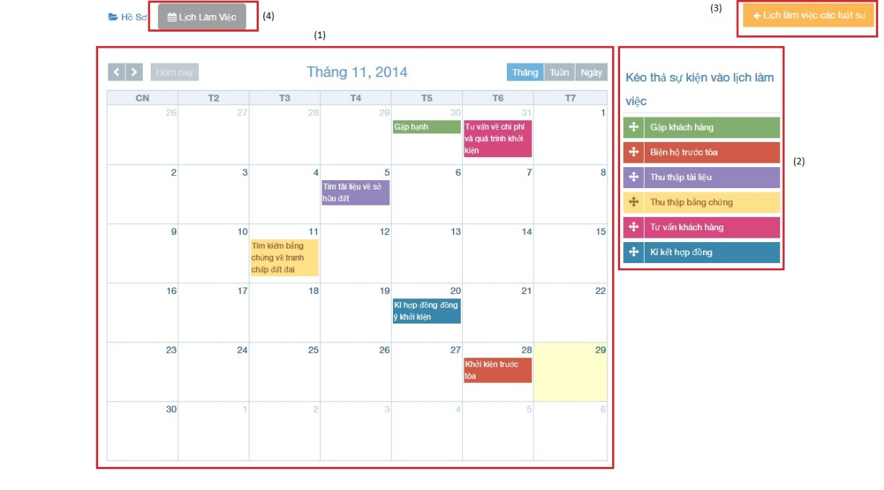

**Figure 4-22: :List calendar events image**

|  |  |  |  |  |
| --- | --- | --- | --- | --- |
| No | Object/ControlName | Type | Required | Description |
| 1 | Calendar | Full Calendar | Yes | Show all event of Staff on calendar |
| 2 | Dropable event | Object | Yes | Drag and drop into calendar to create new event |
| 3 | Lịch làm việc của các luật sư | Button | Yes | Show other staff calendar pop-up |
| 4 | “Lịch làm việc” | Label | Yes | Tab for view calendar events |

##### Sequence diagram

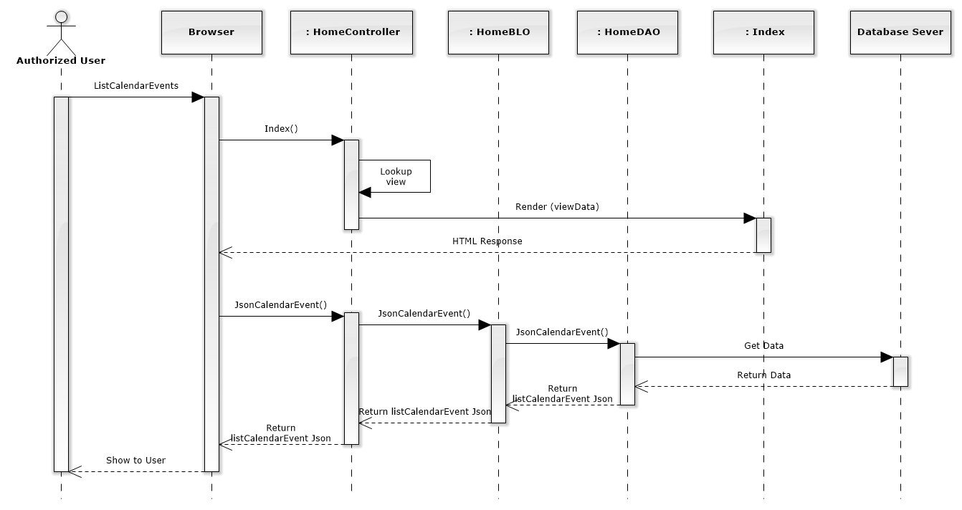

**Figure 4-23: List Calendar Events Sequence Diagram**

#### Add new calendar event

##### Screen design

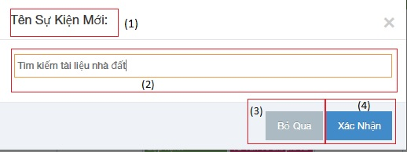

**Figure 4-24 :Add new calendar events image**

|  |  |  |  |  |
| --- | --- | --- | --- | --- |
| No | Object/ControlName | Type | Required | Description |
| 1 | “Tên Sự Kiện Mới:” | Label | Yes | View name event |
| 2 | “Tên sự kiện” | Textbox | Yes | Name event |
| 3 | “Bỏ Qua” | Button | Yes | Click to close Add new calendar event pop-up |
| 4 | “Xác Nhận” | Button | Yes | Click to create a new calendar event |

##### Sequence diagram

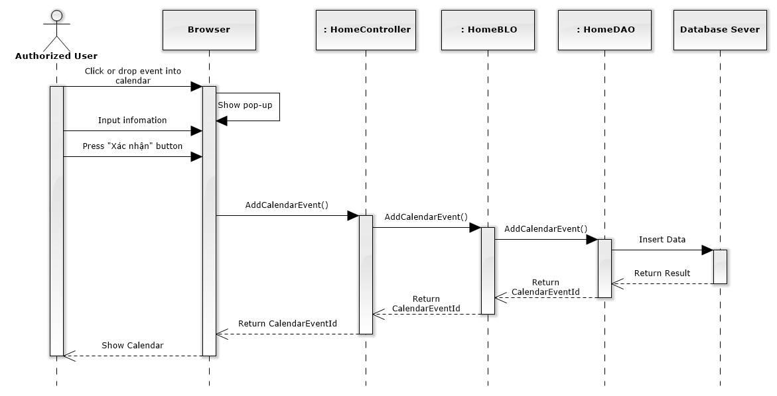

**Figure 4-25: Add New Calendar Event Sequence Diagram**

#### Edit calendar event

##### Screen design

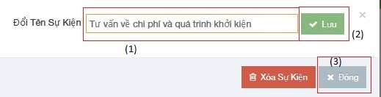

**Figure 4-26 :Edit calendar events image**

|  |  |  |  |  |
| --- | --- | --- | --- | --- |
| No | Object/ControlName | Type | Required | Description |
| 1 | “Tên sự kiện” | Textbox | Yes | Name event |
| 2 | “Lưu” | Button | Yes | Click to save edit new calendar event |
| 3 | “Đóng” | Button | Yes | Click to close Edit new calendar event pop-up |

##### Sequence diagram

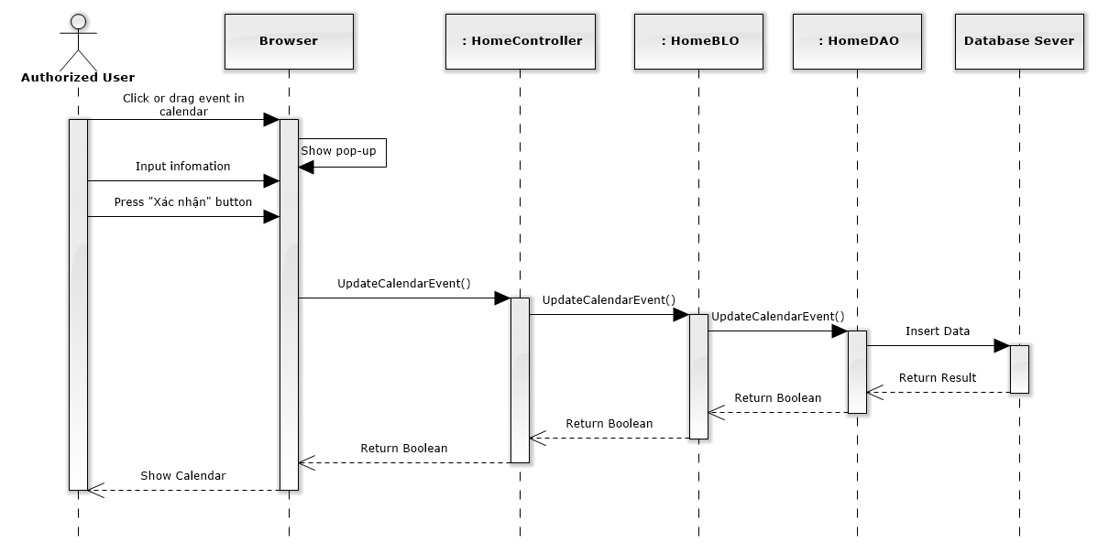

**Figure 4-27: Edit Calendar Event Sequence Diagram**

#### Delete calendar event

##### Screen design

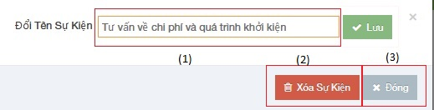

**Figure 4-28 :Delete calendar events image**

|  |  |  |  |  |
| --- | --- | --- | --- | --- |
| No | Object/ControlName | Type | Required | Description |
| 1 | “Tên sự kiện” | Textbox | Yes | Name event |
| 2 | “Xóa sự kiện” | Button | Yes | Click to delete calendar event |
| 3 | “Đóng” | Button | Yes | Click to close Delete calendar event pop-up |

##### Sequence diagram

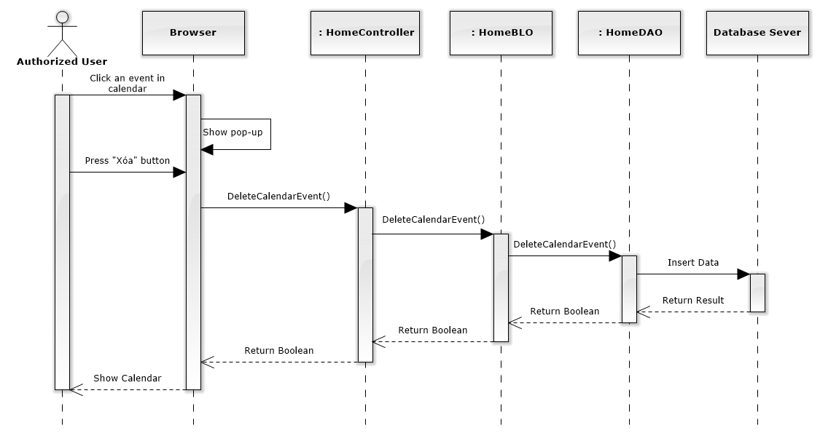

**Figure 4-29: Delete Calendar Event Sequence Diagram**

### Manage Case

#### List all cases

##### Class diagram

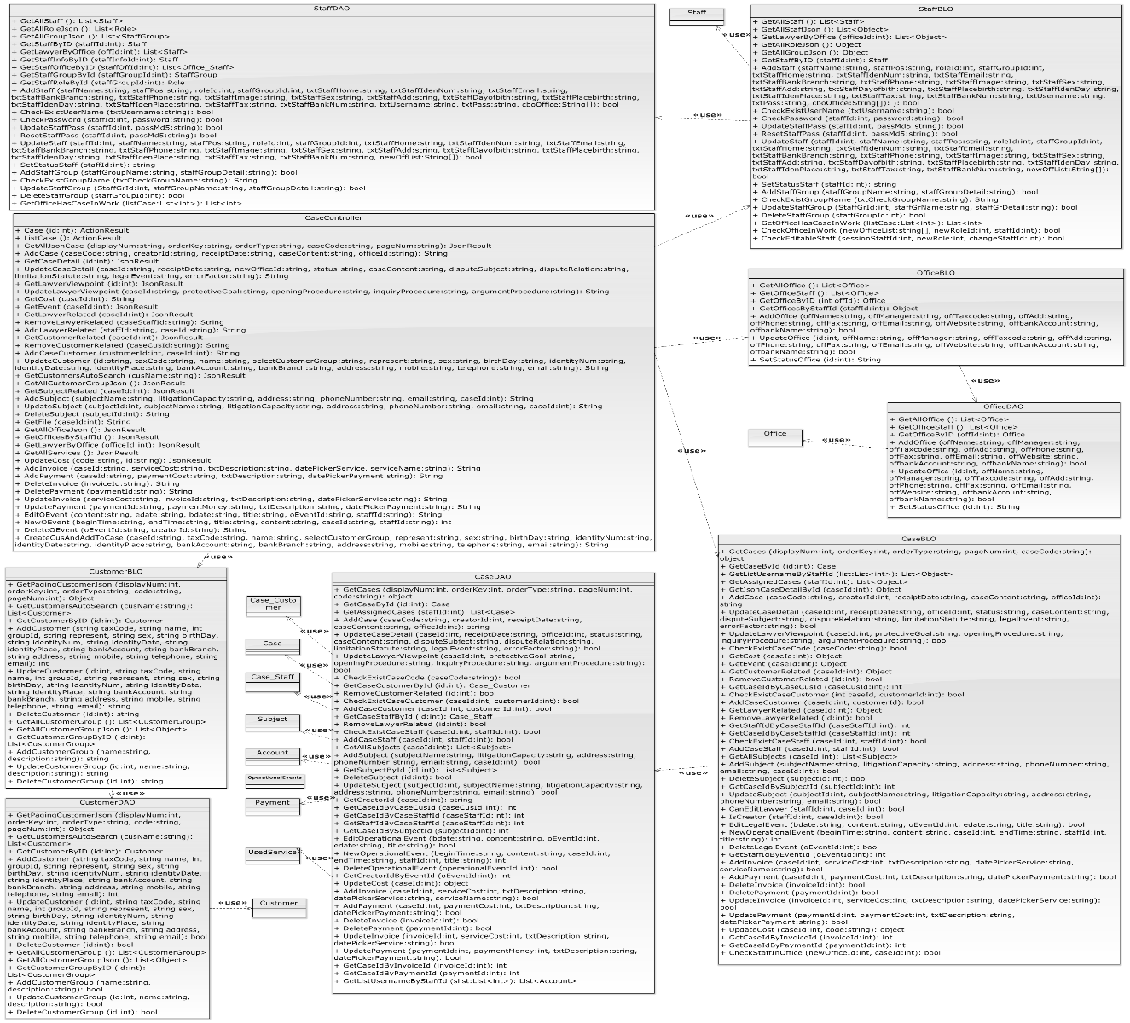

**Figure 4-30 :Manage class diagram**

##### Screen design

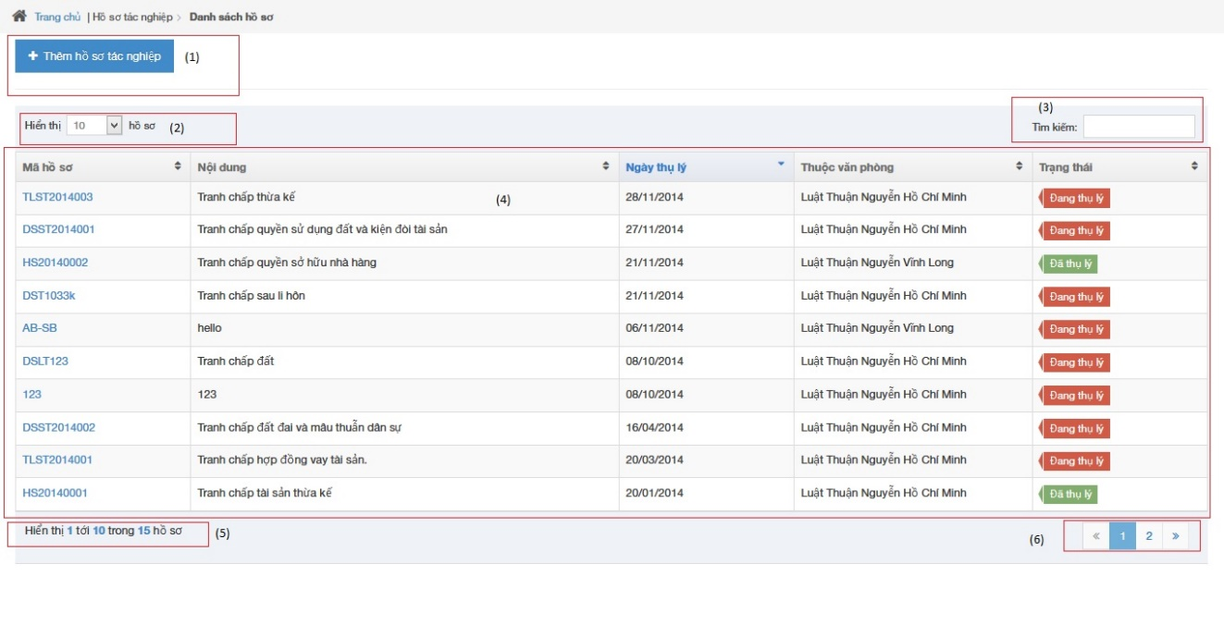

**Figure 4-31 :List all case image**

|  |  |  |  |  |
| --- | --- | --- | --- | --- |
| No | Object/ControlName | Type | Required | Description |
| 1 | “Thêm hồ sơ tác nghiệp” | Button | Yes | Click to show popup for add new case |
| 2 | Line count | Dropdown list | Yes | Select line quantity in table |
| 3 | “Tìm kiếm” | Textbox | Yes | Search case automatically |
| 4 | View all cases | Table | Yes | Show all of case |
| 5 | Case count | Label | Yes | Show case quantity of page in table |
| 6 | Paging | Button | Yes | List case page by page |

##### Sequence diagram

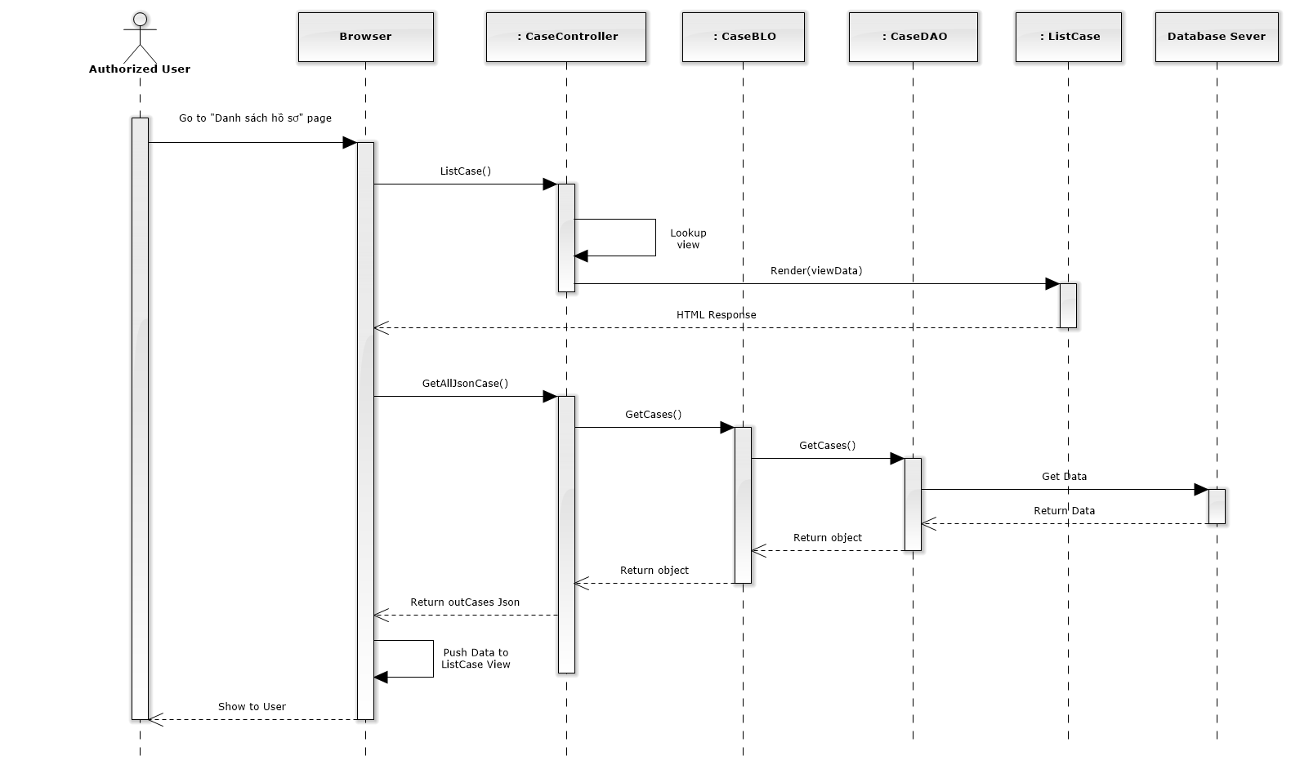

**Figure 4-32: List All Cases Sequence Diagram**

#### Add new case

##### Screen design

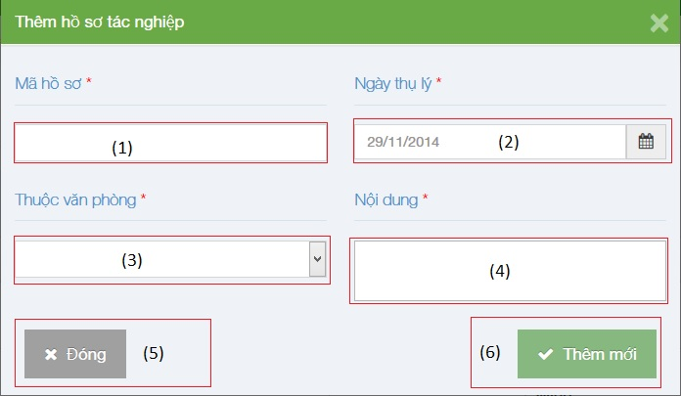

**Figure 4-33 :Add new case image**

|  |  |  |  |  |
| --- | --- | --- | --- | --- |
| No | Object/ControlName | Type | Required | Description |
| 1 | “Mã hồ sơ” | Textbox | Yes | Case code |
| 2 | “Ngày thụ lý” | Textbox list | Yes | Receipt date |
| 3 | “Thuộc văn phòng” | Textbox | Yes | Choose one office |
| 4 | “Nội dung” | Textbox | Yes | Case content |
| 5 | “Đóng” | Button | Yes | Click to close modal popup |
| 6 | “Thêm mới” | Button | Yes | Click to create a new case |

##### Sequence diagram

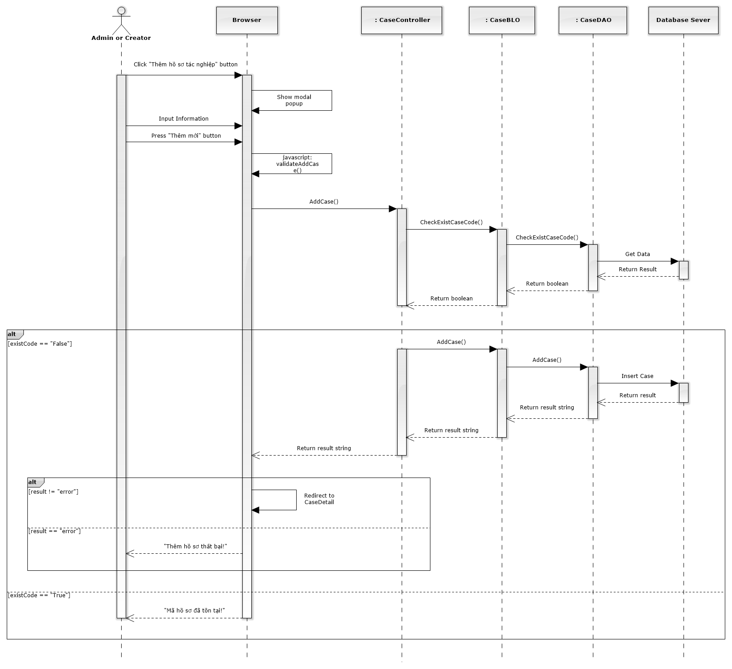

**Figure 4-34: Add New Case Sequence Diagram**

#### Manage Case Detail

##### View case detail

###### Screen design

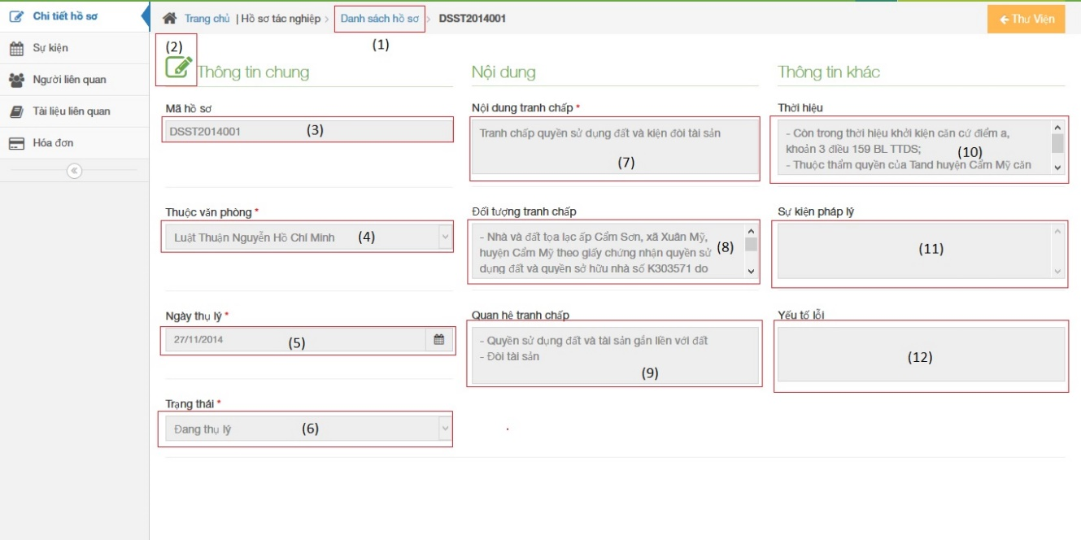

**Figure 4-35: View case detail image**

|  |  |  |  |  |
| --- | --- | --- | --- | --- |
| No | Object/ControlName | Type | Required | Description |
| 1 | “Danh sách hồ sơ” | Link | Yes | Redirect to view all cases |
| 2 | Edit | Button | Yes | Must be click to edit infor |
| 3 | “Mã hồ sơ” | Textbox | Yes | Case code |
| 4 | “Ngày thụ lý” | Textbox | Yes | Receipt date |
| 5 | “Thuộc văn phòng” | Textbox | Yes | Choose one office |
| 6 | “Trạng thái” | Textbox | Yes | Case status |
| 7 | “Nội dung tranh chấp” | Textbox | Yes | The contents of dispute |
| 8 | “Đối tượng tranh chấp” | Textbox | Yes | The subject of dispute |
| 9 | “Quan hệ tranh chấp” | Textbox | Yes | The relation of dispute |
| 10 | “Thời hiệu” | Textbox | Yes | The statute of limitations |
| 11 | “Sự kiện pháp lý” | Textbox | Yes | Legal event |
| 12 | “Yếu tố lỗi” | Textbox | Yes | Error factor |

###### Sequence diagram

##### Update case detail

###### Screen design

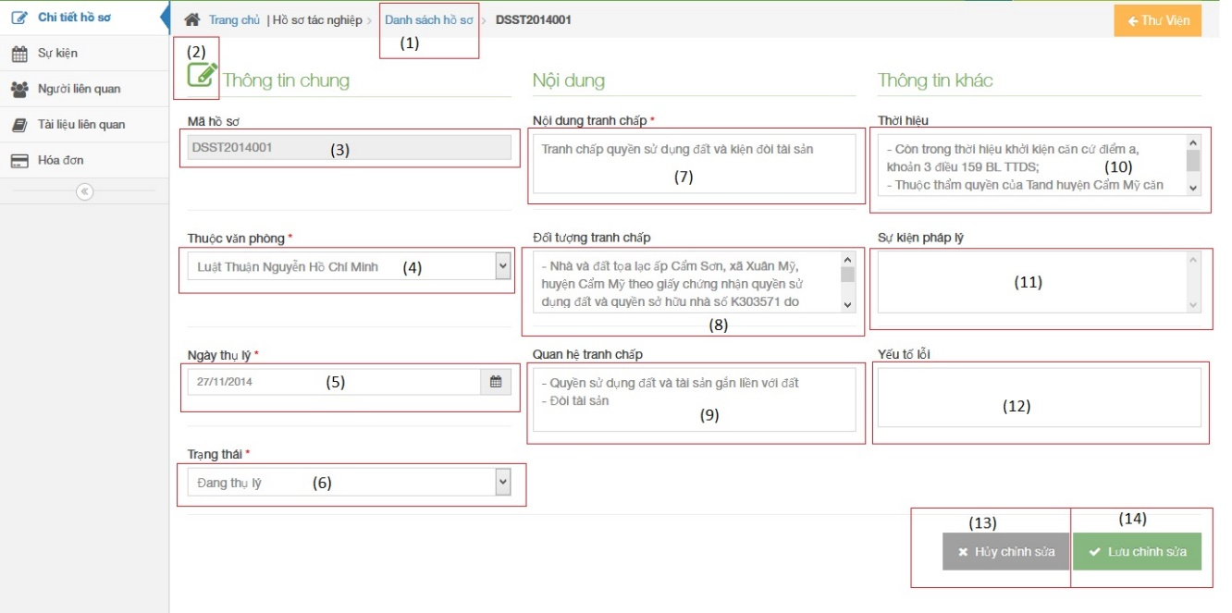

**Figure 4-36: Update case detail image**

|  |  |  |  |  |
| --- | --- | --- | --- | --- |
| No | Object/ControlName | Type | Required | Description |
| 1 | “Danh sách hồ sơ” | Link | Yes | Redirect to view all cases |
| 2 | Edit | Button | Yes | Must be click to edit infor |
| 3 | “Mã hồ sơ” | Textbox | Yes | Case code |
| 4 | “Ngày thụ lý” | Textbox | Yes | Receipt date |
| 5 | “Thuộc văn phòng” | Textbox | Yes | Choose one office |
| 6 | “Trạng thái” | Textbox | Yes | Case status |
| 7 | “Nội dung tranh chấp” | Textbox | Yes | The contents of dispute |
| 8 | “Đối tượng tranh chấp” | Textbox | Yes | The subject of dispute |
| 9 | “Quan hệ tranh chấp” | Textbox | Yes | The relation of dispute |
| 10 | “Thời hiệu” | Textbox | Yes | The statute of limitations |
| 11 | “Sự kiện pháp lý” | Textbox | Yes | Legal event |
| 12 | “Yếu tố lỗi” | Textbox | Yes | Error factor |
| 13 | “Hủy chỉnh sửa” | Button | Yes | Cancel edit infor |
| 14 | “Lưu chỉnh sửa” | Button | Yes | Save new infor |

###### Sequence diagram

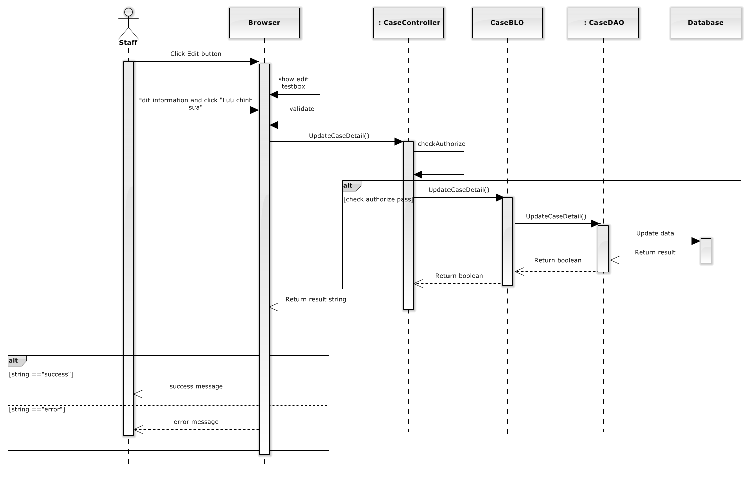

**Figure 4-36: Update case detail sequence diagram**

##### Manage Operation Event

###### List operation events

Screen design

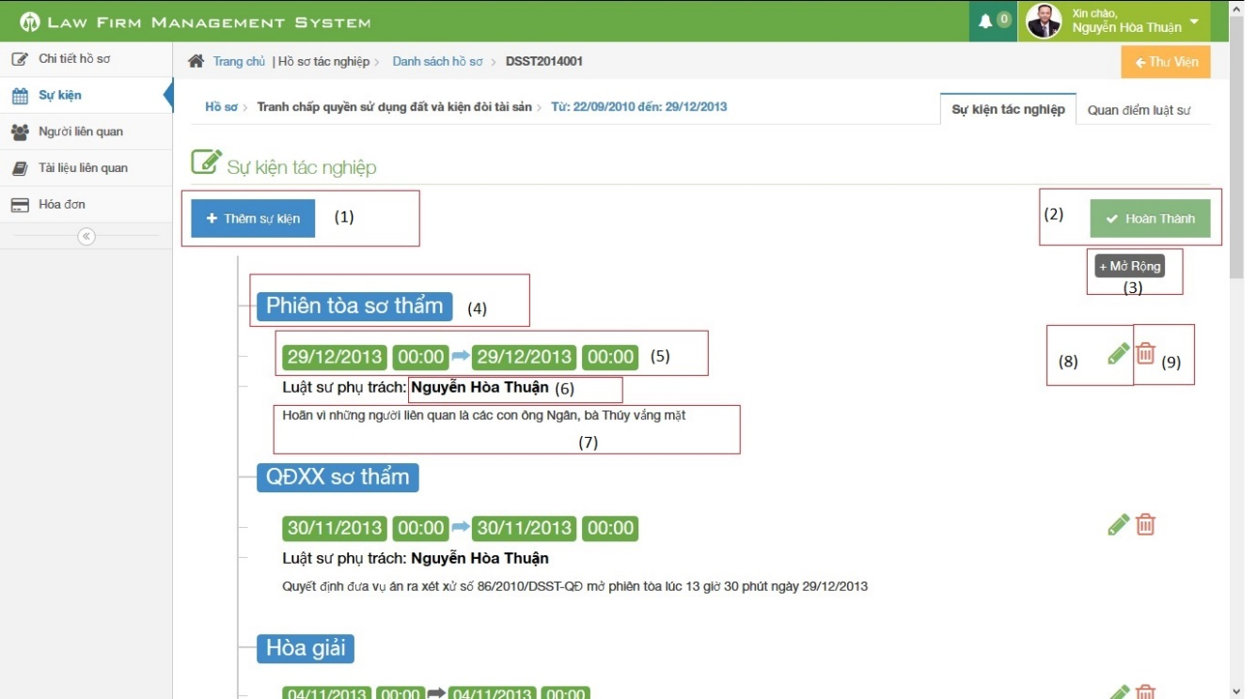

**Figure 4-37: List operation event image**

|  |  |  |  |  |
| --- | --- | --- | --- | --- |
| No | Object/ControlName | Type | Required | Description |
| 1 | Thêm sự kiện | Button | Yes | Click to add new operation event |
| 2 | Hoàn thành | Button | Yes | Click to finish edit operation event |
| 3 | Thu nhỏ / Mở rộng | Button | Yes | Reduce / Expand |
| 4 | Title | Label | Yes | Title of Operation Event |
| 5 | Time range | Label | Yes | Click to choose begin time and end time of event |
| 6 | Staff username | Label | Yes | The lawyer who create a case |
| 7 | Content | Information | Yes | Content of Operation Event |
| 8 | Pencil | Button | Yes | Edit operation event |
| 9 | Trash | Button | Yes | Delete operation event |

Sequence diagram

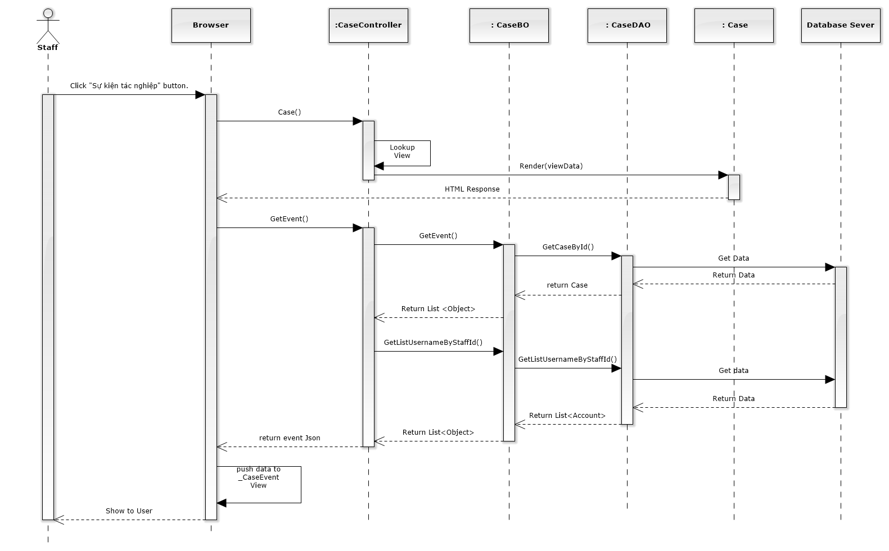

**Figure 4-38: List Operation Events Sequence Diagram**

###### Add new operation event

Screen design

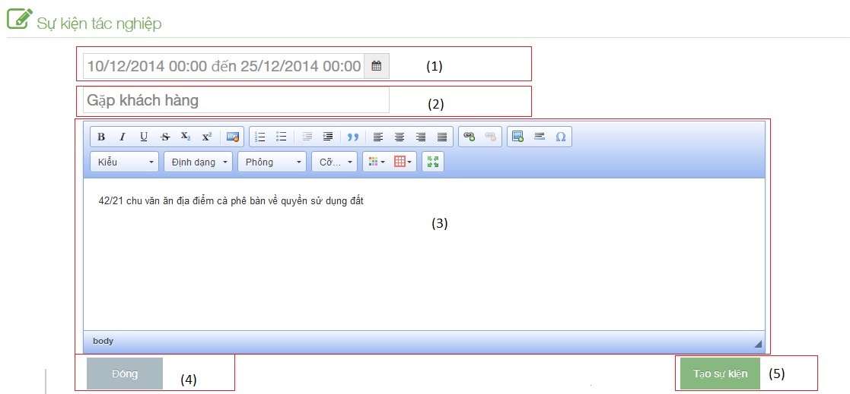

**Figure 4-39: Add new operation event image**

|  |  |  |  |  |
| --- | --- | --- | --- | --- |
| No | Object/ControlName | Type | Required | Description |
| 1 | Time range | Button | Yes | Click to choose begin time and end time of event |
| 2 | Title | Table | Yes | Title of Operation Event |
| 3 | Content | Label | Yes | Content of Operation Event |
| 4 | “Đóng” | Button | Yes | Click to close add new operation event |
| 5 | “Tạo sự kiện” | Button | Yes | Click to add new operation event |

Sequence diagram

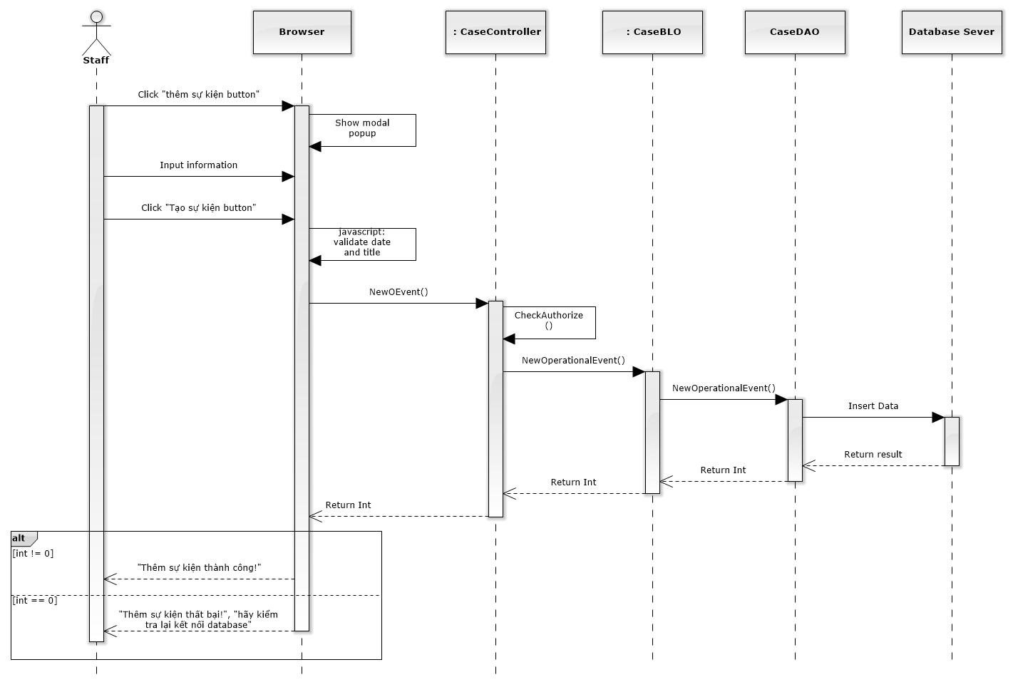

**Figure 4-40: Add New Operation Event Sequence Diagram**

###### Edit operation event

Screen design

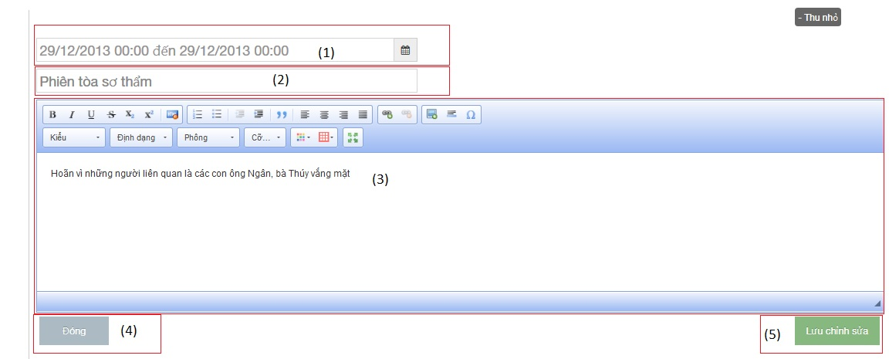

**Figure 4-41: Edit operation event image**

|  |  |  |  |  |
| --- | --- | --- | --- | --- |
| No | Object/ControlName | Type | Required | Description |
| 1 | Time range | Button | Yes | Click to choose begin time and end time of event |
| 2 | Title | Table | Yes | Title of Operation Event |
| 3 | Content | Label | Yes | Content of Operation Event |
| 4 | “Đóng” | Button | Yes | Click to close edit operation event |
| 5 | “Lưu chỉnh sửa” | Button | Yes | Click to edit operation event |

Sequence diagram

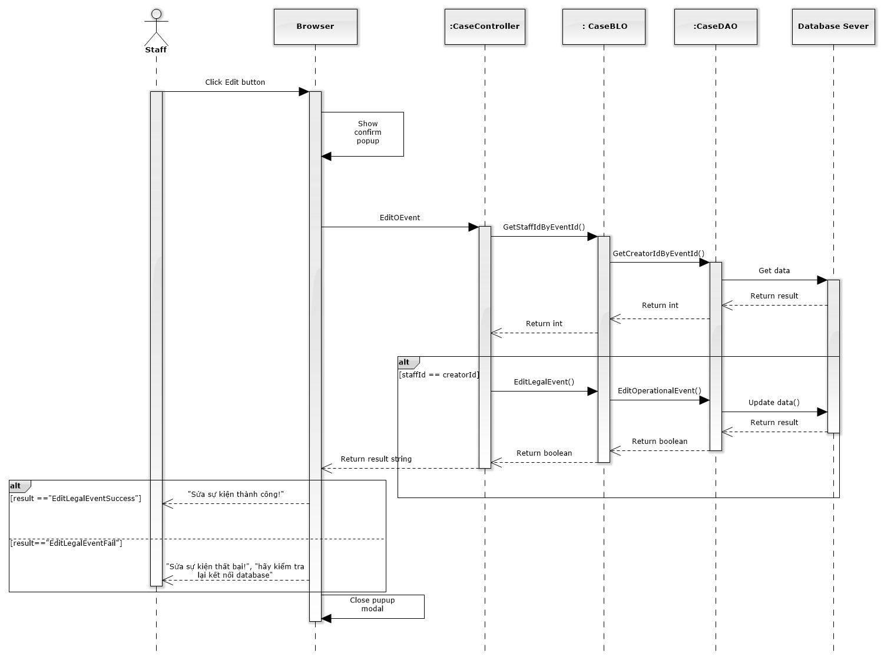

**Figure 4-42: Edit Operation Event Sequence Diagram**

###### Delete operation event

Screen design

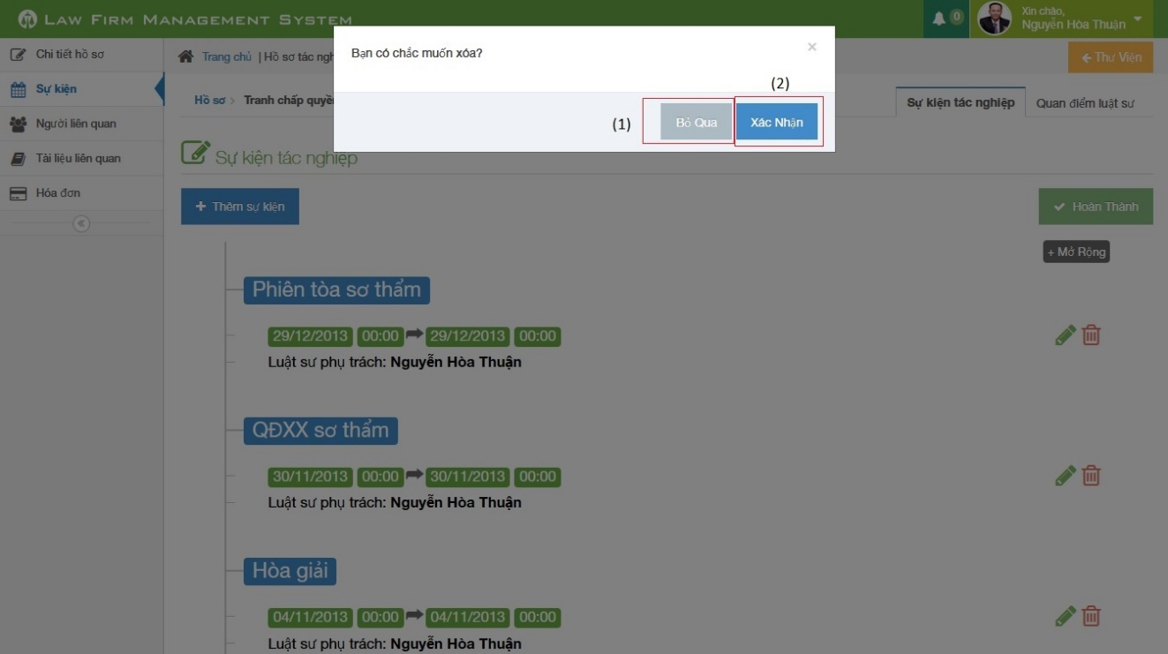

**Figure 4-43: Delete operation event image**

|  |  |  |  |  |
| --- | --- | --- | --- | --- |
| No | Object/ControlName | Type | Required | Description |
| 1 | “Bỏ qua” | Button | Yes | Click to close delete operation event |
| 2 | “Xác nhận” | Button | Yes | Click to delete operation event |

Sequence diagram

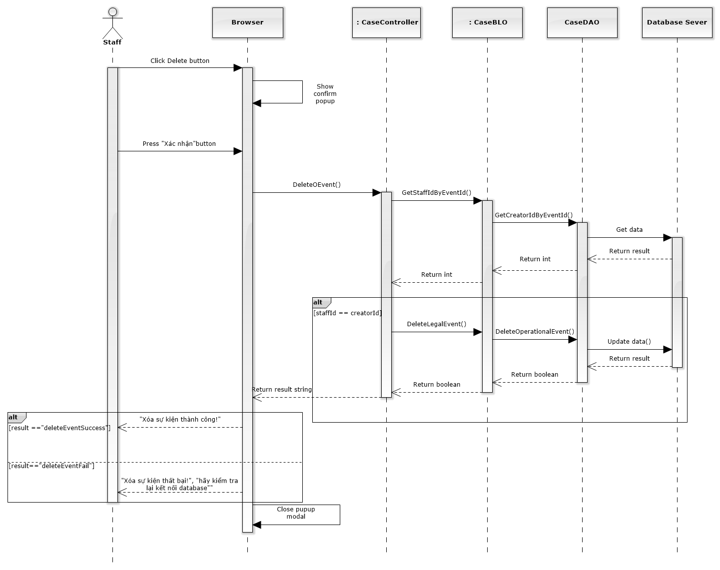

**Figure 4-44: Delete Operation Event Sequence Diagram**

##### Manage Lawyer Related

###### List lawyer related

Screen design

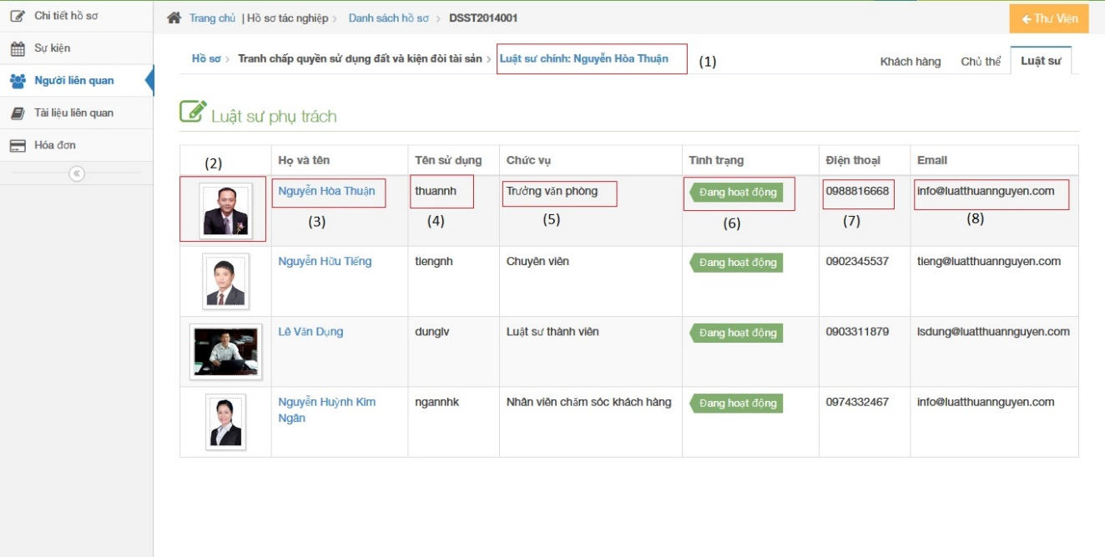

**Figure 4-45: List lawyer related image**

|  |  |  |  |  |
| --- | --- | --- | --- | --- |
| No | Object/ControlName | Type | Required | Description |
| 1 | “Luật sư chính” | Label | Yes | View the name main lawyer in charge of case |
| 2 | Image of staff | Picture | Yes | Click to show popup detail of staff |
| 3 | “Họ và tên” | Link | Yes | Click to show popup detail of staff |
| 4 | “Tên sử dụng” | Label | Yes | Username of staff |
| 5 | “Chức vụ” | Label | Yes | Role of staff |
| 6 | “Tình trạng” | Label | Yes | Status of staff |
| 7 | “Điện thoại” | Label | Yes | Phone number of staff |
| 8 | “Email” | Label | Yes | Email of staff |

Sequence diagram

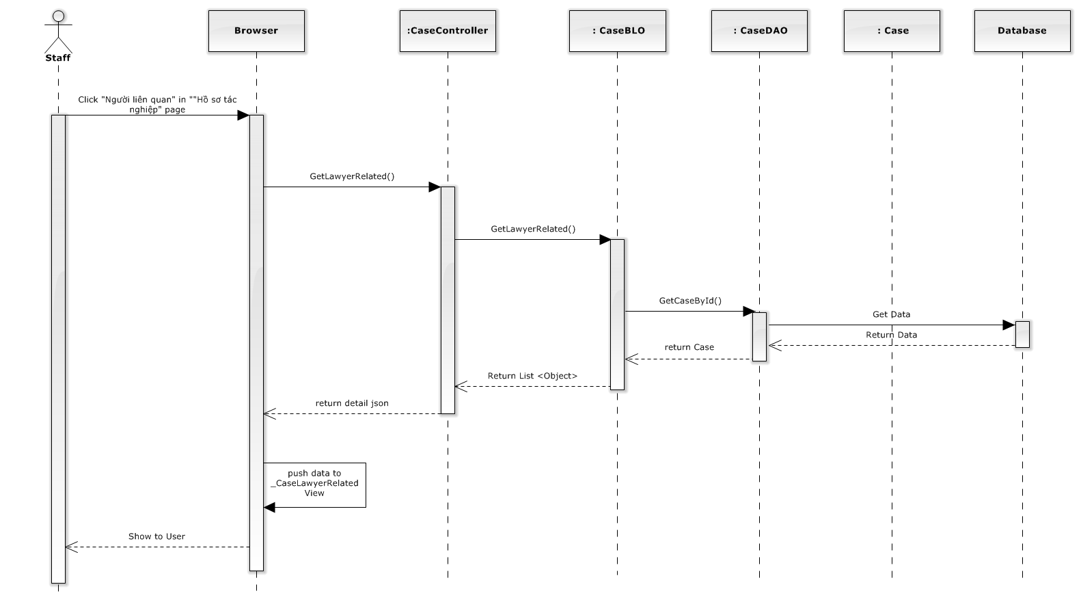

**Figure 4-46: List lawyer related sequence diagram**

###### Add lawyer related

Screen design

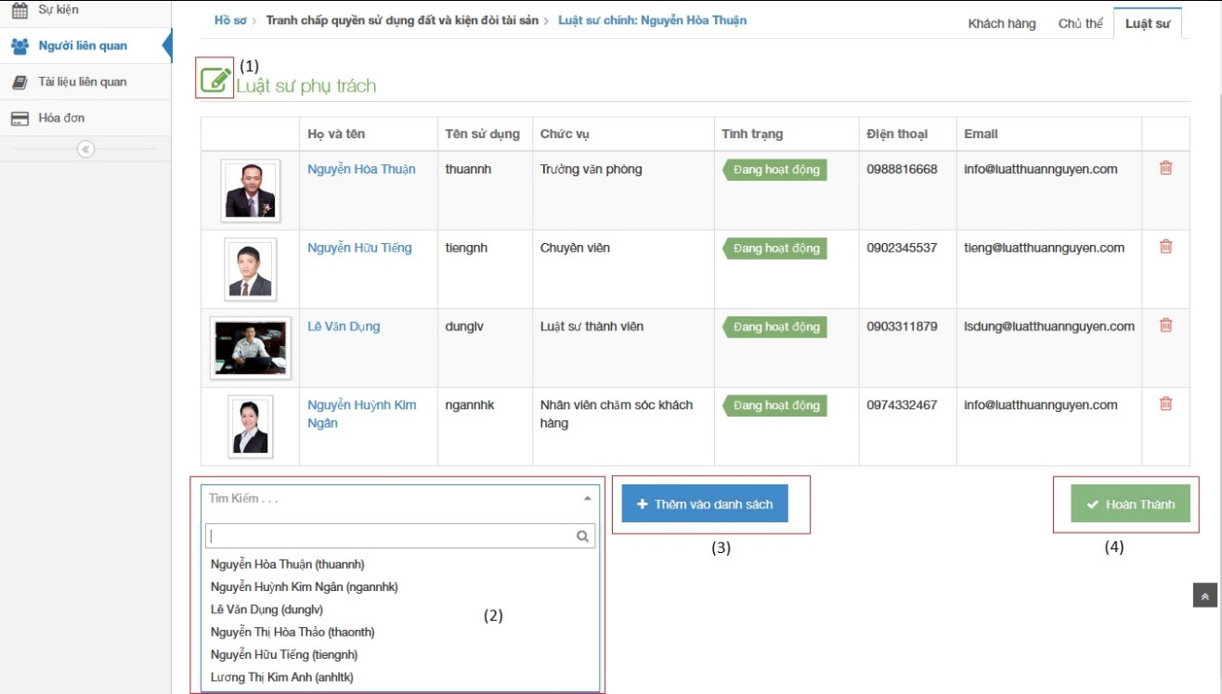

**Figure 4-47: Add lawyer related image**

|  |  |  |  |  |
| --- | --- | --- | --- | --- |
| No | Object/ControlName | Type | Required | Description |
| 1 | Edit | Button | Yes | Must be click to edit lawyer related |
| 2 | List of staff | Combo box | Yes | Select the name will be add to lawyer related |
| 3 | “Thêm vào danh sách” | Button | Yes | Click to add new lawyer related |
| 4 | “Hoàn thành” | Button | Yes | Click to finish add new lawyer related |

Sequence diagram

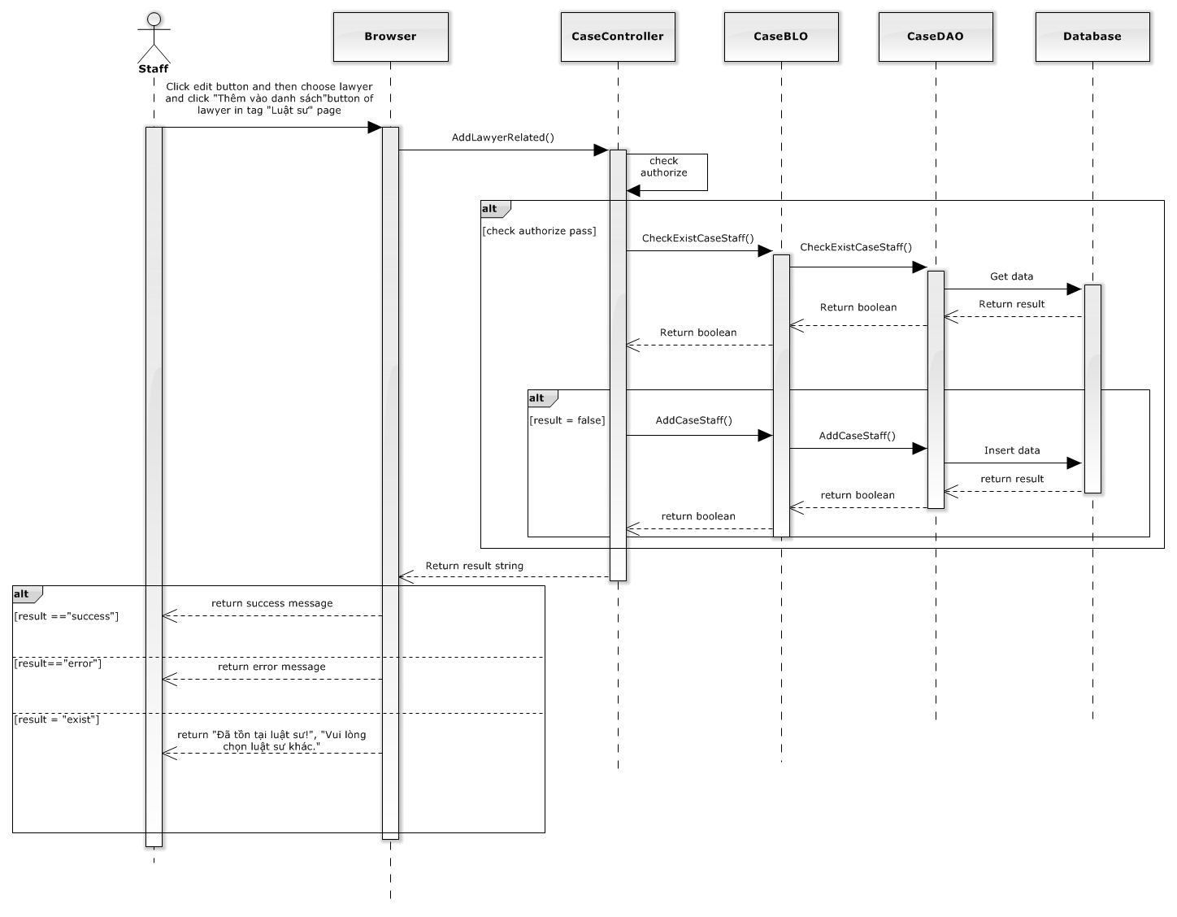

**Figure 4-48: Add lawyer related sequence diagram**

###### Delete lawyer related

Screen design

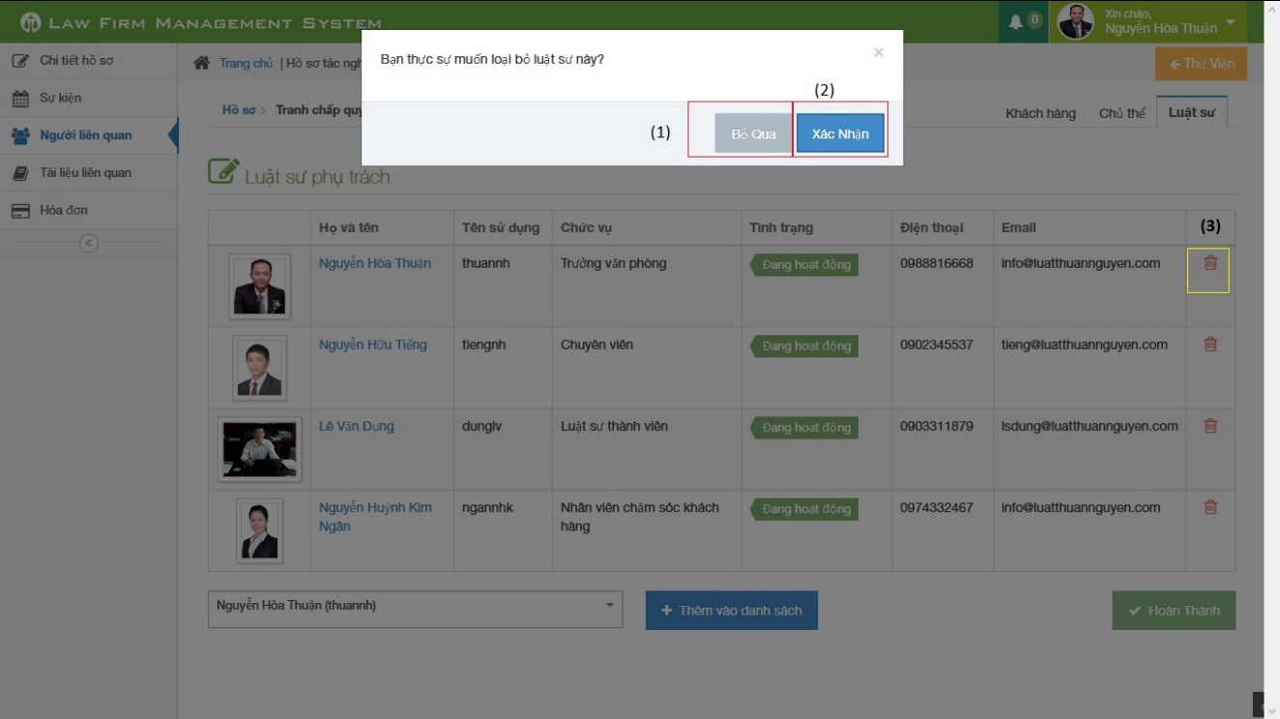

**Figure 4-49: Delete lawyer related image**

|  |  |  |  |  |
| --- | --- | --- | --- | --- |
| No | Object/ControlName | Type | Required | Description |
| 1 | “Bỏ qua” | Button | Yes | Click to close delete lawyer related |
| 2 | “Xác nhận” | Button | Yes | Click to confirm delete lawyer related |
| 3 | Trash | Button | Yes | Click to show pop up delete lawyer related |

Sequence diagram

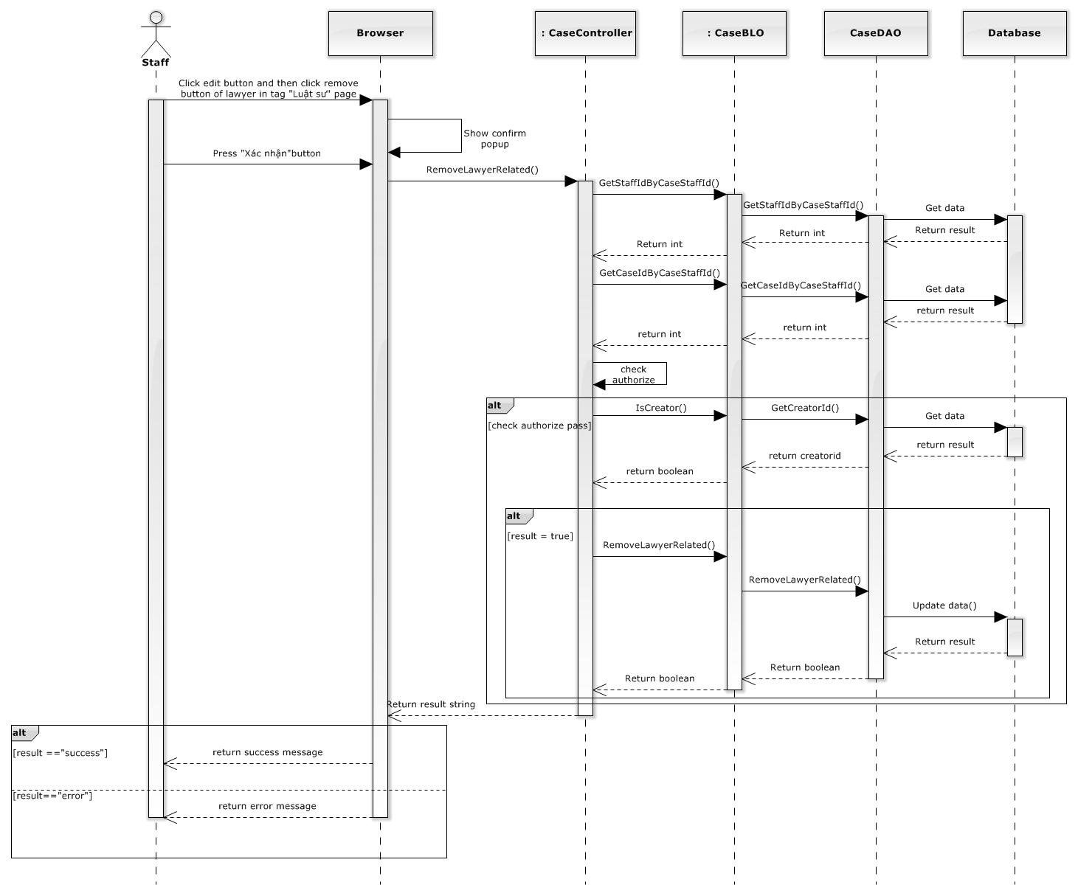

**Figure 4-50: Delete lawyer related sequence diagram**

##### Manage Customer Related

###### List customer related

Screen design

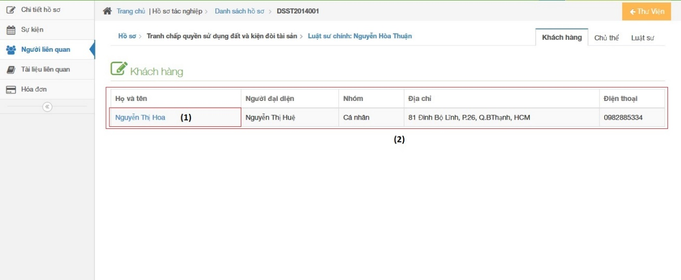

**Figure 4-51: List customer related image**

|  |  |  |  |  |
| --- | --- | --- | --- | --- |
| No | Object/ControlName | Type | Required | Description |
| 1 | “Họ và tên” | Link | Yes | Click to show popup detail of customer |
| 2 | List all customer related | Table | Yes | List all customer related |

Sequence diagram

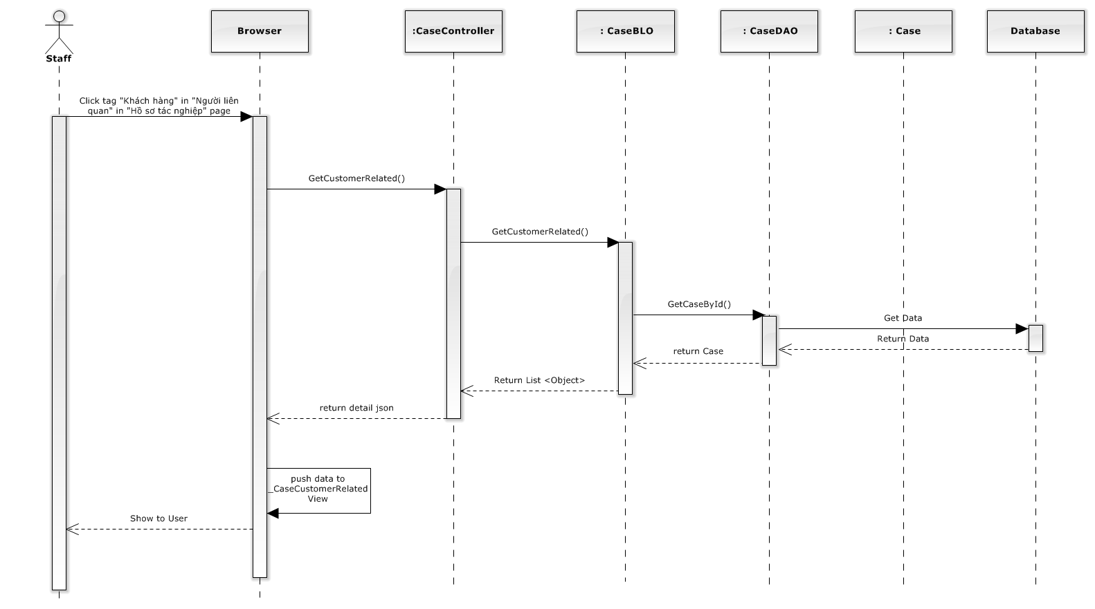

**Figure 4-52: List customer related sequence diagram**

###### Add customer related

Screen design

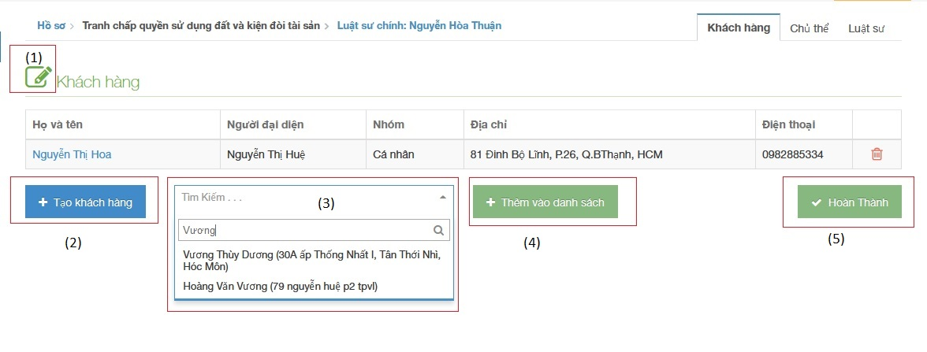

**Figure 4-53: Add customer related image**

|  |  |  |  |  |
| --- | --- | --- | --- | --- |
| No | Object/ControlName | Type | Required | Description |
| 1 | Edit | Button | Yes | Must be click to edit customer related |
| 2 | “Tạo khách hàng” | Button | Yes | Click to create new customer |
| 3 | List of customer | Combo box | Yes | Select the name will be add to customer related |
| 4 | “Thêm vào danh sách” | Button | Yes | Click to add new customer related |
| 5 | “Hoàn thành” | Button | Yes | Click to finish add new customer related |

Sequence diagram

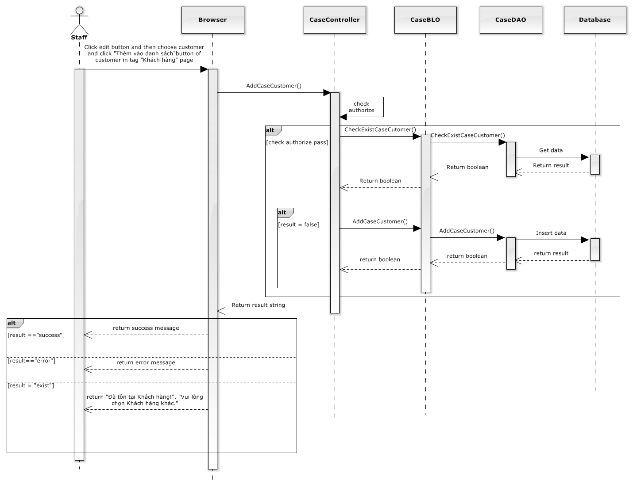

**Figure 4-54: Add customer related sequence diagram**

###### Delete customer related

Screen design

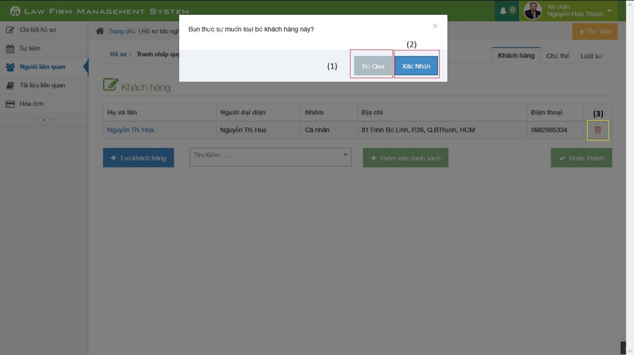

**Figure 4-55: Delete customer related image**

|  |  |  |  |  |
| --- | --- | --- | --- | --- |
| No | Object/ControlName | Type | Required | Description |
| 1 | “Bỏ qua” | Button | Yes | Click to close delete customer related |
| 2 | “Xác nhận” | Button | Yes | Click to confirm delete customer related |
| 3 | Trash | Button | Yes | Click to show pop up delete customer related |

Sequence diagram

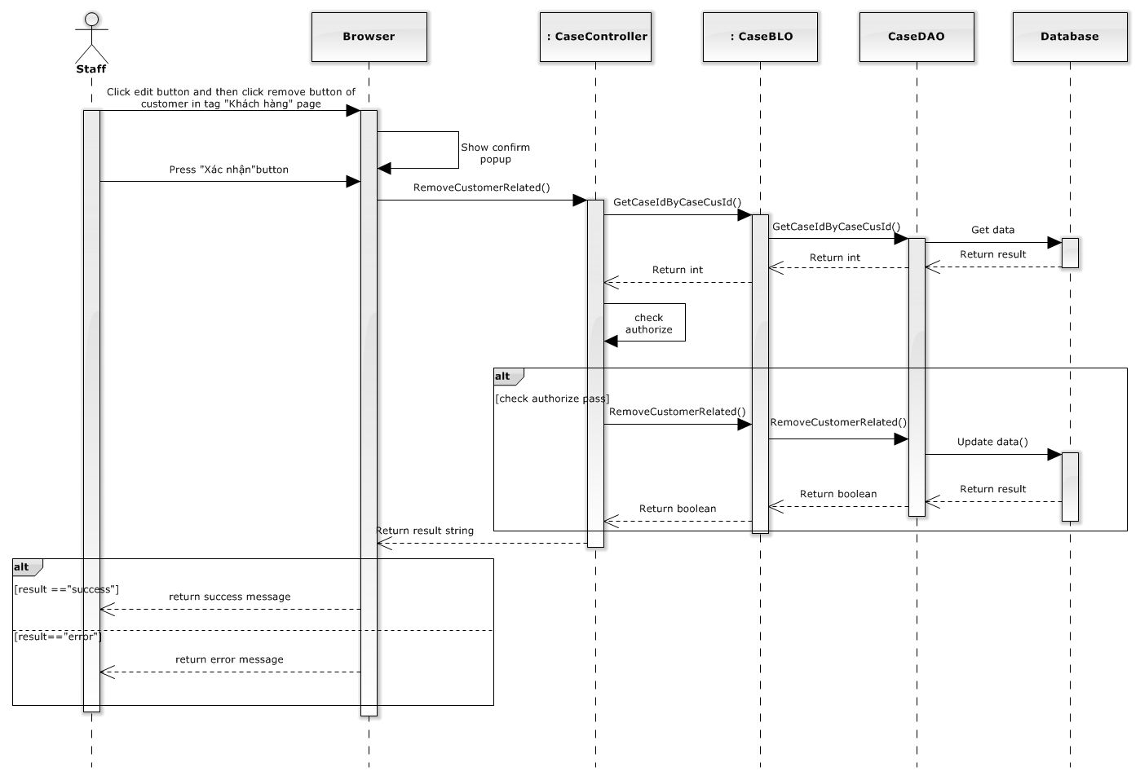

**Figure 4-56: Delete customer related image**

##### Manage Subject Related

###### View subject related

Screen design

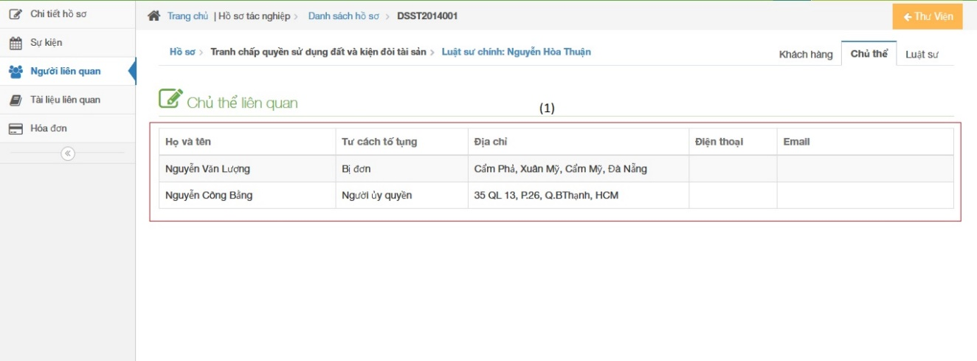

**Figure 4-57: View subject related image**

|  |  |  |  |  |
| --- | --- | --- | --- | --- |
| No | Object/ControlName | Type | Required | Description |
| 1 | List all subject related | Table | Yes | List all subject related |

Sequence diagram

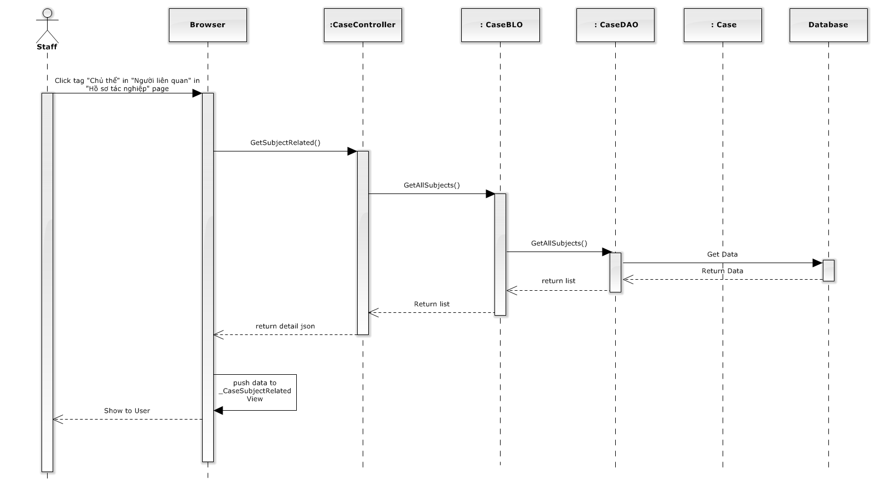

**Figure 4-58: View subject related sequence diagram**

###### Add subject related

Screen design

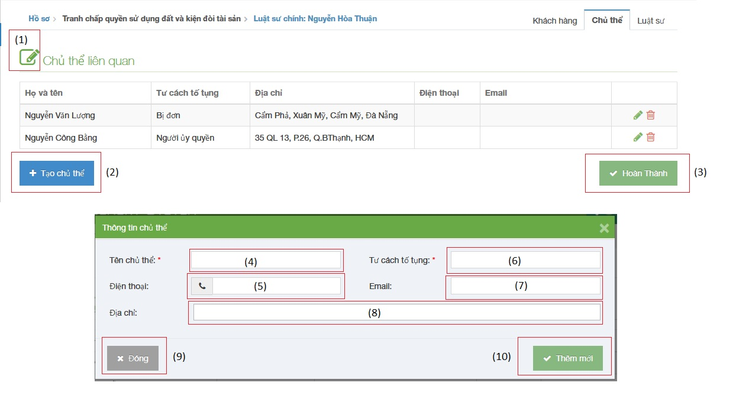

**Figure 4-59: Add subject related image**

|  |  |  |  |  |
| --- | --- | --- | --- | --- |
| No | Object/ControlName | Type | Required | Description |
| 1 | Edit | Button | Yes | Must be click to edit subject related |
| 2 | “Tạo chủ thể” | Button | Yes | Click to open pop-up create new subject |
| 3 | “Hoàn thành” | Button | Yes | Click to finish add new subject related |
| 4 | “Tên chủ thể” | Textbox | Yes | Name of subject |
| 5 | “Điện thoại” | Textbox | Yes | Phone of subject |
| 6 | “Tư cách tố tụng” | Textbox | Yes | litigation capacity of subject |
| 7 | “Email” | Textbox | Yes | Email of subject |
| 8 | “Địa chỉ” | Textbox | Yes | Address of subject |
| 9 | “Đóng” | Button | Yes | Click to close pop-up add new subject |
| 10 | “Thêm mới” | Button | Yes | Click to add new subject |

Sequence diagram

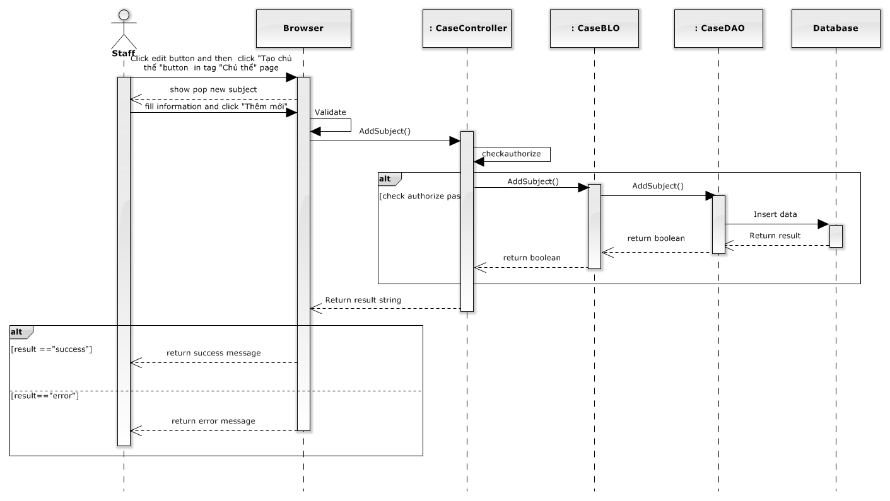

**Figure 4-60: Add subject related sequence diagram**

###### Update subject related

Screen design

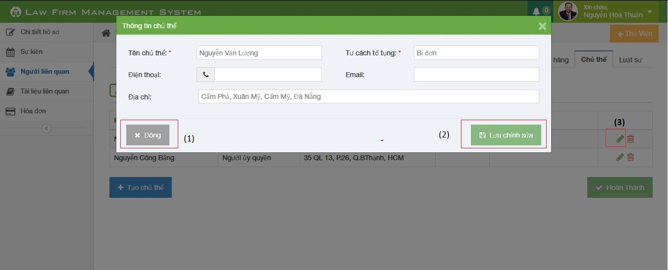

**Figure 4-61: Update subject related image**

|  |  |  |  |  |
| --- | --- | --- | --- | --- |
| No | Object/ControlName | Type | Required | Description |
| 1 | “Đóng” | Button | Yes | Click to close update subject related |
| 2 | “Lưu chỉnh sửa” | Button | Yes | Click to confirm update subject related |
| 3 | Edit | Icon | Yes | Click to show pop up update subject related |

Sequence diagram

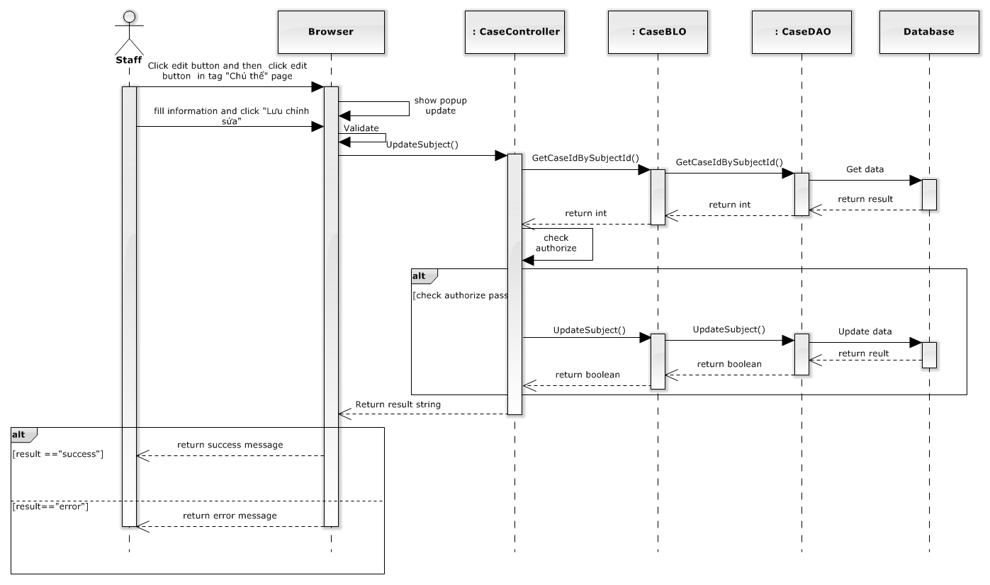

**Figure 4-62: Update subject related sequence diagram**

###### Delete subject related

Screen design

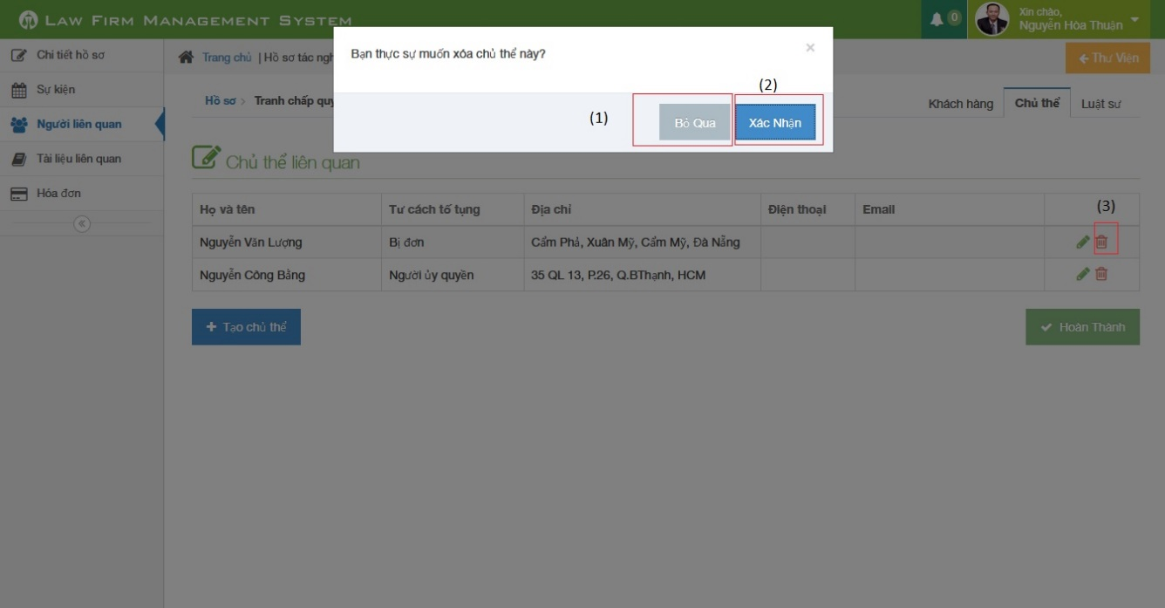

**Figure 4-63: Delete subject related image**

|  |  |  |  |  |
| --- | --- | --- | --- | --- |
| No | Object/ControlName | Type | Required | Description |
| 1 | “Bỏ qua” | Button | Yes | Click to close delete subject related |
| 2 | “Xác nhận” | Button | Yes | Click to confirm delete subject related |
| 3 | Trash | Button | Yes | Click to show pop up delete subject related |

Sequence diagram

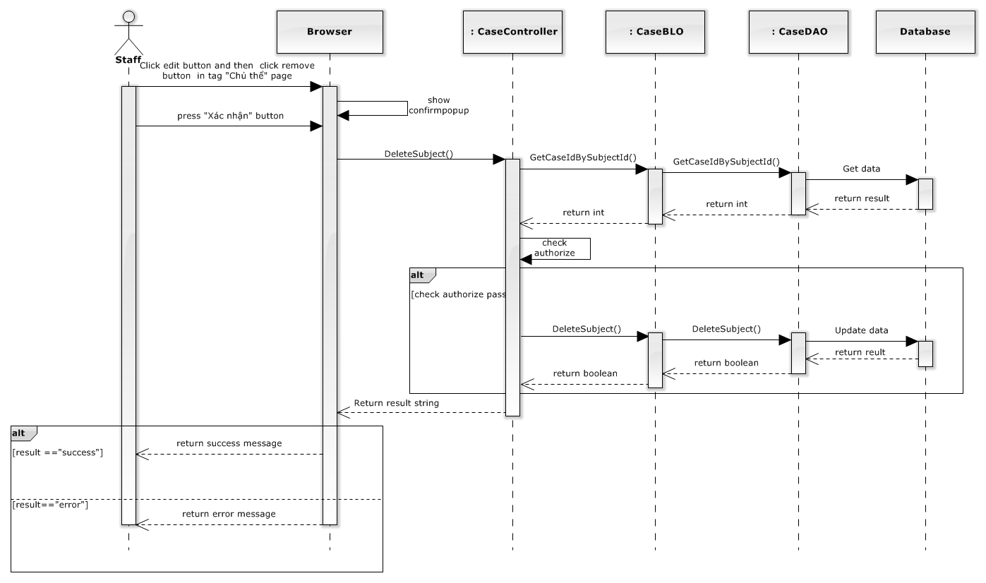

**Figure 4-64: Delete subject related sequence diagram**

##### Manage Used Service

###### View used service

Screen design

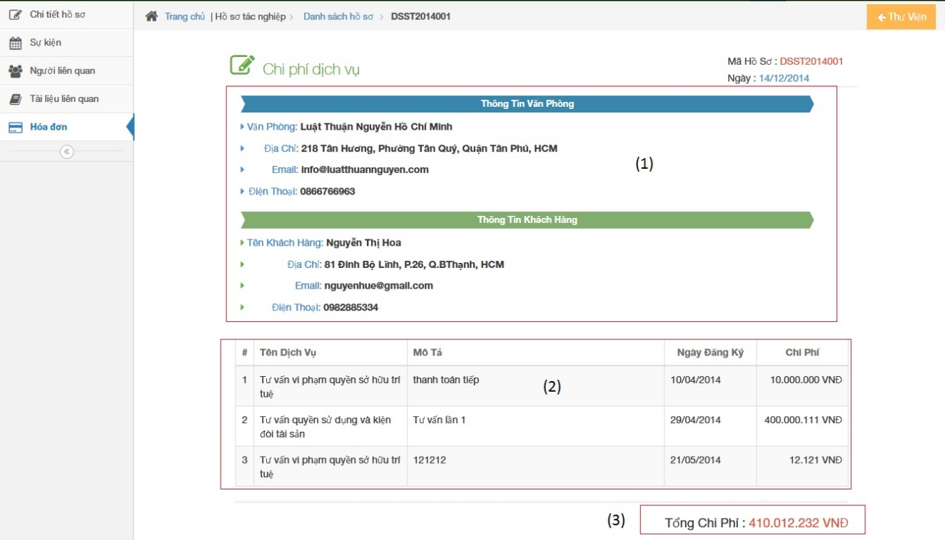

**Figure 4-65: View used service image**

|  |  |  |  |  |
| --- | --- | --- | --- | --- |
| No | Object/ControlName | Type | Required | Description |
| 1 | List all customer and office information | Table | Yes | List all customer and office information |
| 2 | List all used service | Table | Yes | List all used service |
| 3 | List total cost | Label | Yes | List total cost |

Sequence diagram

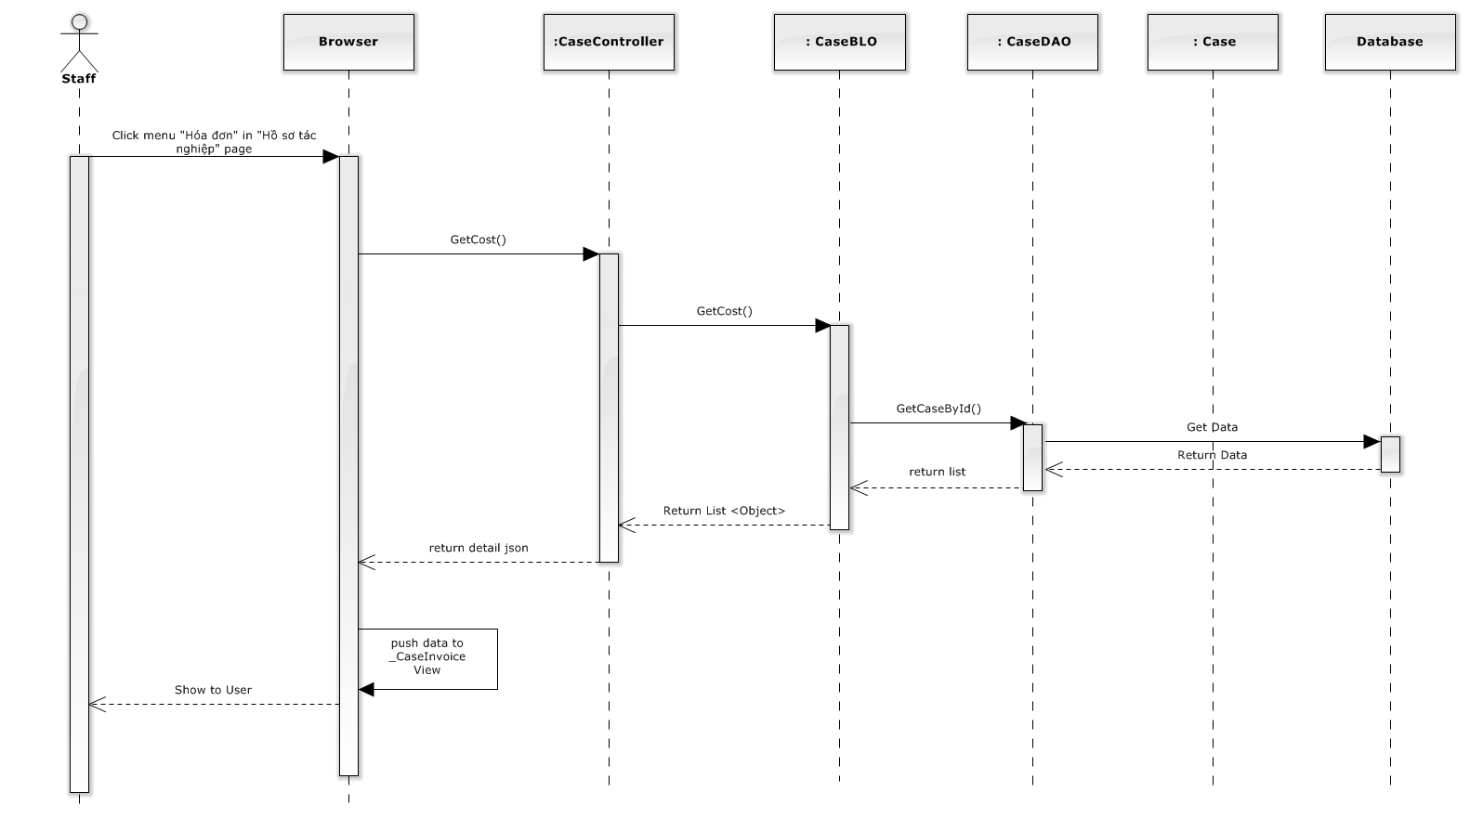

**Figure 4-66: View used service sequence diagram**

###### Add invoice

Screen design

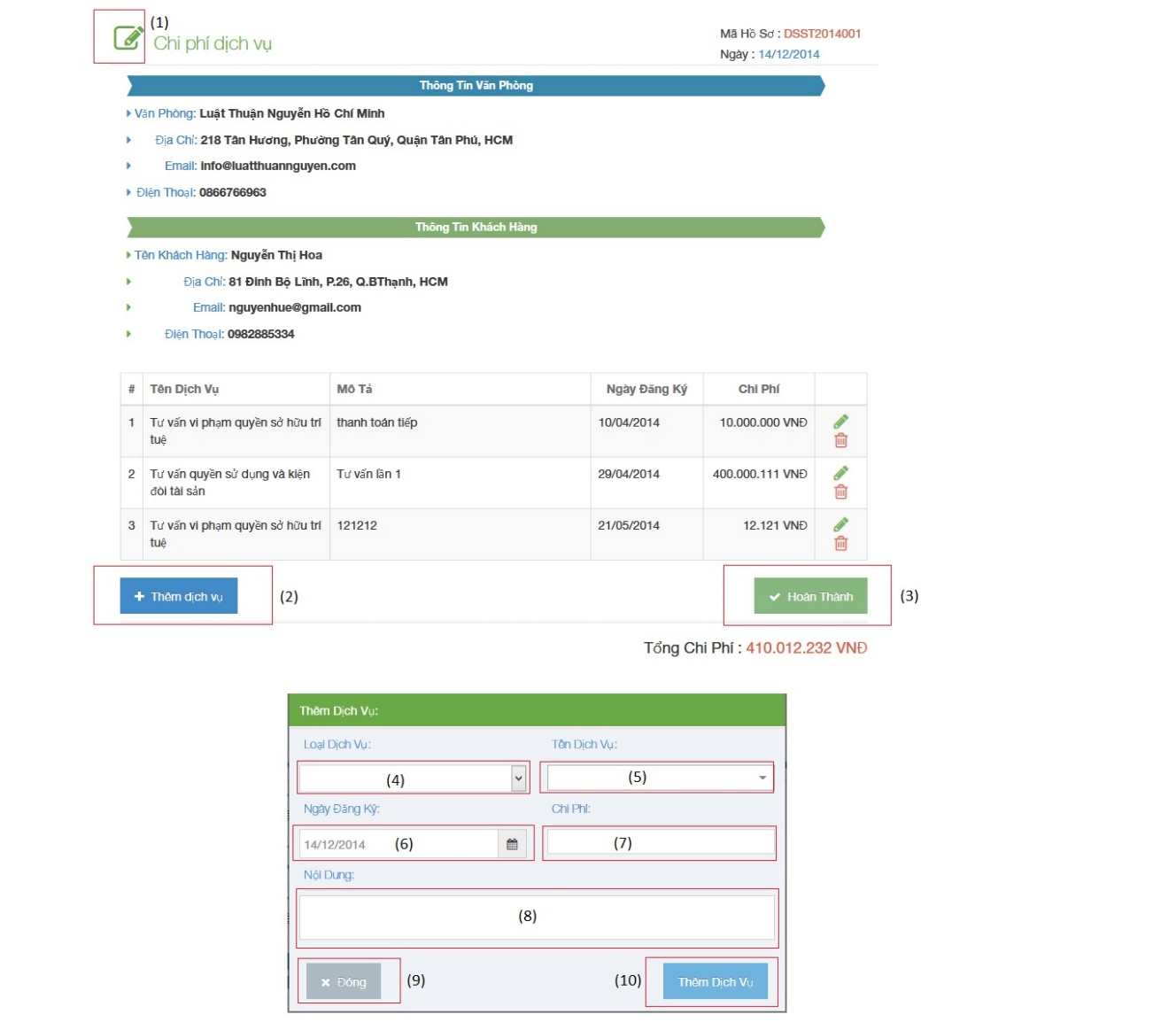

**Figure 4-67: Add invoice image**

|  |  |  |  |  |
| --- | --- | --- | --- | --- |
| No | Object/ControlName | Type | Required | Description |
| 1 | Edit | Button | Yes | Must be click to edit invoice |
| 2 | “Thêm dịch vụ” | Button | Yes | Click to open pop-up create new invoice |
| 3 | “Hoàn thành” | Button | Yes | Click to finish add new invoice |
| 4 | “Loại dịch vụ” | Textbox | Yes | Type of service |
| 5 | “Tên dịch vụ” | Textbox | Yes | Name of service |
| 6 | “Ngày đăng ký” | Textbox | Yes | Registration Date |
| 7 | “Chi phí” | Textbox | Yes | Costs of invoice |
| 8 | “Nội dung” | Textbox | Yes | Content of invoice |
| 9 | “Đóng” | Button | Yes | Click to close pop-up add new invoice |
| 10 | “Thêm mới” | Button | Yes | Click to add new invoice |

Sequence diagram

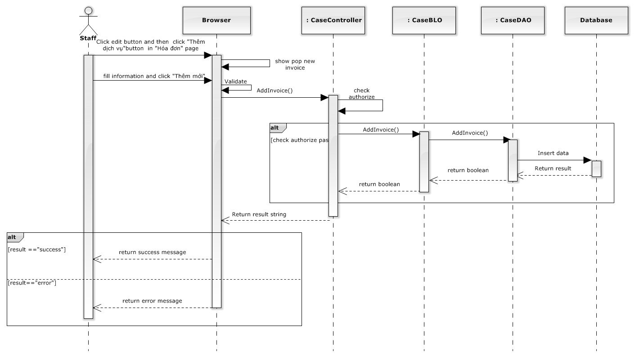

**Figure 4-68: Add invoice sequence diagram**

###### Update invoice

Screen design

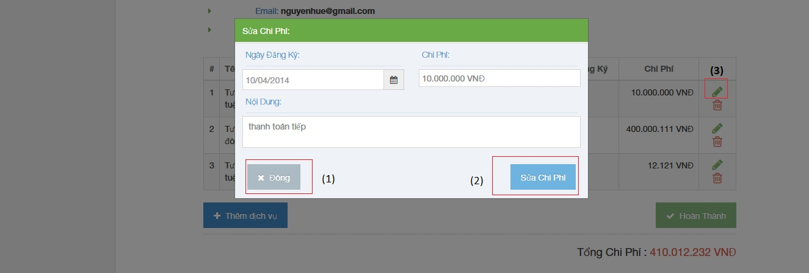

**Figure 4-69: Update invoice image**

|  |  |  |  |  |
| --- | --- | --- | --- | --- |
| No | Object/ControlName | Type | Required | Description |
| 1 | “Đóng” | Button | Yes | Click to close update invoice |
| 2 | “Sửa chi phí” | Button | Yes | Click to confirm update invoice |
| 3 | Edit | Icon | Yes | Click to show pop up update invoice |

Sequence diagram

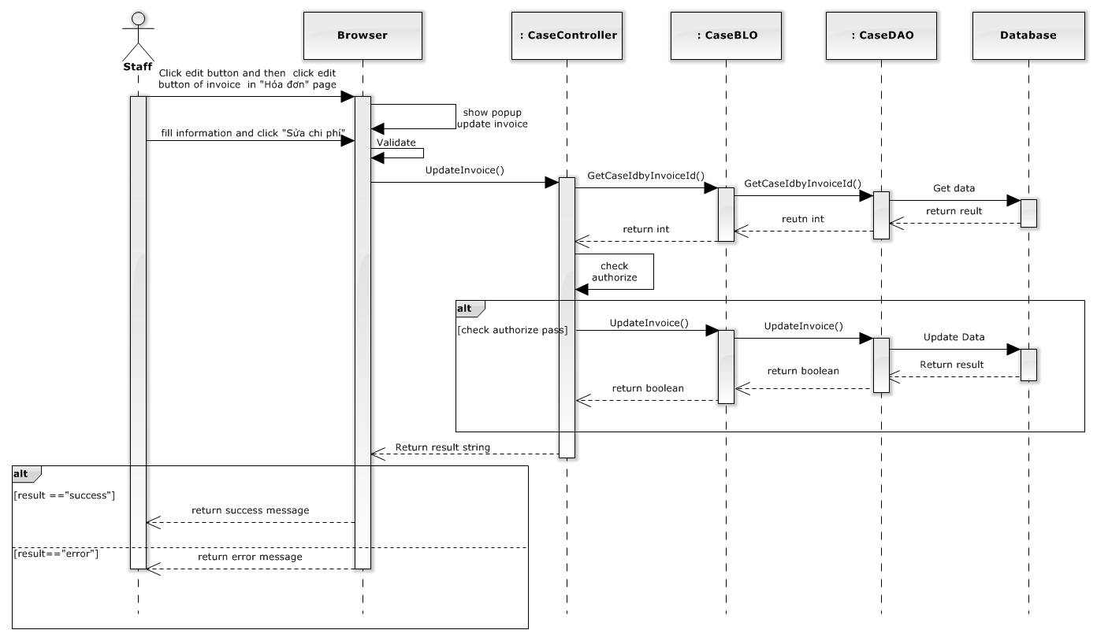

**Figure 4-70: Update invoice sequence diagram**

###### Delete invoice

Screen design

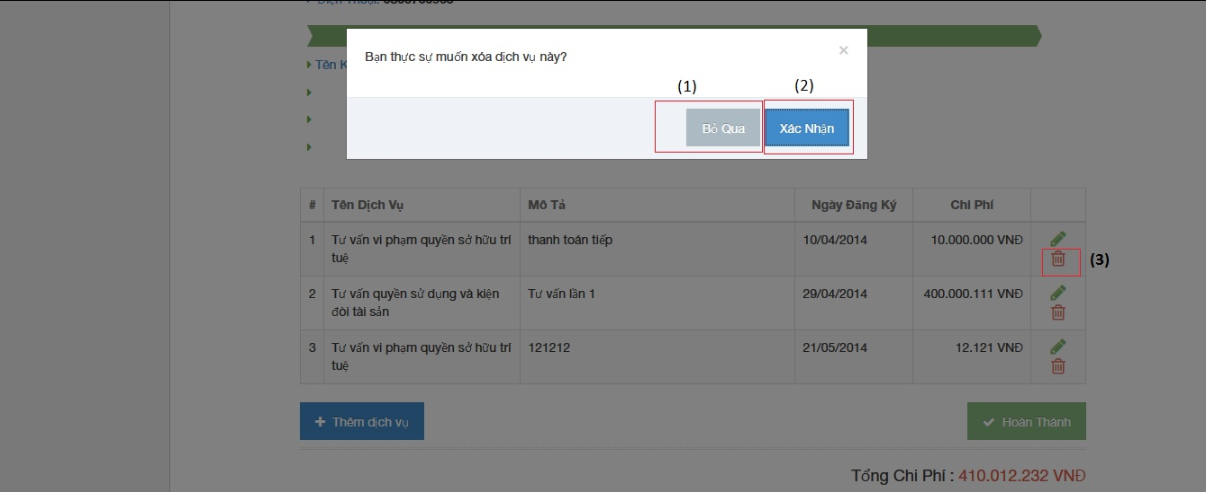

**Figure 4-71: Delete invoice image**

|  |  |  |  |  |
| --- | --- | --- | --- | --- |
| No | Object/ControlName | Type | Required | Description |
| 1 | “Bỏ qua” | Button | Yes | Click to close delete invoice |
| 2 | “Xác nhận” | Button | Yes | Click to confirm delete invoice |
| 3 | Trash | Button | Yes | Click to show pop up delete invoice |

Sequence diagram

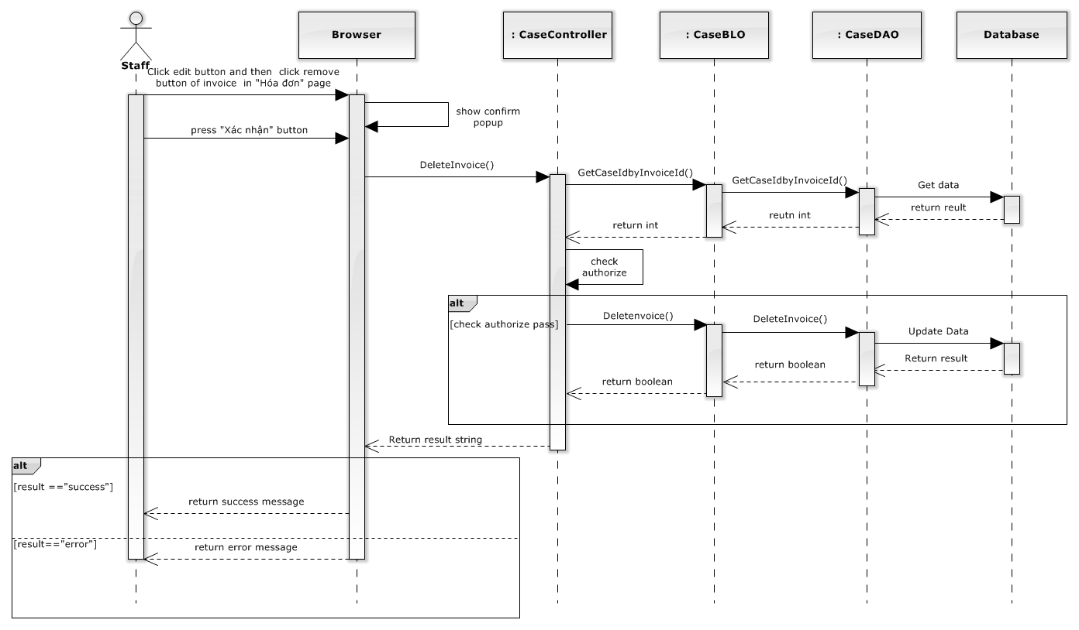

**Figure 4-72: Delete invoice sequence diagram**

##### Manage Payment

###### View payment

Screen design

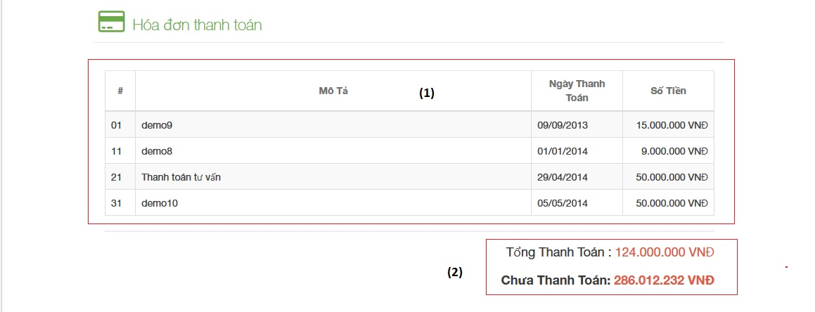

**Figure 4-73: View payment image**

|  |  |  |  |  |
| --- | --- | --- | --- | --- |
| No | Object/ControlName | Type | Required | Description |
| 1 | List all payment information | Table | Yes | List all payment information |
| 2 | List total cost has paid and not has paid | Label | Yes | List total cost has paid and not has paid |

Sequence diagram



**Figure 4-74: View payment sequence diagram**

###### Add payment

Screen design

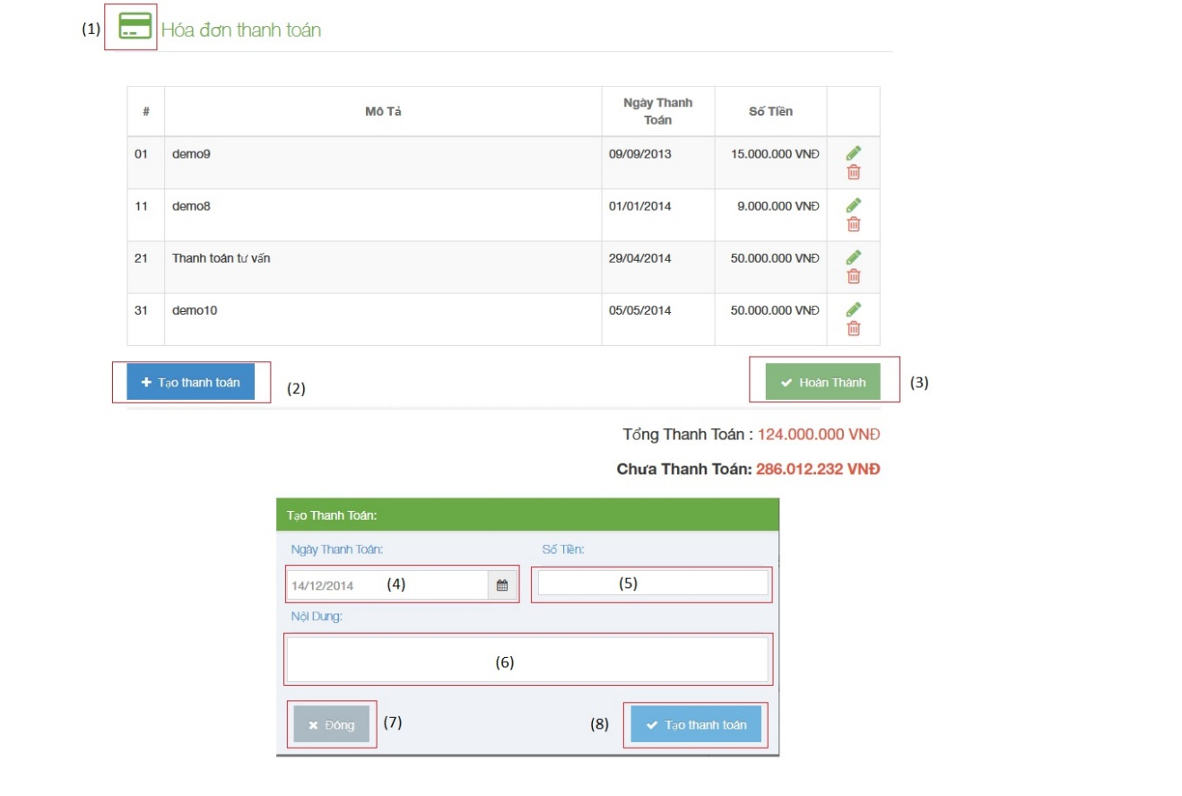

**Figure 4-75: Add payment image**

|  |  |  |  |  |
| --- | --- | --- | --- | --- |
| No | Object/ControlName | Type | Required | Description |
| 1 | Edit | Button | Yes | Must be click to edit payment |
| 2 | “Tạo thanh toán” | Button | Yes | Click to open pop-up create new payment |
| 3 | “Hoàn thành” | Button | Yes | Click to finish add new payment |
| 4 | “Ngày thanh toán” | Textbox | Yes | Day of payment |
| 5 | “Số tiền” | Textbox | Yes | Amount of payment |
| 6 | “Nội dung” | Textbox | Yes | Content of payment |
| 7 | “Đóng” | Button | Yes | Click to close pop-up add new payment |
| 8 | “Thêm mới” | Button | Yes | Click to add new payment |

Sequence diagram

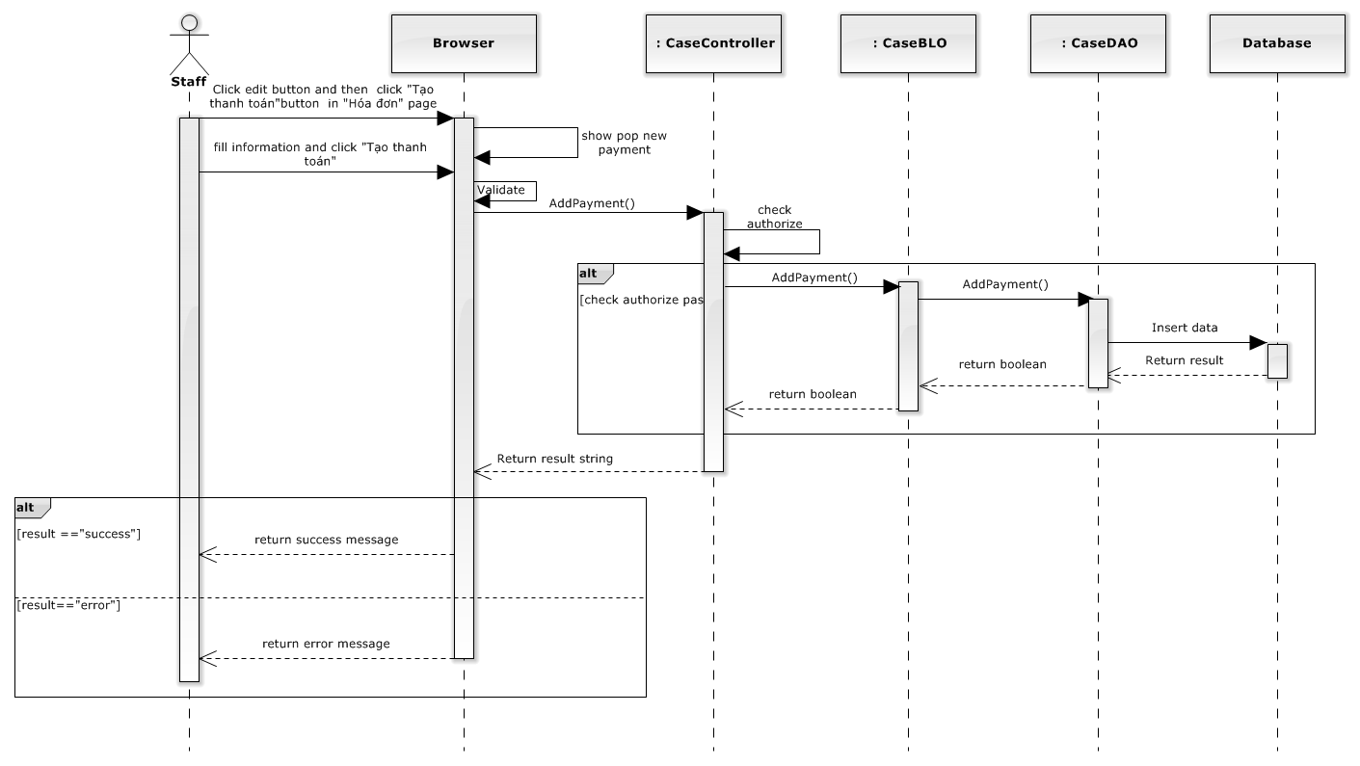

**Figure 4-76: Add payment sequence diagram**

###### Update payment

Screen design

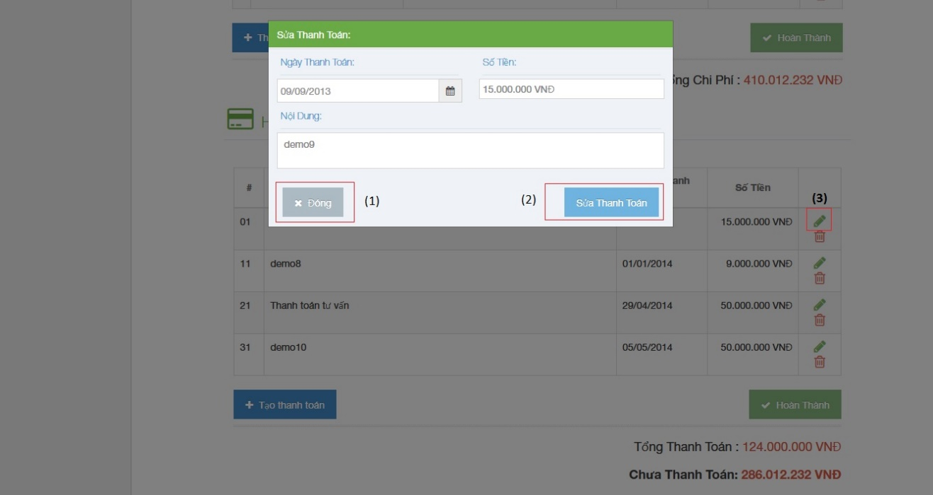

**Figure 4-77: Update payment image**

|  |  |  |  |  |
| --- | --- | --- | --- | --- |
| No | Object/ControlName | Type | Required | Description |
| 1 | “Đóng” | Button | Yes | Click to close update payment |
| 2 | “Sửa thanh toán” | Button | Yes | Click to confirm update payment |
| 3 | Edit | Icon | Yes | Click to show pop up update payment |

Sequence diagram

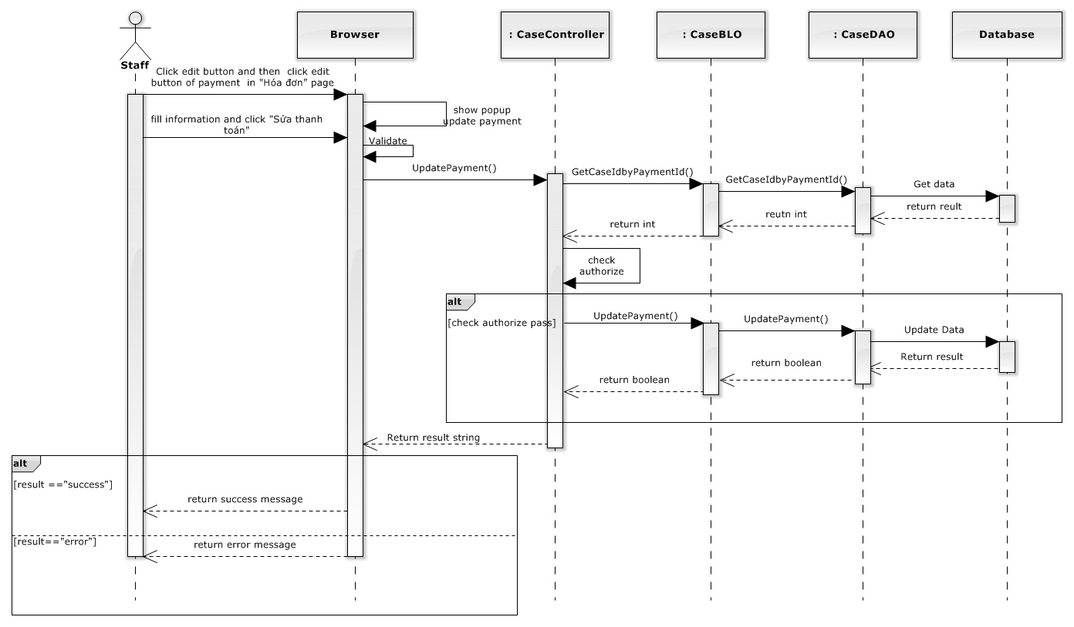

**Figure 4-78: Update payment sequence diagram**

###### Delete payment

Screen design

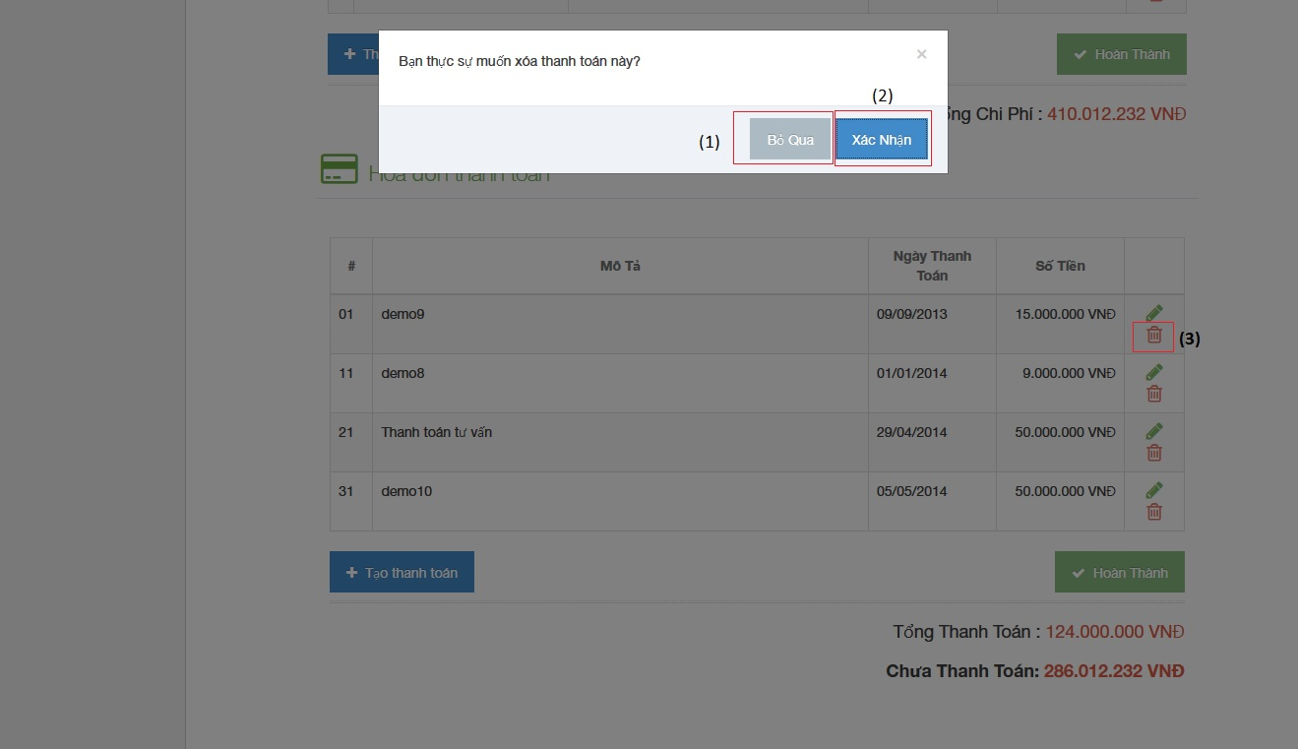

**Figure 4-79: Delete payment image**

|  |  |  |  |  |
| --- | --- | --- | --- | --- |
| No | Object/ControlName | Type | Required | Description |
| 1 | “Bỏ qua” | Button | Yes | Click to close delete payment |
| 2 | “Xác nhận” | Button | Yes | Click to confirm delete payment |
| 3 | Trash | Button | Yes | Click to show pop up delete payment |

Sequence diagram

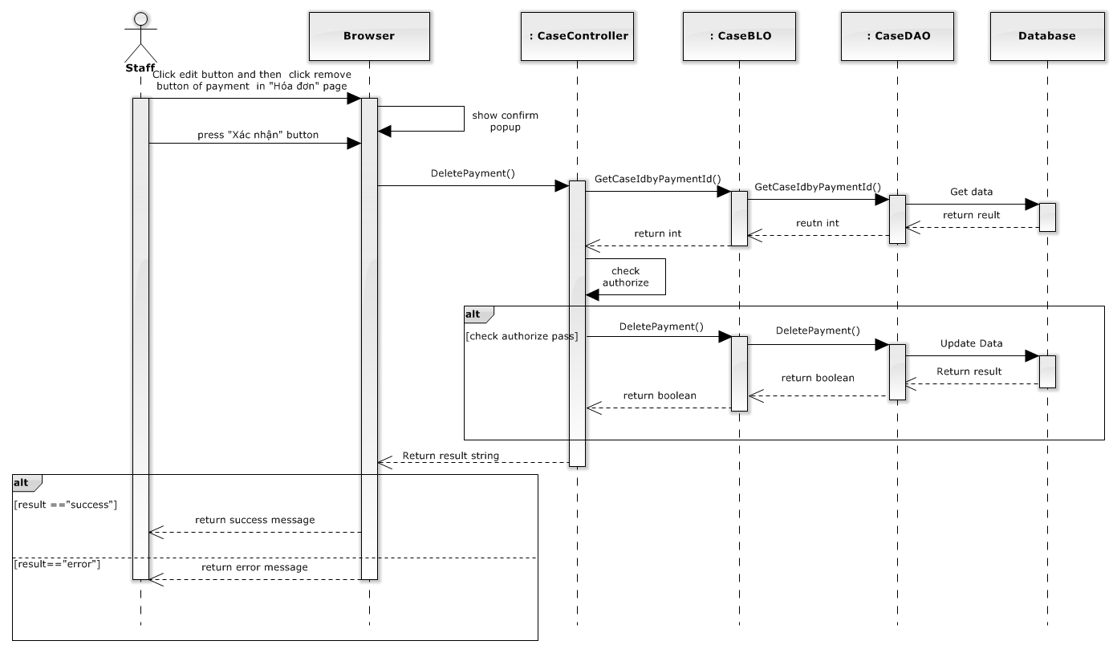

**Figure 4-80: Delete payment sequence diagram**

### Manage Customer Group

#### List customer group

##### Class diagram

**Figure 4-81: List customer group class diagram**

##### Screen design

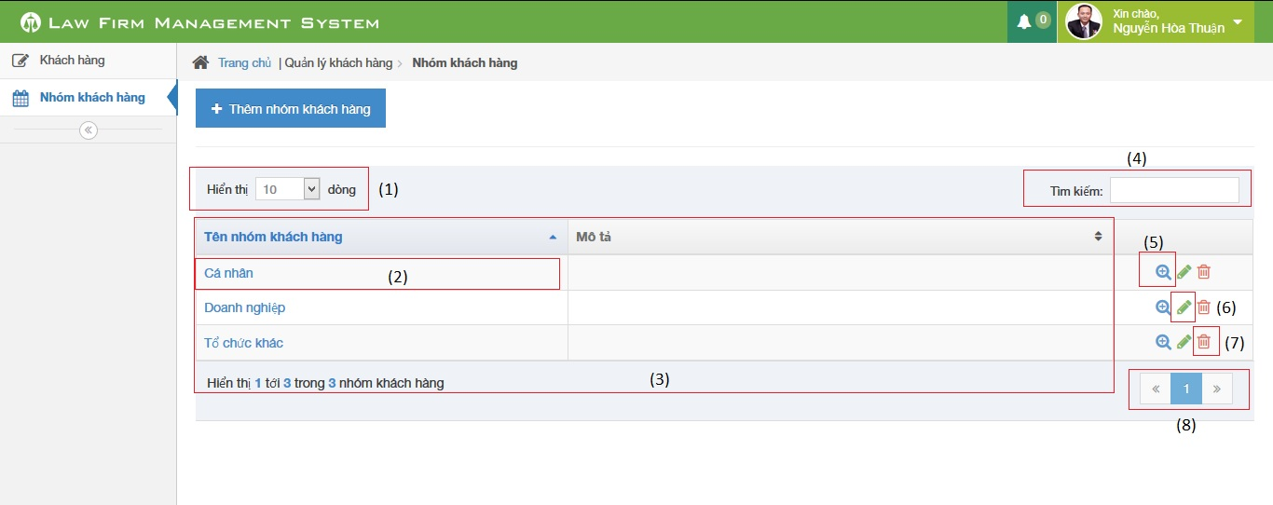

**Figure 4-82: List customer group image**

|  |  |  |  |  |
| --- | --- | --- | --- | --- |
| No | Object/ControlName | Type | Required | Description |
| 1 | Number of rows | Combo-box | Yes | Choose number of rows in table |
| 2 | Name customer group | Text | Yes | Show Customer group detail pop-up |
| 3 | Customer table | Table | Yes | List Customer group |
| 4 | Search | Textbox | Yes | Search customer group |
| 5 | View customer group detail | Icon | Yes | Show Customer group detail pop-up |
| 6 | Delete customer group | Icon | Yes | Delete customer group |
| 7 | Edit customer group | Icon | Yes | Show edit customer group pop-up |
| 8 | Paging | Button | Yes | Paging the customer group list |

##### Sequence diagram

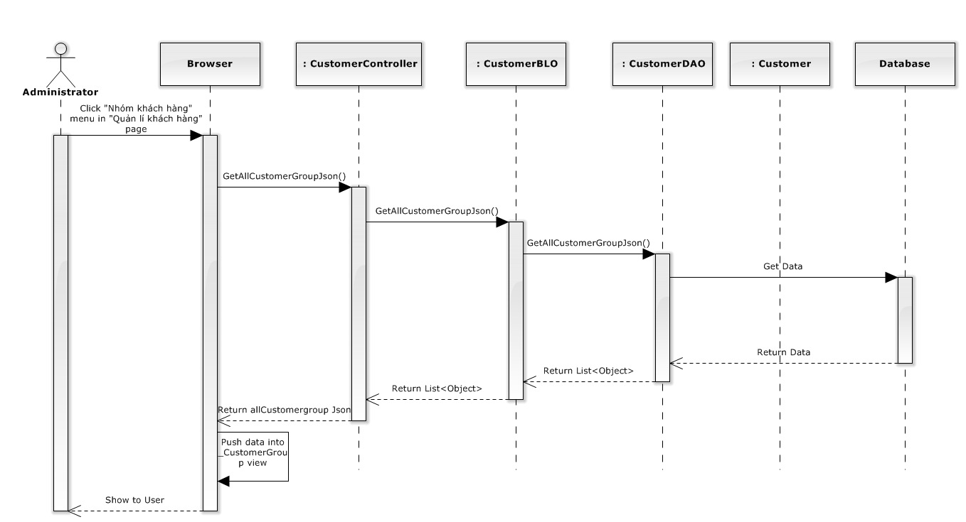

**Figure 4-83: List customer group sequence diagram**

#### Add customer group

##### Screen design

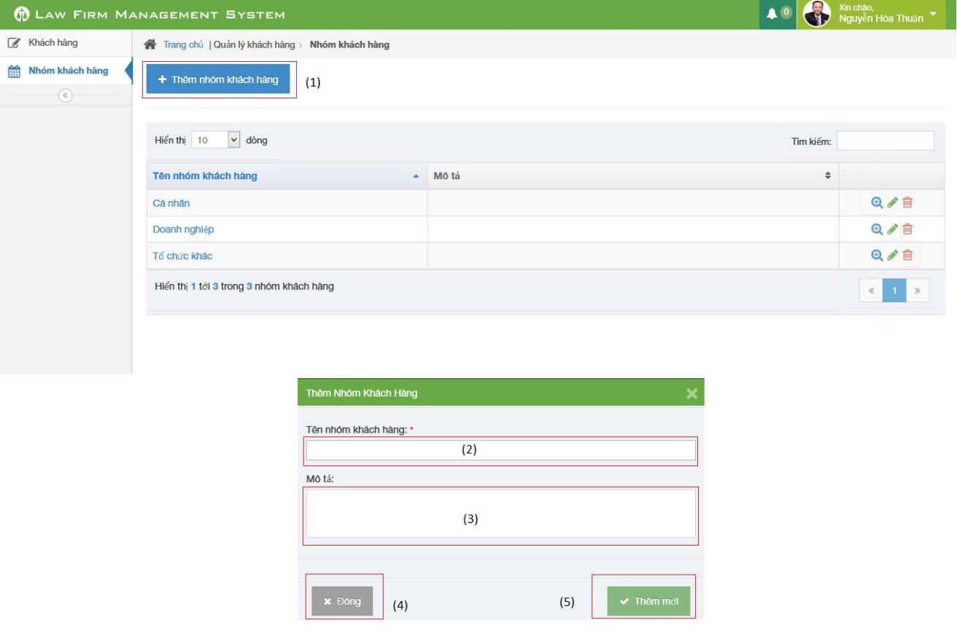

**Figure 4-84: Add customer group image**

|  |  |  |  |  |
| --- | --- | --- | --- | --- |
| No | Object/ControlName | Type | Required | Description |
| 1 | “Thêm nhóm khách hàng” | Button | Yes | Click to open pop-up create new customer group |
| 2 | “Tên nhóm khách hàng” | Textbox | Yes | Name of customer group |
| 3 | “Mô tả” | Textbox | Yes | Description of customer group |
| 4 | “Đóng” | Button | Yes | Click to close pop-up add new customer group |
| 5 | “Thêm mới” | Button | Yes | Click to add new customer group |

##### Sequence diagram

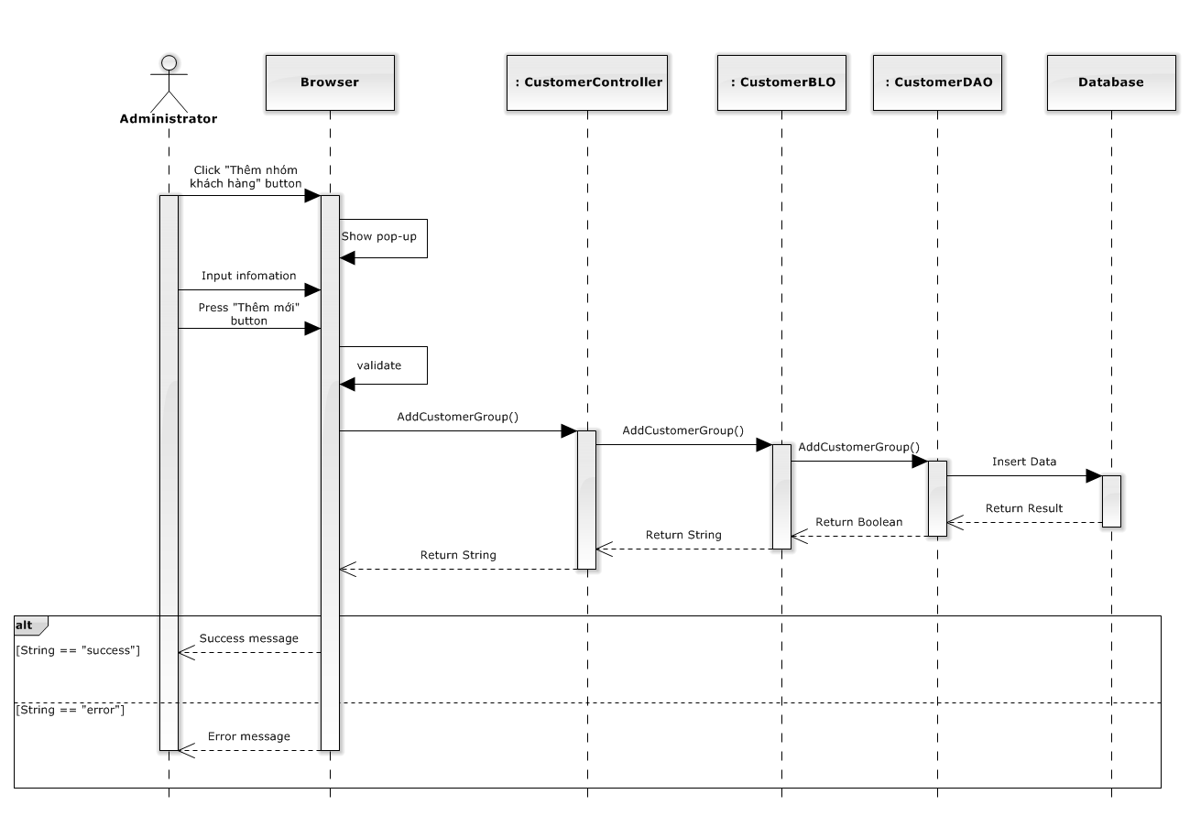

**Figure 4-85: Add customer group sequence diagram**

#### Edit customer group

##### Screen design

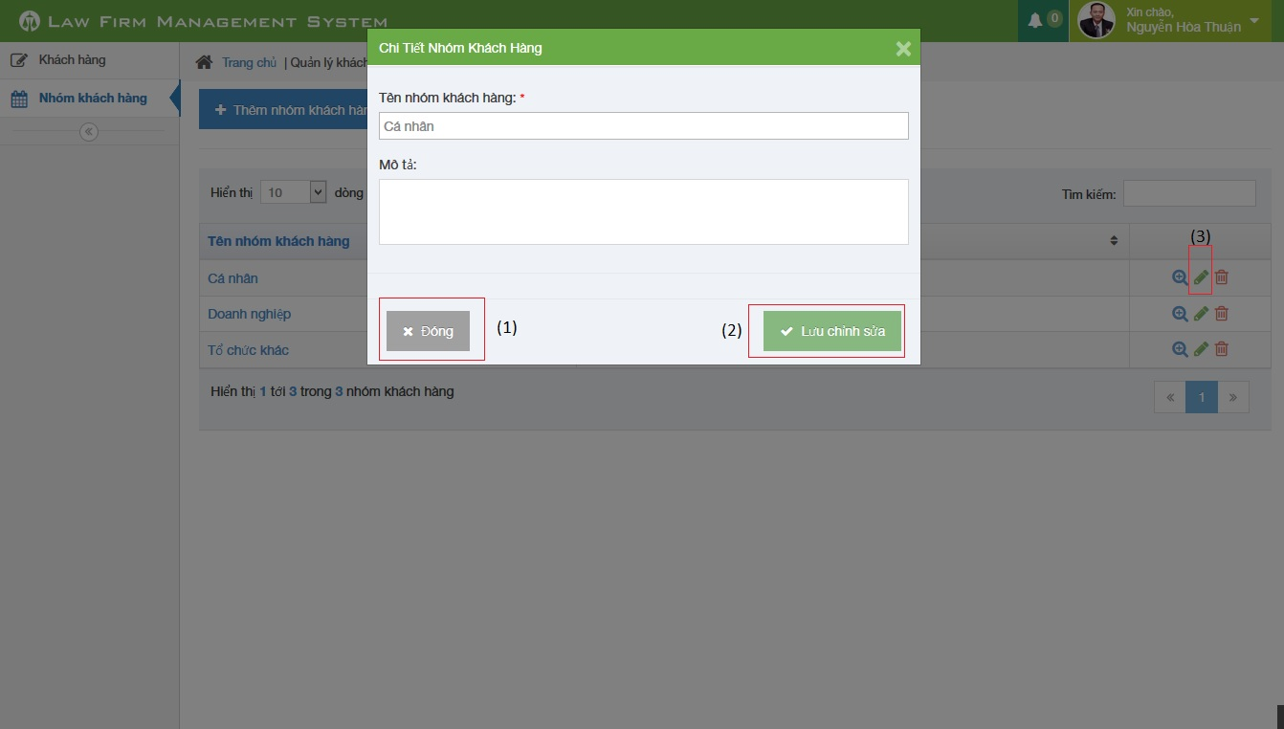

**Figure 4-86: Edit customer group image**

|  |  |  |  |  |
| --- | --- | --- | --- | --- |
| No | Object/ControlName | Type | Required | Description |
| 1 | “Đóng” | Button | Yes | Click to close update customer group |
| 2 | “Lưu chỉnh sửa” | Button | Yes | Click to confirm update customer group |
| 3 | Edit | Icon | Yes | Click to show pop up update customer group |

##### Sequence diagram

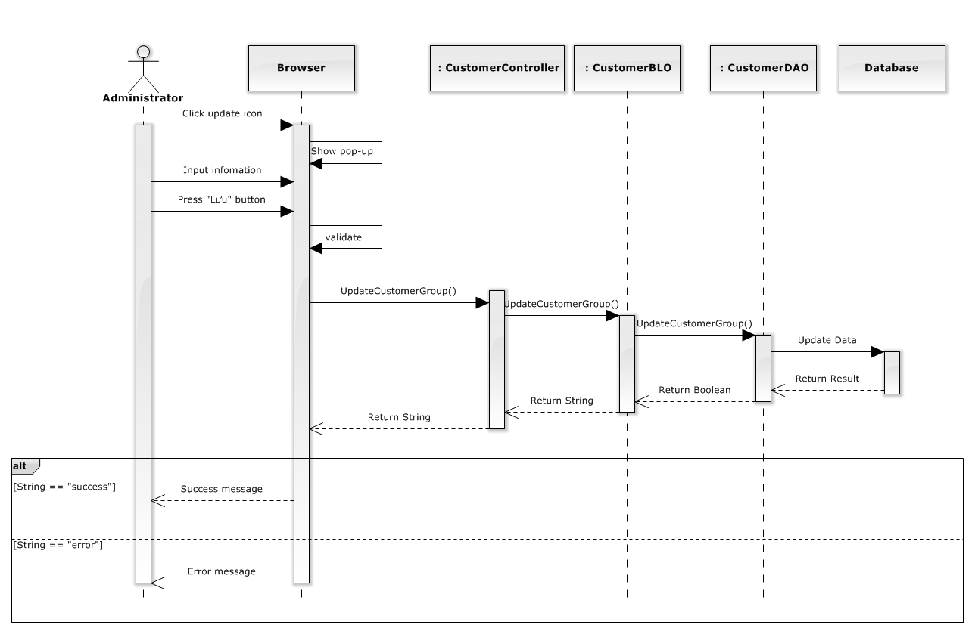

**Figure 4-87: Edit customer group sequence diagram**

#### Delete customer group

##### Screen design

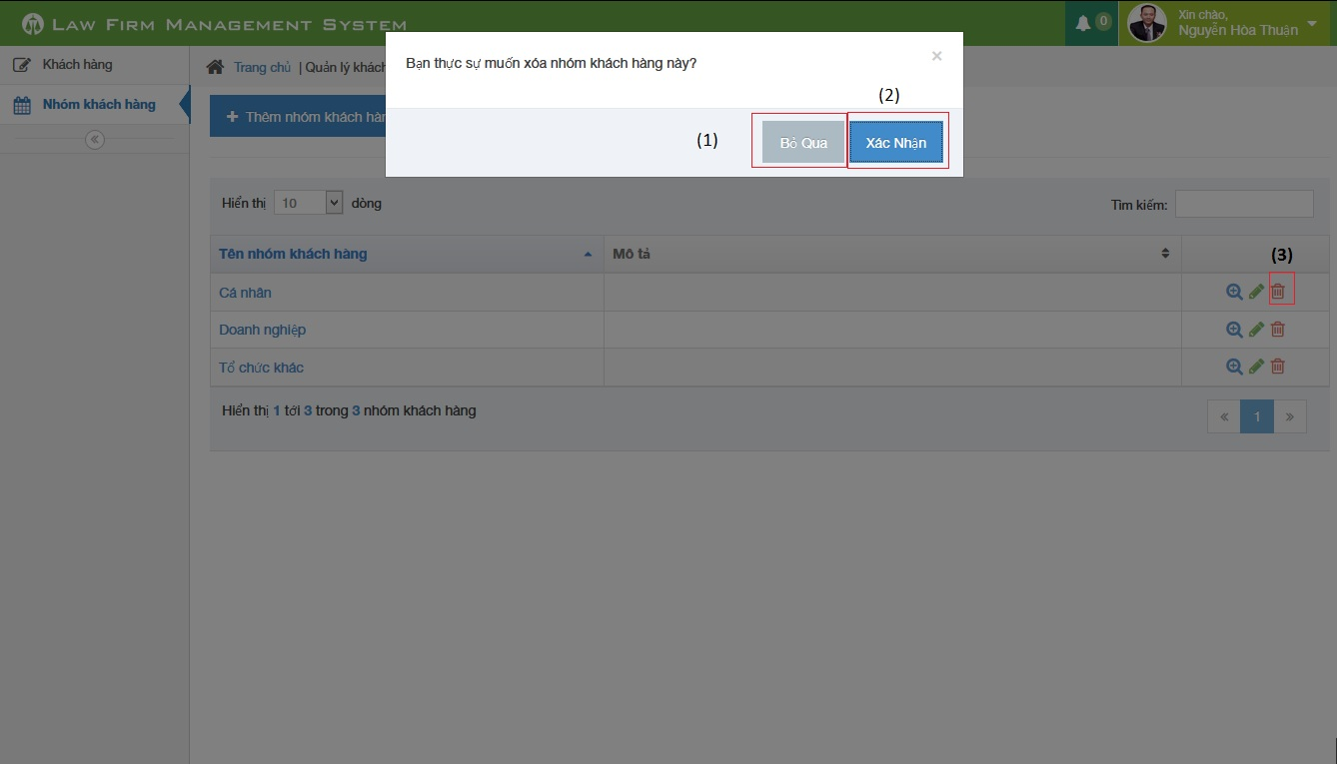

**Figure 4-88: Delete customer group image**

|  |  |  |  |  |
| --- | --- | --- | --- | --- |
| No | Object/ControlName | Type | Required | Description |
| 1 | “Bỏ qua” | Button | Yes | Click to close delete customer group |
| 2 | “Xác nhận” | Button | Yes | Click to confirm delete customer group |
| 3 | Trash | Button | Yes | Click to show pop up delete customer group |

##### Sequence diagram

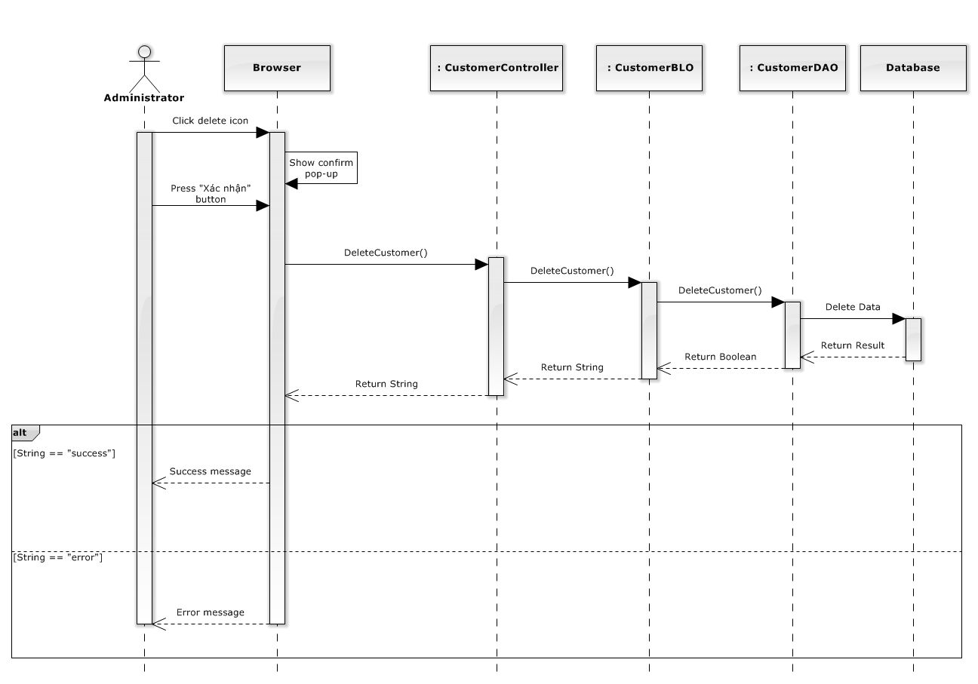

**Figure 4-89: Delete customer group sequence diagram**

### Manage Customer

#### List customers

##### Class diagram

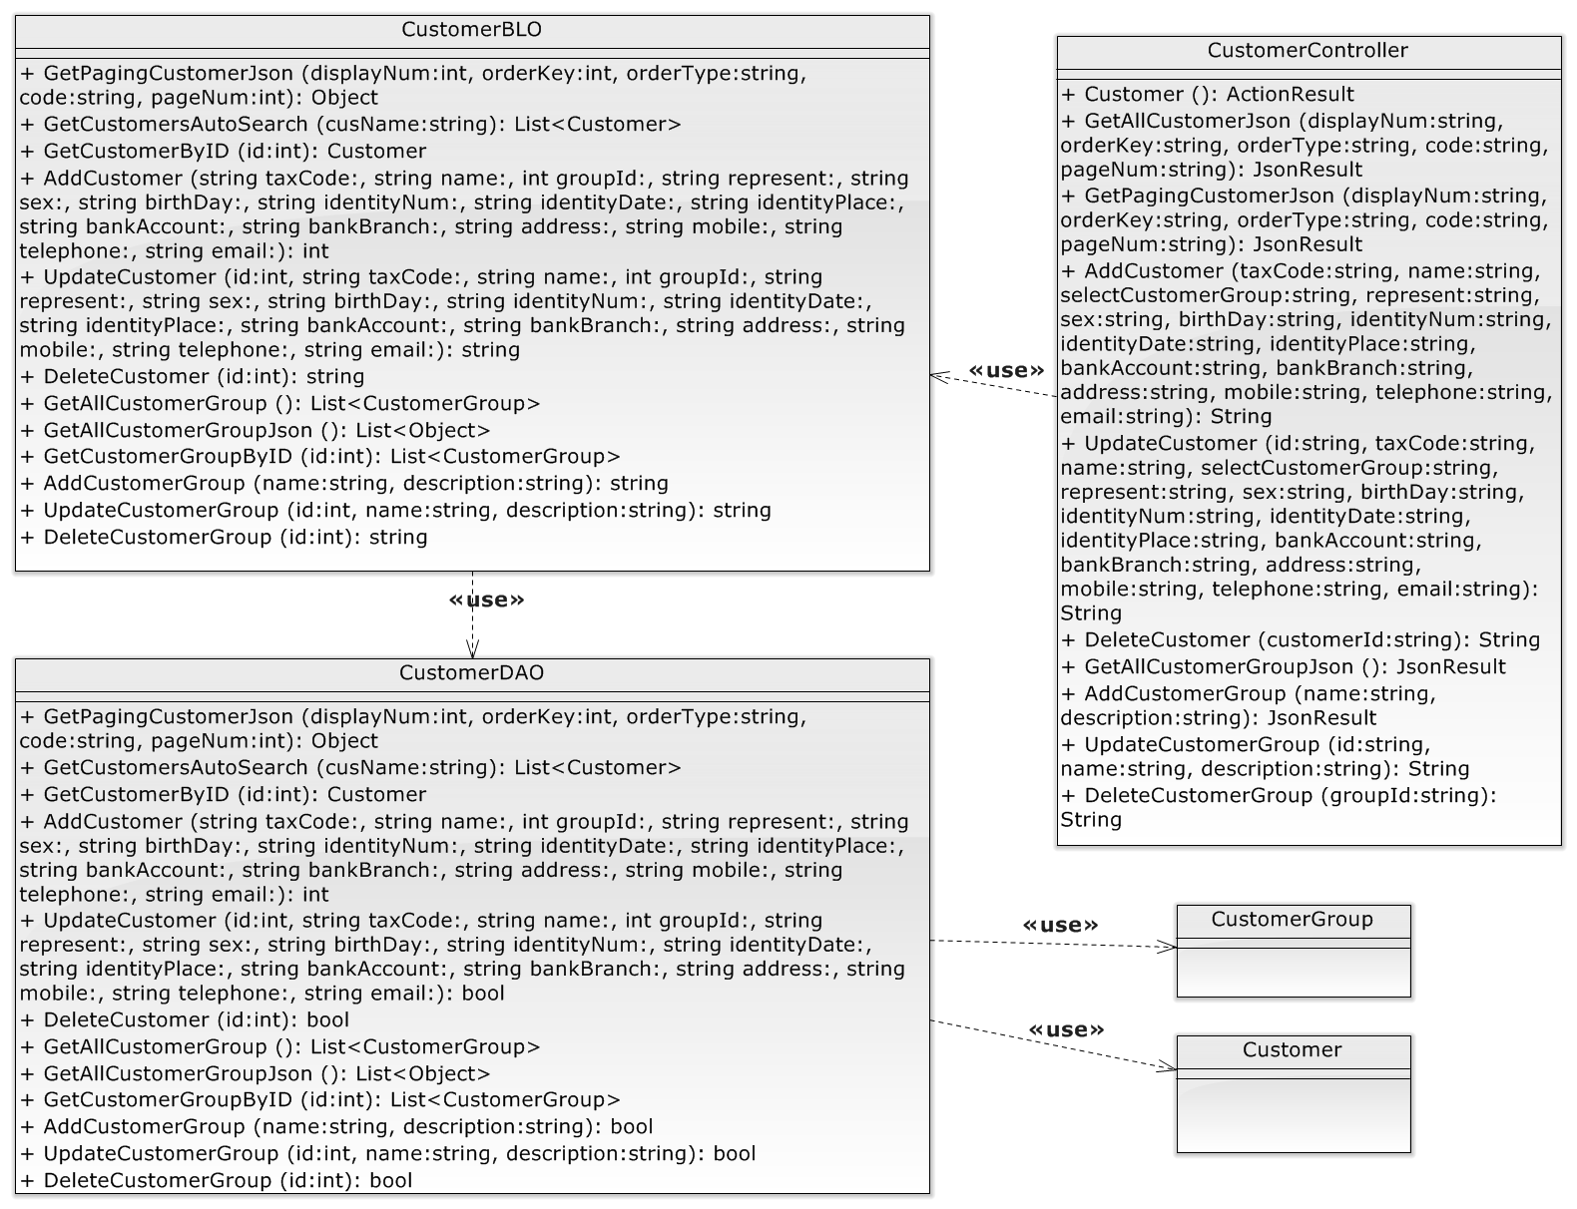

**Figure 4-90: Manage customer class diagram**

##### Screen design

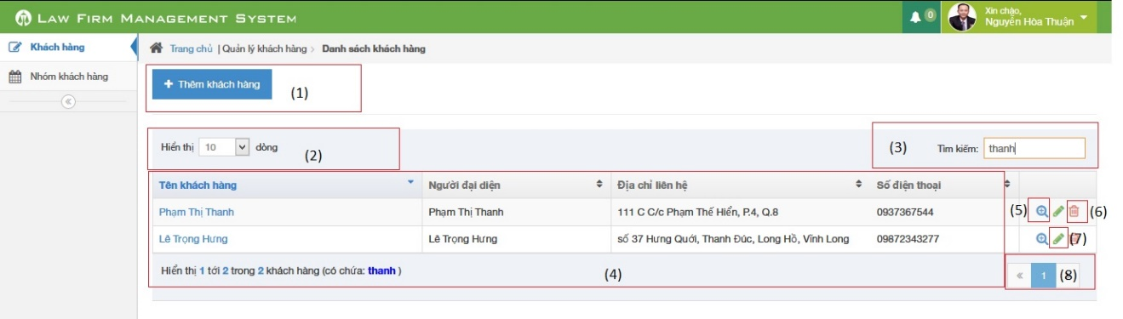

**Figure 4-91: List customer image**

|  |  |  |  |  |
| --- | --- | --- | --- | --- |
| No | Object/ControlName | Type | Required | Description |
| 1 | Thêm khách hàng | Button | Yes | Show Add new customer pop-up |
| 2 | Number of rows | Combo-box | Yes | Choose number of rows in table |
| 3 | Search | Textbox | Yes | Search customer |
| 4 | Customer table | Table | Yes | List Customer |
| 5 | View customer detail | Icon | Yes | Show Customer detail pop-up |
| 6 | Delete customer | Icon | Yes | Delete customer |
| 7 | Edit customer | Icon | Yes | Show edit customer pop-up |
| 8 | Paging | Button | Yes | Paging the customer list |

##### Sequence diagram

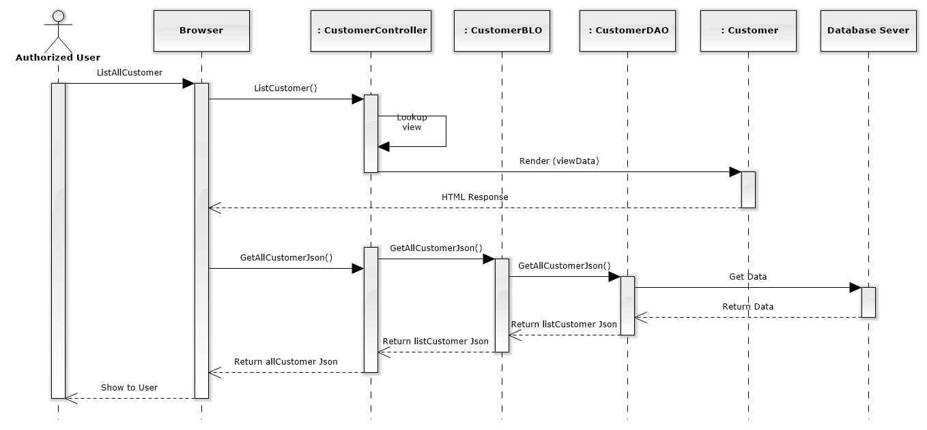

**Figure 4-92: List Customers Sequence Diagram**

#### Add new customer

##### Screen design

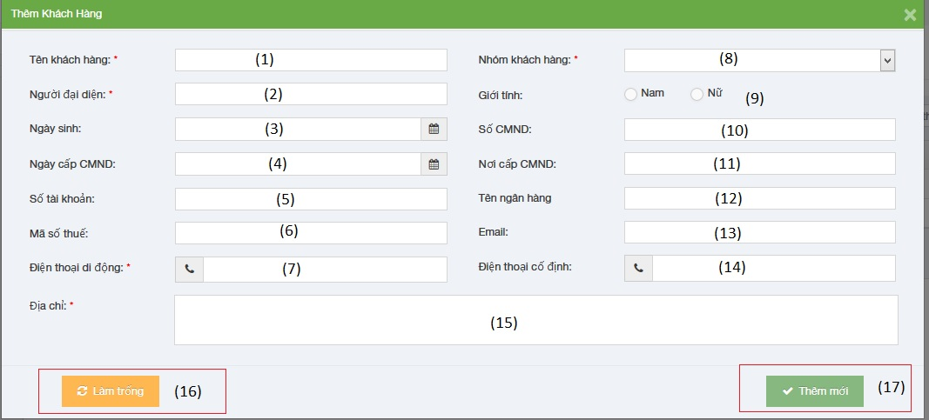

**Figure 4-93: Add new customer image**

|  |  |  |  |  |
| --- | --- | --- | --- | --- |
| No | Object/ControlName | Type | Required | Description |
| 1 | Tên Khách hàng | Textbox | Yes | Customer name |
| 2 | Người đại diện | Textbox | Yes | Presentative |
| 3 | Ngày sinh | Date picker | Yes | Date of Birth |
| 4 | Ngày cấp CMND | Date picker | Yes | Identity Date |
| 5 | Số tài khoản | Textbox | Yes | Bank account |
| 6 | Mã số thuế | Textbox | Yes | Tax code |
| 7 | Điện thoại di động | Textbox | Yes | Mobile |
| 8 | Nhóm khách hàng | Combo-box | Yes | Customer group |
| 9 | Giới tính | Radio-button | Yes | Gender |
| 10 | Số CMND | Textbox | Yes | Identity Number |
| 11 | Nơi cấp CMND | Textbox | Yes | Identity Place |
| 12 | Tên ngân hàng | Textbox | Yes | Bank Branch |
| 13 | Email | Textbox | Yes | Email |
| 14 | Điện thoại cố định | Textbox | Yes | Phone |
| 15 | Địa chỉ | Text area | Yes | Address |
| 16 | Làm trống | Button | Yes | Clear all field |
| 17 | Thêm mới | Button | Yes | Add new customer |

##### Sequence diagram

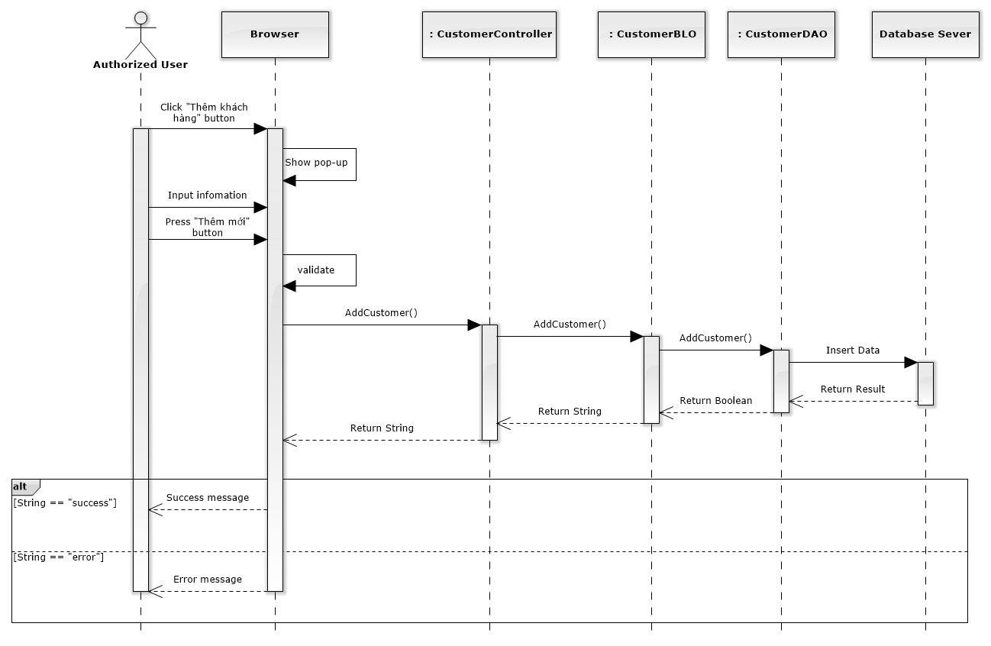

**Figure 4-94: Add New Customer Sequence Diagram**

#### Edit customer

##### Screen design

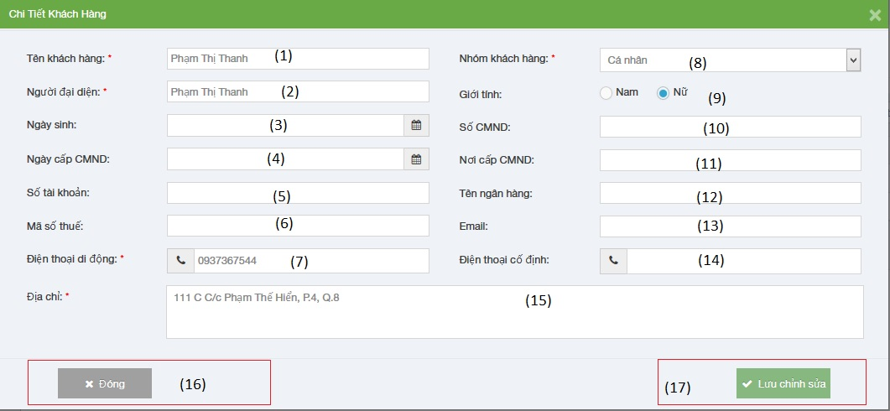

**Figure 4-95: Edit customer image**

|  |  |  |  |  |
| --- | --- | --- | --- | --- |
| No | Object/ControlName | Type | Required | Description |
| 1 | Tên Khách hàng | Textbox | Yes | Customer name |
| 2 | Người đại diện | Textbox | Yes | Presentative |
| 3 | Ngày sinh | Date picker | Yes | Date of Birth |
| 4 | Ngày cấp CMND | Date picker | Yes | Identity Date |
| 5 | Số tài khoản | Textbox | Yes | Bank account |
| 6 | Mã số thuế | Textbox | Yes | Tax code |
| 7 | Điện thoại di động | Textbox | Yes | Mobile |
| 8 | Nhóm khách hàng | Combo-box | Yes | Customer group |
| 9 | Giới tính | Radio-button | Yes | Gender |
| 10 | Số CMND | Textbox | Yes | Identity Number |
| 11 | Nơi cấp CMND | Textbox | Yes | Identity Place |
| 12 | Tên ngân hàng | Textbox | Yes | Bank Branch |
| 13 | Email | Textbox | Yes | Email |
| 14 | Điện thoại cố định | Textbox | Yes | Phone |
| 15 | Địa chỉ | Text area | Yes | Address |
| 16 | Đóng | Button | Yes | Close edit customer |
| 17 | Lưu chỉnh sửa | Button | Yes | Edit customer |

##### Sequence diagram

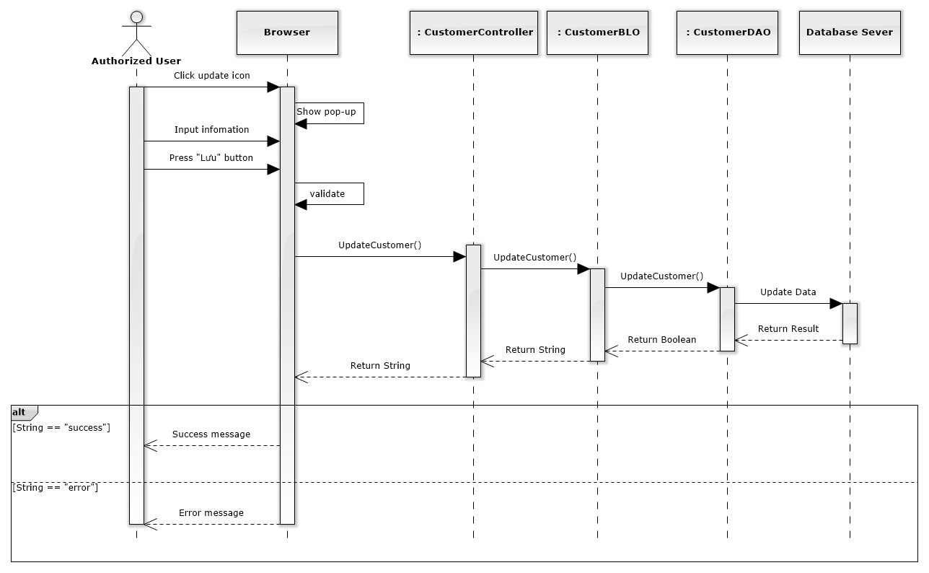

**Figure 4-96: Edit Customer Sequence Diagram**

#### Delete customer

##### Screen design

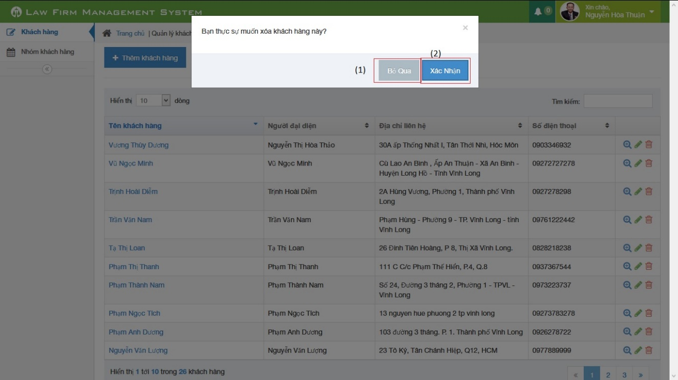

**Figure 4-97: Delete customer image**

|  |  |  |  |  |
| --- | --- | --- | --- | --- |
| No | Object/ControlName | Type | Required | Description |
| 1 | “Bỏ qua” | Button | Yes | Click to close delete customer |
| 2 | “Xác nhận” | Button | Yes | Click to delete customer |

##### Sequence diagram

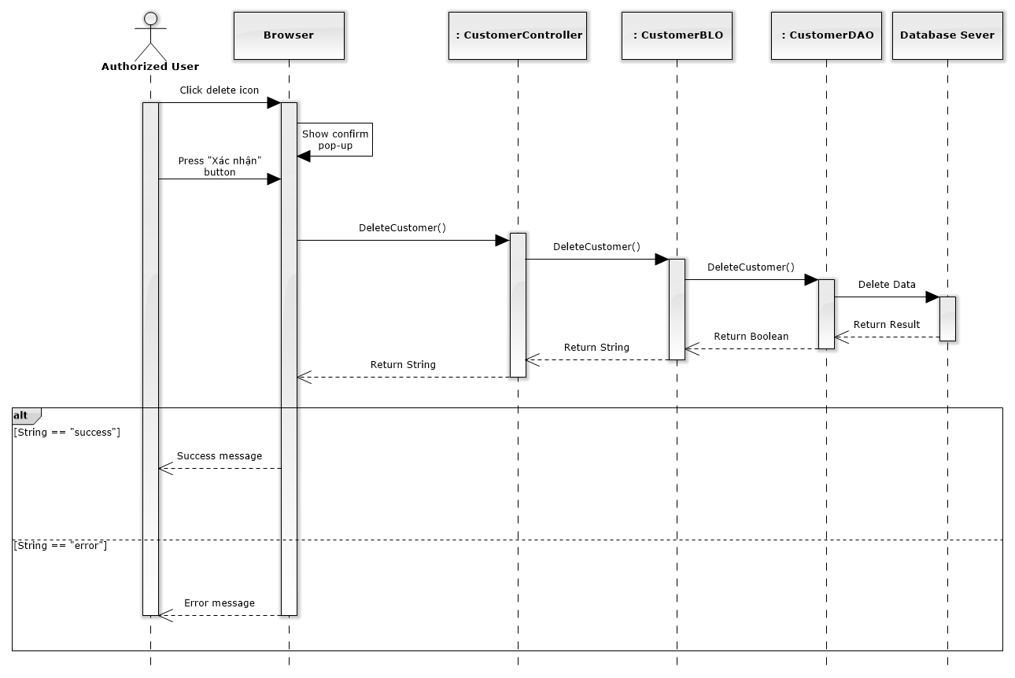

**Figure 4-98: Delete Customer Sequence Diagram**

### Manage Staff Group

#### List staff group

##### Class diagram

**Figure 4-99: Manage staff group class diagram**

##### Screen design

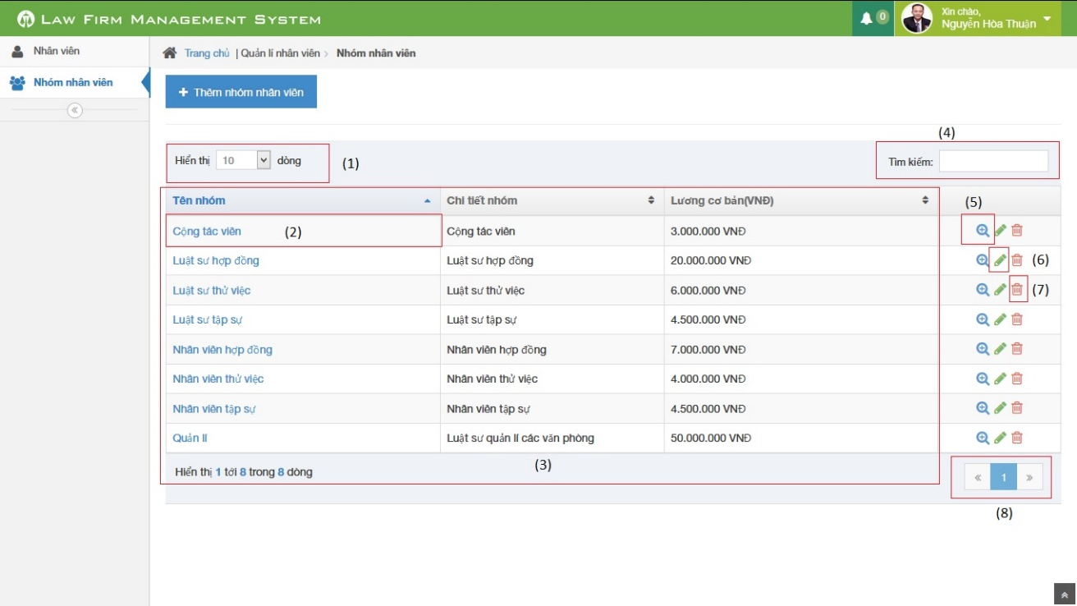

**Figure 4-100: List staff group image**

|  |  |  |  |  |
| --- | --- | --- | --- | --- |
| No | Object/ControlName | Type | Required | Description |
| 1 | Number of rows | Combo-box | Yes | Choose number of rows in table |
| 2 | Name staff group | Text | Yes | Click to show popup detail of staff group |
| 3 | List all staff | Table | Yes | List all staff |
| 4 | Tìm kiếm | Textbox | Yes | Search staff |
| 5 | View | Button | Yes | Click to show popup detail of staff |
| 6 | Edit | Button | Yes | Click to show popup edit detail of staff information. |
| 7 | Delete staff group | Icon | Yes | Delete staff group |
| 8 | Paging | Button | Yes | Paging page |

##### Sequence diagram

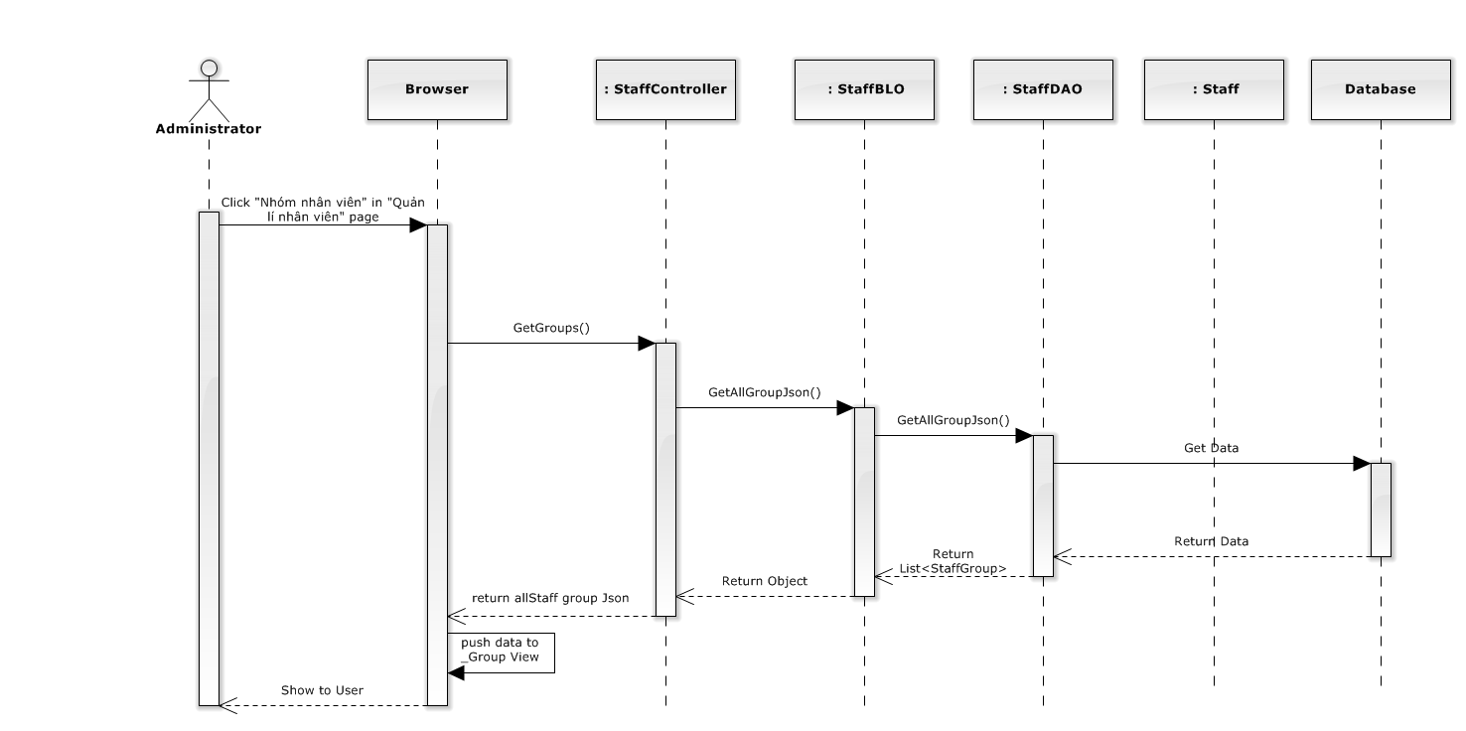

**Figure 4-101: List staff group sequence diagram**

#### Add staff group

##### Screen design

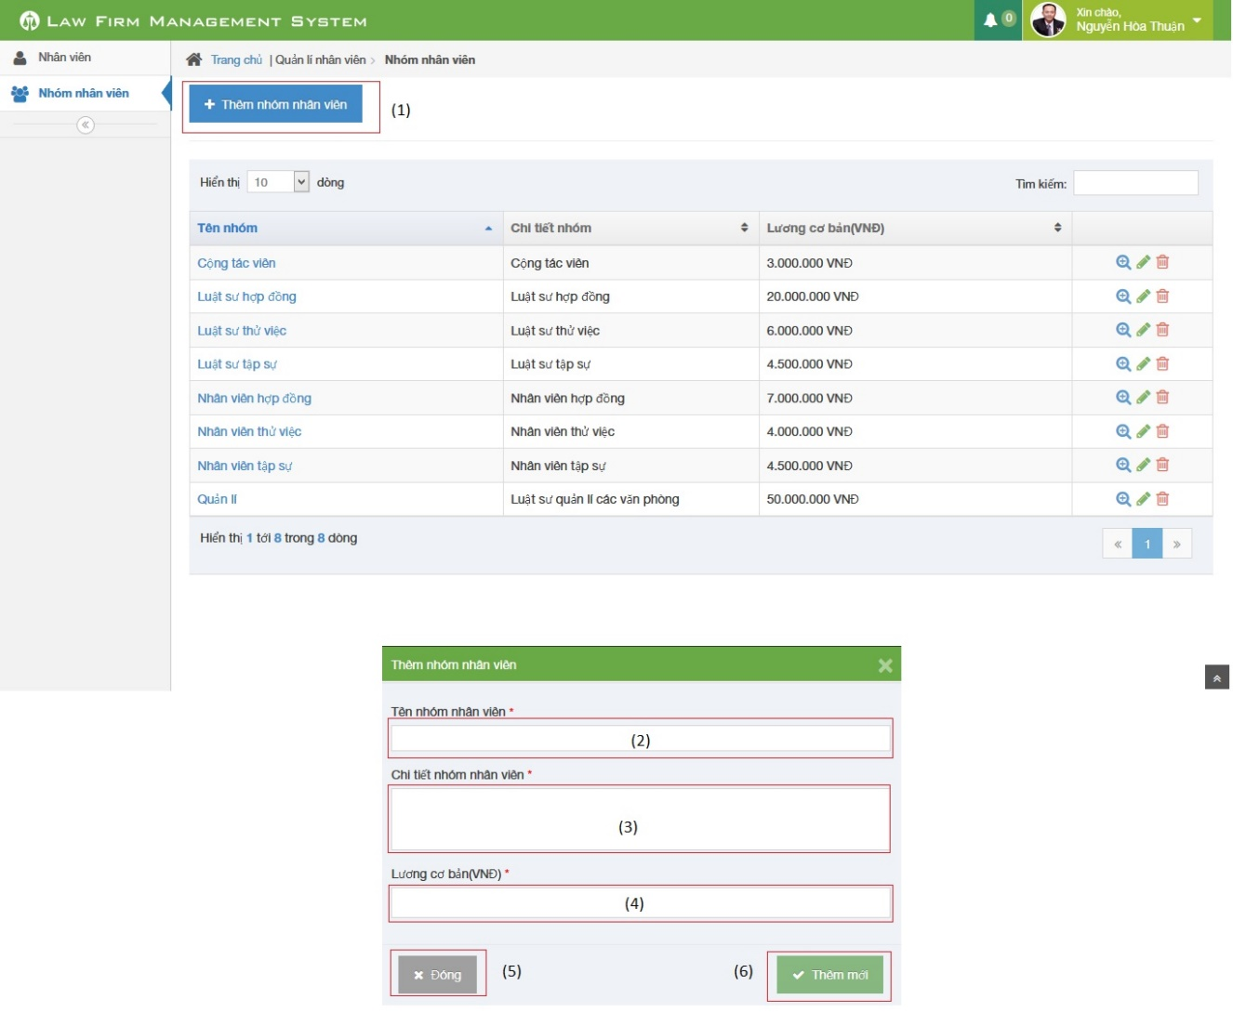

**Figure 4-102: Add staff group image**

|  |  |  |  |  |
| --- | --- | --- | --- | --- |
| No | Object/ControlName | Type | Required | Description |
| 1 | “Thêm nhóm nhân viên” | Button | Yes | Click to open pop-up create new staff group |
| 2 | “Tên nhóm nhân viên” | Textbox | Yes | Name of staff group |
| 3 | “Chi tiết nhóm nhân viên” | Textbox | Yes | Detail of staff group |
| 4 | “Lương cơ bản” | Textbox | Yes | Basic salary of staff group |
| 5 | “Đóng” | Button | Yes | Click to close pop-up add new staff group |
| 6 | “Thêm mới” | Button | Yes | Click to add new staff group |

##### Sequence diagram

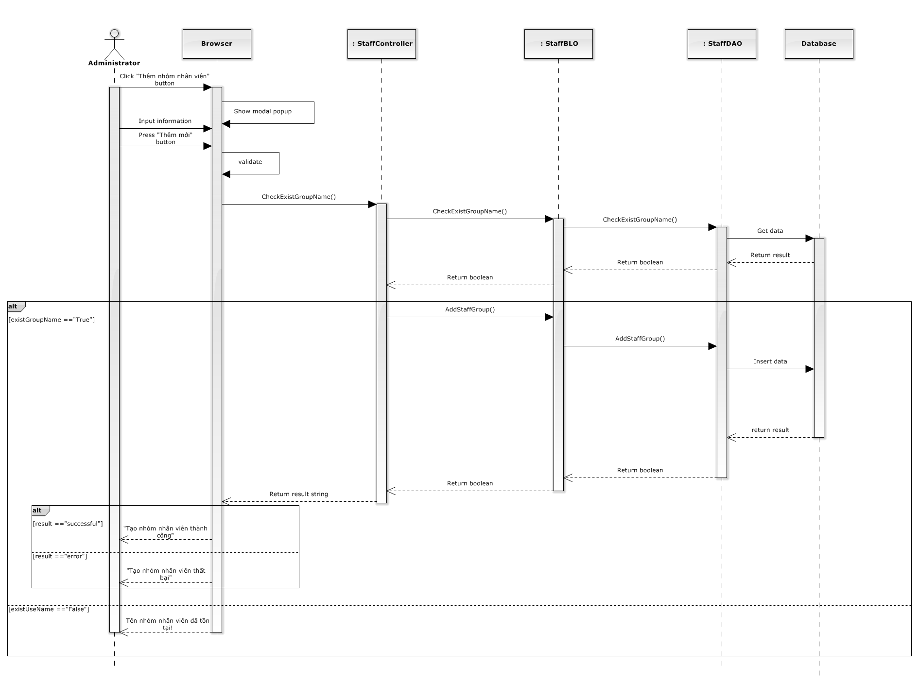

**Figure 4-103: Add staff group sequence diagram**

#### Edit staff group

##### Screen design

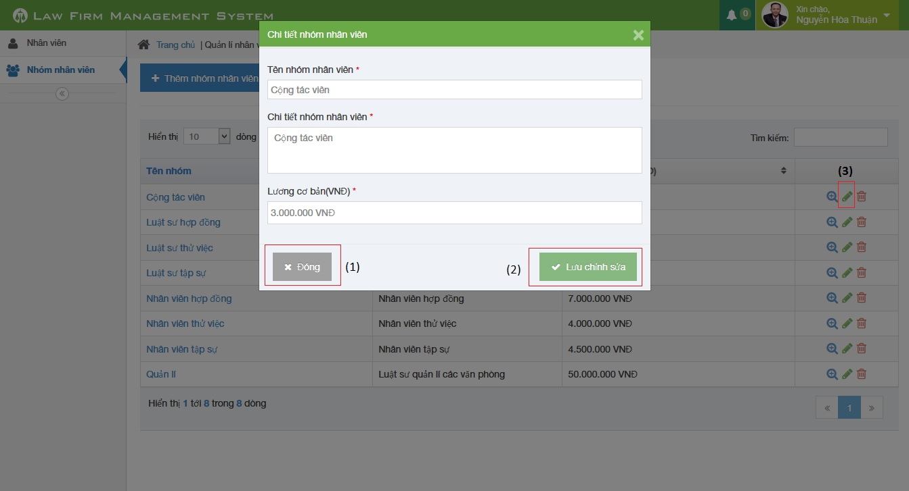

**Figure 4-104: Edit staff group image**

|  |  |  |  |  |
| --- | --- | --- | --- | --- |
| No | Object/ControlName | Type | Required | Description |
| 1 | “Đóng” | Button | Yes | Click to close update staff group |
| 2 | “Lưu chỉnh sửa” | Button | Yes | Click to confirm update staff group |
| 3 | Edit | Icon | Yes | Click to show pop up update staff group |

##### Sequence diagram

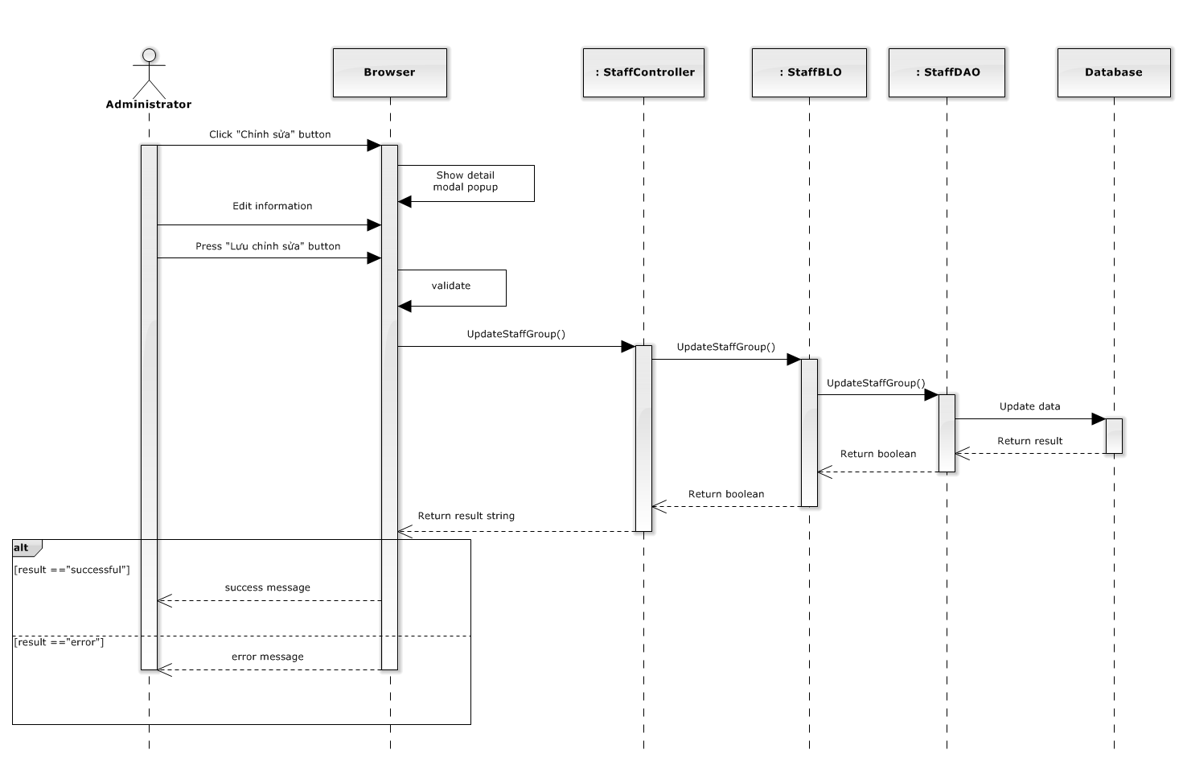

**Figure 4-105: Edit staff group sequence diagram**

#### Delete staff group

##### Screen design

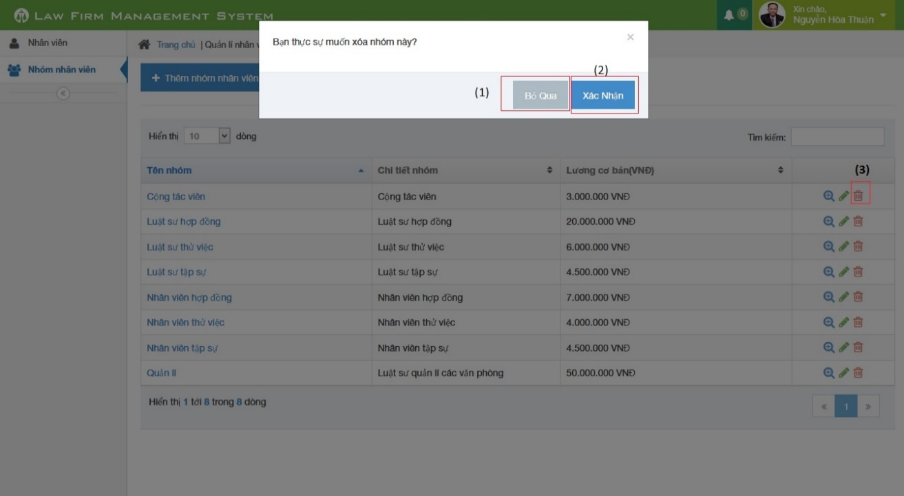

**Figure 4-106: Delete staff group image**

|  |  |  |  |  |
| --- | --- | --- | --- | --- |
| No | Object/ControlName | Type | Required | Description |
| 1 | “Bỏ qua” | Button | Yes | Click to close delete staff group |
| 2 | “Xác nhận” | Button | Yes | Click to confirm delete staff group |
| 3 | Trash | Button | Yes | Click to show pop up delete staff group |

##### Sequence diagram

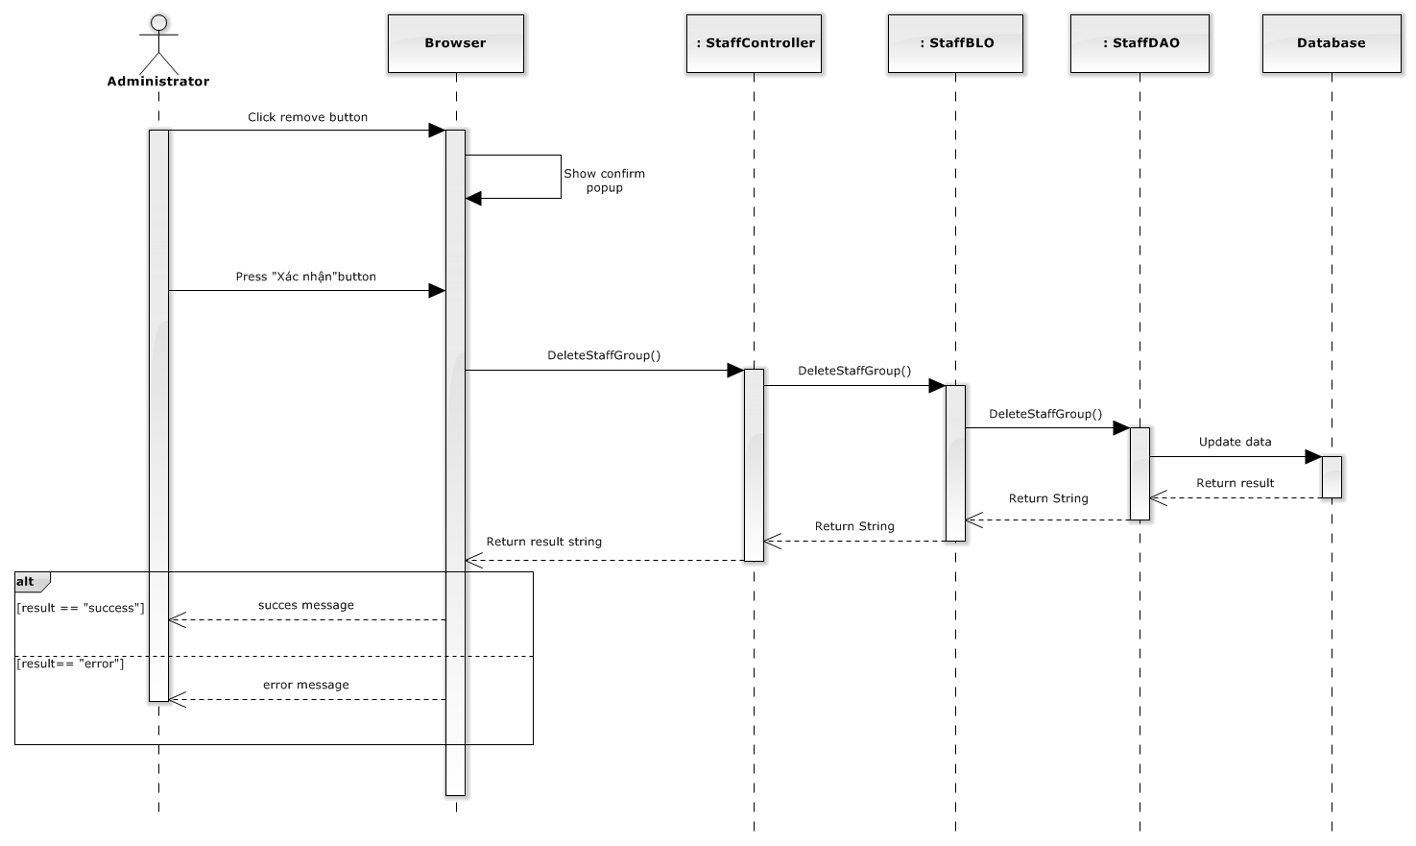

**Figure 4-107: Delete staff group sequence diagram**

### Manage Staff

#### List staffs

##### Class diagram

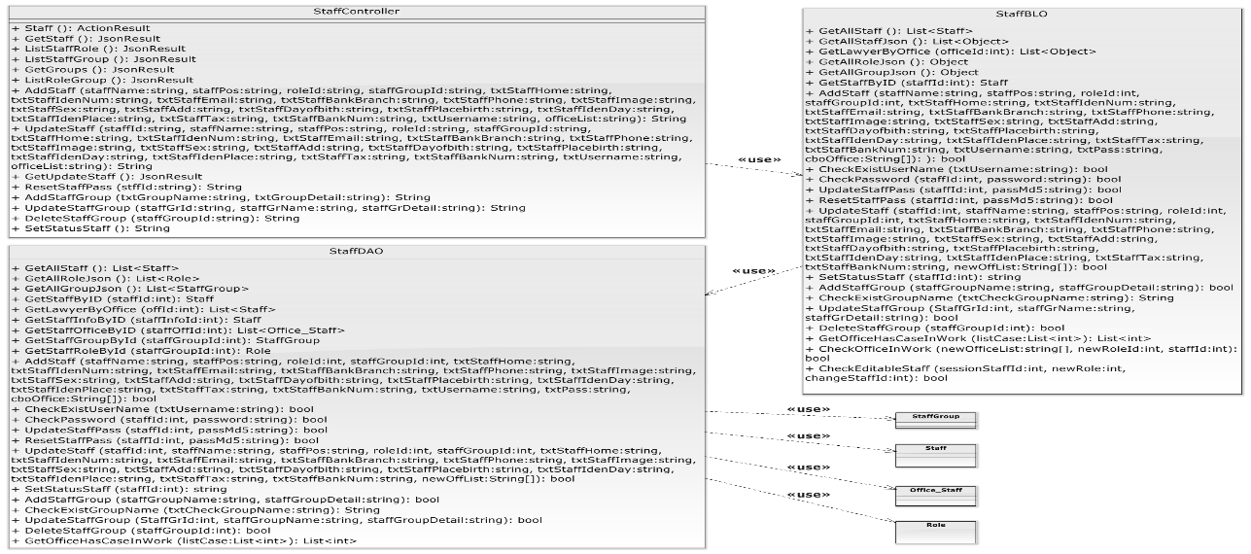

**Figure 4-108: Manage staff class diagram**

##### Screen design

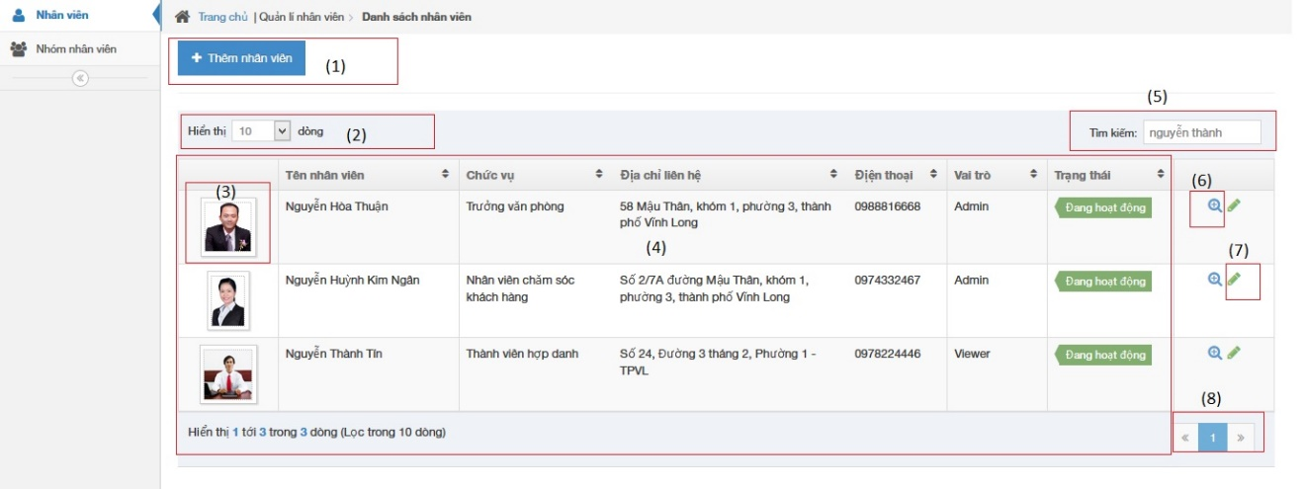

**Figure 4-109: View staff image**

|  |  |  |  |  |
| --- | --- | --- | --- | --- |
| No | Object/ControlName | Type | Required | Description |
| 1 | Thêm nhân viên | Button | Yes | Click to show popup for add new staff |
| 2 | Number of rows | Combo-box | Yes | Choose number of rows in table |
| 3 | Image of staff | Image | Yes | Click to show popup detail of staff |
| 4 | List all staff | Table | Yes | List all staff |
| 5 | Tìm kiếm | Textbox | Yes | Search staff |
| 6 | View | Button | Yes | Click to show popup detail of staff |
| 7 | Edit | Button | Yes | Click to show popup edit detail of staff information. |
| 8 | Paging | Button | Yes | Paging page |

##### Sequence diagram

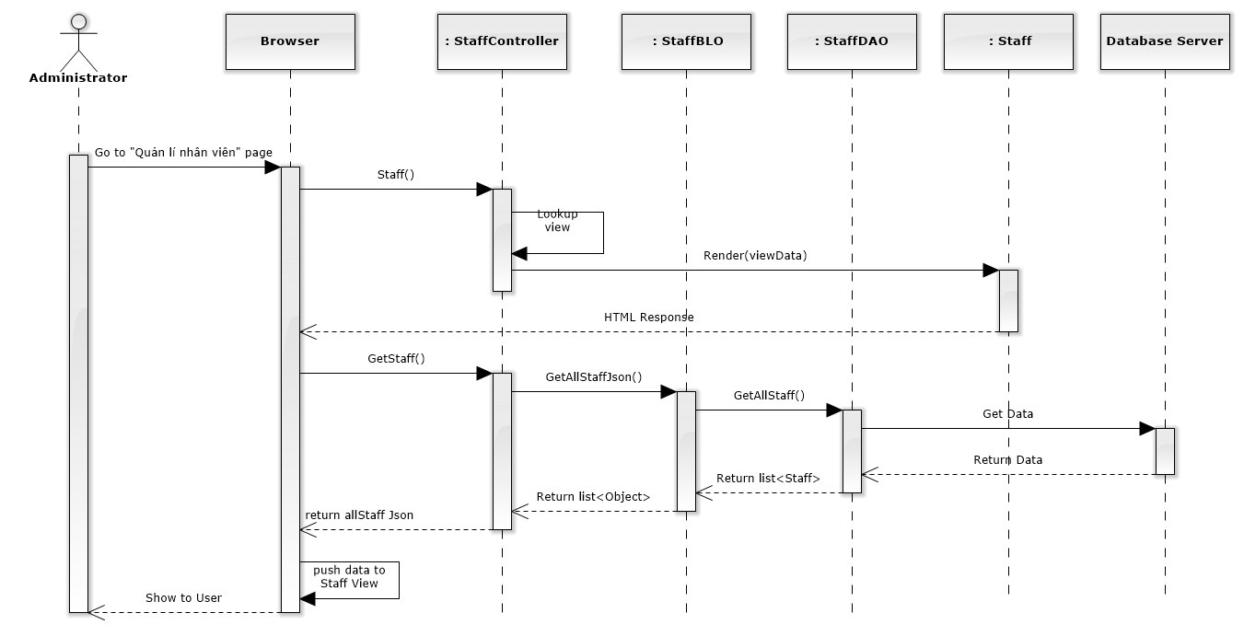

**Figure 4-110: List Staffs Sequence Diagram**

#### Add new staff

##### Screen design

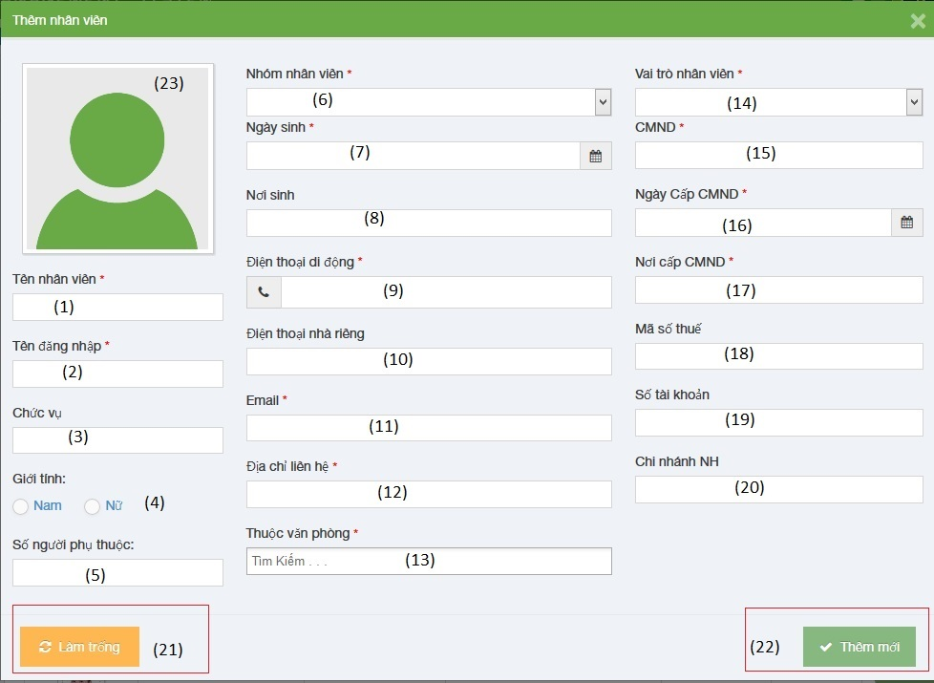

**Figure 4-111: Add new staff image**

|  |  |  |  |  |
| --- | --- | --- | --- | --- |
| No | Object/ControlName | Type | Required | Description |
| 1 | Tên nhân viên | Textbox | Yes | Name of staff |
| 2 | Tên đăng nhập | Textbox | Yes | Username of staff |
| 3 | Chức vụ | Textbox | Yes | Position of staff |
| 4 | Giới tính | Radio button | Yes | Choose sex of staff |
| 5 | Số người phụ thuộc | Textbox | Yes | Number of dependents |
| 6 | Nhóm nhân viên | Textbox | Yes | Select group of staff |
| 7 | Ngày sinh | Datetime picker | Yes | Date of birth of staff |
| 8 | Nơi sinh | Textbox | Yes | Place of birth of staff |
| 9 | Điện thoại di động | Textbox | Yes | Phone number of staff |
| 10 | Điện thoại nhà riêng | Textbox | Yes | Telephone of staff |
| 11 | Email | Textbox | Yes | Email of staff |
| 12 | Địa chỉ liên hệ | Textbox | Yes | Address of staff |
| 13 | Thuộc văn phòng | Multiple select box | Yes | Select office of staff |
| 14 | Vai trò nhân viên | Select box | Yes | Select role of staff |
| 15 | CMND | Textbox | Yes | Indentity number of staff |
| 16 | Ngày cấp CMND | Datetime picker | Yes | Date of Identity of staff |
| 17 | Nơi cấp CMND | Textbox | Yes | Place of Identity of staff |
| 18 | Mã số thuế | Textbox | Yes | Tax number of staff |
| 19 | Số tài khoản | Textbox | Yes | Bank account number of staff |
| 20 | Chi nhánh ngân hàng | Textbox | Yes | Name of bank of staff |
| 21 | “Làm trống” | Button | Yes | Clear all field |
| 22 | “Thêm mới” | Button | Yes | Add new staff |
| 23 | Image of staff | Image | Yes | Image of staff |

##### Sequence diagram

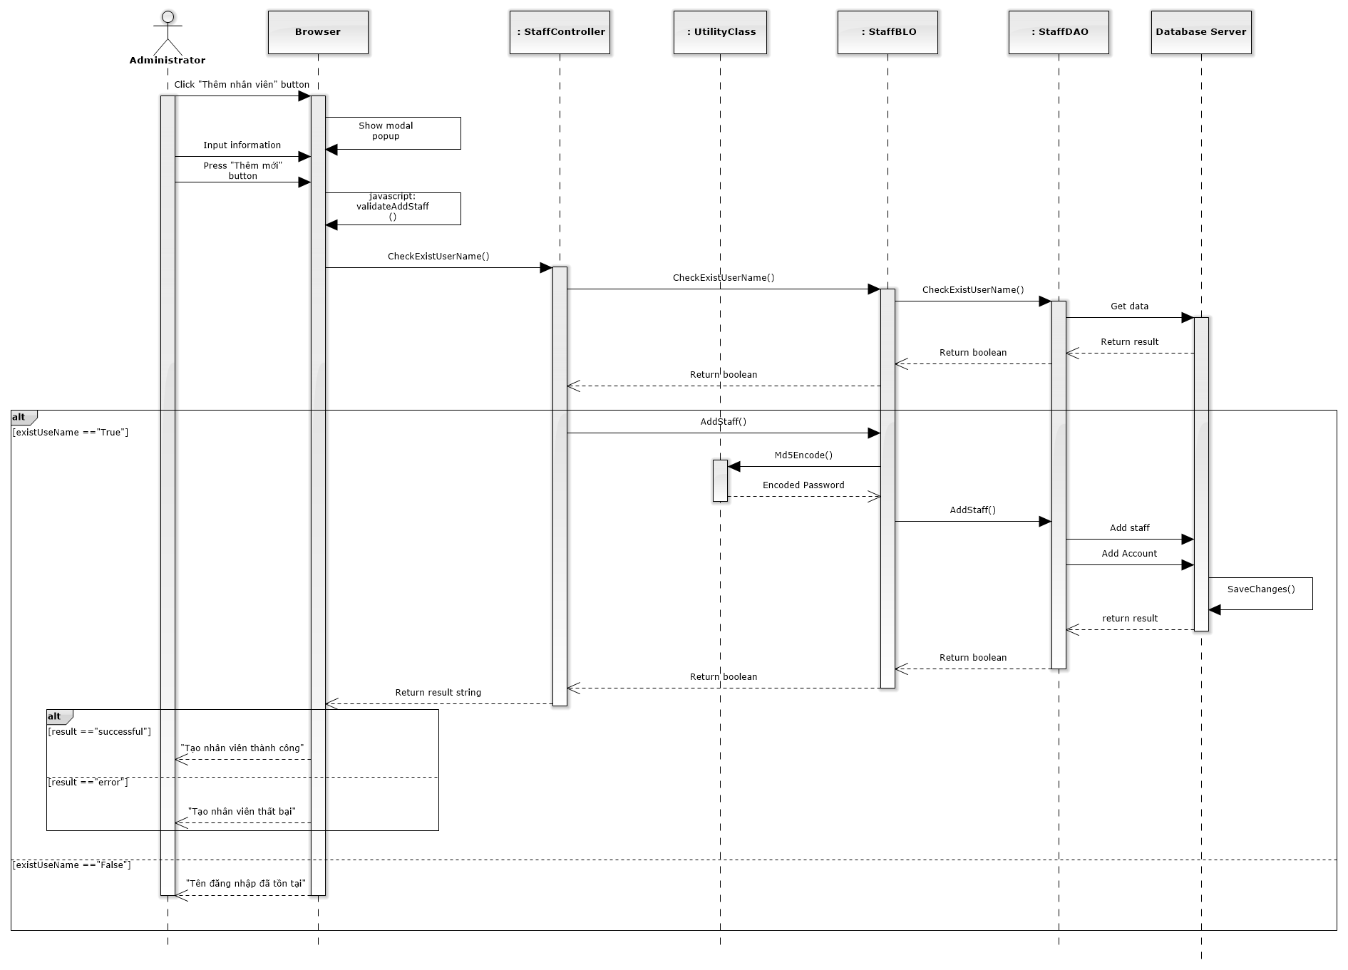

**Figure 4-112: Add New Staff Sequence Diagram**

#### Edit staff

##### Screen design

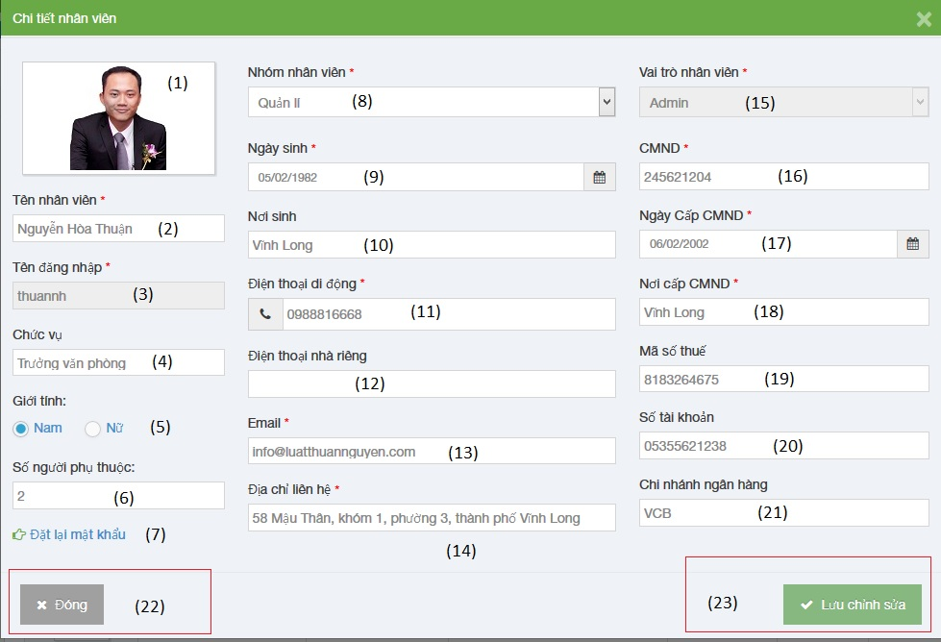

**Figure 4-113: Edit staff image**

|  |  |  |  |  |
| --- | --- | --- | --- | --- |
| No | Object/ControlName | Type | Required | Description |
| 1 | Image of staff | Image | Yes | Image of staff |
| 2 | Tên nhân viên | Textbox | Yes | Name of staff |
| 3 | Tên đăng nhập | Textbox | Yes | Username of staff |
| 4 | Chức vụ | Textbox | Yes | Position of staff |
| 5 | Giới tính | Radio button | Yes | Choose sex of staff |
| 6 | Số người phụ thuộc | Textbox | Yes | Number of dependents |
| 7 | Đặt lại mật khẩu | Link | Yes | Change staff password |
| 8 | Nhóm nhân viên | Textbox | Yes | Select group of staff |
| 9 | Ngày sinh | Datetime picker | Yes | Date of birth of staff |
| 10 | Nơi sinh | Textbox | Yes | Place of birth of staff |
| 11 | Điện thoại di động | Textbox | Yes | Phone number of staff |
| 12 | Điện thoại nhà riêng | Textbox | Yes | Telephone of staff |
| 13 | Email | Textbox | Yes | Email of staff |
| 14 | Địa chỉ liên hệ | Textbox | Yes | Address of staff |
| 15 | Vai trò nhân viên | Select box | Yes | Select role of staff |
| 16 | CMND | Textbox | Yes | Indentity number of staff |
| 17 | Ngày cấp CMND | Datetime picker | Yes | Date of Identity of staff |
| 18 | Nơi cấp CMND | Textbox | Yes | Place of Identity of staff |
| 19 | Mã số thuế | Textbox | Yes | Tax number of staff |
| 20 | Số tài khoản | Textbox | Yes | Bank account number of staff |
| 21 | Chi nhánh ngân hàng | Textbox | Yes | Name of bank of staff |
| 22 | “Đóng” | Button | Yes | Close edit staff |
| 23 | “Lưu chỉnh sửa” | Button | Yes | Save edit staff |

##### Sequence diagram

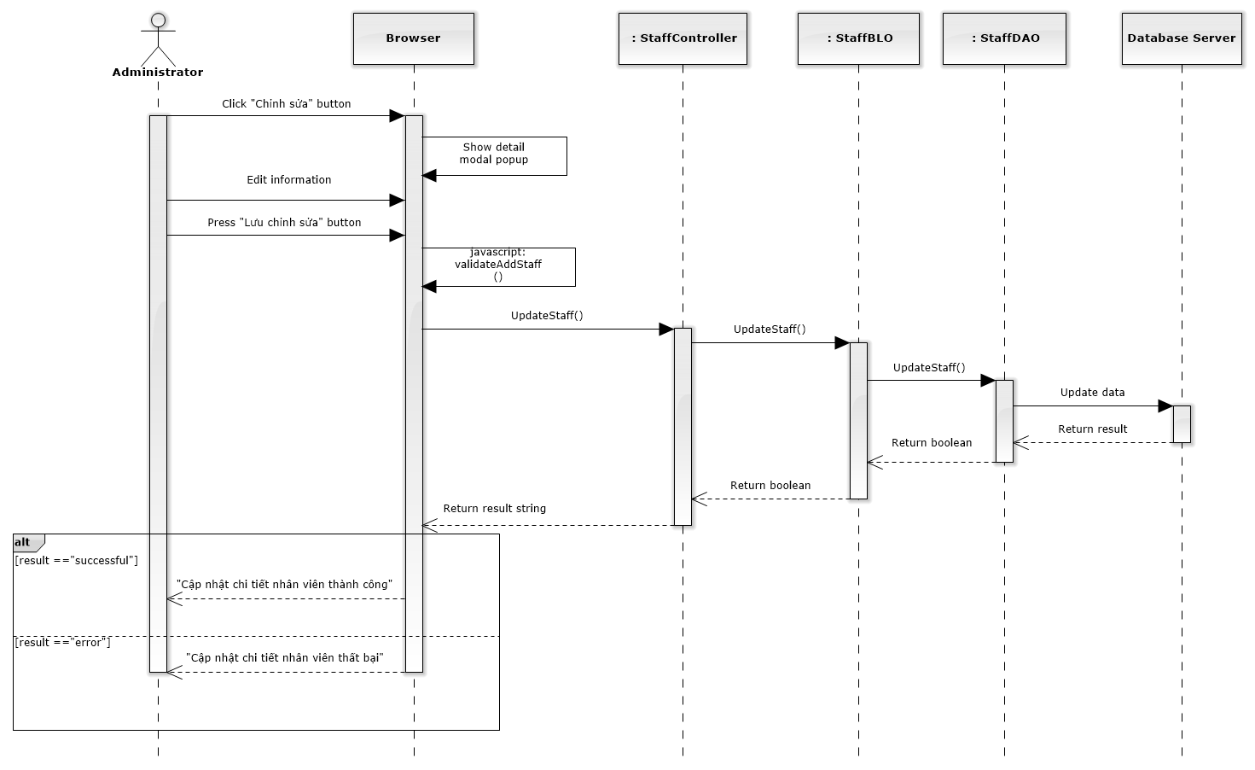

**Figure 4-114: Edit Staff Sequence Diagram**

#### Deactivate/ Activate staff

##### Screen design

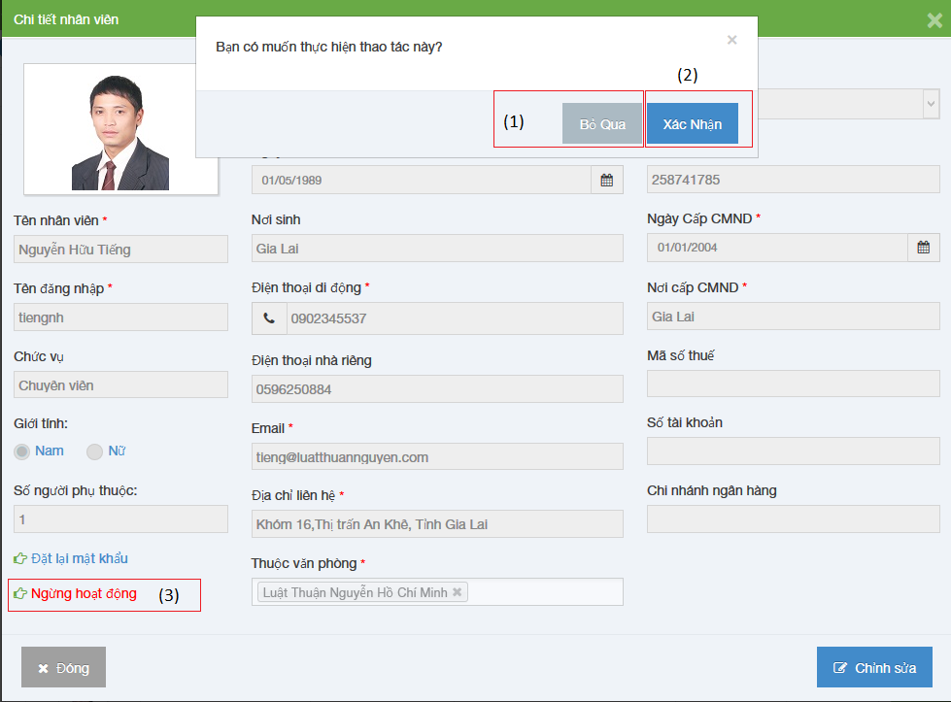

**Figure 4-115: Deactivate / Activate Staff image**

|  |  |  |  |  |
| --- | --- | --- | --- | --- |
| No | Object/ControlName | Type | Required | Description |
| 1 | “Bỏ qua” | Button | Yes | Click to close Deactive staff |
| 2 | “Xác nhận” | Button | Yes | Click to Deactive staff |
| 3 | Ngừng hoạt động | Link | Yes | Click to open confirm Deactive staff |

##### Sequence diagram

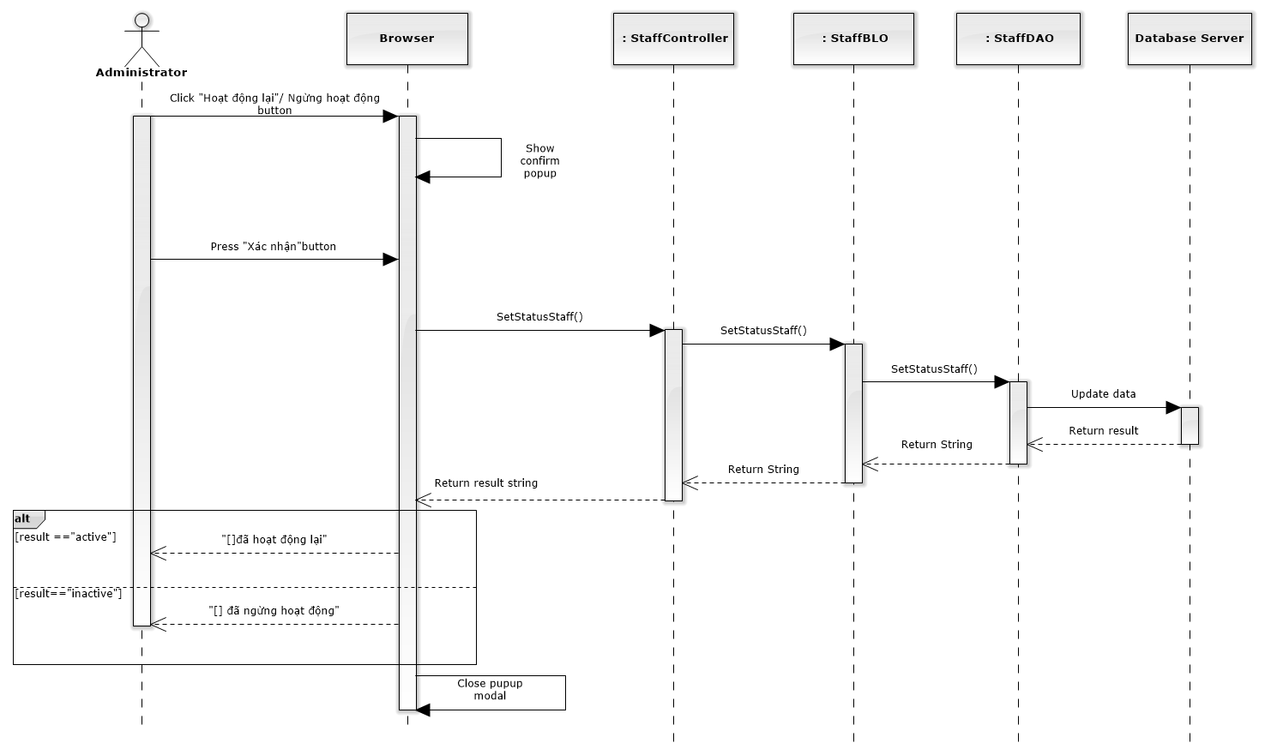

**Figure 4-116: Deactivate / Activate Staff Sequence Diagram**

#### Reset password

##### Screen design

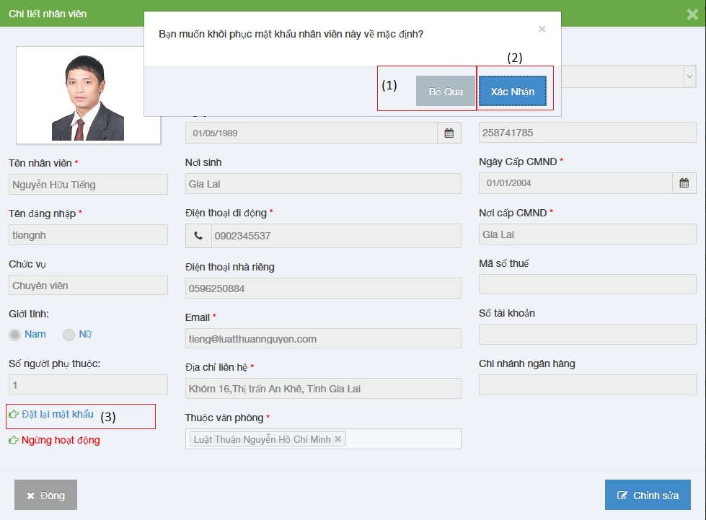

**Figure 4-117: Reset password staff image**

|  |  |  |  |  |
| --- | --- | --- | --- | --- |
| No | Object/ControlName | Type | Required | Description |
| 1 | “Bỏ qua” | Button | Yes | Click to close reset password staff |
| 2 | “Xác nhận” | Button | Yes | Click to reset password staff |
| 3 | Đặt lại mật khẩu | Link | Yes | Click to open reset password staff |

##### Sequence diagram

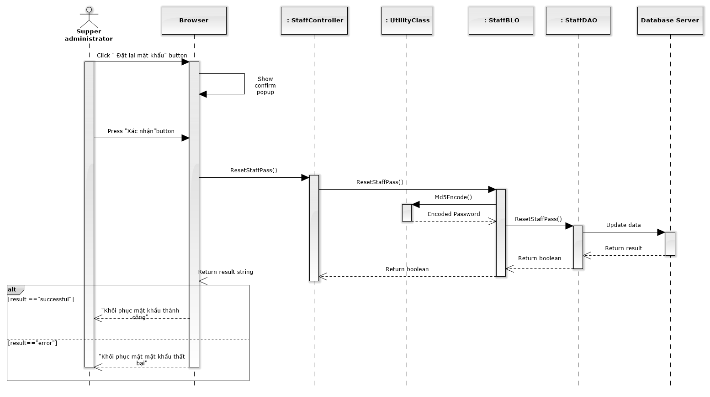

**Figure 4-118: Reset Password Sequence Diagram**

### Manage Service Type

#### List service type

##### Class diagram

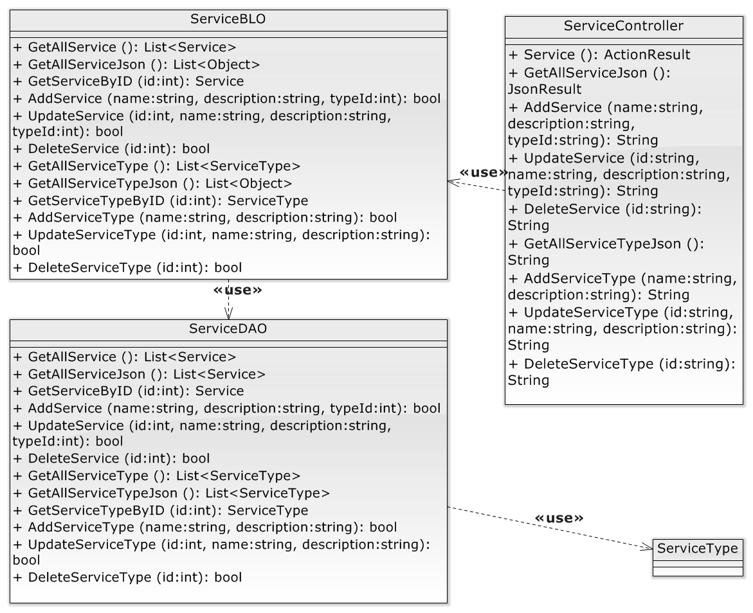

**Figure 4-119: Manage service type class diagram**

##### Screen design

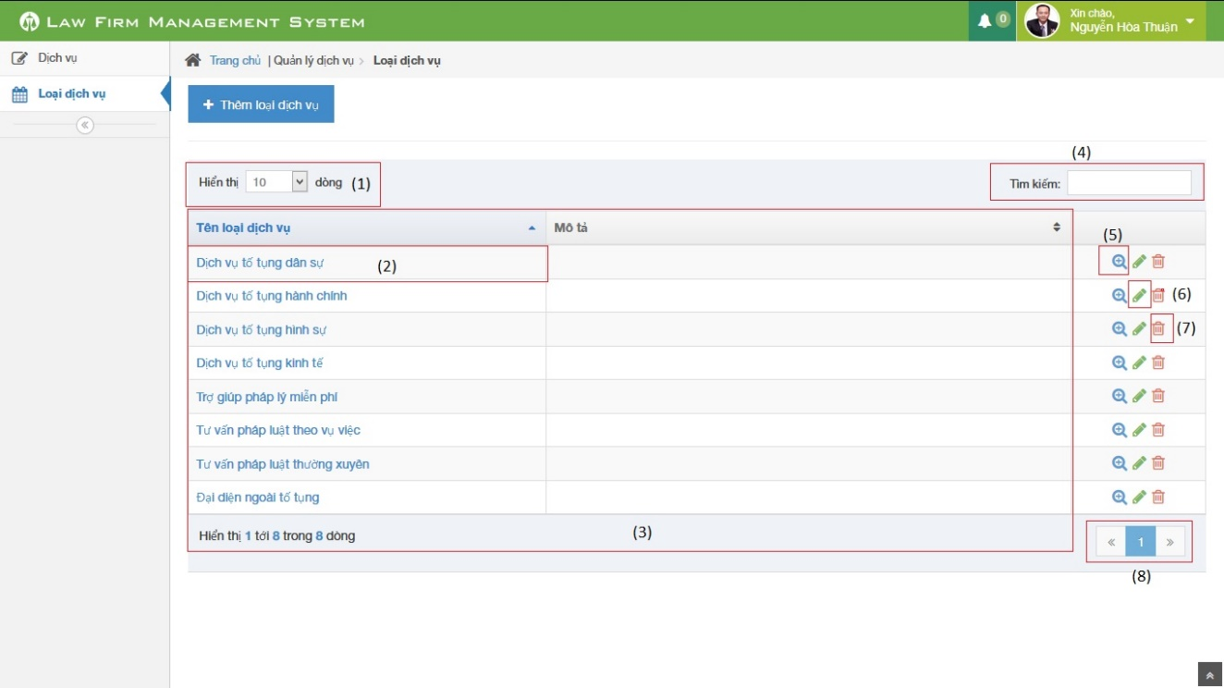

**Figure 4-120: List service type image**

|  |  |  |  |  |
| --- | --- | --- | --- | --- |
| No | Object/ControlName | Type | Required | Description |
| 1 | Number of rows | Combo-box | Yes | Choose number of rows in table |
| 2 | Name service type | Text | Yes | Show service type detail pop-up |
| 3 | List all Service type | Table | Yes | List all Service type |
| 4 | Search | Textbox | Yes | Search service type |
| 5 | View service type detail | Icon | Yes | Show service type detail pop-up |
| 6 | Delete service type | Icon | Yes | Delete service type |
| 7 | Edit service type | Icon | Yes | Show edit service type pop-up |
| 8 | Paging | Button | Yes | Paging the service type list |

##### Sequence diagram

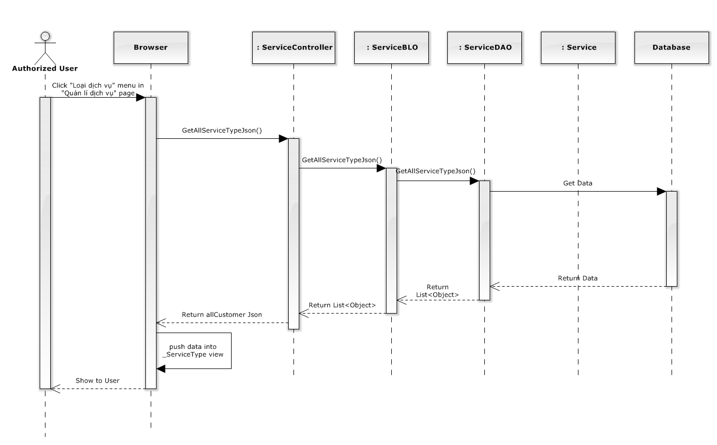

**Figure 4-121: List service type sequence diagram**

#### Add service type

##### Screen design

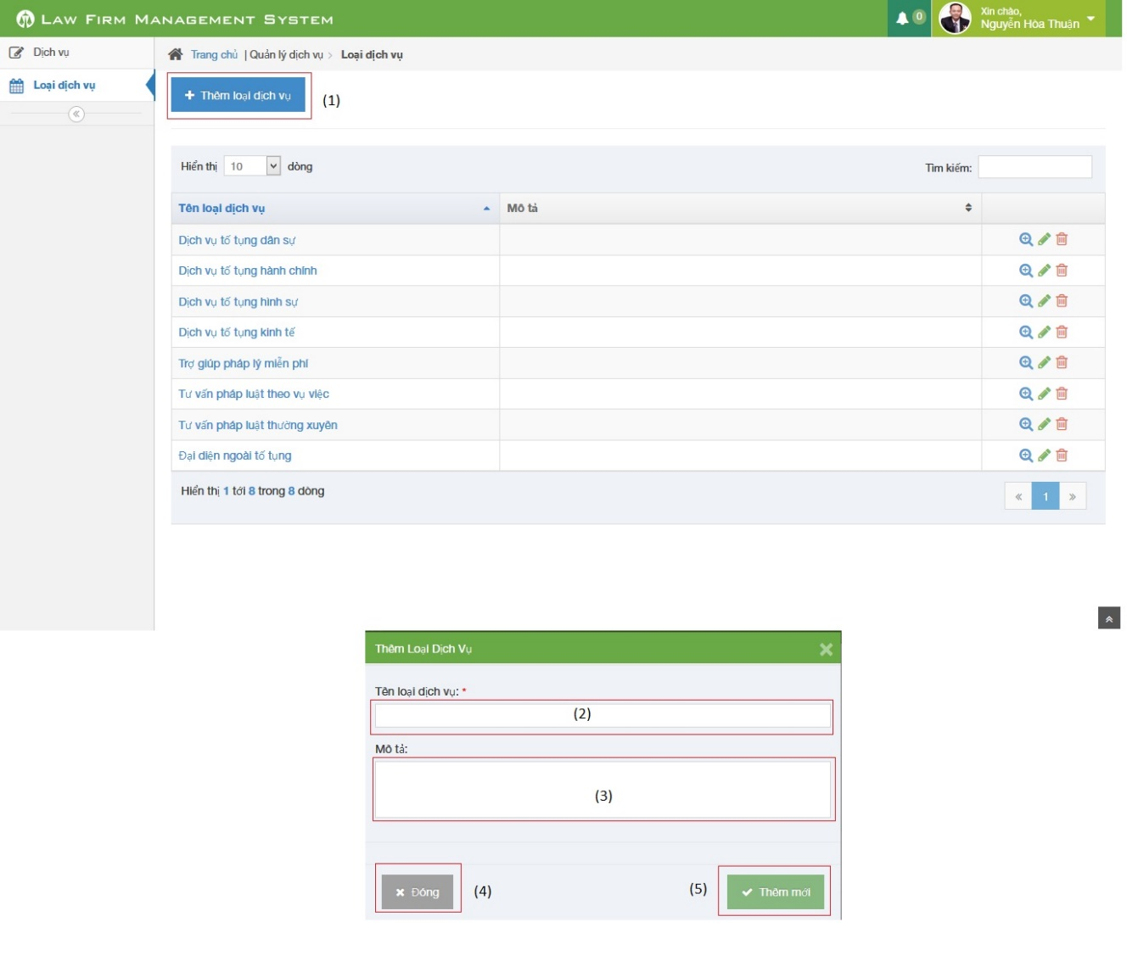

**Figure 4-122: Add service type image**

|  |  |  |  |  |
| --- | --- | --- | --- | --- |
| No | Object/ControlName | Type | Required | Description |
| 1 | “Thêm loại dịch vụ” | Button | Yes | Click to open pop-up create new type of service |
| 2 | “Tên loại dịch vụ” | Textbox | Yes | Name of service type |
| 3 | “Mô tả” | Textbox | Yes | Description of service type |
| 4 | “Đóng” | Button | Yes | Click to close pop-up add new service type |
| 5 | “Thêm mới” | Button | Yes | Click to add new service type |

##### Sequence diagram

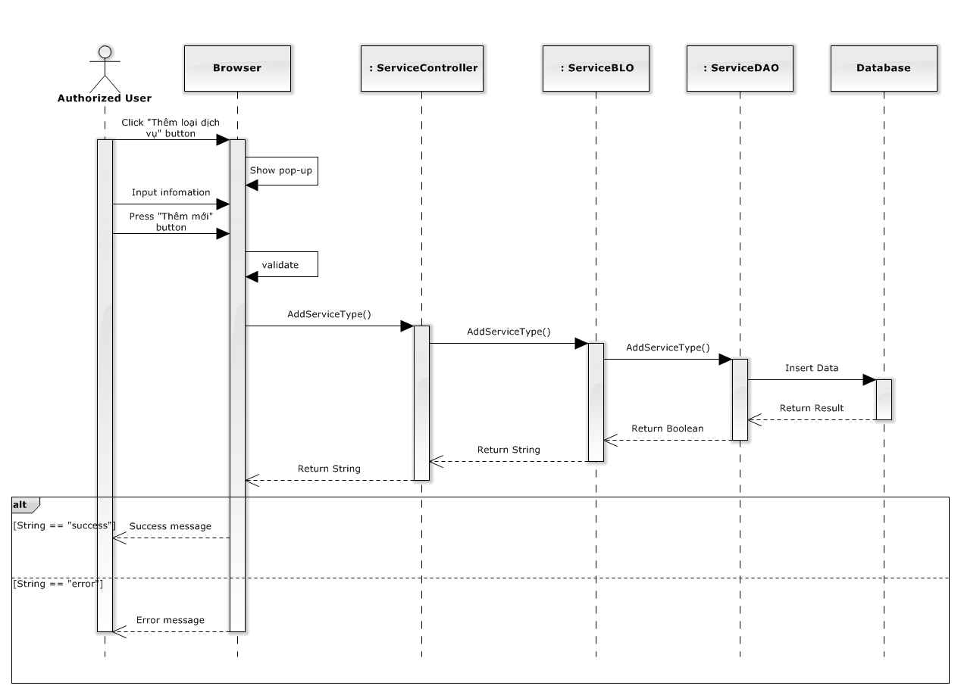

**Figure 4-123: Add service type sequence diagram**

#### Update service type

##### Screen design

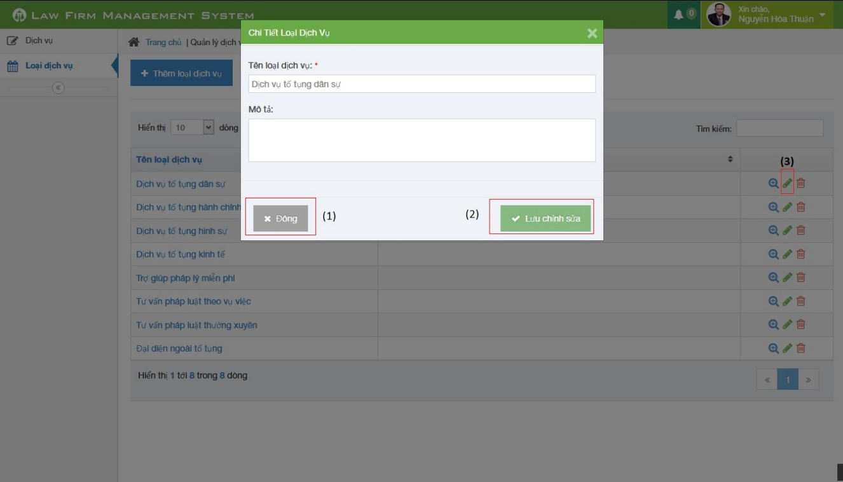

**Figure 4-124: Update service type image**

|  |  |  |  |  |
| --- | --- | --- | --- | --- |
| No | Object/ControlName | Type | Required | Description |
| 1 | “Đóng” | Button | Yes | Click to close update service type |
| 2 | “Lưu chỉnh sửa” | Button | Yes | Click to confirm update service type |
| 3 | Edit | Icon | Yes | Click to show pop up update service type |

##### Sequence diagram

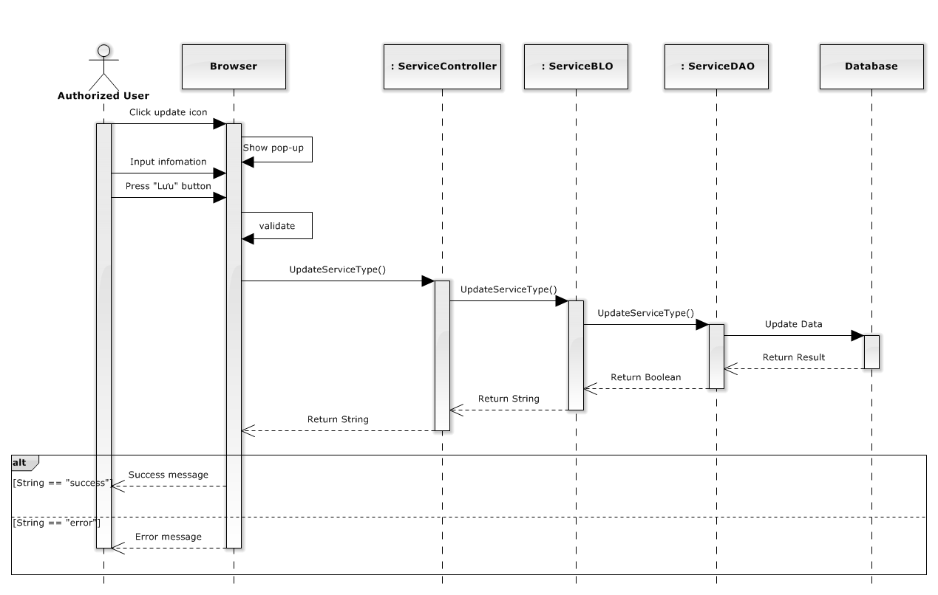

**Figure 4-125: Update service type sequence diagram**

#### Delete service type

##### Screen design

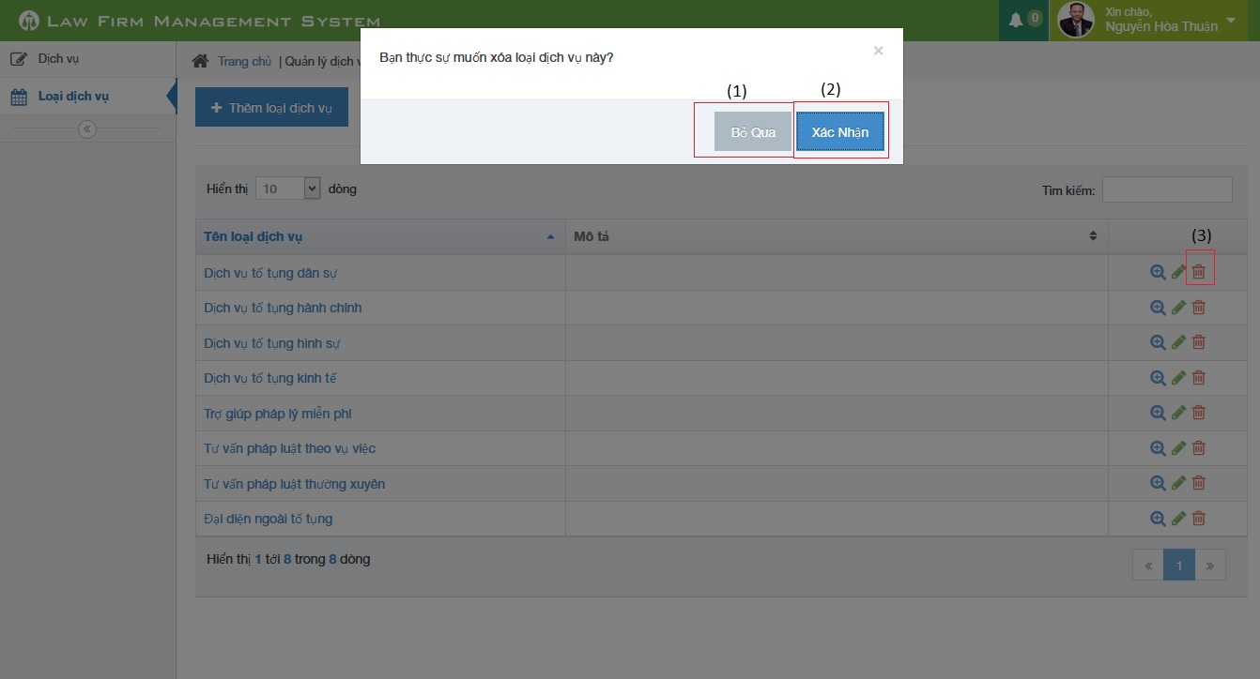

**Figure 4-126: Delete service type image**

|  |  |  |  |  |
| --- | --- | --- | --- | --- |
| No | Object/ControlName | Type | Required | Description |
| 1 | “Bỏ qua” | Button | Yes | Click to close delete service type |
| 2 | “Xác nhận” | Button | Yes | Click to confirm delete service type |
| 3 | Trash | Button | Yes | Click to show pop up delete service type |

##### Sequence diagram

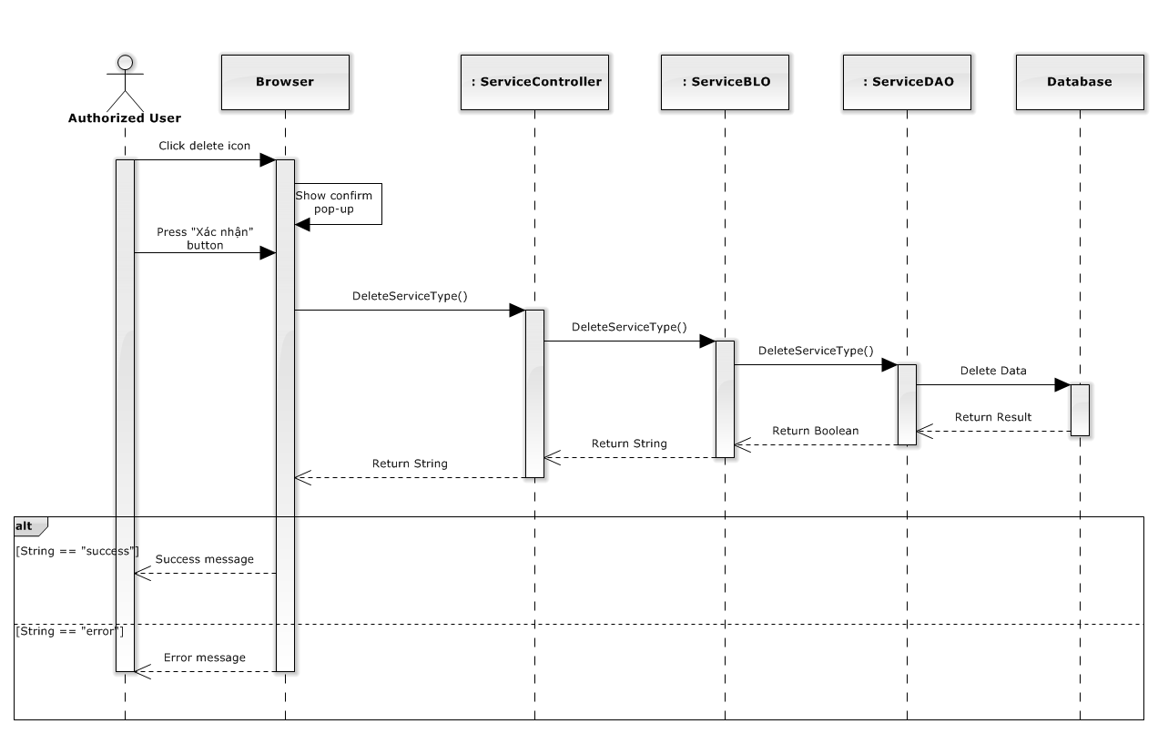

**Figure 4-127: Delete service type sequence diagram**

### Manage Service

#### List Services

##### Class diagram

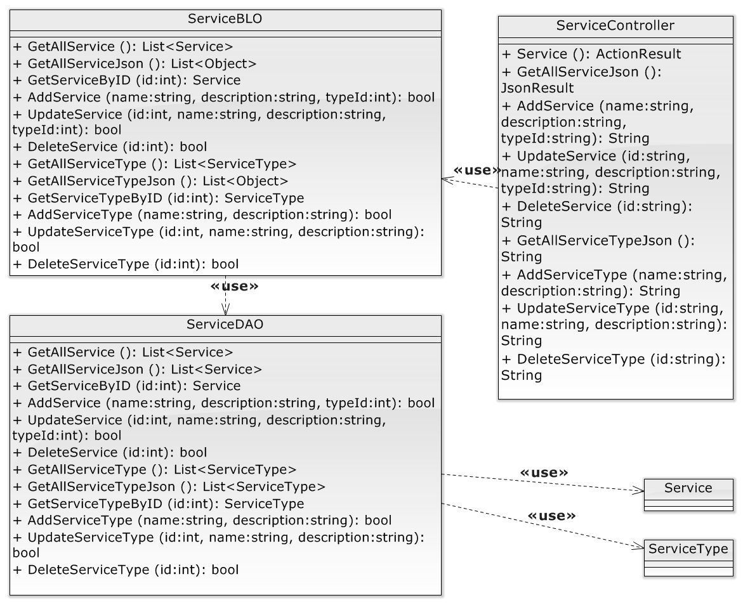

**Figure 4-128: Manage service class diagram**

##### Screen design

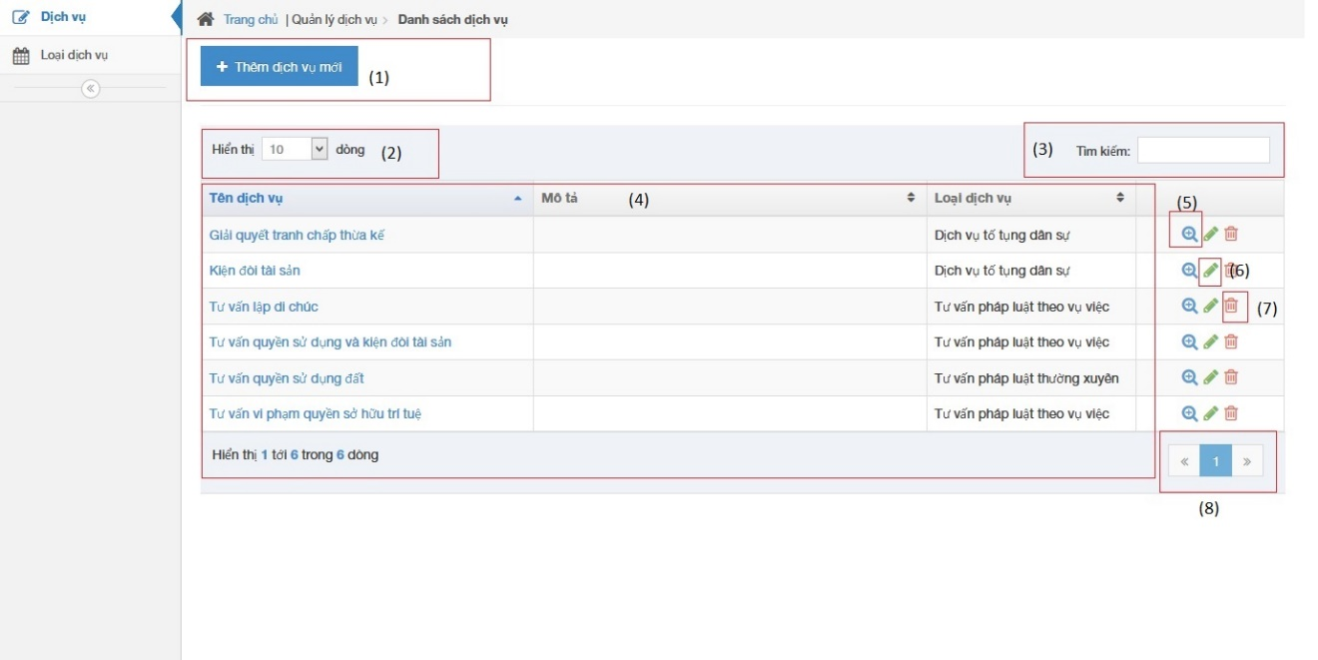

**Figure 4-129: List service image**

|  |  |  |  |  |
| --- | --- | --- | --- | --- |
| No | Object/ControlName | Type | Required | Description |
| 1 | Thêm dịch vụ mới | Button | Yes | Show Add new service pop-up |
| 2 | Number of rows | Combo-box | Yes | Choose number of rows in table |
| 3 | Search | Textbox | Yes | Search service |
| 4 | Services table | Table | Yes | List service |
| 5 | View service detail | Icon | Yes | Show service detail pop-up |
| 6 | Edit service | Icon | Yes | Delete service |
| 7 | Delete service | Icon | Yes | Show edit service pop-up |
| 8 | Paging | Button | Yes | Paging the service list |

##### Sequence diagram

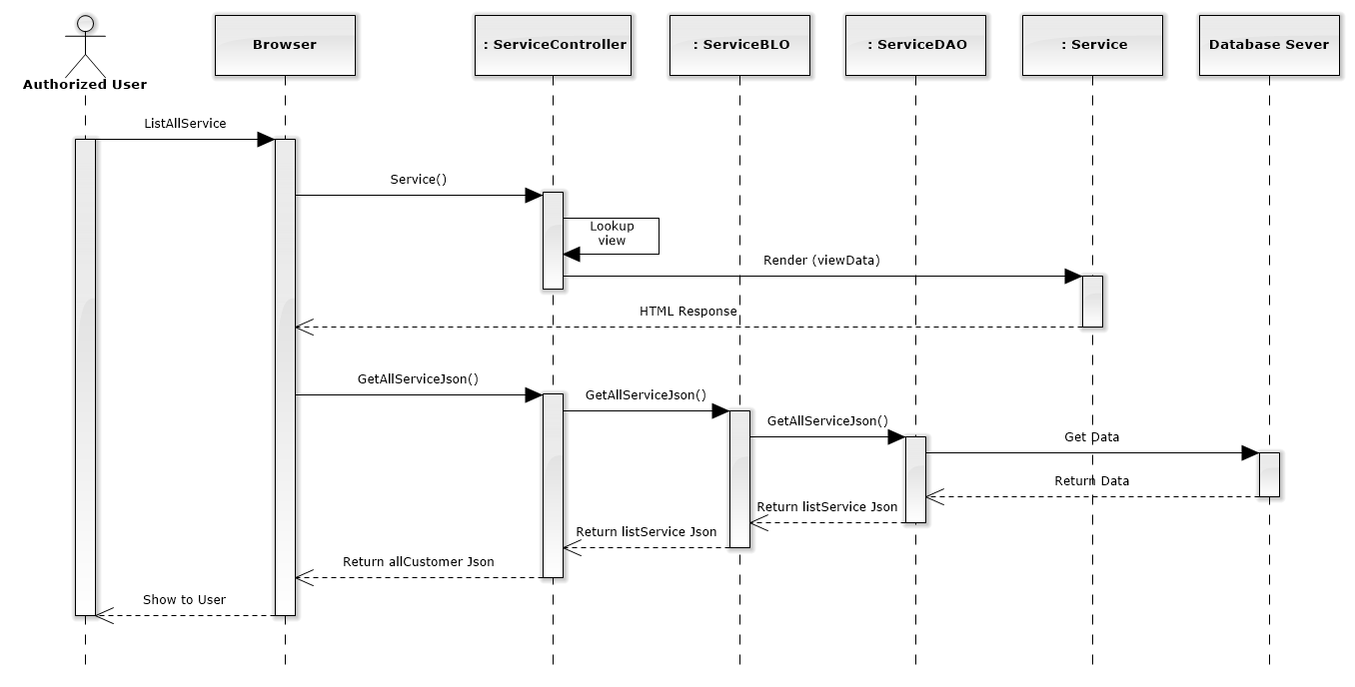

**Figure 4-130: List Services Sequence Diagram**

#### Add new service

##### Screen design

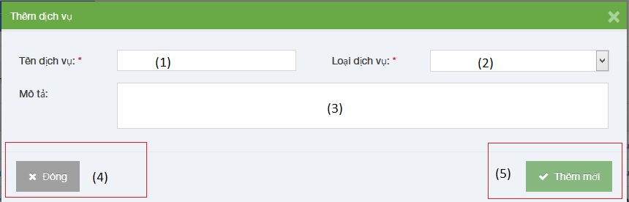

**Figure 4-131: Add new service image**

|  |  |  |  |  |
| --- | --- | --- | --- | --- |
| No | Object/ControlName | Type | Required | Description |
| 1 | Tên dịch vụ | Textbox | Yes | Name Service |
| 2 | Loại dịch vụ | Combo-box | Yes | Service type |
| 3 | Mô tả | Textbox | Yes | Description |
| 4 | “Đóng” | Button | Yes | Click to close add new service pop-up |
| 5 | “Thêm mới” | Button | Yes | Click to add new service |

##### Sequence diagram

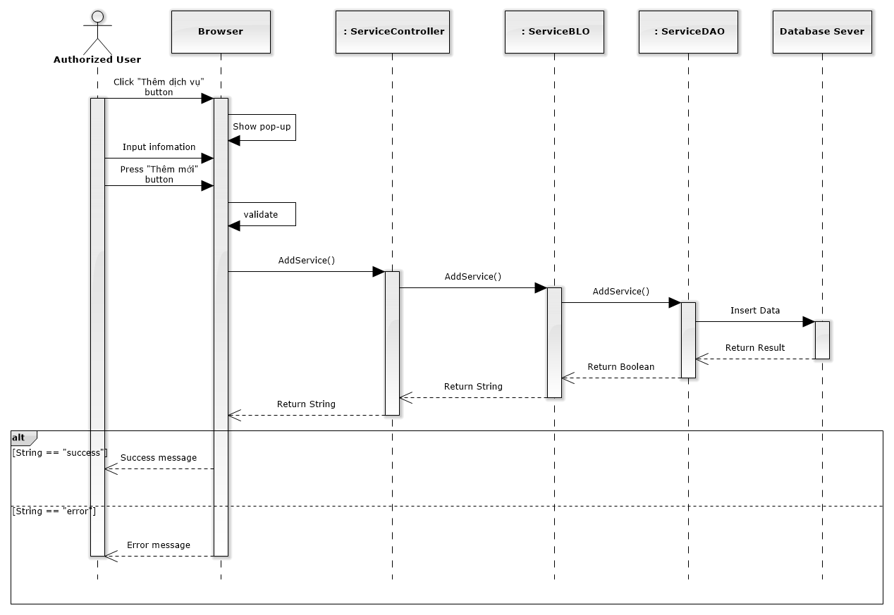

**Figure 4-132: Add New Service Sequence Diagram**

#### Edit service

##### Screen design

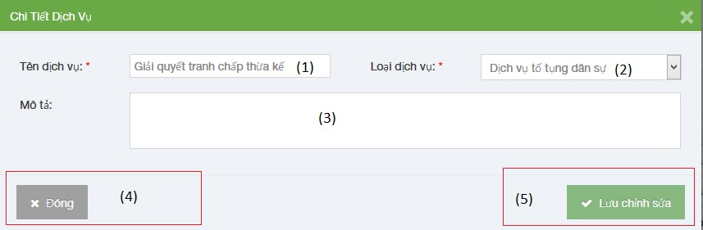

**Figure 4-133: Edit service image**

|  |  |  |  |  |
| --- | --- | --- | --- | --- |
| No | Object/ControlName | Type | Required | Description |
| 1 | Tên dịch vụ | Textbox | Yes | Name Service |
| 2 | Loại dịch vụ | Combo-box | Yes | Service type |
| 3 | Mô tả | Textbox | Yes | Description |
| 4 | “Đóng” | Button | Yes | Click to close edit service pop-up |
| 5 | “Lưu chỉnh sửa” | Button | Yes | Click to save edit service |

##### Sequence diagram

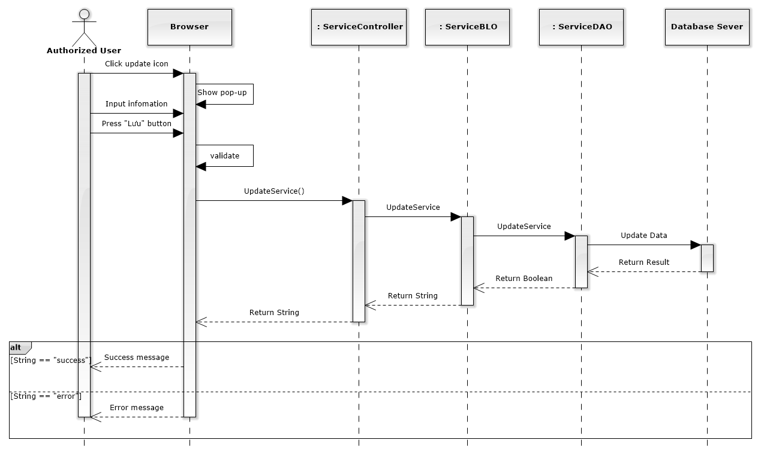

**Figure 4-134: Edit Service Sequence Diagram**

#### Delete service

##### Screen design

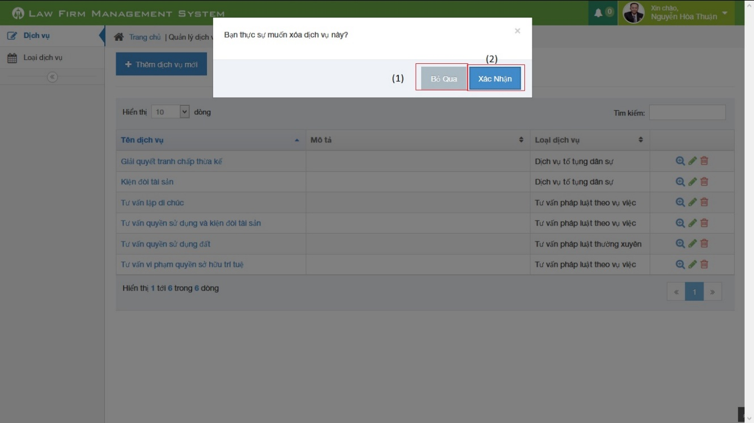

**Figure 4-135: Delete service image**

|  |  |  |  |  |
| --- | --- | --- | --- | --- |
| No | Object/ControlName | Type | Required | Description |
| 1 | Bỏ qua | Button | Yes | Click to close delete service pop-up |
| 2 | Xác nhận | Button | Yes | Click to delete service pop-up |

##### Sequence diagram

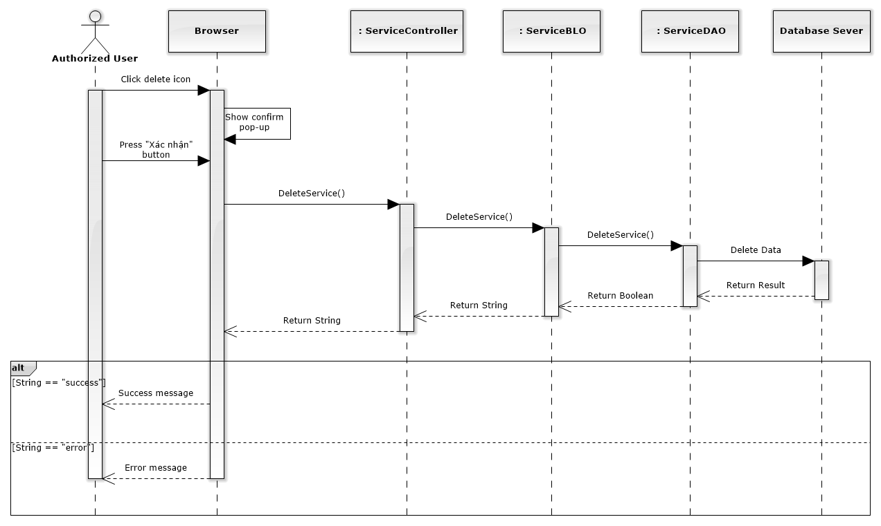

**Figure 4-136: Delete Service Sequence Diagram**

### Manage Office

#### List offices

##### Class diagram

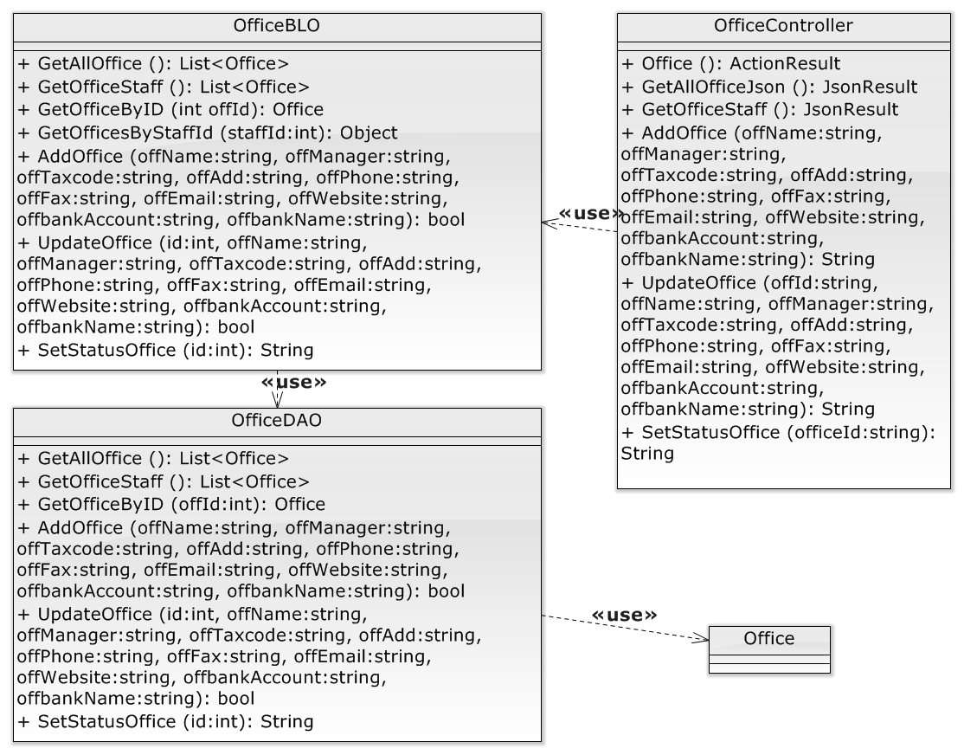

**Figure 4-137: Manage office class diagram**

##### Screen design

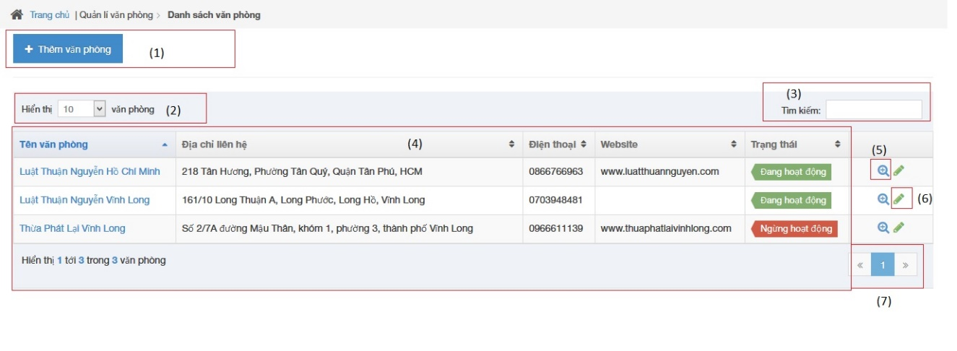

**Figure 4-138: List office image**

|  |  |  |  |  |
| --- | --- | --- | --- | --- |
| No | Object/ControlName | Type | Required | Description |
| 1 | Thêm văn phòng | Button | Yes | Click to show popup for add new office |
| 2 | Number of rows | Combo-box | Yes | Choose number of rows in table |
| 3 | Tìm kiếm | Textbox | Yes | Search office |
| 4 | List all office | Table | Yes | List all office |
| 5 | View | Button | Yes | Click to show popup detail of office |
| 6 | Edit | Button | Yes | Click to show popup edit detail of office information. |
| 7 | Paging | Button | Yes | Paging page |

##### Sequence diagram

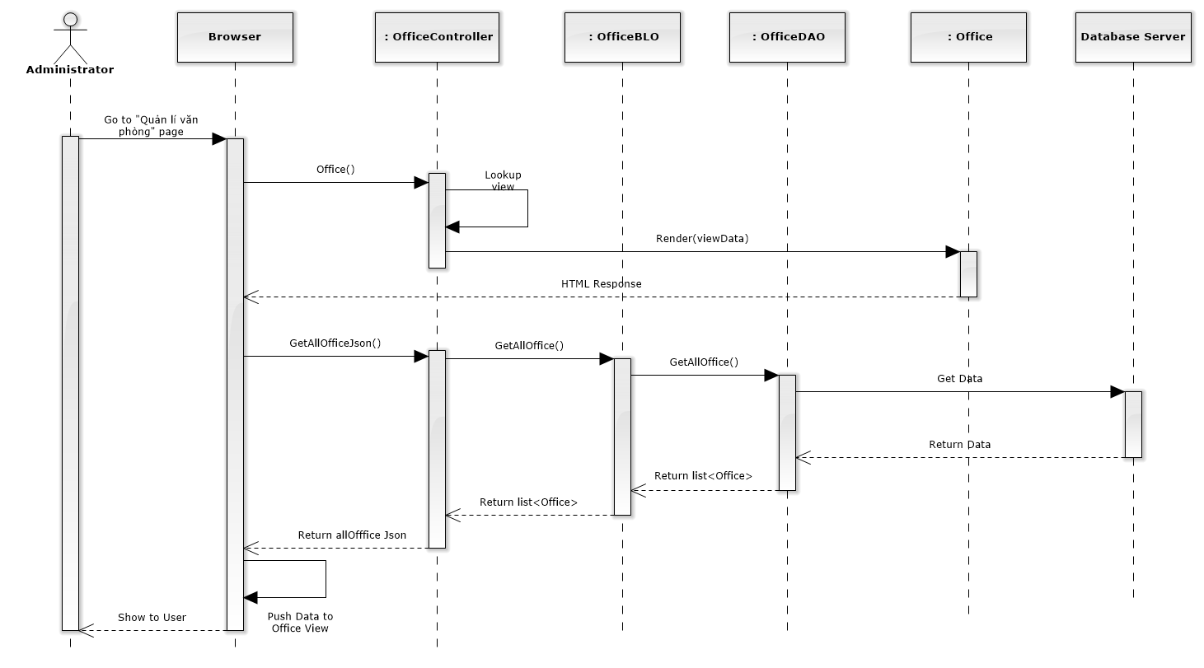

**Figure 4-139: List Offices Sequence Diagram**

#### Add new office

##### Screen design

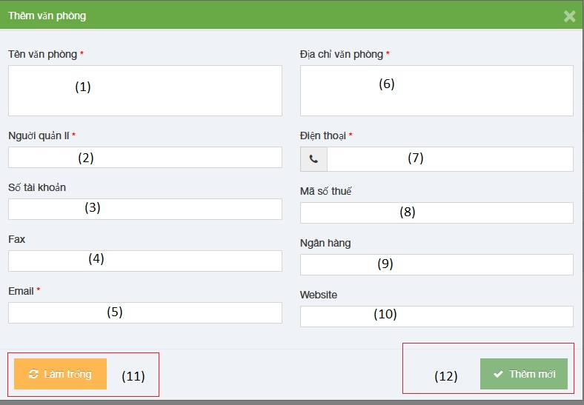

**Figure 4-140: Add new office image**

|  |  |  |  |  |
| --- | --- | --- | --- | --- |
| No | Object/ControlName | Type | Required | Description |
| 1 | Tên văn phòng | Textbox | Yes | Name of office |
| 2 | Người quản lí | Textbox | Yes | Nam’s manager of office |
| 3 | Số tài khoản | Textbox | Yes | Bank account number of office |
| 4 | Fax | Textbox | Yes | Fax of office |
| 5 | Email | Textbox | Yes | Email of office |
| 6 | Địa chỉ văn phòng | Textbox | Yes | Address of office |
| 7 | Điện thoại | Textbox | Yes | Phone number of office |
| 8 | Mã số thuế | Textbox | Yes | Tax number of office |
| 9 | Ngân hàng | Textbox | Yes | Name of bank of office |
| 10 | Website | Textbox | Yes | Website of office |
| 11 | “Làm trống” | Button | Yes | Clear field |
| 12 | “Thêm mới” | Button | Yes | Click to add new office |

##### Sequence diagram

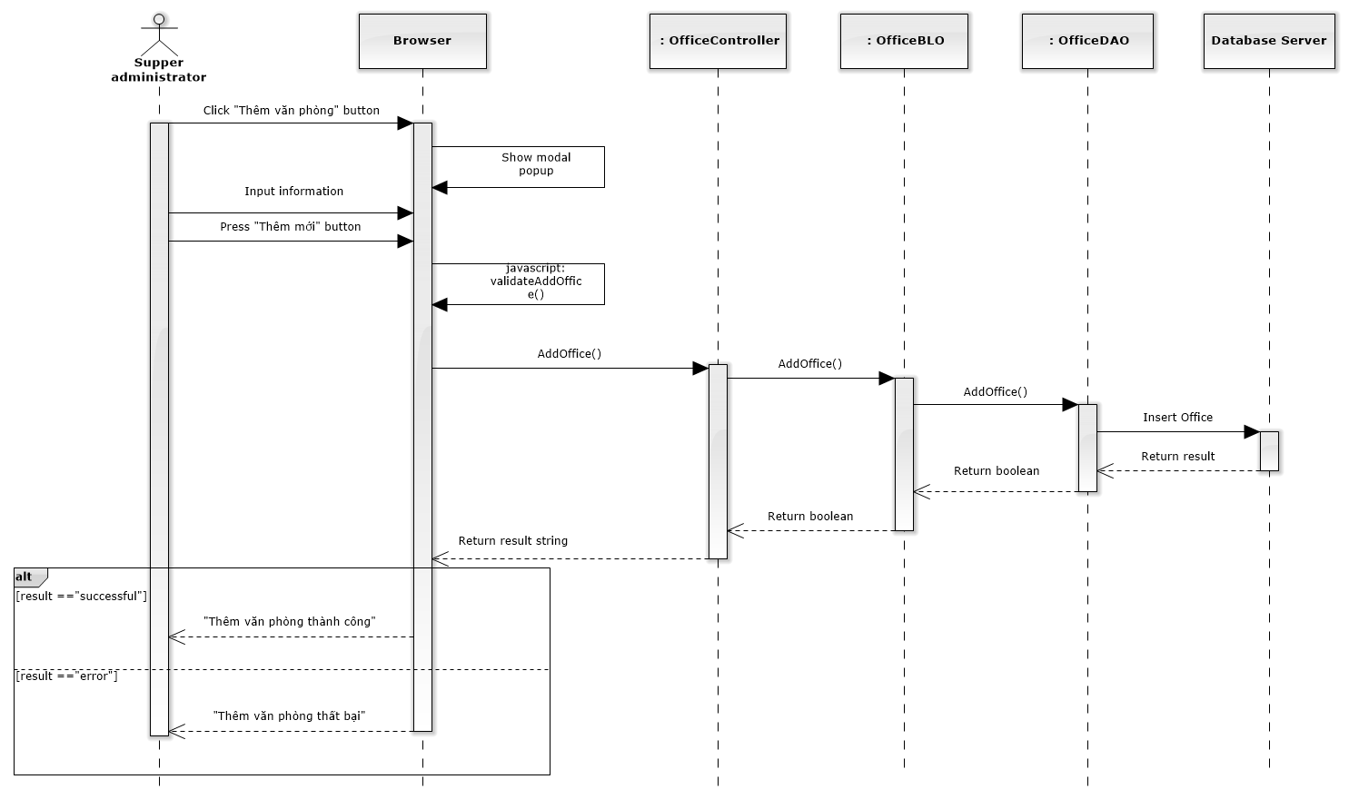

**Figure 4-141: Add New Office Sequence Diagram**

#### Edit office

##### Screen design

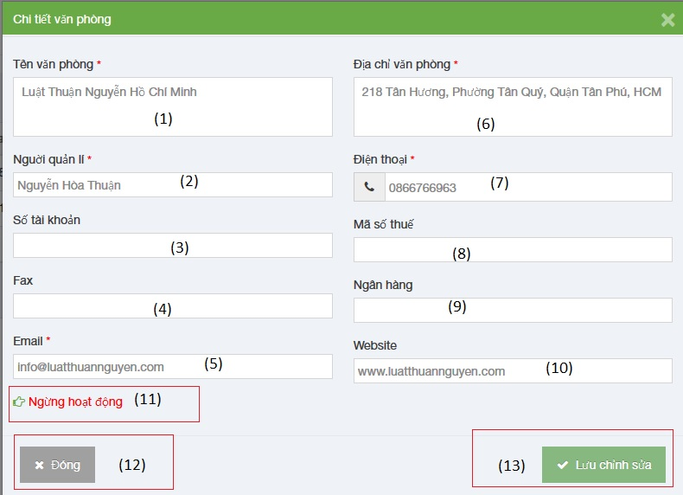

**Figure 4-142: Edit office image**

|  |  |  |  |  |
| --- | --- | --- | --- | --- |
| No | Object/ControlName | Type | Required | Description |
| 1 | Tên văn phòng | Textbox | Yes | Name of office |
| 2 | Người quản lí | Textbox | Yes | Nam’s manager of office |
| 3 | Số tài khoản | Textbox | Yes | Bank account number of office |
| 4 | Fax | Textbox | Yes | Fax of office |
| 5 | Email | Textbox | Yes | Email of office |
| 6 | Địa chỉ văn phòng | Textbox | Yes | Address of office |
| 7 | Điện thoại | Textbox | Yes | Phone number of office |
| 8 | Mã số thuế | Textbox | Yes | Tax number of office |
| 9 | Ngân hàng | Textbox | Yes | Name of bank of office |
| 10 | Website | Textbox | Yes | Website of office |
| 11 | Ngừng hoạt động | Link | Yes | Status of office |
| 12 | “Đóng” | Button | Yes | Click to close edit office |
| 13 | “Lưu chỉnh sửa” | Button | Yes | Click to save edit office |

##### Sequence diagram

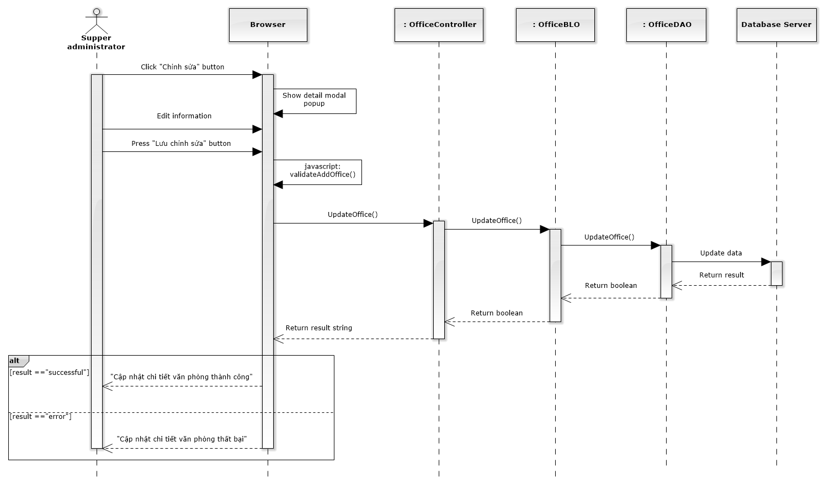

**Figure 4-143: Edit Office Sequence Diagram**

#### Deactivate/ Activate office

##### Screen design

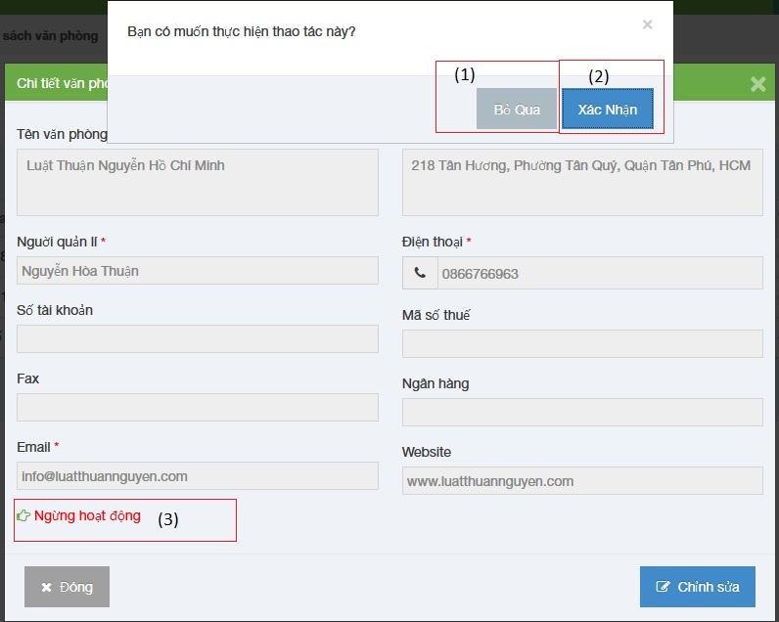

**Figure 4-144: Deactivate / Activate Office image**

|  |  |  |  |  |
| --- | --- | --- | --- | --- |
| No | Object/ControlName | Type | Required | Description |
| 1 | “Bỏ qua” | Button | Yes | Click to close Deactive office |
| 2 | “Xác nhận” | Button | Yes | Click to Deactive office |
| 3 | Ngừng hoạt động | Link | Yes | Click to open confirm Deactive office |

##### Sequence diagram

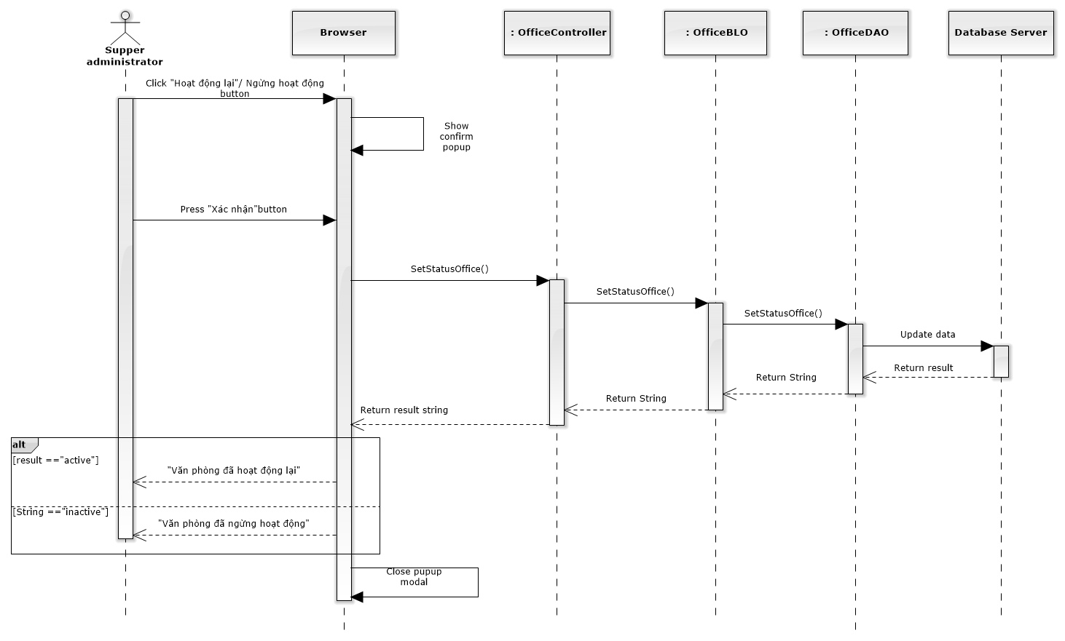

**Figure 4-145: Deactivate / Activate Office Sequence Diagram**

### Statistic

#### Office statistic

##### Class diagram

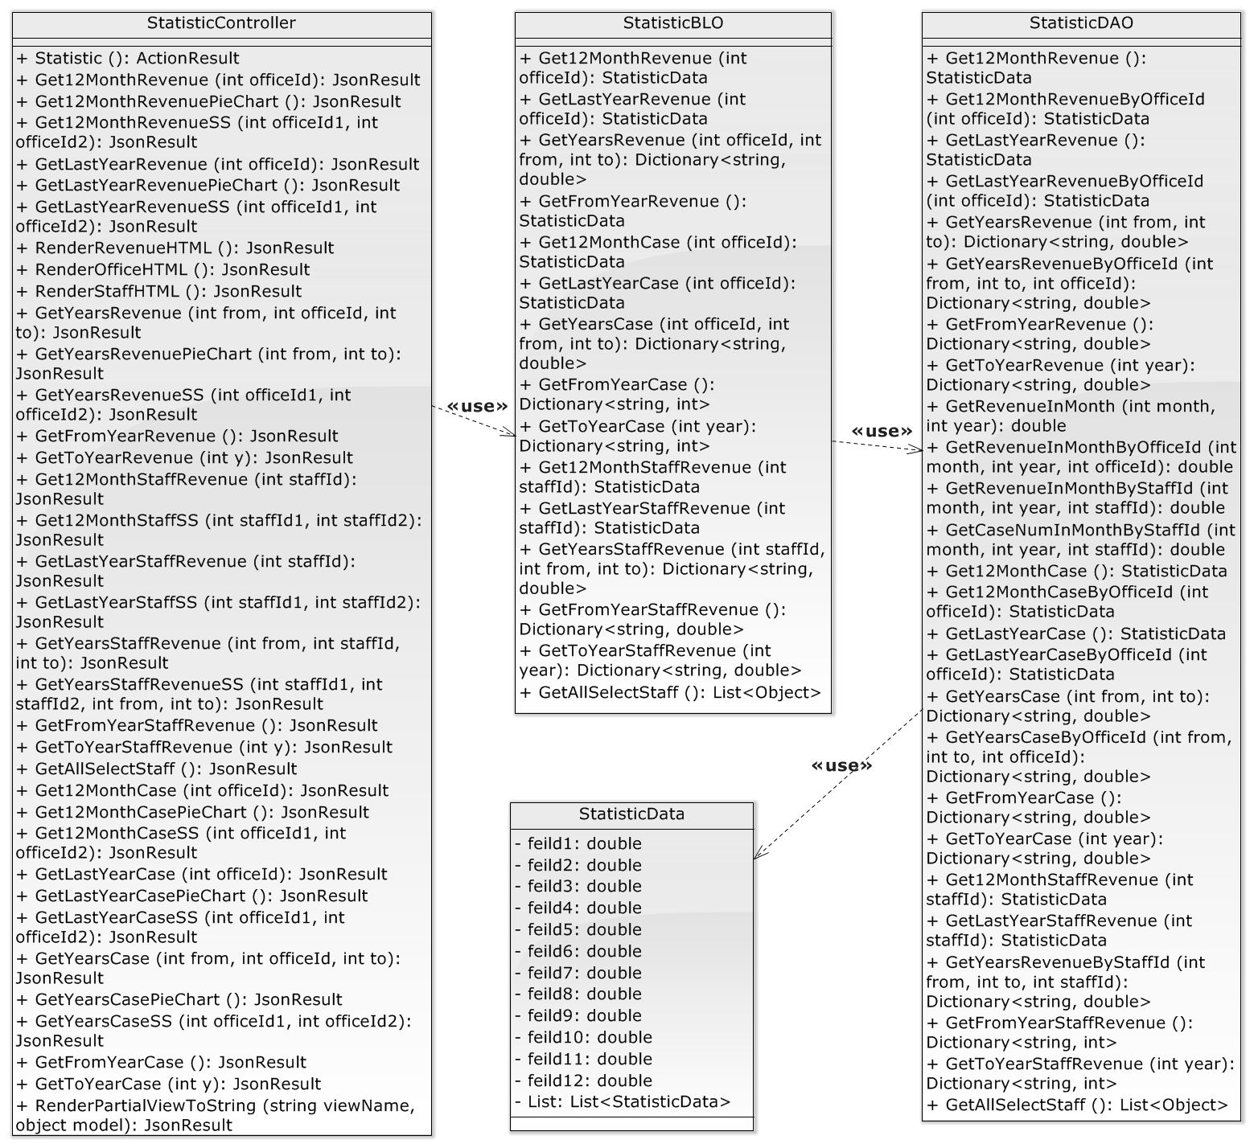

**Figure 4-146: Statistic Class Diagram**

##### Screen design

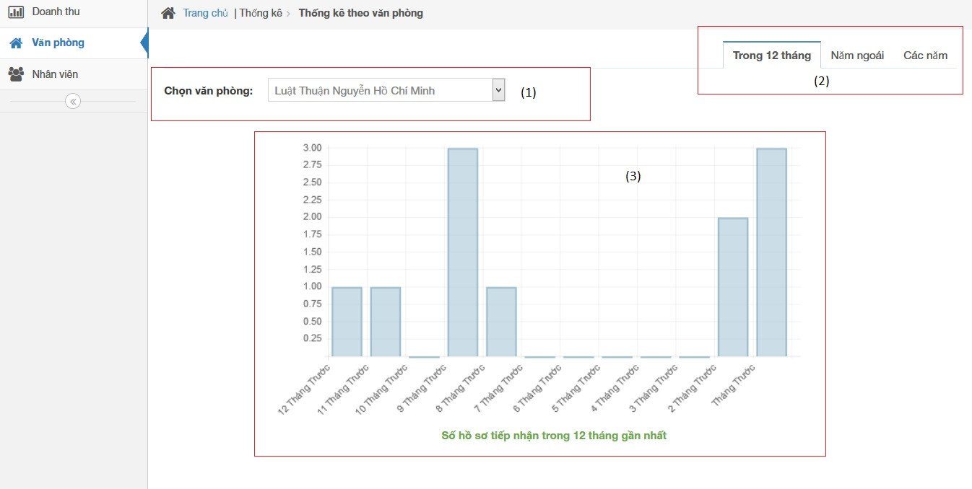

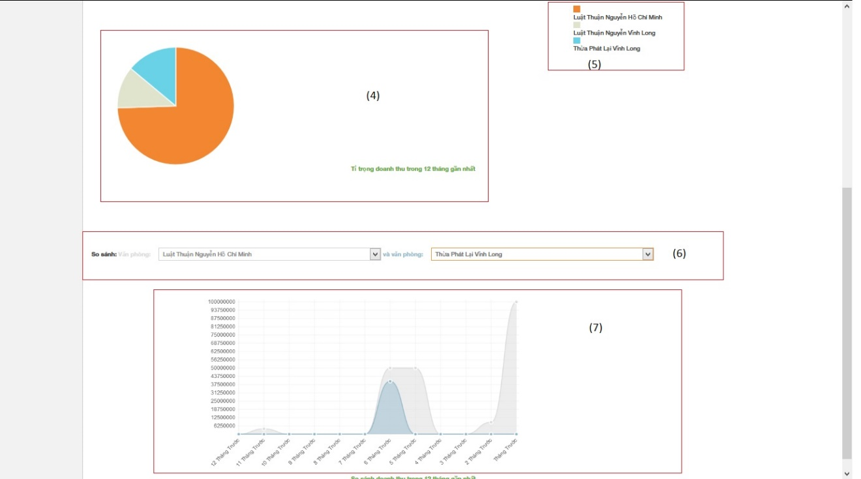

**Figure 4-147: Office Statistic image**

|  |  |  |  |  |
| --- | --- | --- | --- | --- |
| No | Object/ControlName | Type | Required | Description |
| 1 | Chọn văn phòng | Combo box | Yes | Click to choose name of office |
| 2 | Tab statistic | Link | Yes | Click to choose tab of statistic |
| 3 | Bar chart | Image | Yes | Image display of Bar chart |
| 4 | Pie chart | Image | Yes | Image display of Bar chart |
| 5 | Name office | Text | Yes | Name of office |
| 6 | Select name office | Combo box | Yes | Select name for comparison office |
| 7 | Comparison chart | Image | Yes | Image display of Bar chart |

##### Sequence diagram

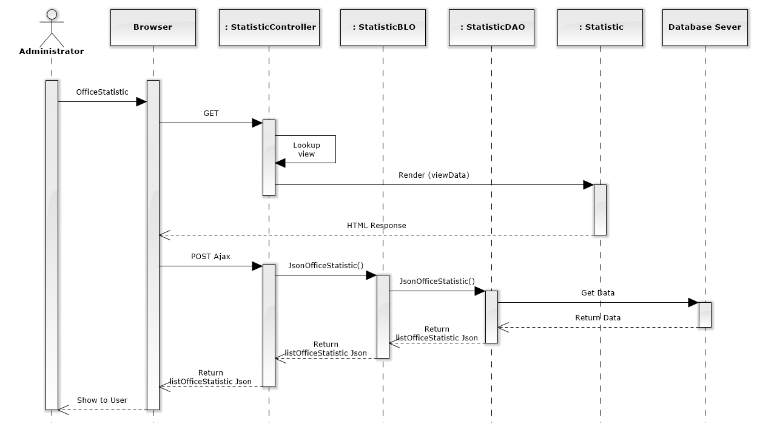

**Figure 4-148: Office Statistic Sequence Diagram**

#### Office statistic in year

##### Screen design

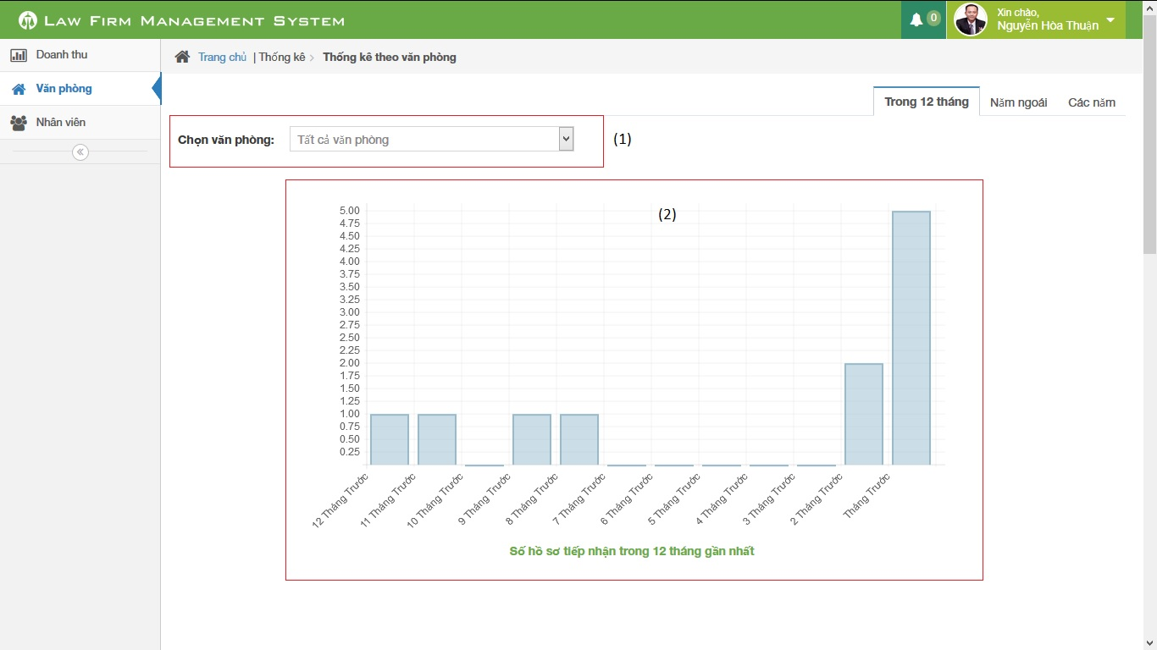

**Figure 4-149: Office Statistic in year image**

|  |  |  |  |  |
| --- | --- | --- | --- | --- |
| No | Object/ControlName | Type | Required | Description |
| 1 | Chọn văn phòng | Combo box | Yes | Click to choose name of office |
| 2 | Bar chart | Image | Yes | Image display of Bar chart |

##### Sequence diagram

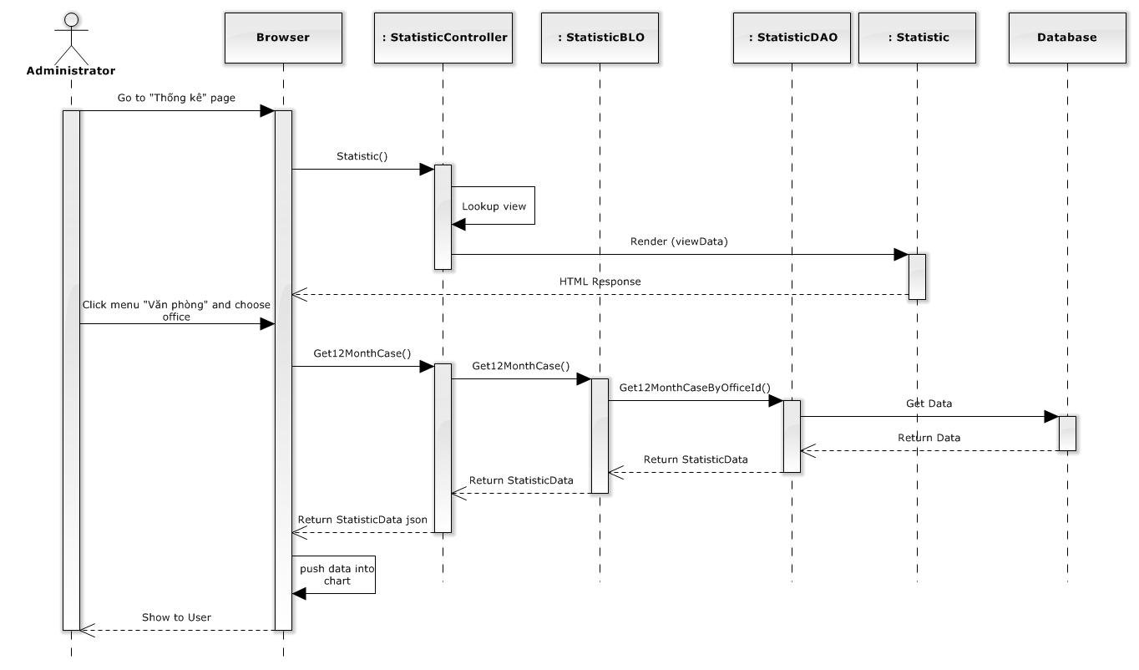

**Figure 4-150: Office Statistic in year sequence diagram**

#### Office statistic last year

##### Screen design

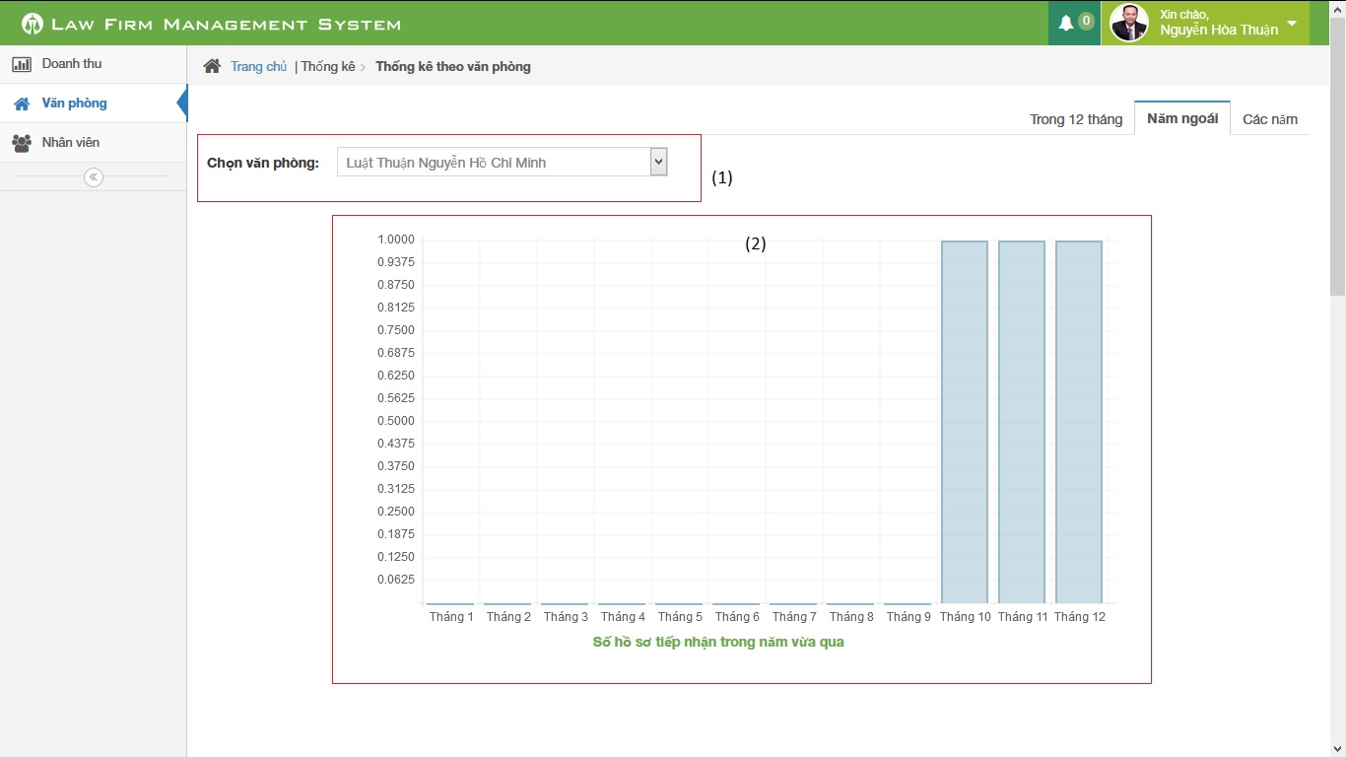

**Figure 4-151: Office Statistic last year image**

|  |  |  |  |  |
| --- | --- | --- | --- | --- |
| No | Object/ControlName | Type | Required | Description |
| 1 | Chọn văn phòng | Combo box | Yes | Click to choose name of office |
| 2 | Bar chart | Image | Yes | Image display of Bar chart |

##### Sequence diagram

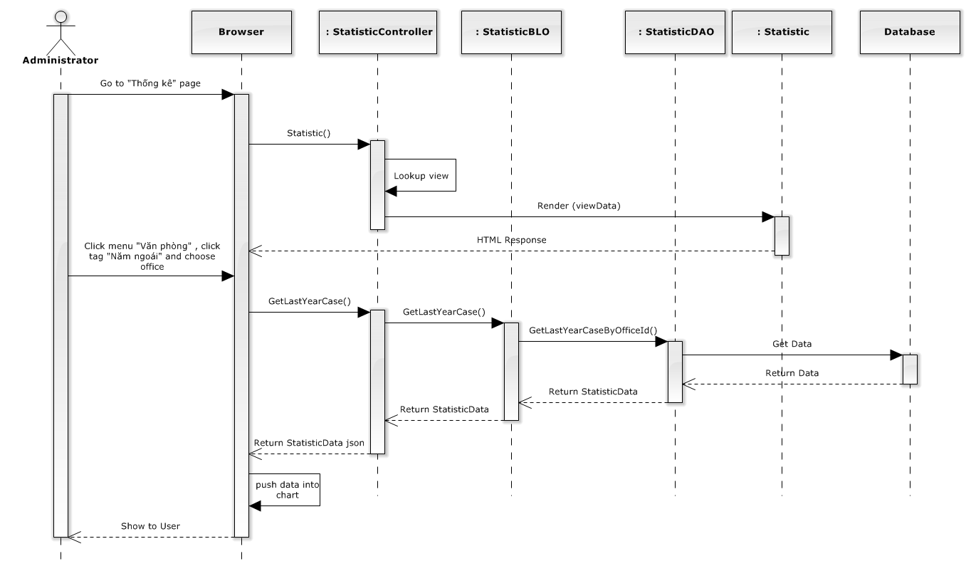

**Figure 4-152: Office Statistic last year sequence diagram**

#### Office statistic in every year

##### Screen design

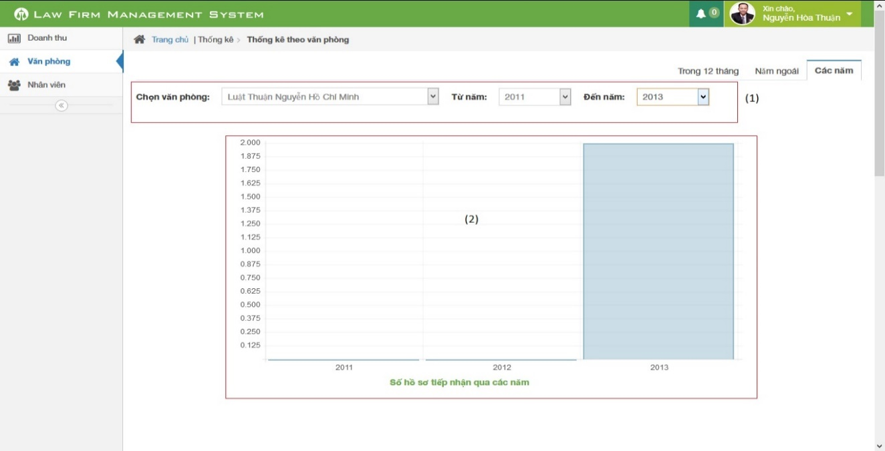

**Figure 4-153: Office Statistic in every year image**

|  |  |  |  |  |
| --- | --- | --- | --- | --- |
| No | Object/ControlName | Type | Required | Description |
| 1 | Chọn văn phòng từ năm đến năm | Combo box | Yes | Click to choose name of office with from year and to year |
| 2 | Bar chart | Image | Yes | Image display of Bar chart |

##### Sequence diagram

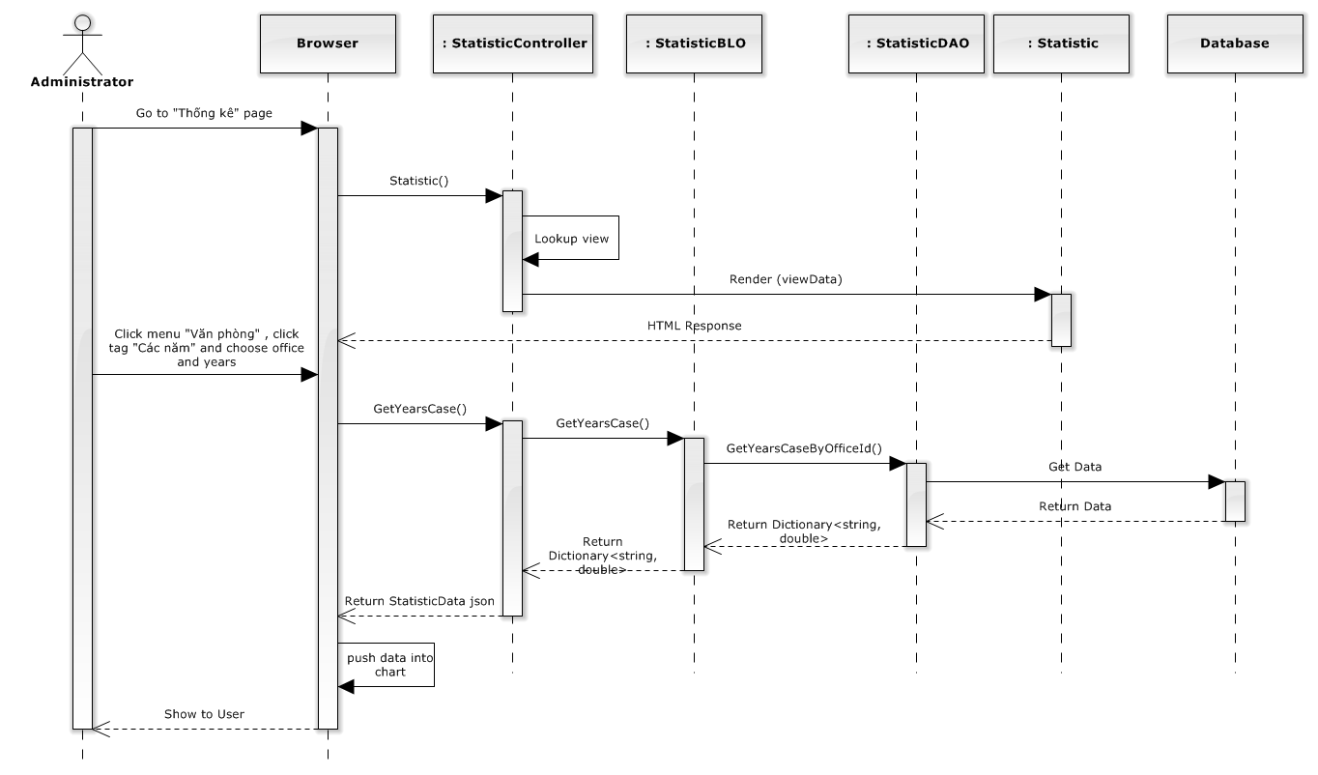

**Figure 4-154: Office Statistic in every year sequence diagram**

#### Staff statistic

##### Screen design

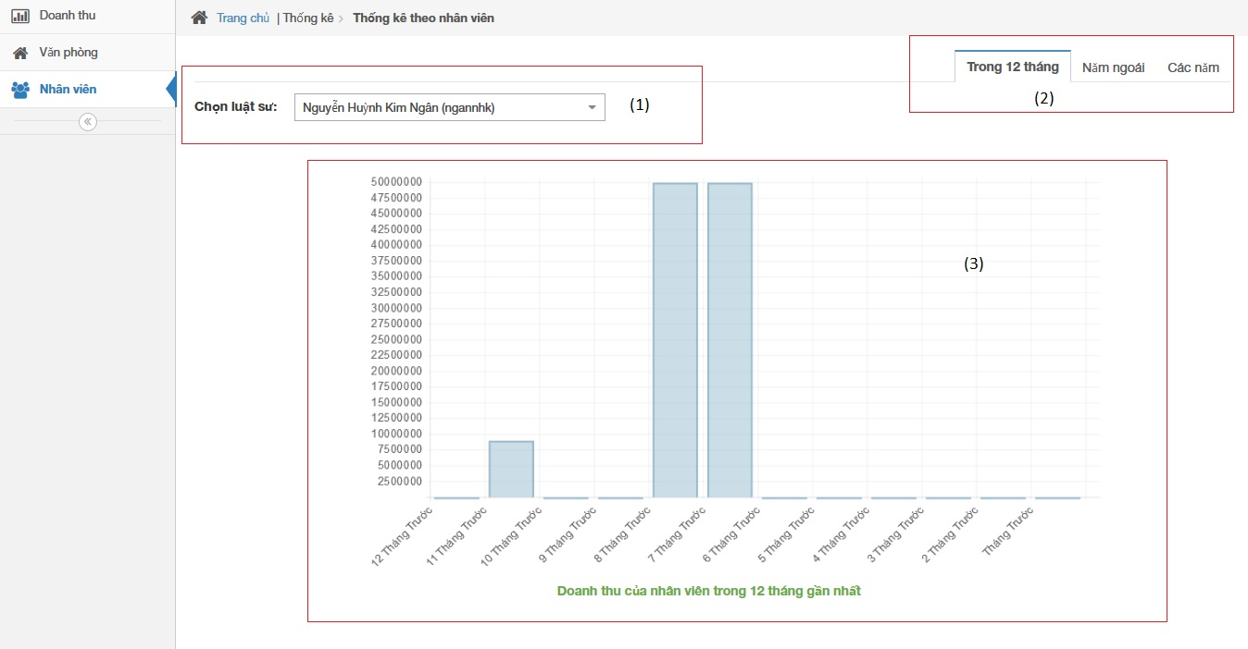

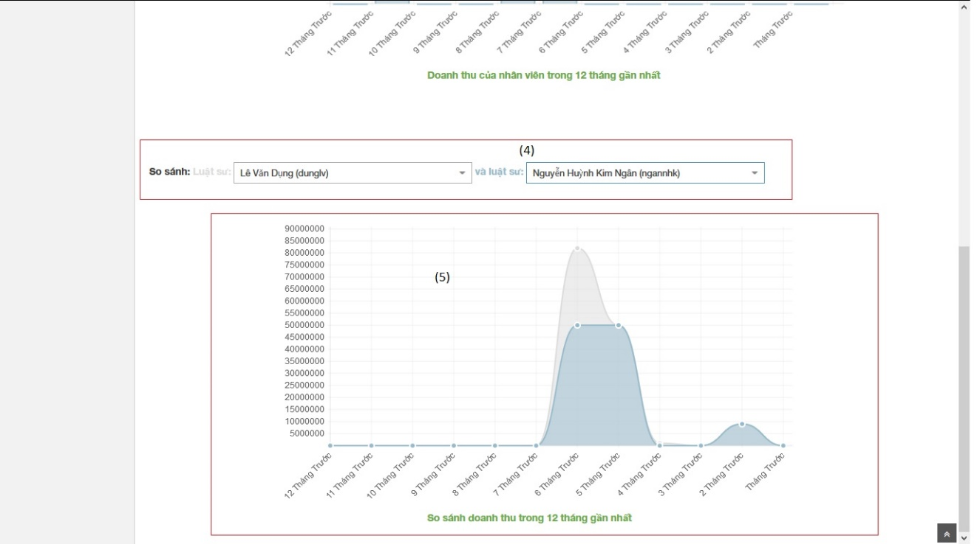

**Figure 4-155: Staff Statistic image**

|  |  |  |  |  |
| --- | --- | --- | --- | --- |
| No | Object/ControlName | Type | Required | Description |
| 1 | Chọn luật sư | Combo box | Yes | Click to choose name of staff |
| 2 | Tab statistic | Link | Yes | Click to choose tab of statistic |
| 3 | Bar chart | Image | Yes | Image display of Bar chart |
| 4 | Select name staff | Combo box | Yes | Select name for comparison staff |
| 5 | Comparison chart | Image | Yes | Image display of Bar chart |

##### Sequence diagram

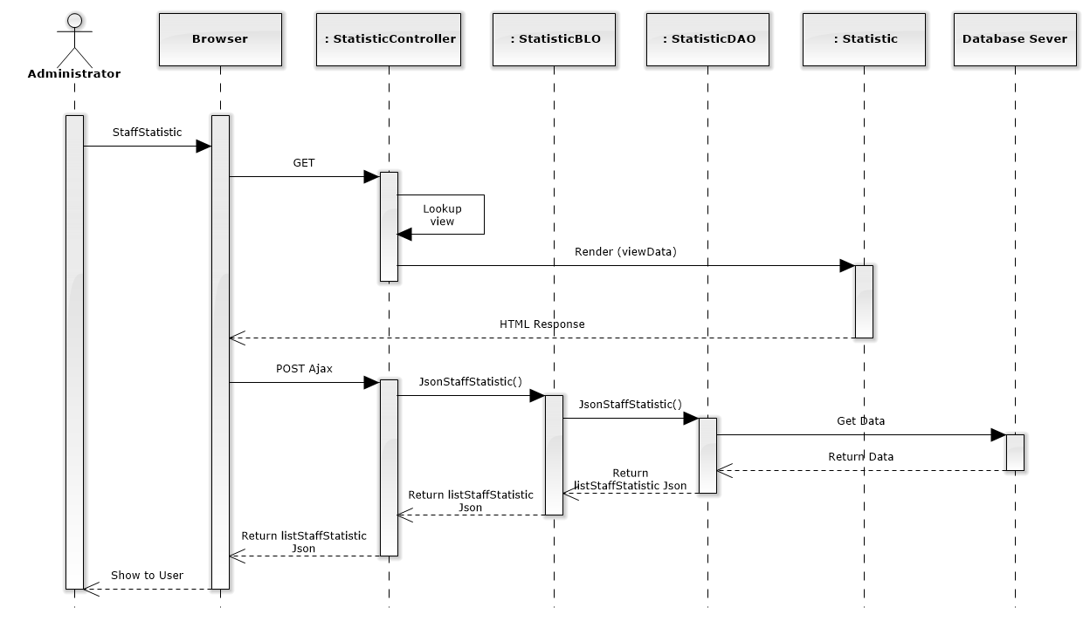

**Figure 4-156: Staff Statistic Sequence Diagram**

#### Staff statistic in year

##### Screen design

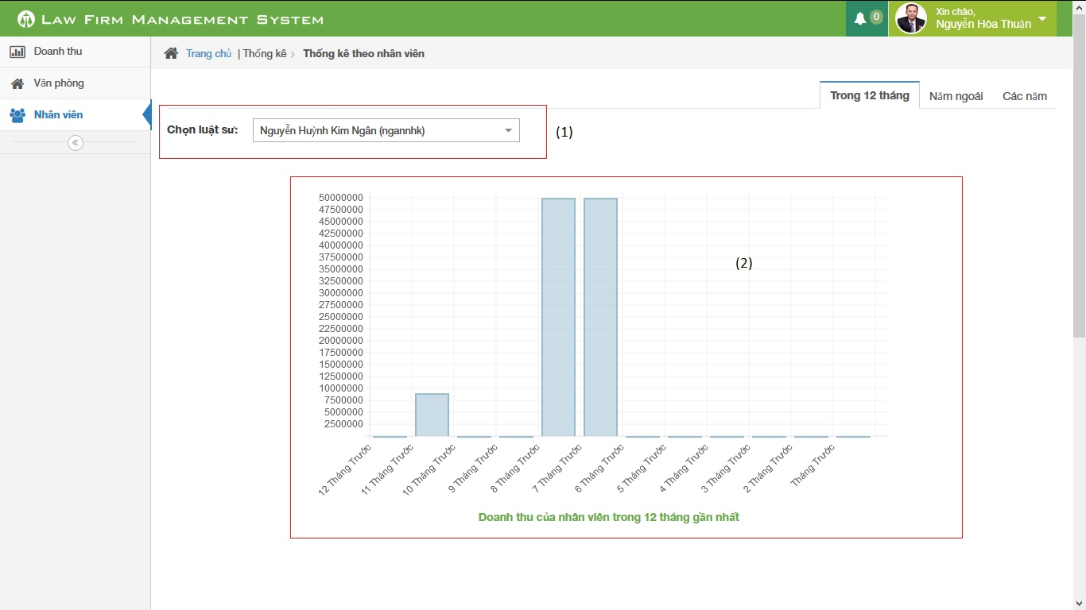

**Figure 4-157: Staff Statistic in year image**

|  |  |  |  |  |
| --- | --- | --- | --- | --- |
| No | Object/ControlName | Type | Required | Description |
| 1 | Chọn luật sư | Combo box | Yes | Click to choose name of lawyer |
| 2 | Bar chart | Image | Yes | Image display of Bar chart |

##### Sequence diagram

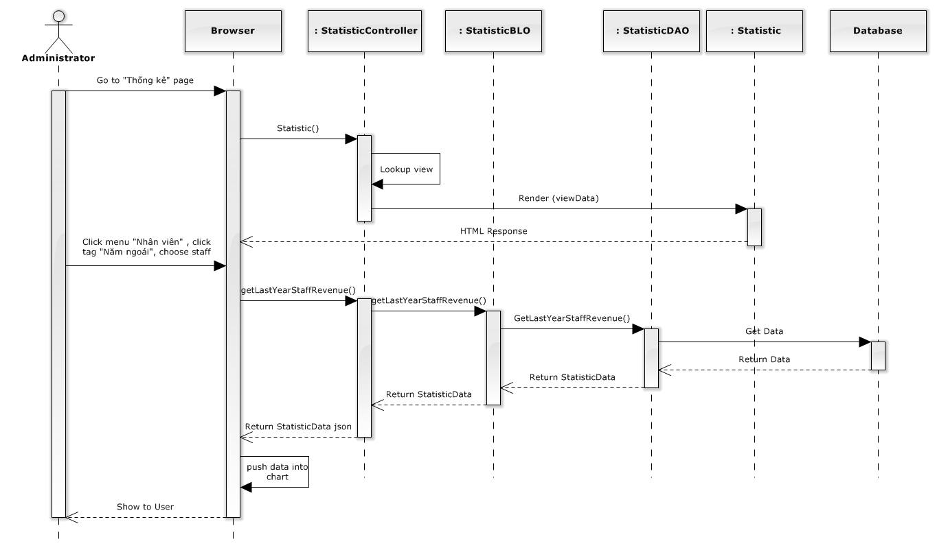

**Figure 4-158: Staff Statistic in year sequence diagram**

#### Staff statistic in last year

##### Screen design

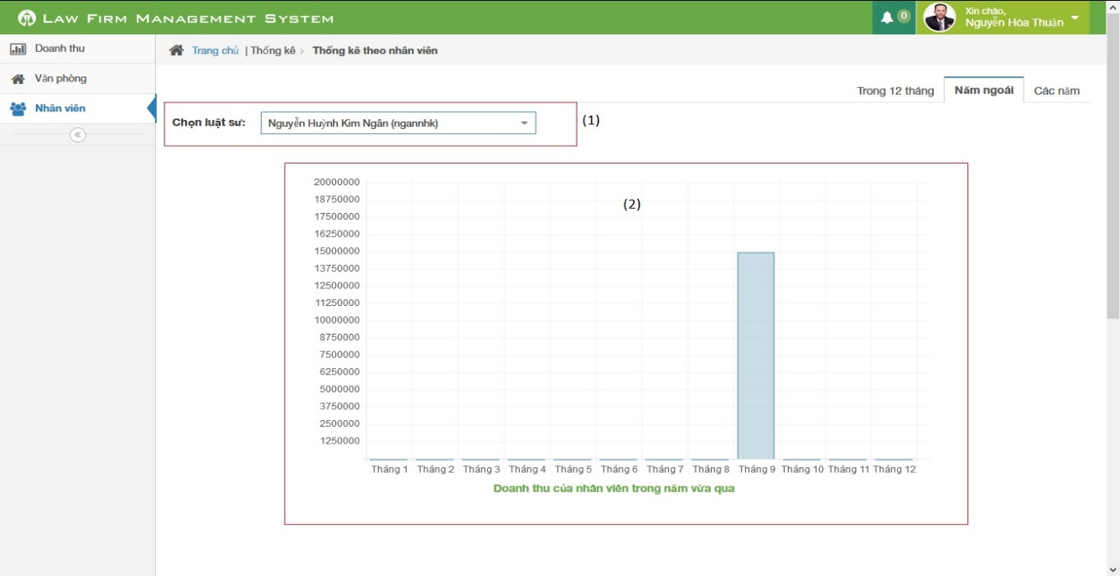

**Figure 4-159: Staff Statistic in last year image**

|  |  |  |  |  |
| --- | --- | --- | --- | --- |
| No | Object/ControlName | Type | Required | Description |
| 1 | Chọn luật sư | Combo box | Yes | Click to choose name of lawyer |
| 2 | Bar chart | Image | Yes | Image display of Bar chart |

##### Sequence diagram

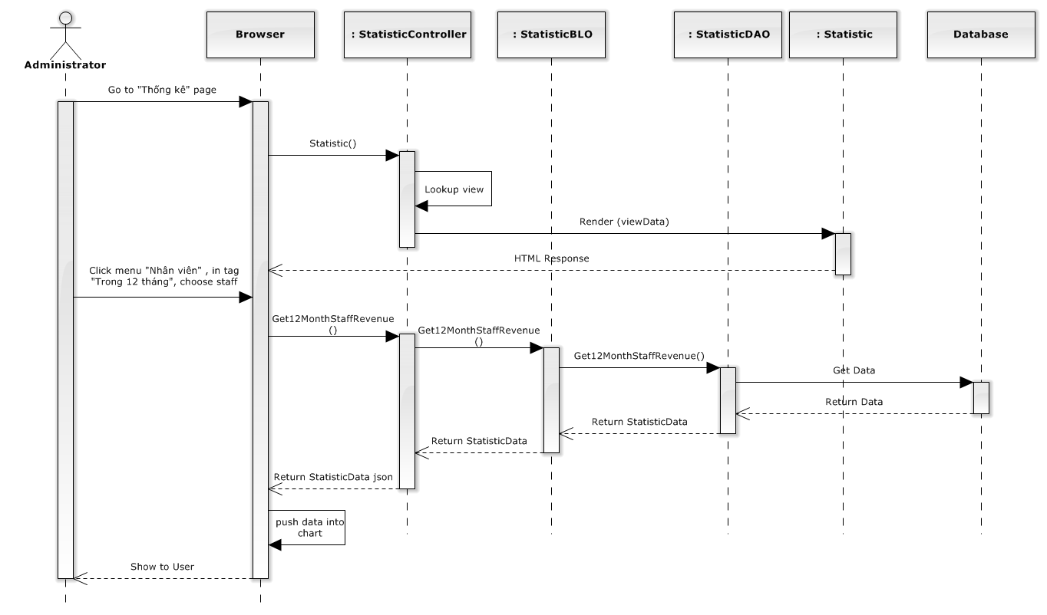

**Figure 4-160: Staff Statistic in last year sequence diagram**

#### Staff statistic in every year

##### Screen design

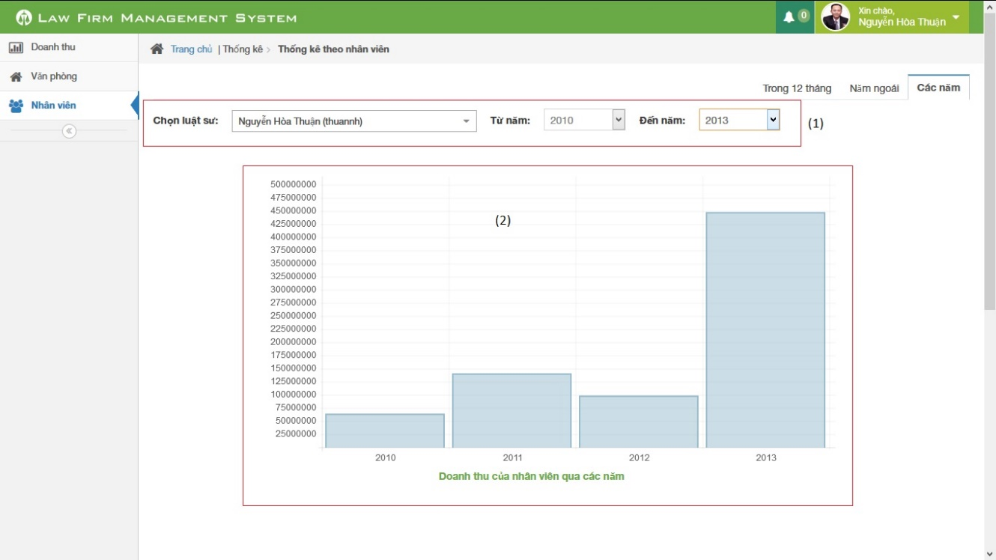

**Figure 4-161: Staff Statistic in every year image**

|  |  |  |  |  |
| --- | --- | --- | --- | --- |
| No | Object/ControlName | Type | Required | Description |
| 1 | Chọn luật sư từ năm đến năm | Combo box | Yes | Click to choose name of lawyer with from year and to year |
| 2 | Bar chart | Image | Yes | Image display of Bar chart |

##### Sequence diagram

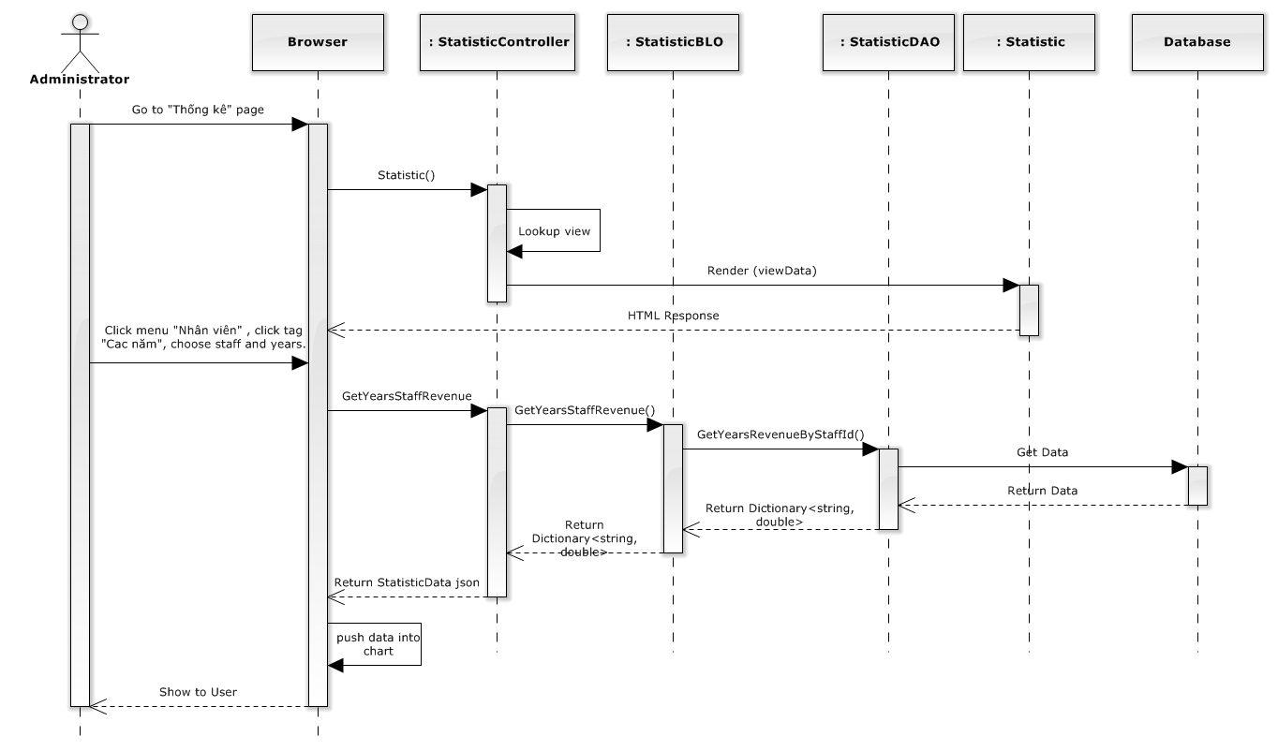

**Figure 4-162: Staff Statistic in every year sequence diagram**

#### Revenue statistic

##### Screen design

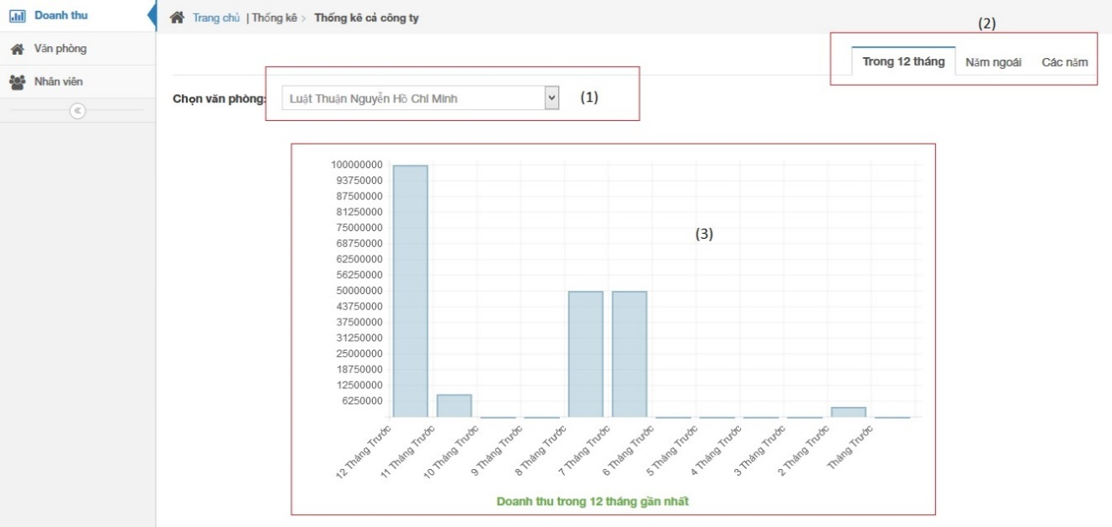

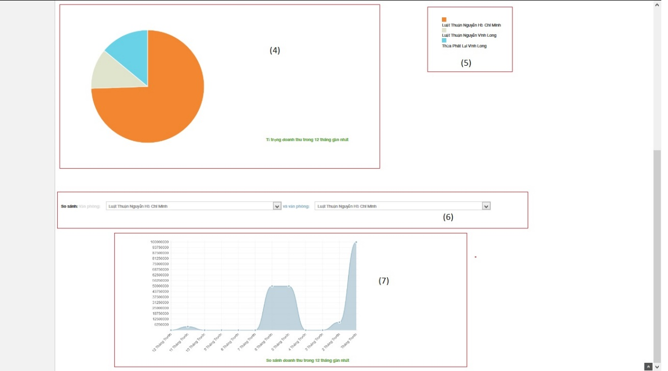

**Figure 4-163: Revenue Statistic image**

|  |  |  |  |  |
| --- | --- | --- | --- | --- |
| No | Object/ControlName | Type | Required | Description |
| 1 | Chọn văn phòng | Combo box | Yes | Click to choose name of office |
| 2 | Tab statistic | Link | Yes | Click to choose tab of statistic |
| 3 | Bar chart | Image | Yes | Image display of Bar chart |
| 4 | Pie chart | Image | Yes | Image display of Bar chart |
| 5 | Name office | Text | Yes | Name of office |
| 6 | Select name office | Combo box | Yes | Select name for comparison office |
| 7 | Comparison chart | Image | Yes | Image display of Bar chart |

##### Sequence diagram

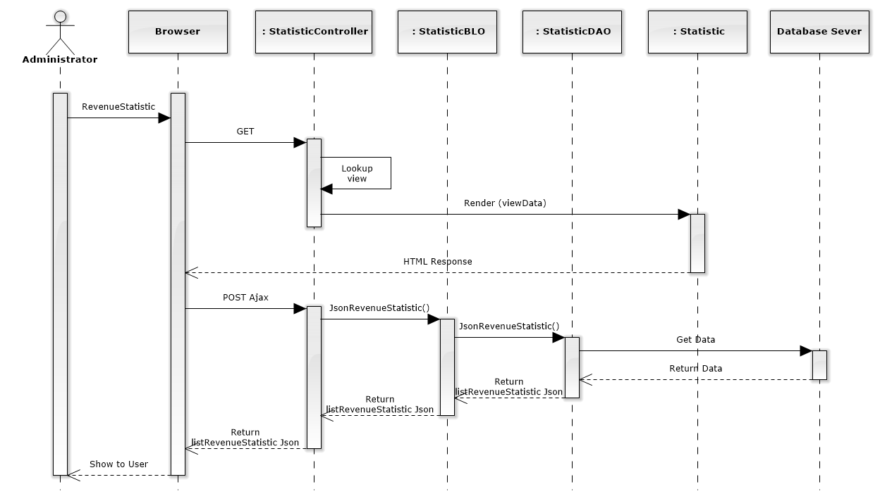

**Figure 4-164: Revenue Statistic Sequence Diagram**

#### Revenue statistic in year

##### Screen design

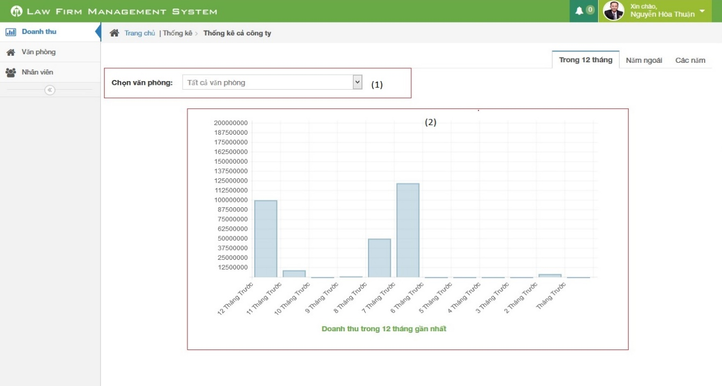

**Figure 4-165: Revenue Statistic in year image**

|  |  |  |  |  |
| --- | --- | --- | --- | --- |
| No | Object/ControlName | Type | Required | Description |
| 1 | Chọn văn phòng | Combo box | Yes | Click to choose name of office |
| 2 | Bar chart | Image | Yes | Image display of Bar chart |

##### Sequence diagram

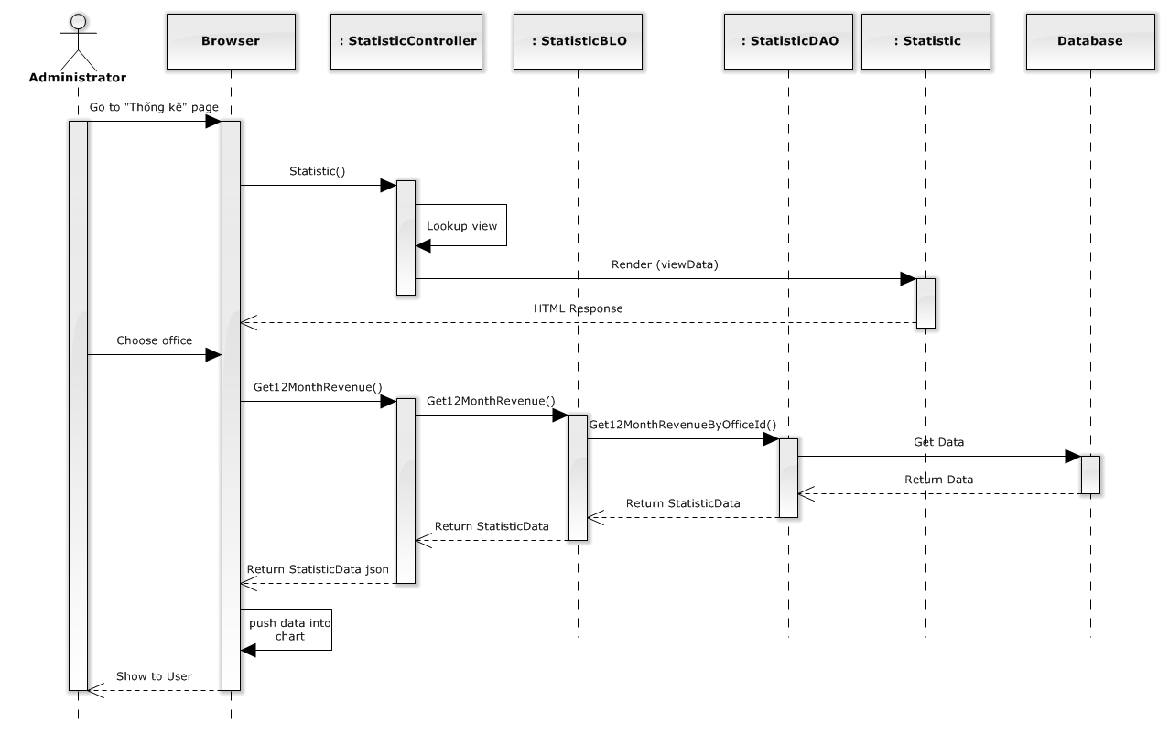

**Figure 4-166: Revenue Statistic in year sequence diagram**

#### Revenue statistic in last year

##### Screen design

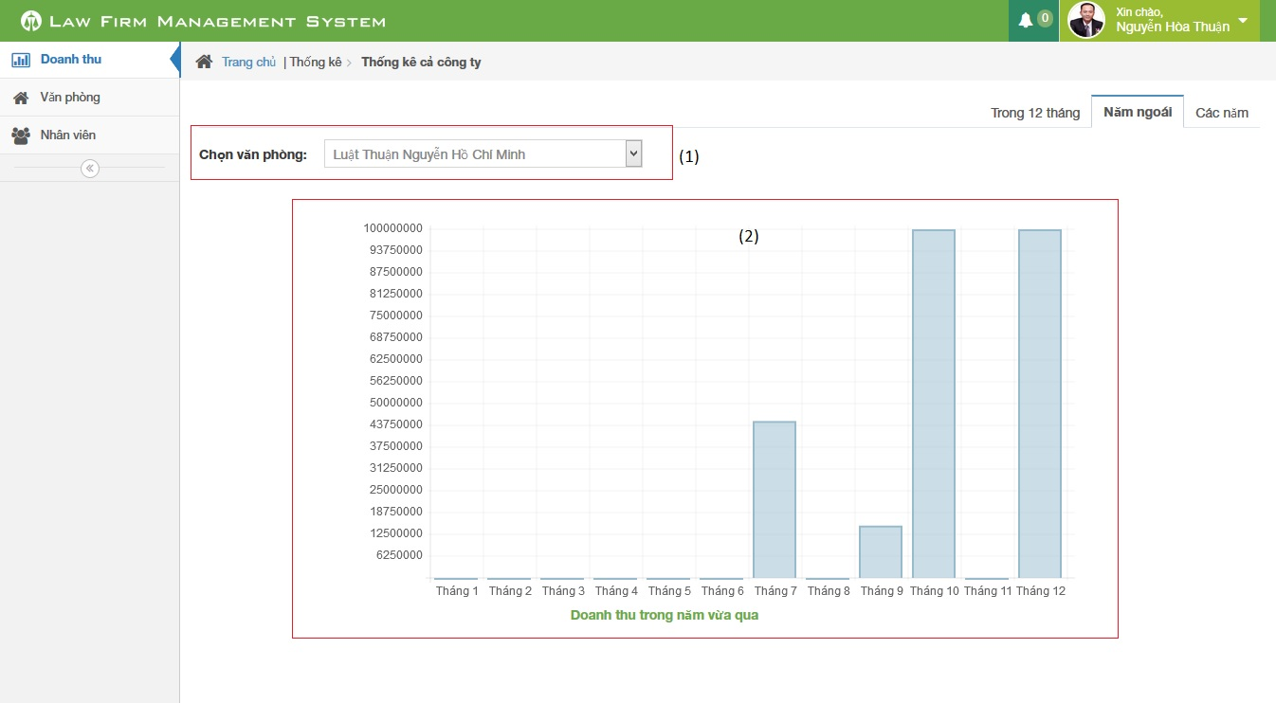

**Figure 4-167: Revenue Statistic in last year image**

|  |  |  |  |  |
| --- | --- | --- | --- | --- |
| No | Object/ControlName | Type | Required | Description |
| 1 | Chọn văn phòng | Combo box | Yes | Click to choose name of office |
| 2 | Bar chart | Image | Yes | Image display of Bar chart |

##### Sequence diagram

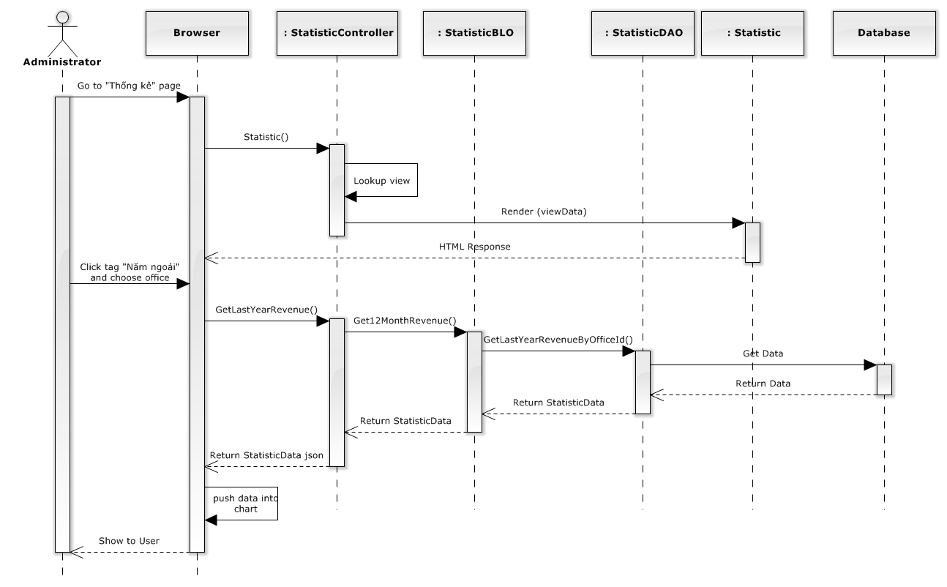

**Figure 4-168: Revenue Statistic in last year sequence diagram**

#### Revenue statistic in every year

##### Screen design

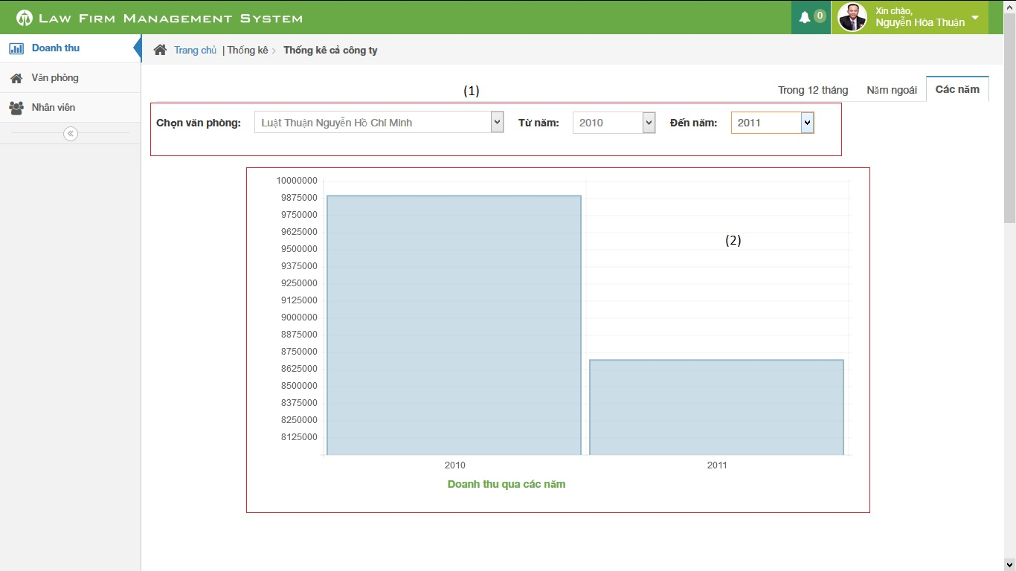

**Figure 4-169: Revenue Statistic in every year image**

|  |  |  |  |  |
| --- | --- | --- | --- | --- |
| No | Object/ControlName | Type | Required | Description |
| 1 | Chọn văn phòng từ năm đến năm | Combo box | Yes | Click to choose name of office with from year and to year |
| 2 | Bar chart | Image | Yes | Image display of Bar chart |

##### Sequence diagram

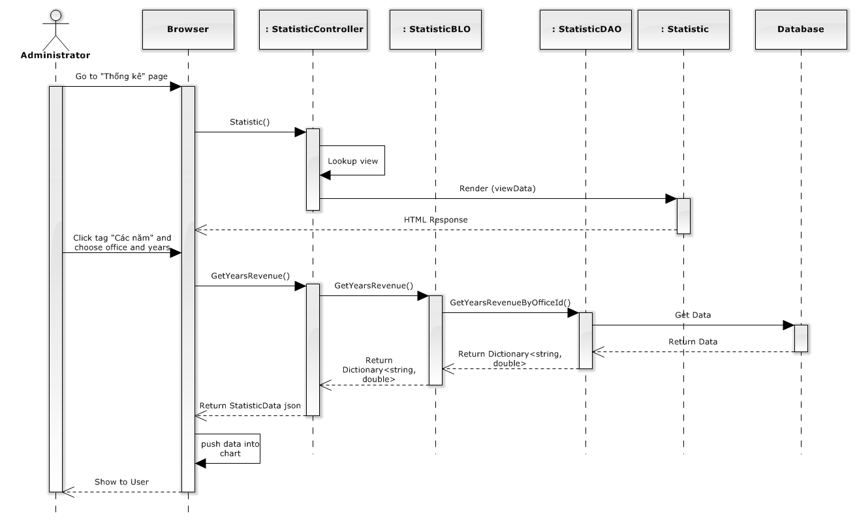

**Figure 4-170: Revenue Statistic in every year sequence diagram**

## Database Design

### Relational Database Diagram

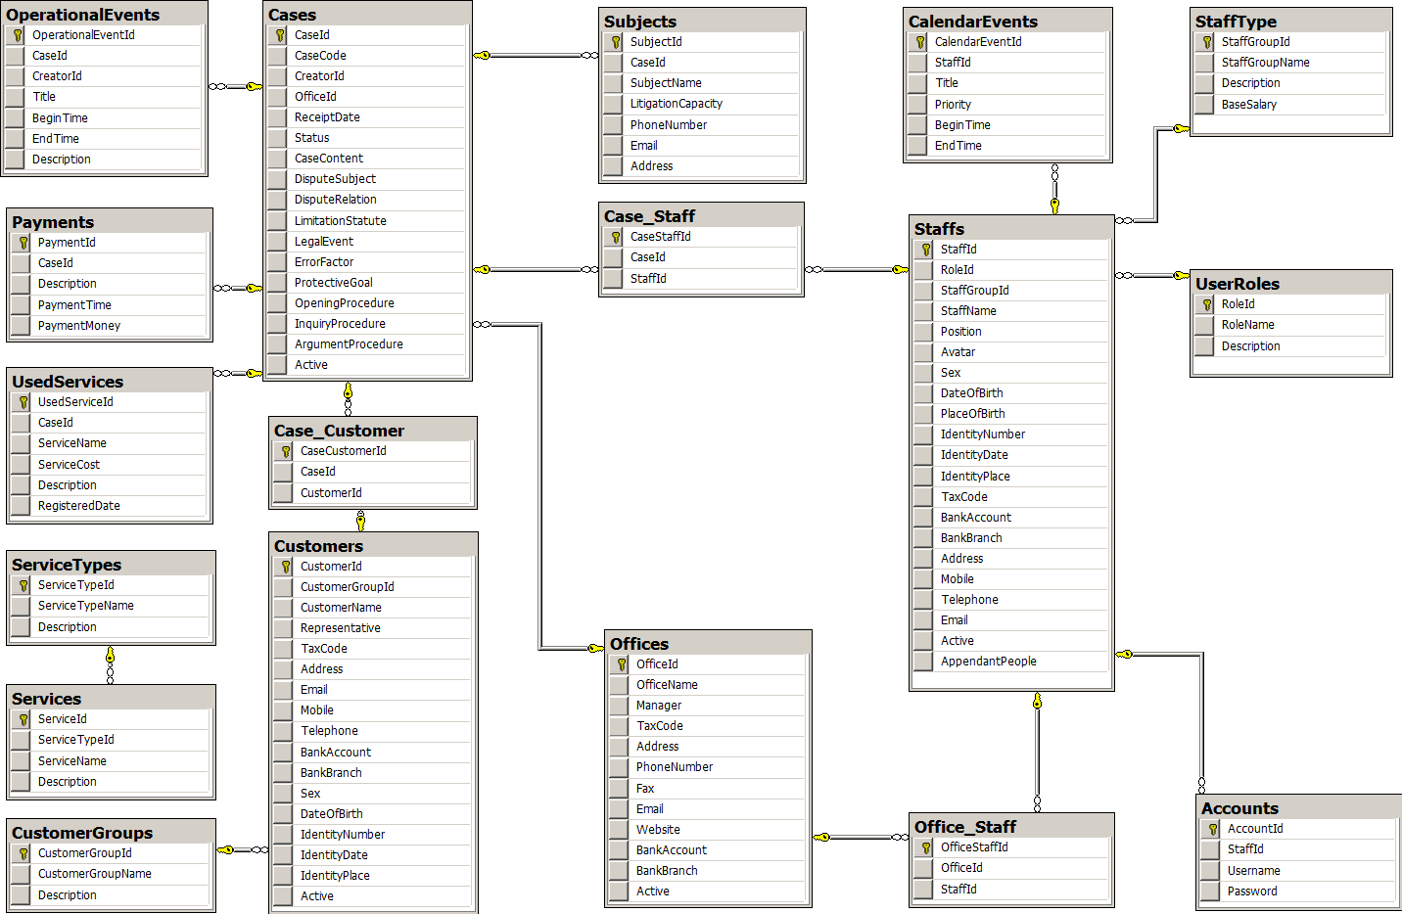

**Figure 4-171: Relational Database Diagram**

### Table Dictionary

#### Cases Table

|  |  |  |  |  |
| --- | --- | --- | --- | --- |
| Field Name | Type | Null | P/F Key | Thuật ngữ tiếng Việt |
| CaseId | int |  | PK |  |
| CaseCode | nvarchar(50) |  |  | Mã hồ sơ |
| CreatorId | int |  | FK |  |
| OfficeId | int |  | FK |  |
| ReceiptDate | date |  |  | Ngày thụ lý |
| Status | nvarchar(50) |  |  | Trạng thái hồ sơ |
| CaseContent | nvarchar(MAX) |  |  | Nội dung |
| DisputeSubject | nvarchar(MAX) | x |  | Đối tượng tranh chấp |
| DisputeRelation | nvarchar(MAX) | x |  | Quan hệ tranh chấp |
| LimitationStatute | nvarchar(MAX) | x |  | Thời hiệu |
| LegalEvent | nvarchar(MAX) | x |  | Sự kiện pháp lý |
| ErrorFactor | nvarchar(MAX) | x |  | Yếu tố lỗi |
| ProtectiveGoal | nvarchar(MAX) | x |  | Mục tiêu bảo vệ |
| OpeningProcedure | nvarchar(MAX) | x |  | Phần thủ tục bắt đầu |
| InquiryProcedure | nvarchar(MAX) | x |  | Phần thủ tục xét hỏi |
| ArgumentProcedure | nvarchar(MAX) | x |  | Phần tranh luận |
| Active | bit |  |  |  |

#### OperationEvents Table

|  |  |  |  |  |
| --- | --- | --- | --- | --- |
| Field Name | Type | Null | P/F Key | Thuật ngữ tiếng Việt |
| OperationalEventId | int |  | PK |  |
| CaseId | int |  | FK |  |
| CreatorId | int |  | FK |  |
| Title | nvarchar(100) |  |  | Tiêu đề |
| BeginTime | datetime |  |  | Thời gian bắt đầu |
| EndTime | datetime |  |  | Thời gian kết thúc |
| Description | nvarchar(MAX) | x |  | Mô tả nội dung |

#### Subjects Table

|  |  |  |  |  |
| --- | --- | --- | --- | --- |
| Field Name | Type | Null | P/F Key | Thuật ngữ tiếng Việt |
| SubjectId | int |  | PK |  |
| CaseId | int |  | FK |  |
| SubjectName | nvarchar(50) |  |  | Tên chủ thể |
| LitigationCapacity | nvarchar(50) |  |  | Tư cách tố tụng |
| PhoneNumber | nvarchar(20) | x |  | Số điện thoại |
| Email | nvarchar(50) | x |  | Hòm thư |
| Address | nvarchar(100) | x |  | Địa chỉ |

#### UsedServices Table

|  |  |  |  |  |
| --- | --- | --- | --- | --- |
| Field Name | Type | Null | P/F Key | Thuật ngữ tiếng Việt |
| UsedServiceId | int |  | PK |  |
| CaseId | int |  | FK |  |
| ServiceName | nvarchar(50) |  |  | Tên dịch vụ sử dụng |
| ServiceCost | int |  |  | Chi phí của dịch vụ |
| RegisteredDate | date |  |  | Ngày đăng ký dịch vụ |
| Description | nvarchar(MAX) |  |  | Mô tả chi tiết |

#### Payments Table

|  |  |  |  |  |
| --- | --- | --- | --- | --- |
| Field Name | Type | Null | P/F Key | Thuật ngữ tiếng Việt |
| PaymentId | int |  | PK |  |
| CaseId | int |  | FK |  |
| Description | nvarchar(MAX) |  |  | Mô tả chi tiết |
| PaymentTime | datetime |  |  | Thời gian thanh toán |
| PaymentMoney | int |  |  | Số tiền thanh toán |

#### Staffs Table

|  |  |  |  |  |
| --- | --- | --- | --- | --- |
| Field Name | Type | Null | P/F Key | Thuật ngữ tiếng Việt |
| StaffId | int |  | PK |  |
| StaffGroupId | int |  | FK |  |
| StaffName | nvarchar(50) |  |  | Tên nhân viên |
| Position | nvarchar(50) | x |  | Chức vụ |
| Avatar | nvarchar(100) | x |  | Đường dẫn ảnh đại diện |
| Sex | nvarchar(30) | x |  | Giới tính |
| DateOfBirth | date |  |  | Ngày sinh |
| PlaceOfBirth | nvarchar(100) | x |  | Nơi sinh |
| IdentityNumber | nvarchar(12) |  |  | Số CMND |
| IdentityDate | date |  |  | Ngày cấp |
| IdentityPlace | nvarchar(50) |  |  | Nơi cấp |
| TaxCode | nvarchar(14) | x |  | Mã số thuế |
| BankAccount | nvarchar(20) | x |  | Số TK ngân hàng |
| BankBranch | nvarchar(50) | x |  | Chi nhánh ngân hàng |
| Address | nvarchar(100) |  |  | Địa chỉ |
| Mobile | nvarchar(20) |  |  | Số di động |
| Telephone | nvarchar(20) | x |  | Số máy bàn |
| Email | nvarchar(50) |  |  | Hòm thư |
| Active  AppendantPeople | bit  int | x |  | Người phụ thuộc |

#### StaffType Table

|  |  |  |  |  |
| --- | --- | --- | --- | --- |
| Field Name | Type | Null | P/F Key | Thuật ngữ tiếng Việt |
| StaffGroupId | int |  | PK |  |
| StaffGroupName | nvarchar(50) |  |  | Tên nhóm nhân viên |
| Description  BaseSalary | nvarchar(MAX)  float | x  x |  | Mô tả chi tiết  Lương cơ bản |

#### UserRoles Table

|  |  |  |  |  |
| --- | --- | --- | --- | --- |
| Field Name | Type | Null | P/F Key | Thuật ngữ tiếng Việt |
| RoleId | int |  | PK |  |
| RoleName | nvarchar(50) |  |  | Tên vai trò |
| Description | nvarchar(MAX) | x |  | Mô tả chi tiết |

#### Accounts Table

|  |  |  |  |  |
| --- | --- | --- | --- | --- |
| Field Name | Type | Null | P/F Key | Thuật ngữ tiếng Việt |
| AccountId | int |  | PK |  |
| StaffId | int |  | FK |  |
| RoleId | int |  | FK |  |
| Username | nvarchar(50) |  |  | Tên đăng nhập |
| Password | nvarchar(50) |  |  | Mật khẩu |

#### CalendarEvents Table

|  |  |  |  |  |
| --- | --- | --- | --- | --- |
| Field Name | Type | Null | P/F Key | Thuật ngữ tiếng Việt |
| CalendarEventId | int |  | PK |  |
| StaffId | int |  | FK |  |
| Title | nvarchar(100) |  |  | Tiêu đề |
| Priority | nvarchar(50) |  |  | Mức độ ưu tiên |
| BeginTime | datetime |  |  | Thời gian bắt đầu |
| EndTime | datetime |  |  | Thời gian kết thúc |

#### Customers Table

|  |  |  |  |  |
| --- | --- | --- | --- | --- |
| Field Name | Type | Null | P/F Key | Thuật ngữ tiếng Việt |
| CustomerId | int |  | PK |  |
| CustomerGroupId | int |  | FK |  |
| CustomerName | nvarchar(50) |  |  | Tên khách hàng |
| Representative | nvarchar(50) | x |  | Người đại diện |
| TaxCode | nvarchar(14) | x |  | Mã số thuế |
| Address | nvarchar(100) |  |  | Địa chỉ |
| Email | nvarchar(50) |  |  | Hòm thư |
| Mobile | nvarchar(20) |  |  | Số di động |
| Telephone | nvarchar(20) | x |  | Số máy bàn |
| BankAccount | nvarchar(20) | x |  | Số TK ngân hàng |
| BankBranch | nvarchar(50) | x |  | Chi nhánh ngân hàng |
| Sex | nvarchar(20) | x |  | Giới tính |
| DateOfBirth | date | x |  | Ngày sinh |
| IdentityNumber | nvarchar(12) | x |  | Số CMND |
| IdentityDate | date | x |  | Ngày cấp |
| IdentityPlace | nvarchar(50) | x |  | Nơi cấp |
| Active | bit |  |  |  |

#### CustomerGroups Table

|  |  |  |  |  |
| --- | --- | --- | --- | --- |
| Field Name | Type | Null | P/F Key | Thuật ngữ tiếng Việt |
| CustomerGroupId | int |  | PK |  |
| CustomerGroupName | nvarchar(50) |  |  | Tên nhóm khách hàng |
| Description | nvarchar(MAX) | x |  | Mô tả chi tiết |

#### Offices Table

|  |  |  |  |  |
| --- | --- | --- | --- | --- |
| Field Name | Type | Null | P/F Key | Thuật ngữ tiếng Việt |
| OfficeId | int |  | PK |  |
| OfficeName | nvarchar(100) |  |  | Tên văn phòng |
| Manager | nvarchar(50) |  |  | Quản lý |
| TaxCode | nvarchar(14) | x |  | Mã số thuế |
| Address | nvarchar(100) |  |  | Địa chỉ |
| PhoneNumber | nvarchar(20) |  |  | Số điện thoại |
| Fax | nvarchar(20) | x |  | Số Fax |
| Email | nvarchar(50) |  |  | Hòm thư |
| Website | nvarchar(50) | x |  | Địa chỉ web |
| BankAccount | nvarchar(20) | x |  | Số TK ngân hàng |
| BankBranch | nvarchar(50) | x |  | Chi nhánh ngân hàng |
| Active | bit |  |  |  |

#### Services Table

|  |  |  |  |  |
| --- | --- | --- | --- | --- |
| Field Name | Type | Null | P/F Key | Thuật ngữ tiếng Việt |
| ServiceId | int |  | PK |  |
| ServiceTypeId | int |  | FK |  |
| ServiceName | nvarchar(50) |  |  | Tên dịch vụ |
| Description | nvarchar(MAX) | x |  | Mô tả chi tiết |

#### ServiceTypes Table

|  |  |  |  |  |
| --- | --- | --- | --- | --- |
| Field Name | Type | Null | P/F Key | Thuật ngữ tiếng Việt |
| ServiceTypeId | int |  | PK |  |
| ServiceTypeName | nvarchar(50) |  |  | Tên loại dịch vụ |
| Description | nvarchar(MAX) | x |  | Mô tả chi tiết |

# Software Testing

## Introduction

### System Overview

* This document describes plan and methods used in testing stage, an important step for grading the quality of product before packaging it.
* Testing group would plan, manage and execute the process of testing. Testers must execute and pass all test cases and technical details of system features.
* The testing group is also the coding group of Law Firm Management System.

### Test Approach

The testing of project include unit test system test and acceptance test levels. It is hoped that there will be as less problem as possible in project.

* Unit testing will be done by team member and will be approved by team leader.
* System testing will be performed by all member of team. It will check all main-flow of the system to discover error or bugs that can’t be found on unit testing level.
* Acceptance testing will be performed by all members of team and staffs at the Thuan Nguyen Law Firm. The project be checked from the Customer test to find out if the project in accordance with the expectations of Customer. The acceptance test will be done for a period of 2 weeks after completion of the System test process. Programs will enter into Acceptance test after all critical and major defects have been corrected. A program may have one major defect as long as it does not obstruct testing of the program. Prior to final completion of acceptance testing all open critical and major defects must be corrected.

## Test plan

### Scope of testing

The scope of testing in the project include:

* **Stages of testing**: the team has responsibility to conduct Unite testing, Integration testing and System testing
* **Types of testing**: The test team use functional test, white-box test and user interface testing
* **Range of testing**: Team performs testing all functions defined in the SRS based on the approved version. Test cases of each function are defined in the Test cases document that will be tested to determine if they meet the requirements and intermediate result will also be checked according to the SRS

### Requirement for testing

#### Test items

|  |  |  |
| --- | --- | --- |
| **No** | **Group of functions** | **Functions** |
| Web module | | |
|  | Account control | Login |
|  | Logout |
|  | Change password |
|  | Manage Calendar Event | List calendar events |
|  | Add new calendar event |
|  | Edit calendar event |
|  | Delete calendar event |
|  | Search calendar event |
|  | Manage Case | List all cases |
|  | Add new case |
|  | Search case |
|  | Manage case info | View Case Info |
|  | Edit case info |
|  | Manage operation event | List operation events |
|  | View operation event detail |
|  | Add new operation event |
|  | Edit operation event |
|  | Delete operation event |
|  | Manage Lawyer Related | List lawyer related |
|  | View lawyer related detail |
|  | Assign lawyer related |
|  | Remove lawyer related |
|  | Search lawyer related |
|  | Manage customer related | List customers related |
|  | View customer related detail |
|  | Add customer related |
|  | Remove customer related |
|  | Search customer related |
|  | Manage Subject Related | List subjects related |
|  | Add new subject related |
|  | Edit subject related |
|  | Delete subject related |
|  | Manage Document Related | View Document Related |
|  | View Document Related Detail |
|  | Upload Document Related |
|  | Edit Document Related |
|  | Delete Document Related |
|  | Search Document Related |
|  | Manage User Service | View User Services |
|  | Add New User Servic |
|  | Edit User Service |
|  | Delete User Service |
|  | Manage Payment | View Payments |
|  | Add New Payment |
|  | Edit Payment |
|  | Delete Payment |
|  | Manage Customer | List customers |
|  | View customer detail |
|  | Add new customer |
|  | Edit customer |
|  | Delete customer |
|  | Search customer |
|  | Manage Staff | List staffs |
|  | View staff detail |
|  | Add new staff |
|  | Edit staff |
|  | Deactive/Active staff |
|  | Search staff |
|  | Reset password |
|  | Manage Service | List services |
|  | View service detail |
|  | Add new service |
|  | Edit service |
|  | Delete service |
|  | Search service |
|  | Statistics | Statistics of revenue by office |
|  | Statistics of number of case by office |
|  | Statistics of revenue by staff |
|  | Manage Office | List offices |
|  | View office detail |
|  | Add new office |
|  | Edit office |
|  | Deactive/Active office |
|  | Search office |

**Table 5-3: Requirement for testing**

#### Acceptance Test Criteria

* Test coverage on system test: >= 97%
* Test successful coverage: >= 97%

Number of test cases failed: less than 3% of total test cases

#### Constraints

* Duration of system testing is from 17 November to 9 December
* Testing team require 2 members

#### Risk list

The project could face with some risks:

* Lack of human resource
* Not enough test case cover for business project

### Test strategy

#### Test policy

* “Test without good faith”
* “Find bugs as soon as possible and always make sure they have been fixed”
* “No outstanding high severity faults”
* “Ensuring the product covers key features and attributes requirements”
* “Each primary function has at least one test case”
* “Focus on main function”
* “If any test fails we need to test again”
* “Using valid and invalid data”

#### Test Model

Using V-Model to implement testing process

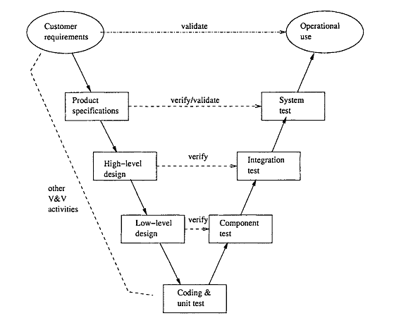

**Figure 5-1: V-Model to implement testing process**

Due to scope of LFMS project and project must always fulfill user requirements. With V-Model, software development is separated into two appropriate phases’ groups: development and testing. Testing phase is carried out simultaneously from the early of project, the requirement specification phase. Therefore, tester could study and understand the entire requirement as well as business of project

Moreover, there are many variations among planning, design and implementation during the whole project. To catch up with all changes and ensure logic as well as business, V-model is chose as a solution to help testers control and follow the actual workflows.

This testing is executed to ensure that all requirements mentioned in SRS, included both functional requirements and non-functional requirements which are implemented correctly.

* **Technique:**
* **Integration test**: Base on requirement in SRS and validation in database, test team will test as black box testing method to check if the input and output display as expected and does that flow work fluently
* **System** **testing**: Based on requirements in SRS, test team will create scenarios for system testing (ST) to ensure project’s business. In ST, tester will create test cases based on these scenarios and run to verify functional and non-functional requirements.
* **Completion criteria:**
* All planned test cases have been executed compared with expected result in test cases.
* System test cases must be green (passed) at least 97%
* All defects must be logged into test documents and re-tested after it is fixed.
* All defects, which are accepted by customer or project technical leader and project manager, will be marked as accepted and not be retested.
* All defects must be resolved or accepted.
* These criteria will be applied for all test types.
* **Special considerations:**
* Test databases will be required
* Testing may be stopped when
* Time runs out
* A certain number of defects found
* Test coverage > 97%
* Stop when testing becomes unproductive.

#### Type of testing

##### Functional Testing

Function testing of the target-of-test should focus on any requirements for test that can be traced directly to use cases or business functions and business rules.  The goals of these tests are to verify proper data acceptance, processing, and retrieval, and the appropriate implementation of the business rules.  Identified below is an outline of the testing recommended for each application.

|  |  |
| --- | --- |
| Test Objective: | The type of this test is to ensure proper target-of-test functionality, including user interaction, all function defined in specification document implemented correctly. |
| Technique: | The test team will use use-case testing or checklist-base testing to verify the following:  Checking performance of software interface function.  The appropriate error or warning messages are displayed when invalid data is used.  Each business rule is properly applied. |
| Completion Criteria: | All test case and checklist have been executed and successful coverage > =97%. |
| Special Considerations: | Testing may be stopped when   * Time runs out * A certain number of defects found * Test coverage > 97% * Stop when testing becomes unproductive |

**Table 5-2: Functional testing**

##### User Interface Testing

User Interface (UI) testing verifies a user’s interaction with the software. The goal of UI testing is to ensure that the User Interface provides the user with the appropriate access and navigation through the functions of the target-of-test.  In addition, UI testing ensures that the objects within the UI function as expected and conform to corporate or industry standards.

|  |  |
| --- | --- |
| Test Objective: | Verify the following: Navigation through the target-of-test properly reflects business functions and requirements, including window-to-window, field-to-field, and use of access methods (tab keys, mouse movements, accelerator keys |
| Technique: | Use checklist and finite-state machine to create test case. |
| Completion Criteria: | All test case and checklist have been executed and successful coverage > =97%. |

**Table 5-3: User Interface testing**

#### Test stage

Clearly state the stage in which the test will be executed. Identified below are the stages in which common test are executed

|  |  |  |  |
| --- | --- | --- | --- |
| Type of Tests | Stage of Test | | |
| Unit | Integration | System |
| Function Test |  | x | x |
| User Interface test | x |  | x |
| Whitebox test | x |  |  |

**Table 5-4: Test stages**

#### Tools

|  |  |  |  |
| --- | --- | --- | --- |
| Purpose | Tool | Vendor/In-house | Version |
| Access to website | Firefox |  |  |
| Keep tracking defects | MS Word |  | Office 2010 & 2013 |
| Test Plan | MS Word |  | Office 2010 & 2013 |
| Test Case, Test Report | MS Excel |  | Office 2010 & 2013 |

**Table 5-5: Tools**

#### Resources

This table shows the staffing assumptions for the project.

|  |  |
| --- | --- |
| Worker/Doer | Specific Responsibilities/Comments |
| Trần Anh Tuấn  Phạm Văn Duy | Manage Test resource and assign test tasks  Create Test Plan  Review Test Cases  Execute Test  Create Test Report  Execute Test |

**Table 5-6: Human resource**

#### Schedule

Duration of all testing is from 27 October to 9 December

Duration of create test plan, test case and checklist are from 20 October to 3 November

## Test Case

Reference to DVD: <root>/Documents/LFMS Project Document - Full Report.docx

## Checklists

### Checklist of Validation

|  |  |  |  |  |
| --- | --- | --- | --- | --- |
| # | Question | Yes | No | N/A |
| 1 | Does a failure of validation on every field cause a sensible user error symbol? |  |  |  |
| 2 | Is the user required to fix entries which have failed validation tests? |  |  |  |
| 3 | Have any fields got multiple validation rules and if so are all rules being applied? |  |  |  |
| 4 | If the user enters an invalid value and clicks on the insert button is the invalid entry identified and highlighted correctly with an error symbol? |  |  |  |
| 5 | Is validation consistently applied at screen level unless specifically required at field level? |  |  |  |
| 6 | For all numeric fields check whether negative numbers can and should be able to be entered. |  |  |  |
| 7 | For all numeric fields check the minimum and maximum values and also some mid-range values allowable? |  |  |  |
| 8 | For all character/alphanumeric fields check the field to ensure that there is a character limit specified and that this limit is exactly correct for the specified database size? |  |  |  |
| 9 | Do all mandatory fields require user input? |  |  |  |
| 10 | If any of the database columns do not allow null values then the corresponding screen fields must be mandatory. (If any field which initially was mandatory has become optional then check whether null values are allowed in this field.) |  |  |  |

### Checklist for user interface

|  |  |  |  |  |
| --- | --- | --- | --- | --- |
| # | Question | Yes | No | N/A |
| USABILITY | | | | |
| 1 | Are the entire field prompts spelt correctly? |  |  |  |
| 2 | Are fonts too large or too small to read? |  |  |  |
| 3 | Are names in command button & option box names are not abbreviations. |  |  |  |
| 4 | Assure that option boxes, option buttons, and command buttons are logically grouped together in clearly demarcated areas "Group Box" |  |  |  |
| 5 | Can the typical user run the system without frustration? |  |  |  |
| 6 | Does the site have a consistent, clearly recognizable "look-&-feel"? |  |  |  |
| 7 | Is all terminology understandable for all of the site’s intended users? |  |  |  |
| USER INTERFACE TESTING-COLOR | | | | |
| 1 | Are hyperlink colors standard? |  |  |  |
| 2 | Are the field prompts the correct color? |  |  |  |
| 3 | Are the field backgrounds the correct color? |  |  |  |
| 4 | Are the screen and field colors adjusted correctly for non-editable mode? |  |  |  |
| 5 | Does the site use (approximately) standard link colors? |  |  |  |
| 6 | Are all the buttons are in standard format and size? |  |  |  |
| 7 | Is the general screen background the correct color? |  |  |  |
| 8 | Is the page background (color) distraction free? |  |  |  |
| USER INTERFACE TESTING-CONTENT | | | | |
| 1 | All fonts to be the same |  |  |  |
| 2 | Are all the screen prompts specified in the correct screen font? |  |  |  |
| 3 | Is all text properly aligned? |  |  |  |
| 4 | Is the text in all fields specified in the correct screen font? |  |  |  |
| 5 | Is all the headings left aligned? |  |  |  |
| 6 | Does the first letter of the second word appear in lowercase? |  |  |  |

### Checklist for document

|  |  |  |  |  |
| --- | --- | --- | --- | --- |
| # | Question | Yes | No | N/A |
| TABLES AND FIGURES | | | | |
| 1 | Does every table column, including the stub column, have a heading? |  |  |  |
| 2 | Are references cited both in text and in the reference list? |  |  |  |
| 3 | Is lettering in a figure no smaller than 12 points and no larger than 14 points? |  |  |  |
| 4 | Are all figures and tables mentioned in the text and numbered in the order in which they are mentioned? |  |  |  |
| REFERENCES | | | | |
| 1 | Are references cited both in text and in the reference list? |  |  |  |
| 2 | Do the text citations and reference list entries agree both in spelling and in date? |  |  |  |
| 3 | Are journal titles in the reference list spelled out fully? |  |  |  |
| 4 | Are the references (both in the parenthetical text citations and in the reference list) ordered alphabetically by the authors’ surnames? |  |  |  |
| 5 | Are inclusive page numbers for all articles or chapters in books provided in the reference list? |  |  |  |
| 6 | Are references to studies included in your meta-analysis preceded by an asterisk? |  |  |  |
| FORMAT | | | | |
| 1 | Have you checked the journal’s website for instructions to authors regarding specific formatting requirements for submission? |  |  |  |
| 2 | Is the entire manuscript—including quotations, references, author note, content footnotes, and figure captions—double-spaced? Is the manuscript neatly prepared? |  |  |  |
| 3 | Are the margins at least 1 in. (2.54 cm)? |  |  |  |
| 4 | Are the title pages, abstracts, references, appendices, content footnotes, tables, and figures on separate pages (with only one table or figure per page)? Are the figure captions on the same page as the figures? Are manuscript elements ordered in sequence, with the text pages between the abstract and the references? |  |  |  |
| PARAGRAPHS AND HEADINGS | | | | |
| 1 | Is each paragraph longer than a single sentence but not longer than one manuscript page? |  |  |  |
| 2 | Do the levels of headings accurately reflect the organization of the paper? |  |  |  |
| 3 | Do all headings of the same level appear in the same format? |  |  |  |

## Test Logs

### Defect Logs

|  |  |  |  |  |  |  |  |
| --- | --- | --- | --- | --- | --- | --- | --- |
| **No** | **Module name** | **Defect** | **Priority** | **Status** | **Assign to** | **Fix on** | **Retest on** |
| 1 | Edit Operation event | After updated successful, the event is shown not enough. | High | Complete | HoangLD | 19/11/2014 | 20/11/2014 |
| 2 | Search lawyer related | When input wrong name, the result stll be shown. | High | Complete | HoangLD | 19/11/2014 | 20/11/2014 |
| 3 | Search Staff | The result after search arewrong. | High | Complete | Duypv | 20/11/2014 | 22/11/2014 |
| 4 | Edit Service | Edit with blank field, Error messege aren ‘t be shown. | High | Complete | KhiemDN | 21/11/2014 | 23/11/2014 |
| 5 | Edit Office | In numberic field, user can input character. | High | Complete | KhiemDN | 27/11/2014 | 29/11/2014 |

### Test Report

|  |  |  |  |
| --- | --- | --- | --- |
| **Project Name** | Website of Law Firm Management System. | **Creator** | TuanTA |
| **Project Code** | LFMS | **Reviewer/Approver** | SangNV |
| **Document Code** | LFMS_TestReport | **Issue Date** | December  5th 2014 |

|  |  |  |  |  |  |  |  |  |  |  |  |  |  |
| --- | --- | --- | --- | --- | --- | --- | --- | --- | --- | --- | --- | --- | --- |
|  | **Function** | | **Test Case** | | | | | | | **Checklist** | | |  |
| **No** | **Pass** | **Fail** | | **Untested** | | | **N/A** | **Pass** | **Fail** | **N/A** | **Total** |
|  | **Web Module** | | | | | | | | | | | | |
|  | Login | | 6 | 0 | | 0 | | | 0 | 27 | 0 | 4 | 37 |
|  | Logout | | 1 | 0 | | 0 | | | 0 | 22 | 0 | 9 | 32 |
|  | Change password | | 7 | 0 | | 0 | | | 0 | 29 | 0 | 2 | 38 |
|  | List calendar events | | 1 | 0 | | 0 | | | 0 | 25 | 0 | 24 | 50 |
|  | Add new calendar event | | 4 | 0 | | 0 | | | 0 | 31 | 0 | 0 | 35 |
|  | Edit calendar event | | 2 | 0 | | 0 | | | 0 | 31 | 0 | 0 | 35 |
|  | Delete calendar event | | 2 | 0 | | 0 | | | 0 | 24 | 0 | 7 | 33 |
|  | Search calendar event | | 2 | 0 | | 0 | | | 0 | 27 | 0 | 4 | 33 |
|  | List all cases | | 1 | 0 | | 0 | | | 0 | 25 | 0 | 6 | 32 |
|  | Add new case | | 7 | 0 | | 0 | | | 0 | 31 | 0 | 18 | 56 |
|  | Search case | | 1 | 0 | | 0 | | | 0 | 27 | 0 | 4 | 32 |
|  | View Case Info | | 1 | 0 | | 0 | | | 0 | 25 | 0 | 6 | 32 |
|  | Edit case info | | 4 | 0 | | 0 | | | 0 | 31 | 0 | 0 | 35 |
|  | List operation events | | 1 | 0 | | 0 | | | 0 | 25 | 0 | 6 | 32 |
|  | View operation event detail | | 1 | 0 | | 0 | | | 0 | 25 | 0 | 6 | 32 |
|  | Add new operation event | | 7 | 0 | | 0 | | | 0 | 31 | 0 | 0 | 38 |
|  | Edit operation event | | 5 | 1 | | 0 | | | 0 | 31 | 0 | 0 | 38 |
|  | Delete operation event | | 2 | 0 | | 0 | | | 0 | 24 | 0 | 7 | 33 |
|  | List lawyer related | | 1 | 0 | | 0 | | | 0 | 25 | 0 | 24 | 32 |
|  | View lawyer related detail | | 1 | 0 | | 0 | | | 0 | 25 | 0 | 6 | 32 |
|  | Assign lawyer related | | 5 | 0 | | 0 | | | 0 | 31 | 0 | 0 | 36 |
|  | Remove lawyer related | | 2 | 0 | | 0 | | | 0 | 24 | 0 | 7 | 33 |
|  | Search lawyer related | | 2 | 1 | | 0 | | | 0 | 25 | 0 | 6 | 33 |
|  | List customers related | | 1 | 0 | | 0 | | | 0 | 25 | 0 | 6 | 32 |
|  | View customer related detail | | 1 | 0 | | 0 | | | 0 | 25 | 0 | 6 | 32 |
|  | Add customer related | | 5 | 0 | | 0 | | | 0 | 31 | 0 | 0 | 36 |
|  | Remove customer related | | 2 | 0 | | 0 | | | 0 | 24 | 0 | 7 | 33 |
|  | Search customer related | | 2 | 0 | | 0 | | | 0 | 25 | 0 | 7 | 33 |
|  | List subjects related | | 1 | 0 | | 0 | | | 0 | 25 | 0 | 6 | 32 |
|  | Add new subject related | | 7 | 0 | | 0 | | | 0 | 31 | 0 | 0 | 38 |
|  | Edit subject related | | 7 | 0 | | 0 | | | 0 | 31 | 0 | 0 | 38 |
|  | Delete subject related | | 3 | 0 | | 0 | | | 0 | 24 | 0 | 7 | 34 |
|  | View Document Related | | 1 | 0 | | 0 | | | 0 | 25 | 0 | 6 | 32 |
|  | View Document Related Detail | | 1 | 0 | | 0 | | | 0 | 25 | 0 | 6 | 32 |
|  | Upload Document Related | | 4 | 0 | | 0 | | | 0 | 31 | 0 | 0 | 35 |
|  | Edit Document Related | | 5 | 0 | | 0 | | | 0 | 31 | 0 | 0 | 36 |
|  | Delete Document Related | | 3 | 0 | | 0 | | | 0 | 24 | 0 | 7 | 34 |
|  | Search Document Related | | 2 | 0 | | 0 | | | 0 | 25 | 0 | 6 | 33 |
|  | View User Services | | 1 | 0 | | 0 | | | 0 | 25 | 0 | 6 | 32 |
|  | Add New User Services | | 5 | 0 | | 0 | | | 0 | 31 | 0 | 0 | 36 |
|  | Edit User Service | | 5 | 0 | | 0 | | | 0 | 31 | 0 | 0 | 36 |
|  | Delete User Service | | 3 | 0 | | 0 | | | 0 | 24 | 0 | 7 | 36 |
|  | View Payments | | 1 | 0 | | 0 | | | 0 | 25 | 0 | 6 | 32 |
|  | Add New Payment | | 5 | 0 | | 0 | | | 0 | 31 | 0 | 0 | 36 |
|  | Edit Payment | | 5 | 0 | | 0 | | | 0 | 31 | 0 | 0 | 36 |
|  | Delete Payment | | 3 | 0 | | 0 | | | 0 | 24 | 0 | 7 | 34 |
|  | List customers | | 1 | 0 | | 0 | | | 0 | 25 | 0 | 6 | 32 |
|  | View customer detail | | 1 | 0 | | 0 | | | 0 | 25 | 0 | 6 | 32 |
|  | Add new customer | | 7 | 0 | | 0 | | | 0 | 31 | 0 | 0 | 38 |
|  | Edit customer | | 6 | 0 | | 0 | | | 0 | 31 | 0 | 0 | 37 |
|  | Delete customer | | 3 | 0 | | 0 | | | 0 | 24 | 0 | 7 | 34 |
|  | Search customer | | 2 | 0 | | 0 | | | 0 | 25 | 0 | 6 | 33 |
|  | List staffs | | 1 | 0 | | 0 | | | 0 | 25 | 0 | 6 | 32 |
|  | View staff detail | | 1 | 0 | | 0 | | | 0 | 25 | 0 | 6 | 32 |
|  | Add new staff | | 9 | 0 | | 0 | | | 0 | 31 | 0 | 0 | 40 |
|  | Edit staff | | 6 | 0 | | 0 | | | 0 | 31 | 0 | 0 | 40 |
|  | Deactive/Active staff | | 2 | 0 | | 0 | | | 0 | 24 | 0 | 7 | 33 |
|  | Search staff | | 2 | 1 | | 0 | | | 0 | 25 | 0 | 7 | 33 |
|  | Reset password | | 3 | 0 | | 0 | | | 0 | 24 | 0 | 25 | 52 |
|  | List services | | 1 | 0 | | 0 | | | 0 | 25 | 0 | 6 | 32 |
|  | View service detail | | 1 | 0 | | 0 | | | 0 | 25 | 0 | 6 | 32 |
|  | Add new service | | 4 | 0 | | 0 | | | 0 | 31 | 0 | 0 | 35 |
|  | Edit service | | 4 | 1 | | 0 | | | 0 | 31 | 0 | 0 | 35 |
|  | Delete service | | 3 | 0 | | 0 | | | 0 | 24 | 0 | 7 | 34 |
|  | Search service | | 2 | 0 | | 0 | | | 0 | 25 | 0 | 6 | 33 |
|  | Statistics of revenue by office | | 2 | 0 | | 0 | | | 0 | 25 | 0 | 6 | 33 |
|  | Statistics of number of case by office | | 2 | 0 | | 0 | | | 0 | 25 | 0 | 6 | 33 |
|  | Statistics of revenue by staff | | 2 | 0 | | 0 | | | 0 | 25 | 0 | 6 | 33 |
|  | List offices | | 1 | 0 | | 0 | | | 0 | 25 | 0 | 6 | 33 |
|  | View office detail | | 1 | 0 | | 0 | | | 0 | 25 | 0 | 6 | 32 |
|  | Add new office | | 6 | 0 | | 0 | | | 0 | 31 | 0 | 0 | 37 |
|  | Edit office | | 5 | 1 | | 0 | | | 0 | 31 | 0 | 0 | 38 |
|  | Deactive/Active office | | 2 | 0 | | 0 | | | 0 | 24 | 0 | 7 | 33 |
|  | Search office | | 2 | 0 | | 0 | | | 0 | 25 | 0 | 6 | 33 |
|  | Document | | 0 | 0 | | 0 | | | 0 | 136 | 8 | 0 | 144 |
|  | Total | | 218 | 5 | | 0 | | | 0 | 2024 | 8 | 406 | 2661 |
|  | | **Test coverage** |  | |  | |  | 100% | | | | | |
|  | | **Test successful coverage** |  | |  | |  | 99,5% | | | | | |

# Software User’s Manuals

## Installation Guide

### Introduction

This document contains guide-lines step by step to use LFMS application, and set up its own database.

### Environment

Following are the software required to start the LFMS System:

- Operating System: Windows 7, Windows 8.

- Application server: LFMS application system requires an application server IIS version 7 running on Windows 7

- Browsers: Firefox 20 or higher.

- .NET 4.0 Framework

- Database: SQL Server 2008

- Tool: Microsoft visual studio 2010

### Application Installation

#### Database creation

Please follow these steps to create a new database for system:

* **Step 1**: Preparing database

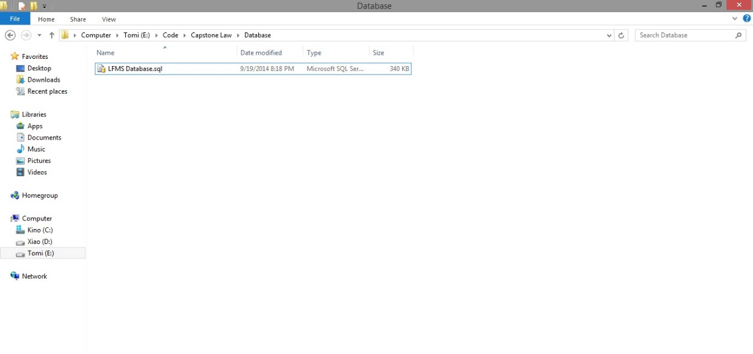

**Figure 6-1: Prepare Database**

They include a .sql file. The .sql file is database SQL scrip file.

* **Step 2**: Import database to SQL Server

Open Script file database using SQL Server

Copy user’s directory that has install SQL Server and replace this location in script file.

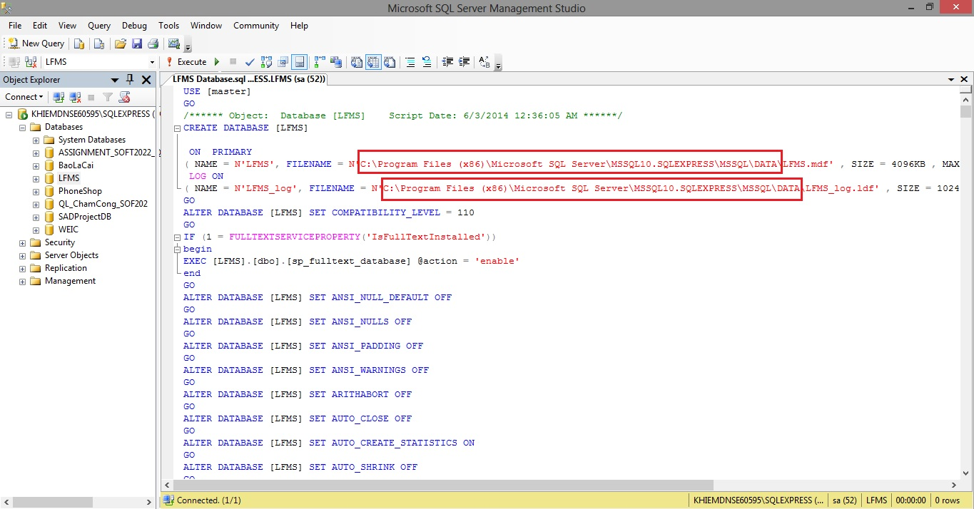

**Figure 6-2: Excute script database**

Excute script file to add new database into SQL Server

#### Setup Internet Information Services(IIS)

* **Step 1**: Go Start 🡪 Control panel 🡪 Click on Programs and Features 🡪 Click on Turn Windows features on or off.
* **Step 2**: Select this features in the picture below to install IIS Service.

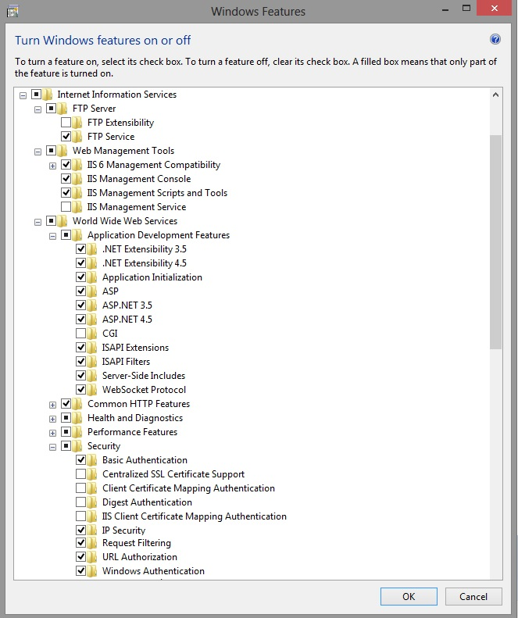

**Figure 6-3: Setup IIS-1**

* **Step 3**: Go Start 🡪 type Run 🡪 input inetmgr

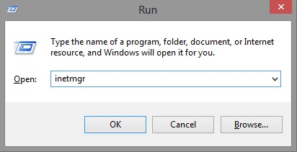

**Figure 6-4: Setup IIS-2**

**Step 4:** Go Application Pools 🡪 Right click to select Add Application Pool 🡪 Setup this like the picture below.

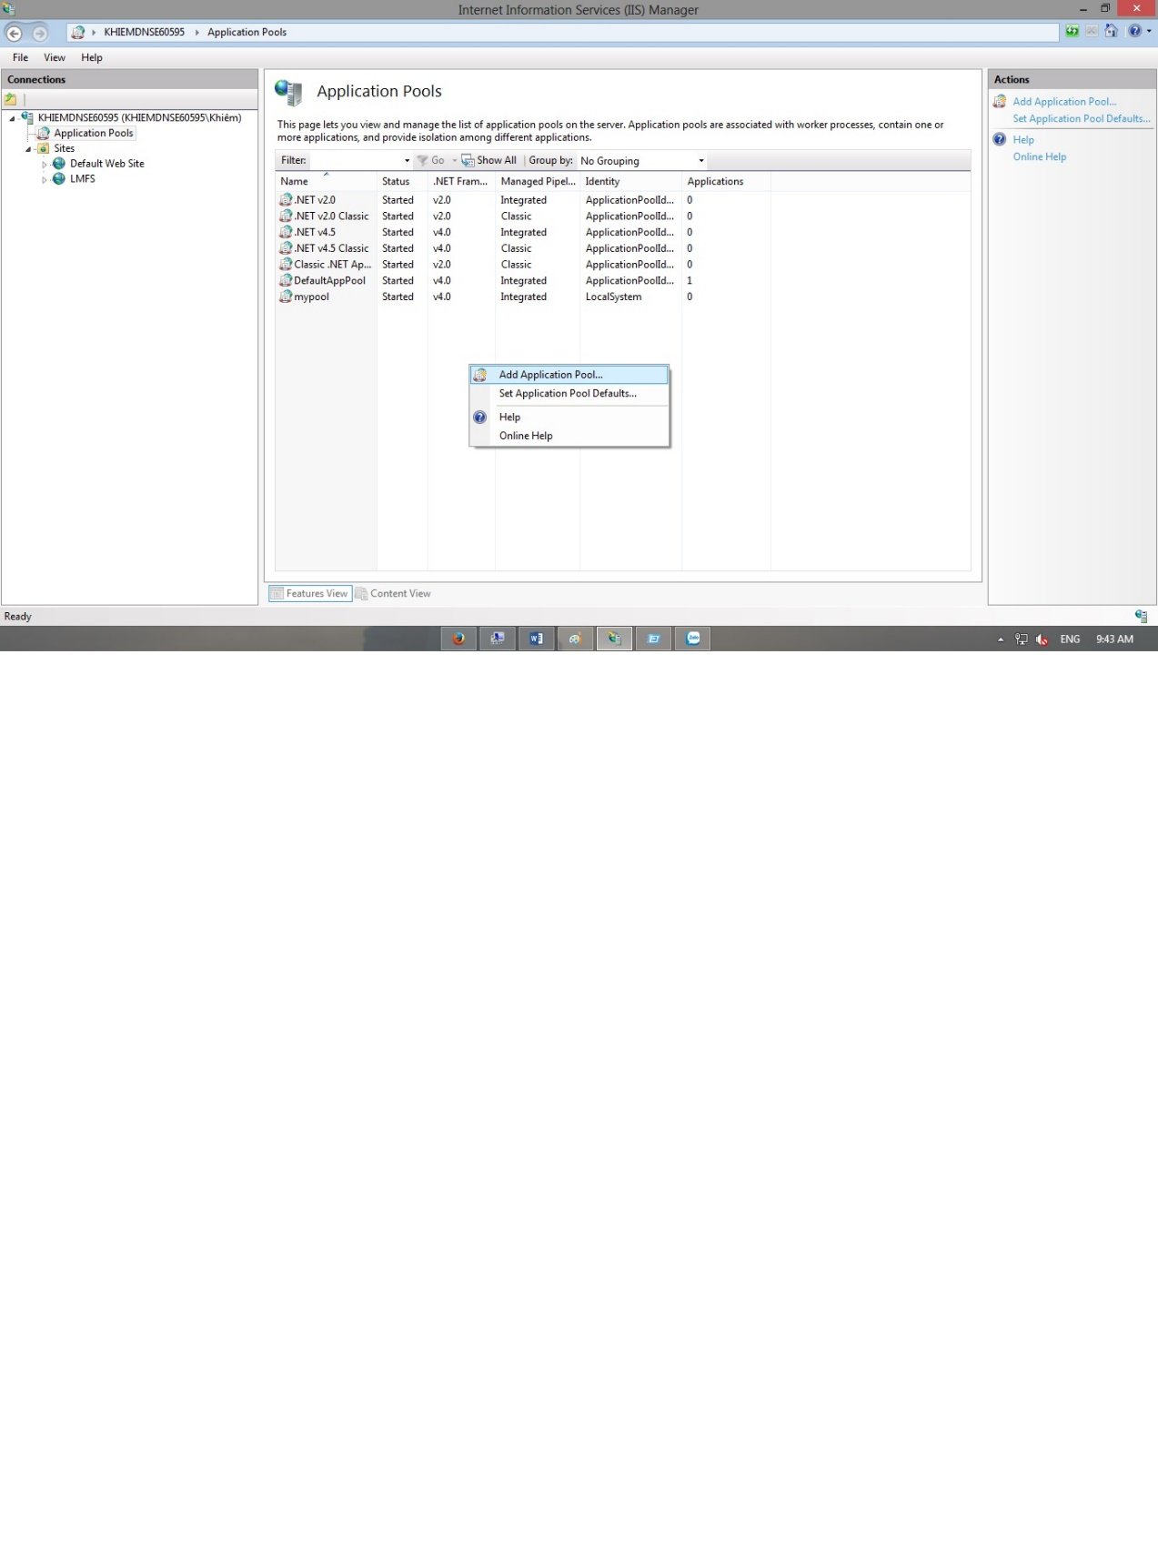

**Figure 6-5: Setup IIS-3**

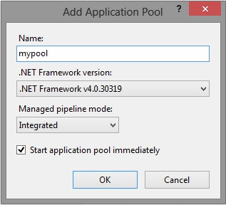

**Figure 6-6: Setup IIS-5**

* **Step 5:** Open Microsoft SQL Server Management Studio 🡪 Go Security 🡪 Right click to select New Login 🡪 Setup this like the picture below

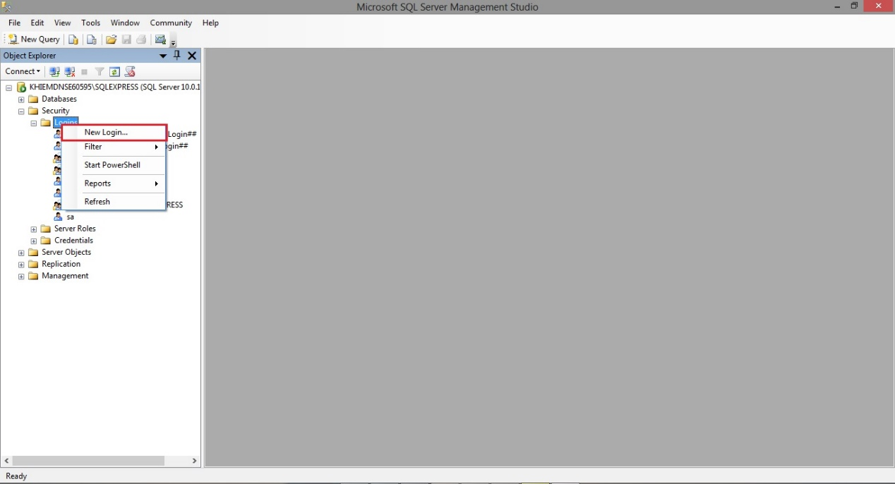

**Figure 6-7: Setup IIS-6**

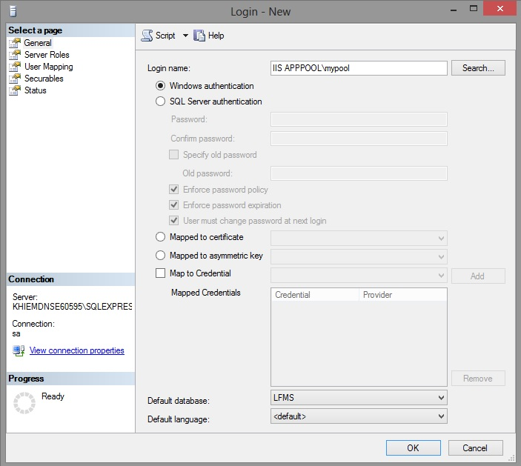

**Figure 6-8: Setup IIS-7**

**Step 6:** Go to login user has been created 🡪 Right click then select Properties 🡪 Click on User Mapping 🡪 Setup this like the picture below

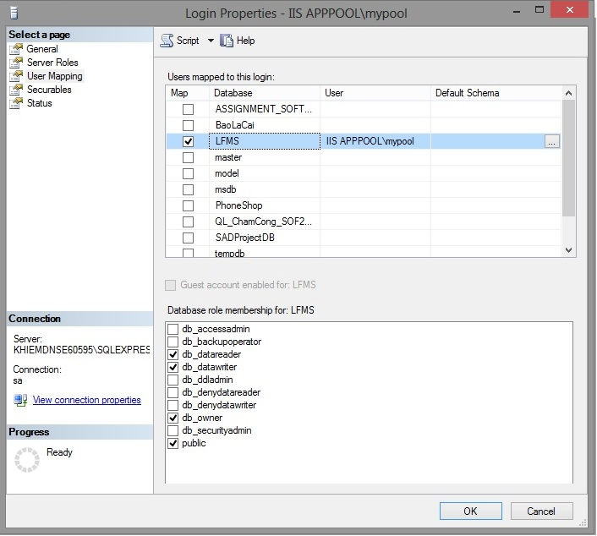

**Figure 6-9: Setup IIS-8**

#### Setup and Deloy website into IIS

* **Step 1:** Go Sites 🡪 Right click to select Add Website 🡪 Setup this like the picture below.

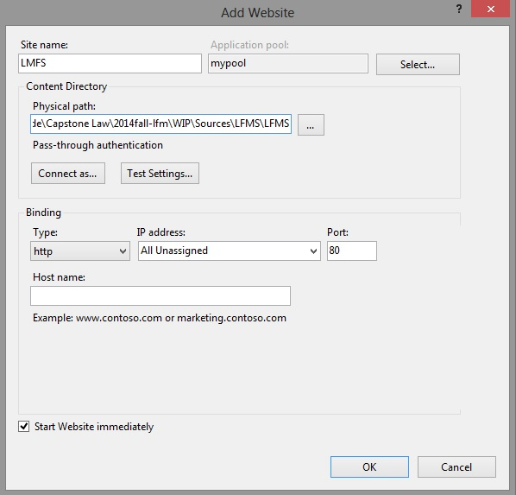

**Figure 6-10: Deploy website on IIS-1**

* **Step 2:** Goto website user has been created 🡪 Double click on Directory Browsing 🡪 Make this select Enable like the picture below.

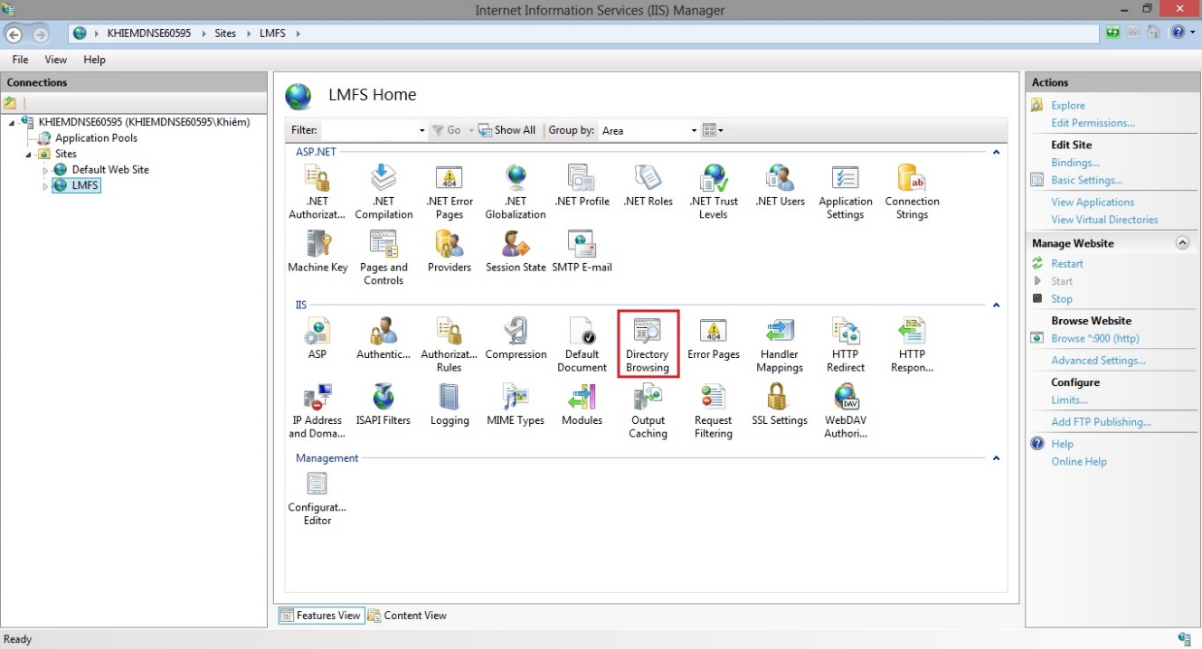

**Figure 6-11: Deploy website on IIS-2**

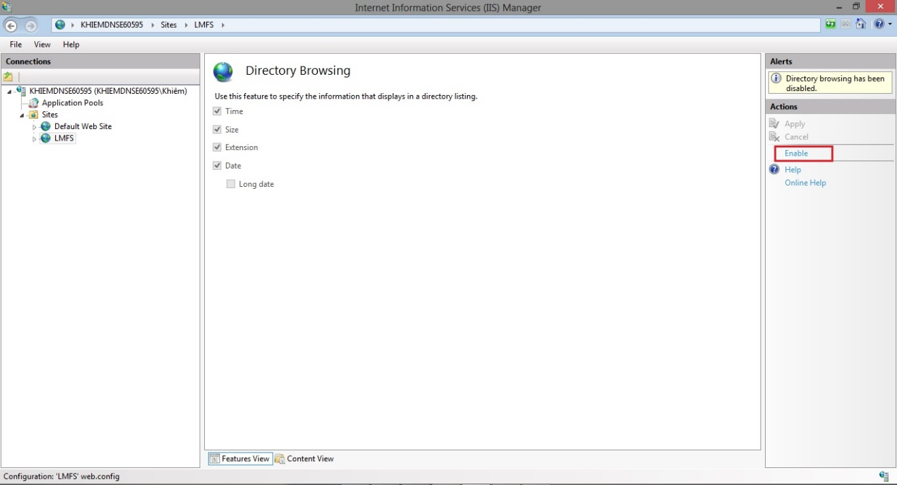

**Figure 6-12: Deploy website on IIS-3**

* **Step 3:** Goto website user has been created 🡪 Right click to select Manage website 🡪 Choose Browse like the picture below.

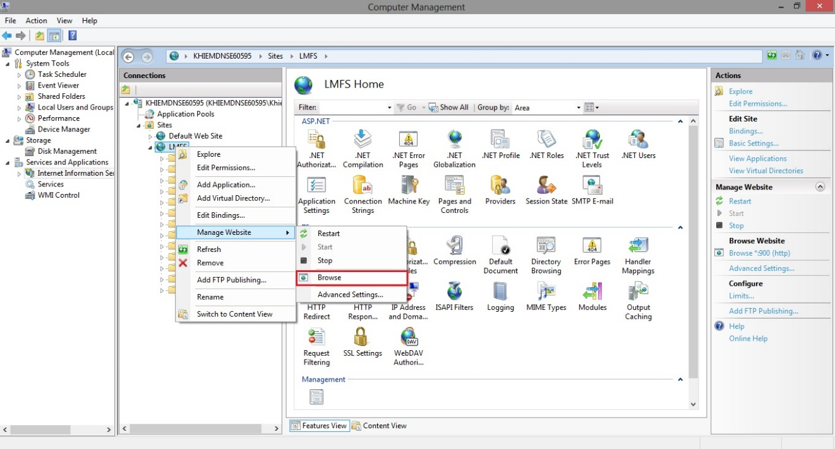

**Figure 6-13: Deploy website on IIS-4**

## User’s Guide

### How to create a Calendar Event

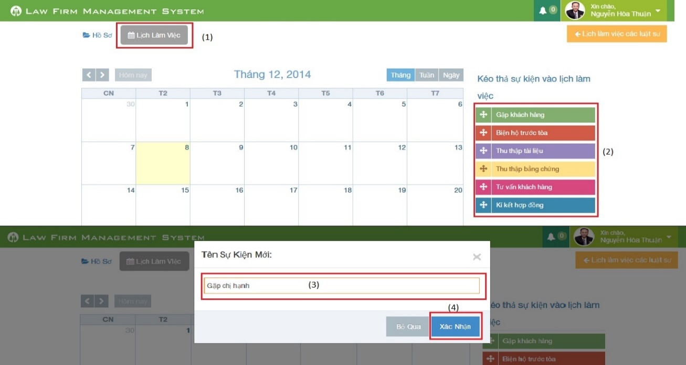

**Figure 6-14: How to create a Calendar Event**

|  |  |
| --- | --- |
| Step | Description |
| 1 | At Index page, click at “Lịch làm việc” tab |
| 2 | Drag any event and drop it into calendar.  (User can also click or click and drag anywhere in calendar to create a new event) |
| 3 | Input New calendar event name. |
| 4 | Press “Xác nhận” button to create new calendar event. |

### How to view calendar event of other lawyer

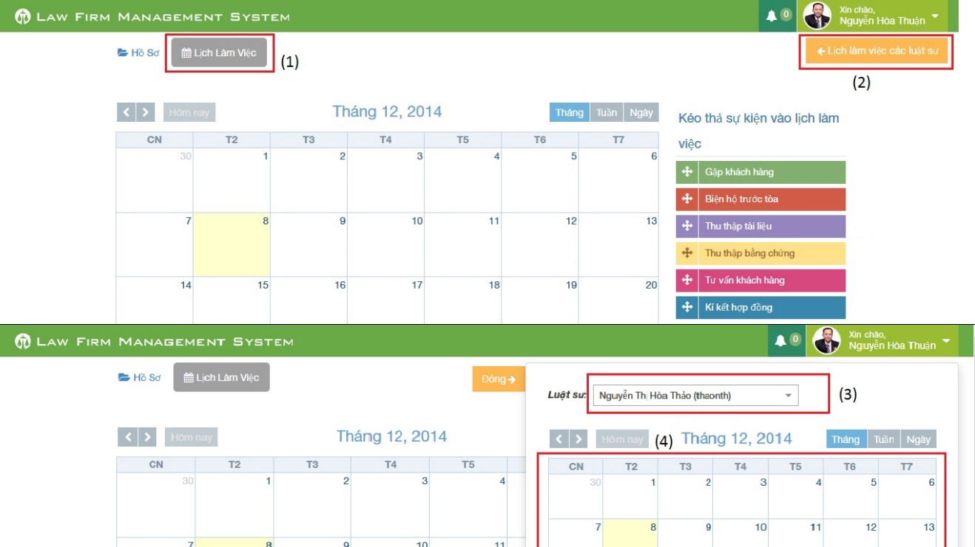

**Figure 6-15: How to view calendar event of other lawyer**

|  |  |
| --- | --- |
| Step | Description |
| 1 | At Index page, click at “Lịch làm việc” tab |
| 2 | At “Lịch làm việc” tab click at “Lịch làm việc các luật sư” |
| 3 | Choose a name of lawyer user want to view at combo-box |
| 4 | Calendar event will show below combo-box |

### How to create an Operation Event

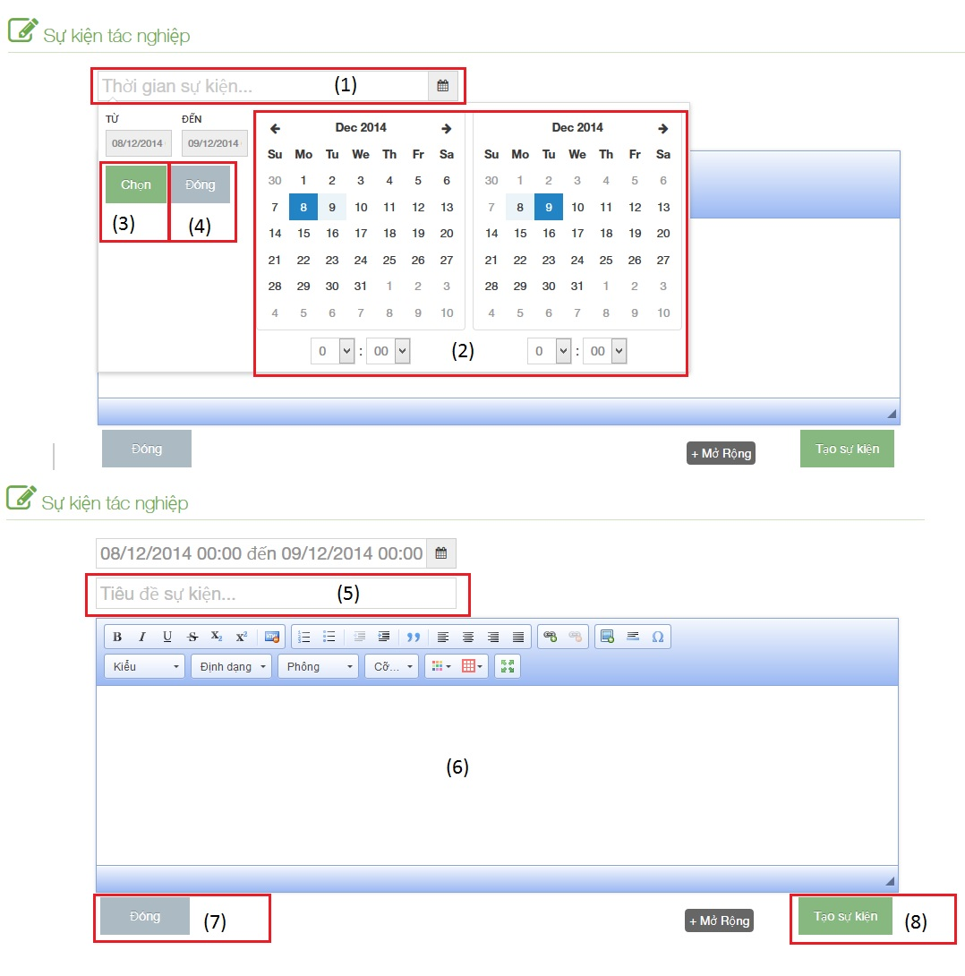

**Figure 6-16: How to create an Operation Event**

|  |  |
| --- | --- |
| Step | Description |
| 1 | Click to text box to add time start and finish of event |
| 2 | Choose date and time of event |
| 3 | Click [Chọn] button to input data on “Thời gian sự kiện” |
| 4 | Click [Đóng] button to cancel input |
| 5 | Input title of event |
| 6 | Input content of event include: text, image…. |
| 7 | Click [Đóng] button to close Popup and back to [List event] screen |
| 8 | Click [Tạo sự kiện] to insert new operation event |

### How to upload photos to Documents Related

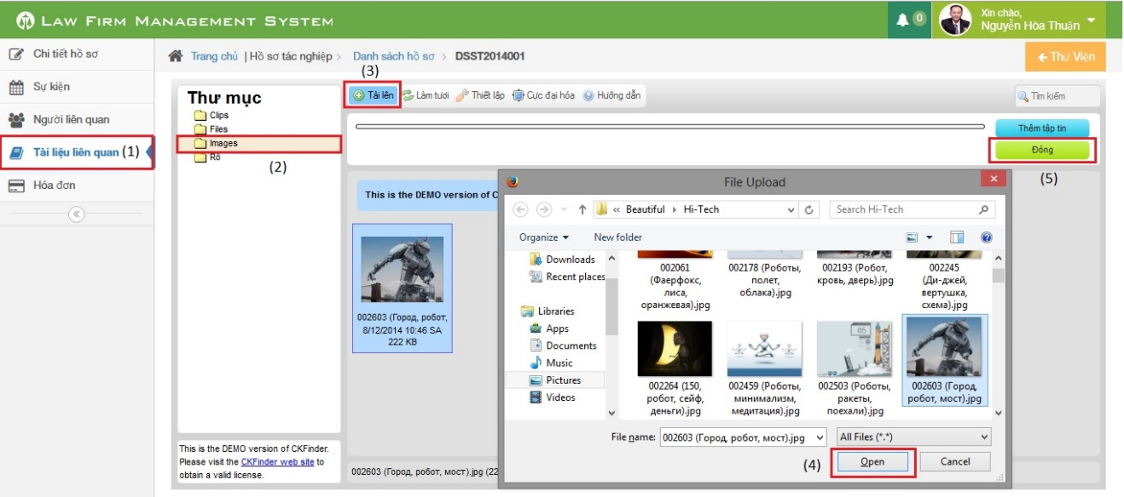

**Figure 6-17: How to upload photos to Documents Related**

|  |  |
| --- | --- |
| Step | Description |
| 1 | Go to case detail page and then click on “Tài liệu liên quan” link |
| 2 | Click on “Images” button (can upload only image file format) |
| 3 | Click on “Tải lên” button to show a popup |
| 4 | Choose one or many photos and then click “Open” button |
| 5 | Click on “Đóng” button to complete upload |

### How to create a case

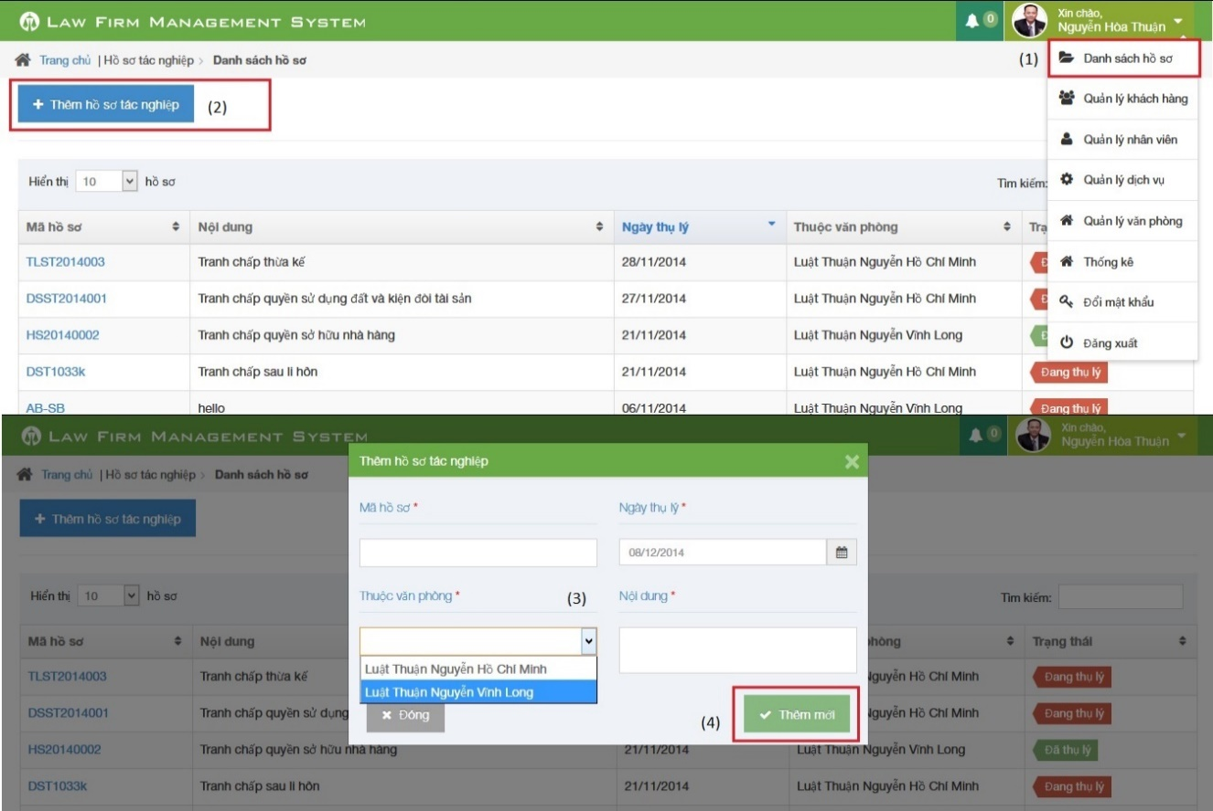

**Figure 6-18: How to create a Case**

|  |  |
| --- | --- |
| Step | Description |
| 1 | Click on list menu and then choose “Danh sách hồ sơ” to go to view list case page |
| 2 | Click on “Thêm hồ sơ tác nghiệp” to show a popup |
| 3 | Fill information of case:  - Mã hồ sơ, Ngày thụ lý, Thuộc văn phòng, Nội dung is required |
| 4 | Click [Thêm mới] button to insert new case |

### How to create a customer

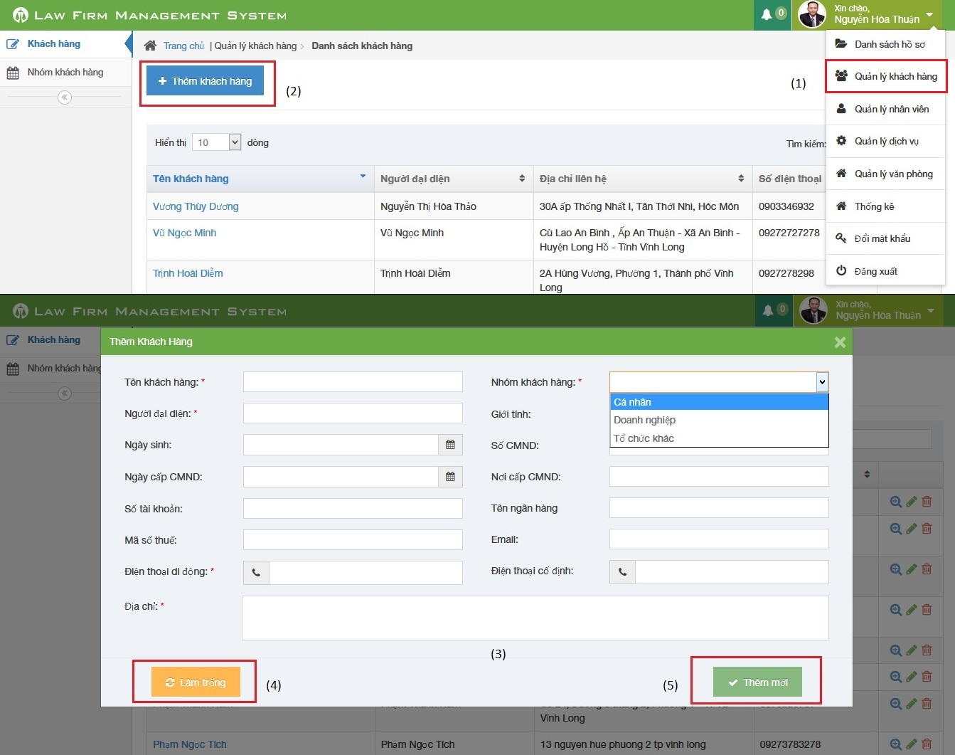

**Figure 6-19: How to create a Customer**

|  |  |
| --- | --- |
| Step | Description |
| 1 | Click on list menu and then choose “Quản lý khách hàng” to go to view list customer page |
| 2 | Click on “Thêm khách hàng” to show a popup |
| 3 | Fill information of case:  - Tên khách hàng, Người đại diện, Nhóm khách hàng, Điện thoại di động, Địa chỉ is required  - Điện thoại di động, Điện thoại cố định, số CMND, Mã số thuế, Số tài khoản must be number  - Email to compliance with format |
| 4 | Click [Làm trống] button to clear all fill to blank. |
| 5 | Click [Thêm mới] button to insert new customer |

### How to create a Staff

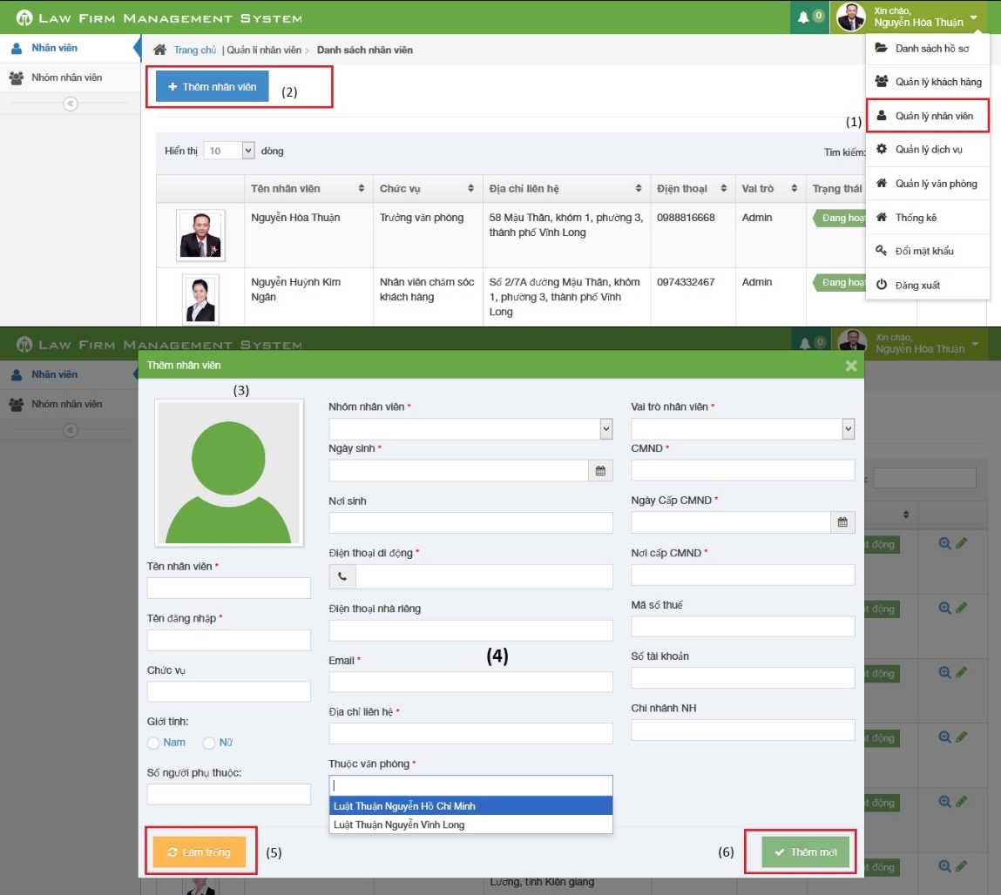

**Figure 6-20: How to create a Staff**

|  |  |
| --- | --- |
| Step | Description |
| 1 | Click on list menu and then choose “Quản lý nhân viên” to go to view list staff page |
| 2 | Click on “Thêm nhân viên” to show a popup |
| 3 | Click to input avatar of staff |
| 4 | Fill information of staff:  - Tên nhân viên, Tên đăng nhập, Nhóm nhân viên, Ngày sinh, Điện thoại di động, Email, Địa chỉ liên hệ, Thuộc văn phòng, Vai trò nhân viên, CMND, Ngày cấp CMND, Nơi cấp CMND is required  - Điện thoại di động, Điện thoại nhà riêng, CMND, Mã số thuế, Số tài khoản must be number  - Email to compliance with format |
| 5 | Click [Làm trống] button to clear all fill to blank. |
| 6 | Click [Thêm mới] button to insert new staff |

### How to create a service

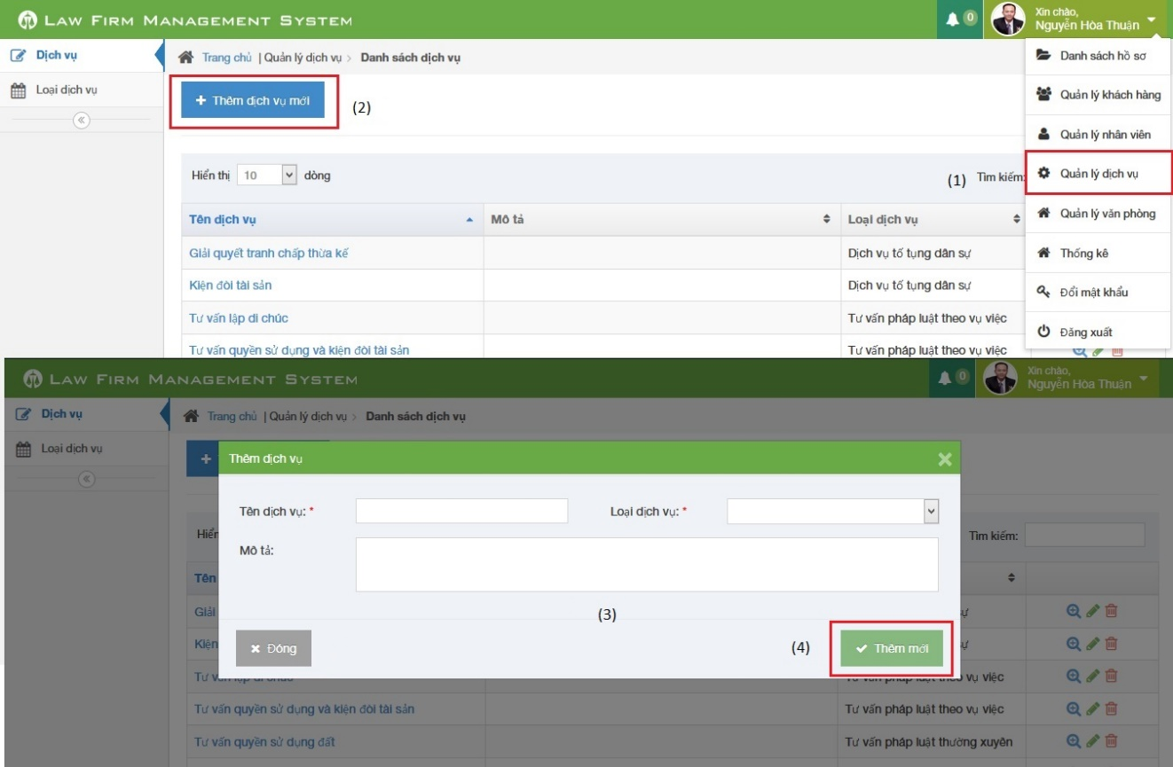

**Figure 6-21: How to create a service**

|  |  |
| --- | --- |
| Step | Description |
| 1 | Click on list menu and then choose “Quản lý dịch vụ” to go to view list service page |
| 2 | Click on “Thêm dịch vụ mới” to show a popup |
| 3 | Fill information of case:  - Tên dịch vụ, Loại dịch vụ is required |
| 4 | Click [Thêm mới] button to insert new service |

### How to create an office

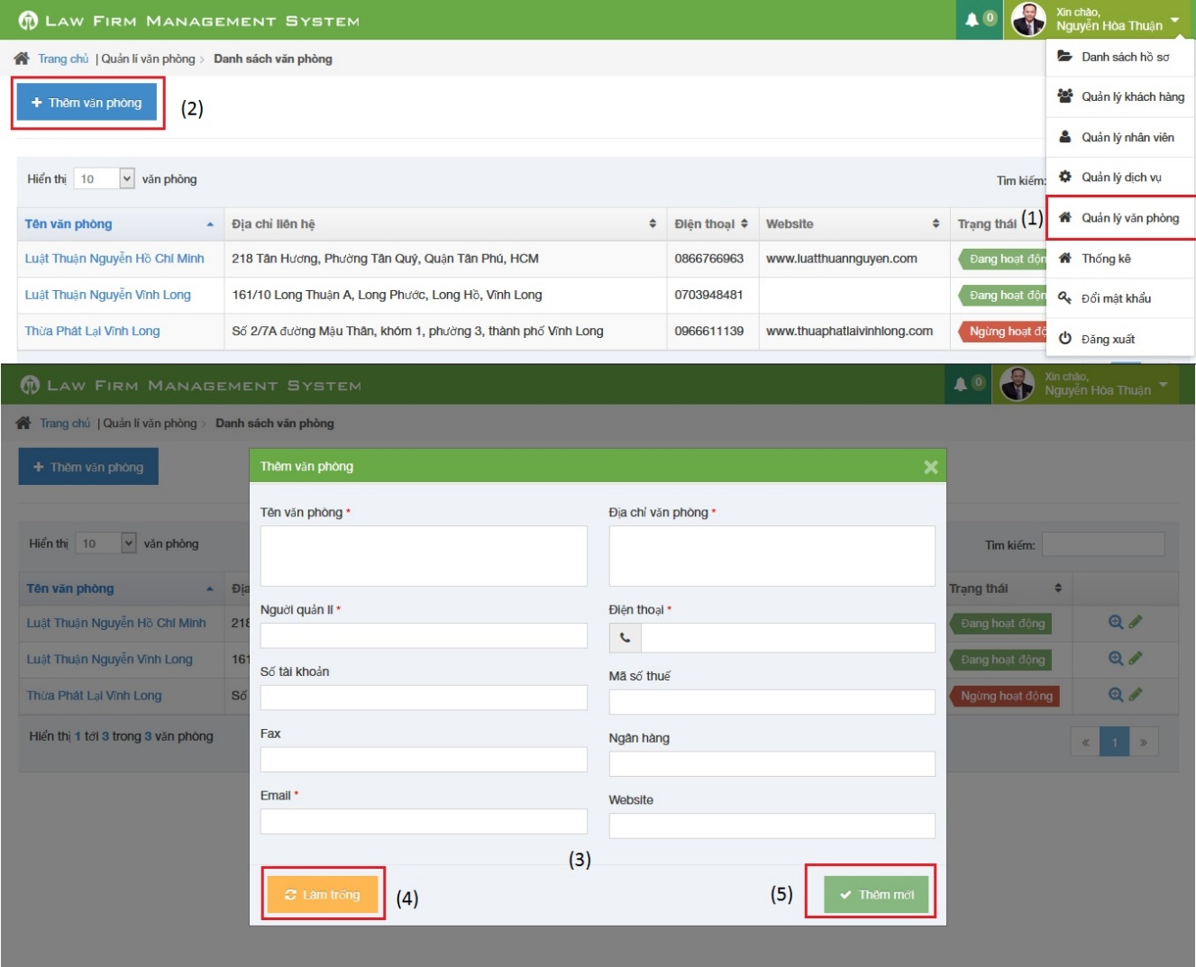

**Figure 6-22: How to create a Staff**

|  |  |
| --- | --- |
| Step | Description |
| 1 | Click on list menu and then choose “Quản lý văn phòng” to go to view list office page |
| 2 | Click on “Thêm văn phòng” to show a popup |
| 3 | Fill information of case:  - Tên văn phòng, Địa chỉ văn phòng, Người quản lí, Điện thoại, Email is required  - Điện thoại, Mã số thuế, Số tài khoản must be number  - Email to compliance with format |
| 4 | Click [Làm trống] button to clear all fill to blank. |
| 5 | Click [Thêm mới] button to insert new service |

### How to view statistic

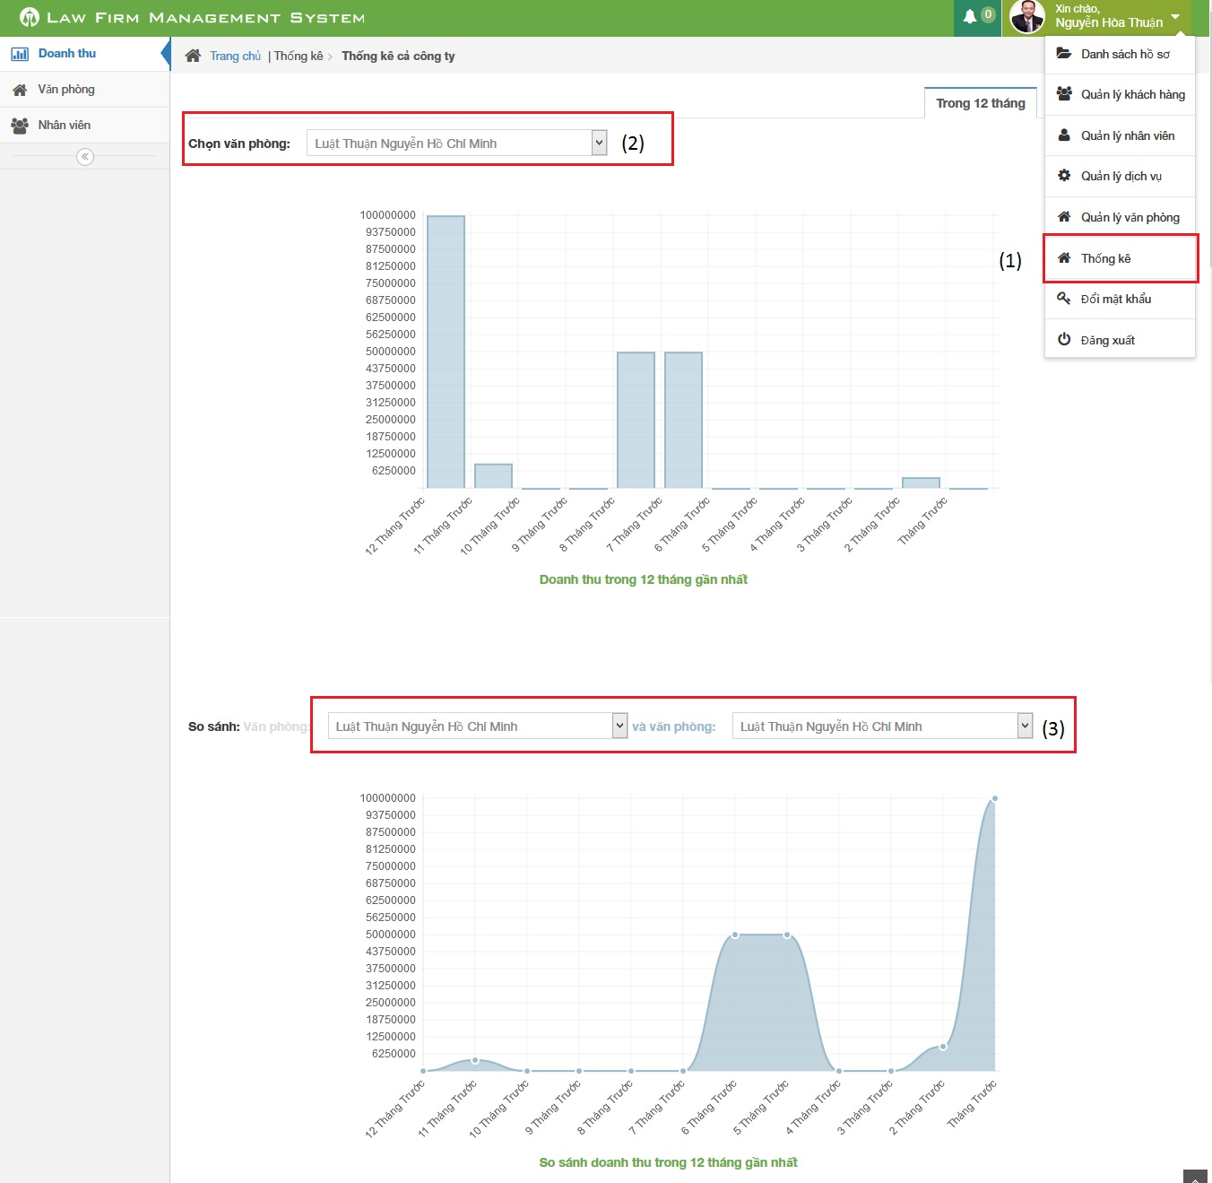

**Figure 6-23: How to view statistic**

|  |  |
| --- | --- |
| Step | Description |
| 1 | Click on list menu and then choose “Thống kê” to go to view list statistic page |
| 2 | Choose office user want to show statistic |
| 3 | Choose two office user want to compare in statistic |

## Project Result Report

### Project judging

#### Advantages of LFMS

The idea of the LFMS is to develop a new website for “Thuan Nguyen Lawyer Office. It has main features of existing website such as easy to manage than traditional methods, online data storage and centralized etc… Besisdes, it has some extra functions: schedule notify each time event occur and statistic in every year

* Lawyers can work more effective, easier and simpler way without remember schedule and operation event.
* Law firm can manage all information like case, customer, staff service and office easier.
* Accounting easier with auto statistical in every year.

#### Current limitations of LFMS

However, some limitations still exist

* Still not using search in “Thư viện pháp luật”
* Only support Firefox

#### Expectation in future

* Develop function search in “Thư viện pháp luật”
* Support more in other browser

### Project summary

|  |  |  |  |  |  |
| --- | --- | --- | --- | --- | --- |
| **Project Title** | | | Website of law firm management system | | |
| **Project Supervisor** | | | Nguyễn Văn Sang | | |
| Committers (5) | | | | | |
| 1 | Project Manager | | Lê Duy Hoàng | | [Hoangldse60744@fpt.edu.vn](mailto:Hoangldse60744@fpt.edu.vn) |
| 2 | Project Technical Leader | | Lê Duy Hoàng | | [Hoangldse60744@fpt.edu.vn](mailto:Hoangldse60744@fpt.edu.vn) |
| 3 | Developer | | Đặng Nguyễn Khiêm | | [Khiemdnse60595@fpt.edu.vn](mailto:Khiemdnse60595@fpt.edu.vn) |
| 4 | Developer | | Phạm Văn Duy | | [Duypvse60634@fpt.edu.vn](mailto:Duypvse60634@fpt.edu.vn) |
| 5 | Tester | | Trần Anh Tuấn | | [[Tuantase60631@fpt.edu.vn](mailto:Tuantase60631@fpt.edu.vn)](mailto:Minhtc01748@fpt.edu.vn) |
| Main objective | | Develop a website that helps users can manage all information like case, customer, staff, service and office easier. | | | |
| Purpose | | Lawyers can work more effective, easier and simpler | | | |
| **Items** | | **Plan** | | **Actual** | |
| Releases Date | | 25/12/2013 | | 27/12/2013 | |
| Releases version | | 1.0 | | 1.0 | |
| Days | | 78 | | 80 | |
| Test cases | |  | | 223 test case | |
| Defects | |  | | 8 | |
| Document pages | |  | | > 200 (include appendix) | |
| Lines of code | |  | | Approximately 50.000 | |

### Lesson learned

* Before this capstone project, we do not know much about ASP. Net MVC4, Ajax and C #language. After more than 3 months, we have more experience and deeply understand how to create a MVC4 website, how to face with problems and bugs in developing a MVC4 website.
* We also improved lots of skills
  + - * Firstly, about technical, we know how to develop application with C# language, how to use SVN to store source code and how to work efficiently with Microsoft Office.

Secondly, about soft skills, while doing this project, we can gain skills in how to work with team efficiently, how to avoid conflict in team members. After lots of team meeting, we know how to brainstorm with all team to generate creative idea or solution to a problem. In addition, two important skills are researching and self-studying, we have to research and self-study a lot to do our work in project, to solve a problem.

* + - * Finally, one of the most important skill we have learnt through this project is project management. We know how to manage a project from the beginning to the end, how to create project plan, how to collect requirements, how to create SRS, how to design an application, how to create test cases etc. It is very important for our job in the future.
* Through this capstone project, we have more expreriences in risk and issues management
  + - * About technique :
        + Some members do not have high level in work with ASP. Net MVC 4, Ajax, Jquery before start this project so we assign some members to take responsibility for researching and training the others.
        + Members do not understand about some general techniques such as searching in internet or asking for supporting from community. We have to support to guide each other to work efficiently.
      * About human resources:
        + Some members are lazy for a while; they cannot finish their work before deadline or cannot do their tasks so we define detail schedules, and often reminding each other.
        + We held lots of team meeting for team members to meet each other, to brainstorming to think about solution of a problem and to support other members.
        + Team members must report what they do twice a week and project manager has to define schedule according to members’ capability.
      * About the missing deadline, there are some reasons
        + The coding language is new with us, so we need more time to be acquainted with it.
        + Sometimes source code has problems and members cannot check in, check out to submit their works
        + There are some conflicts between team members; they lead to the waste of time.

END.